According to the following link about the token’s authorization flux
https://developer.blackbaud.com/skyapi/docs/authorization/auth-code-flow/code-samples/c-sharp
The example code in this link, would have to get to this point, according to the tutorial
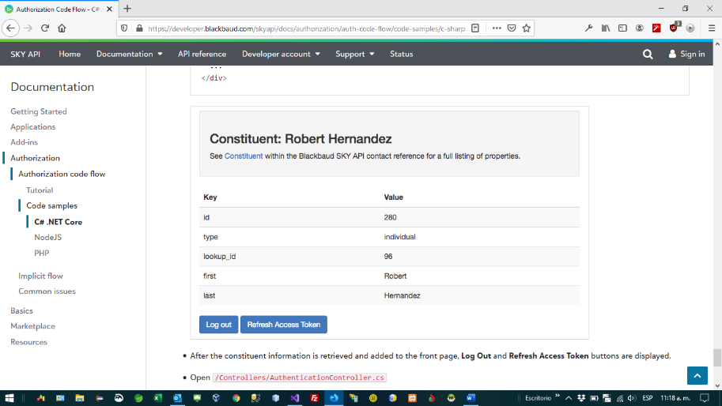

The example code only gets to this point, it doesn’t authenticate
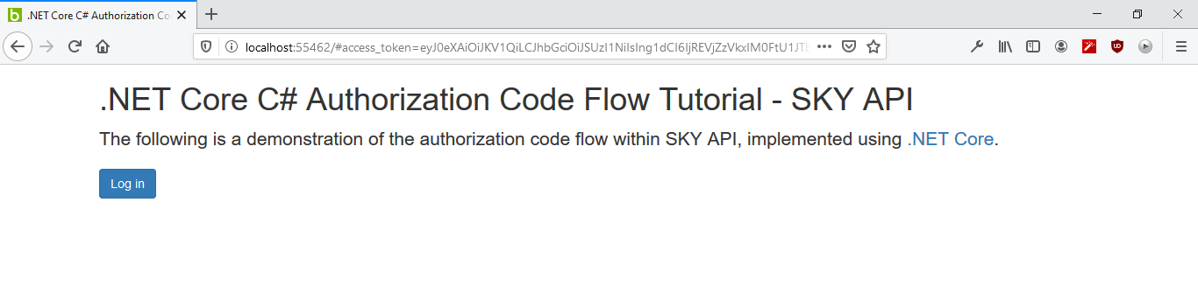

According to the documentation, it redirects to the login page when it is not authenticated
