Entering a New Individual Constituent

Purpose: Create a new record in Raiser’s Edge for an individual or couple.

Tab/Module | Task/Step
Raiser’s Edge/Records | 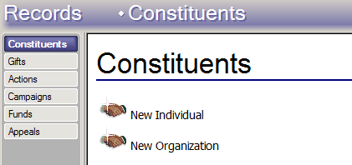  - After checking for an individual by both name and address, go to the Records section in Raiser’s Edge and select New Individual.  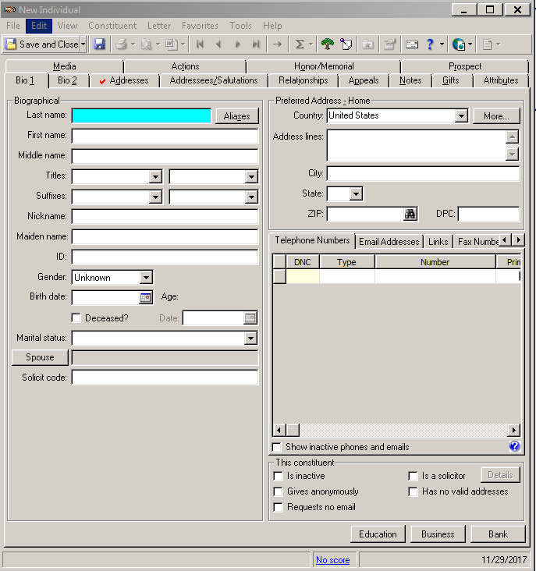  - A New Individual constituent record window will open. Each record has thirteen tabs, each with multiple fields, in order to collect information about a donor. Once data has been entered in a particular tab, a red check mark will appear to the left of the tab name. The three required tabs when entering a new individual constituent record are: Bio 1, Bio 2 and Addressees/Salutations. Required fields are highlighted in teal, but as much information as possible should be entered.
Raiser’s Edge/  Constituent Record – Bio 1 | 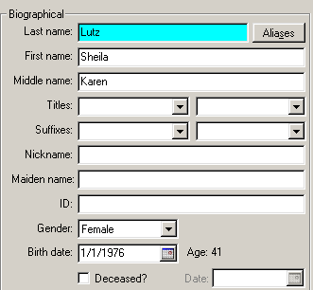  - Enter the Biographical information for the primary donor in the fields located on the left-hand side of the Bio 1 tab, including Last Name and First Name. Also enter any additional information, such as Gender, Maiden name, Birth date, etc., in this section. At minimum, a last name is required to enter a new constituent in Raiser’s Edge; if either a first or last name is unknown, consult the Database Administrator on how to enter the constituent.  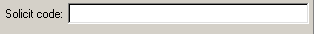  - On the bottom left-hand corner, select Solicit Code (this becomes a hyperlink when the mouse is held over the words).  - When the Solicit Code pop up window opens, select the appropriate Solicit Codes (see Solicit Code Standards - Individuals procedure), either by double-clicking on the selection or by highlighting it with the cursor and clicking the > icon. Select OK when finished.  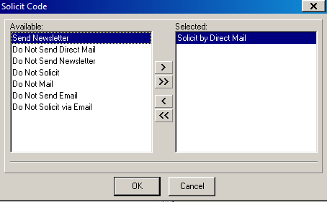  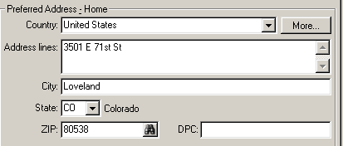  - Enter the donor’s Preferred Address – Home in the section on the right-hand side of the Bio 1 tab using the standards outlined in the Address Standards procedure. Only use the first 5 digits of the ZIP code; adding the additional plus-4 digits will cause address errors on letters and labels.  - Select the Type Main under the Telephone Numbers tab and enter the primary phone number, including area code. Raiser’s Edge will automatically format the number to the form (XXX) XXX-XXXX. Enter additional phone numbers in subsequent lines, using the Type Alternate, Alternate 2, Work or Cell, as appropriate. However, the primary phone number for the donor, regardless of type, should always be listed as Main. If there is an email but not a known phone number, still enter a line with the Type Main, but leave the Number section blank.  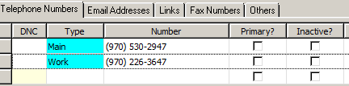  - To enter an email, select the Email Addresses tab. Enter the address under the Type E-mail. For alternate emails, use the subsequent lines and the Type E-mail 2 and E-mail 3. Use lower case letters unless otherwise indicated.  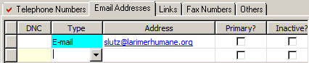
Raiser’s Edge/  Constituent Record – Bio 2 | 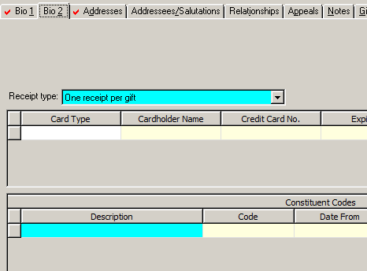  - Click on the Bio 2 tab to open the section.  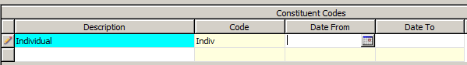  - Select Individual from the drop down menu under Constituent Code. Individual should always be the first Constituent Code listed for individual records. There is no need to set a Date From or Date To for this particular code.
Raiser’s Edge/  Constituent Record –  Addressees/  Salutations | - Click on the Addressees/Salutations tab to open the section.  - The top blue line is used to the set the Primary addressee, or, the name that would go on the outside of a mailing envelope – usually this is the full name of the individual. Select the appropriate option from the drop down menu.  - The second blue line is used to set the Primary salutation, or, the name that goes after “Dear” in a letter – this is usually the first name of the individual, unless the donor indicates a preference for a more formal address (e.g., Dear Mr. and Mrs. Jones). Default to the first name, or nickname if known.  - Click on the Save icon at the top left-hand side to save the primary donor info before adding a spouse or partner. If not adding a spouse, select the Save and Close icon.
Raiser’s Edge/  Constituent Record –  Adding a Spouse or Partner | 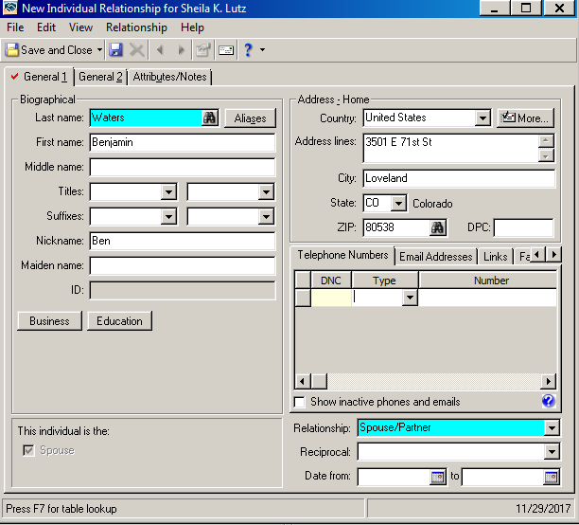  - Go back to the Bio 1 tab and select the Spouse icon on the lower left-hand side of the window. A New Individual Relationship pop up window will open. Enter any Biographical information for the spouse or partner, including Last Name and First Name, and any additional information, such as Nickname, if known.  *Note: the Address - Home field will auto-populate with the primary constituent’s Preferred Address - Home.  - In the drop down Relationship menu, select Spouse/Partner. Select Save and Close from the top left-hand side of the window. There is no need to set a Date From or Date To for this relationship type.  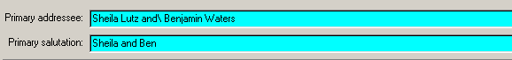  - Occasionally the Addressee/Salutations tab will not update correctly when adding a spouse or partner and should therefore always be checked before closing out of the record. If it hasn’t updated correctly, use the drop down menu under Primary addressee, and find the option that uses the correct first and last names for each individual. If the individual and spouse have a different last name, select the option that has an “and\” between the two names; this does not indicate that there will be a “\” between names when letters or labels are printed, but rather when the truncation will occur if the Primary addressee is long enough to take up more than one line on a letter or label. If you are having any problems finding the correct Primary addressee of Primary salutation, consult the Database Administrator.  - Once the Primary addressee line is correct, Save and Close the primary record.

