Michaela’s RE NetCommunity

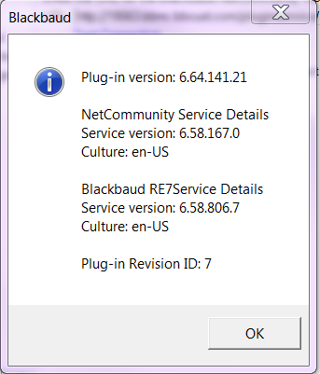

Shannon’s RE NetCommunity

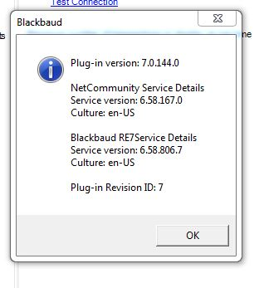

Kelly’s RE NetCommunity

