**BEGINNING OF SHIFT**

1. Get the tablets from the **Database Administrator**
2. Hold down the **Power button** until it vibrates and turns **ON**
3. **Swipe** right on the screen
4. Make sure the **swiper** is plugged FIRMLY into the **Audio jack**  
   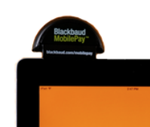
5. Tap the green **MobilePay** Icon  
   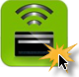
6. Tap the Password field and type in the **Password**. Tap the Shift Key **↑** to get capital letters and special characters. Then tap the **Go** button.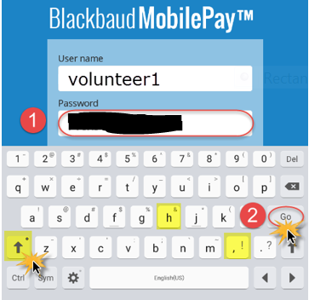
7. **If the screen turns off**, press the power button ONCE and swipe right

**END OF SHIFT**

1. Tap the **Settings** icon  
   C:\Users\RBAILE~1.HFH\AppData\Local\Temp\SNAGHTML6bb2148.PNG
2. Tap **Logout**
3. Tap **OK**
4. Plug the tablets into the **chargers**
5. Hold down the power button on the tablets and tap **Power Off**

**TAKE PAYMENT**

|  |  |
| --- | --- |
| 1. **Enter payment amount.** Enter the amount and tap Enter payment. | 1. **Get credit card info.** Swipe the card or enter its information. https://encrypted-tbn1.gstatic.com/images?q=tbn:ANd9GcRTYIl_Xve8K0KqwLDpcl9986GuWteV_qAy1bb88Zt-oMccBFZITA |
| 1. **Get the signature.** Have the card holder use a finger or stylus to sign. https://static-s.aa-cdn.net/img/ios/662378498/7a089c3162de50c5d244e2c5520c086f | 1. **Enter other details.** Enter email address for receipt and tap Pay Now. https://encrypted-tbn3.gstatic.com/images?q=tbn:ANd9GcRmimKF6NDzKH7dg6WmahCxVjmck94UKb1KKxKURmQiFcIZ2SST 2. Repeat **Steps 1-4** for the next payment |

**REFUND PAYMENT**

***ONLY*** *if you made an error and charged the wrong amount!!!*

|  |  |
| --- | --- |
| 1. Tap the **Settings** icon C:\Users\RBAILE~1.HFH\AppData\Local\Temp\SNAGHTML6bb2148.PNG | 1. For a PARTIAL refund, change the **Refund amount**, then tap **Continue**. 2. Tap **Refund now.** |
| 1. Tap **Recent Transactions** |
| 1. Tap the payment you want to refund |

**TROUBLESHOOTING**

**Why don't cards scan correctly?**

The ***Blackbaud Mobile Pay*** card reader needs to be completely plugged in. When it is, you should see "device detected" or "charging swiper" on the **Swipe or Enter Card** screen. If it’s still not working, trying turning the card over. When you run the credit card through the swiper, the magnetic stripe should be facing away from you. If the magnetic stripe is damaged, you may manually enter the Card holder, Card number, Expiration, and CVV2 on the Swipe or Enter Card screen and then tap continue.

**Why do transactions process slowly?**

Transaction processing requires a stable internet connection. Please be sure to check cellular and wi-fi connectivity before your event. Make sure wi-fi is turned on in Device Settings, choose xxxxxxx as your network, and use the password **xxxxxxx** to connect. If you cannot connect to wi-fi, ensure your cellular signal is strong in the event area.

**Why can't I log into *Blackbaud MobilePay*?**

Typically, users cannot log in if the internet connection is poor or their credentials are incorrect. Please review the following on site before your event to minimize connectivity issues.

* Test performance of cellular and wi-fi connections.
* Log into each tablet that will be used with the user name and password.
* If you are locked out or encounter an error with the user name or password, contact Rachel Bailey (see below).

**Is the email address required?**

The email address is optional. However, you will need to enter it if you want to send an email confirmation of the transaction to the constituent. We recommend capturing the email address.

**Why do I receive the error 'Transaction processing failed' when trying to submit a payment?**

Check your cellular or wi-fi connectivity. The transaction was not received by ***Blackbaud Merchant Services***. You will need to reenter the entire transaction in order to process the payment.

**Who can I call with questions?**

For questions about the Samsung tablets and Blackbaud MobilePay, please call Rachel Bailey at xxxxxxxxxx or email her at [rbailey@xxxx.org](mailto:rbailey@xxxx.org). If she is unavailable, please use the paper payment slips until she can call you back.

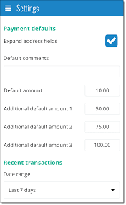

UPON ARRIVAL

1. Log into MobilePay as samtemple and go to **Settings**
   1. **TAKE NOTE** of whether the User name says volunteer1 or volunteer2 when you open the app
2. Under **Acknowledgment subject lines**:
   1. Type “Receipt from Habitat for Humanity of Metro Denver” in the **Payments** field
   2. Type “Refund from Habitat for Humanity of Metro Denver” in the **Refunds** field
3. Type “Trace3 Golf Tournament” into the **Default comments** field
4. Accept payments as usual

WHEN YOU ARE DONE

1. Log out of MobilePay
2. Log back in as volunteer1 or volunteer2 (see 1a above).
3. Go back to Settings
4. Under **Acknowledgment subject lines**:
   1. Type “Receipt from Denver Life Magazine Showhouse” in the **Payments** field
   2. Type “Refund from Denver Life Magazine Showhouse” in the **Refunds** field
5. Type “Denver Life Magazine Showhouse” into the **Default comments** field
6. If you changed the **Default amounts**, change them back to 20, 40, 60, and 80
7. Log out of MobilePay