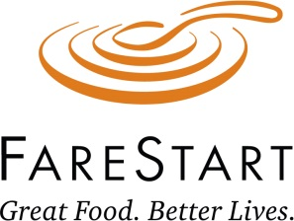

Prospect Research Request Form
If you have any questions, please contact:
April Snow at 206-267-6225 or april.snow@farestart.org.

CONTACT INFORMATION
Name: |  |  | Date Requested:
Date of Meeting/Event: |  |  | Date Needed:

PROSPECT/DONOR INFORMATION
Only fill out the info you know.

Name_____________________________________ Business Name______________________________________

Home Address_____________________________ Business Address:___________________________________

Home Phone:_______________________________ Business Phone:____________________________________

Personal Email:____________________________ Business Email:______________________________________

Please include any other information you may know about the donor/prospect (e.g. RE ID, age, family relations, professional and/or community affiliations:

RESEARCH INFORMATION
How did you identify this prospect?

Contact with the person revealed gift capacity

Referral from volunteer or staff

Recent news item

Giving history suggests capacity

Recent change in assets

Other:

Reason for Research

Discovery/Assessment

Cultivation/Event

Solicitation (does prospect/donor have proposal in Raiser’s Edge? Yes No)

Meeting preparation

Type of Research

Brief Profile (Brief biographical background, FareStart affiliations and giving summary) – 2 days

Comprehensive Profile (In-depth research, including all known information about the prospect) – 7-10 days

Update (Refresh old information and add new information to current prospects) – 3 days

.

