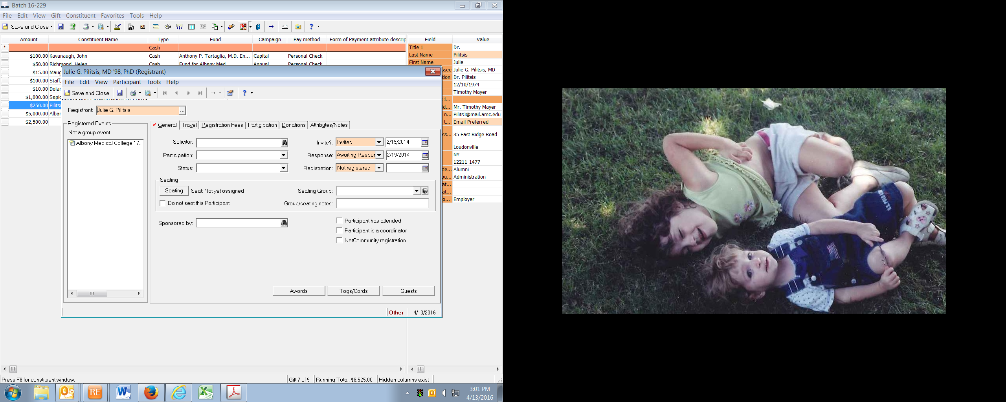

You can toggle back and forth from event module to the record