Adding a Constituent

- ALWAYS search the database before entering any new constituent. Enter last name and first initial for an individual. For an organization, enter first part of Org. name. If a constituent is a contact for an organization the organization name will appear in the response box.

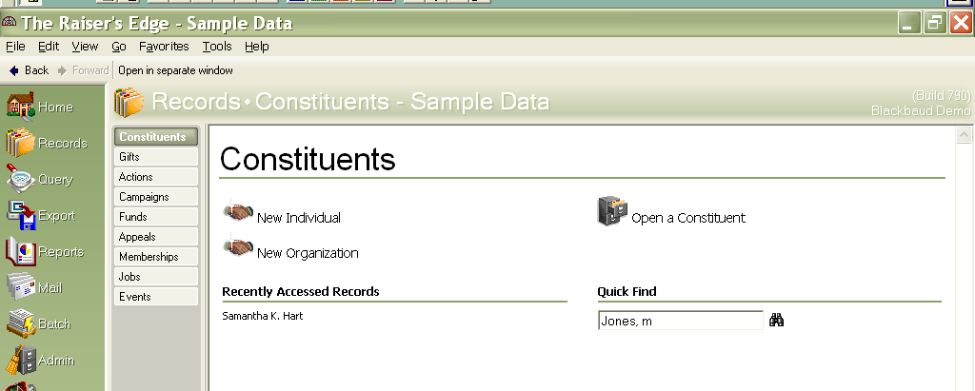

Click on the binoculars to start the search or hit enter.

If your constituent does not show up in the search box and the spelling of the last name is odd try entering just a couple letters and the wild card *. Make sure the “check aliases, contact name and nickname boxes are active (with a check mark in them), if the constituent still is not listed, it is safe to add. Click on the “Add New” button.
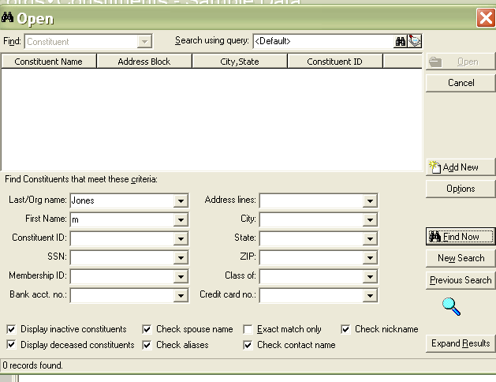
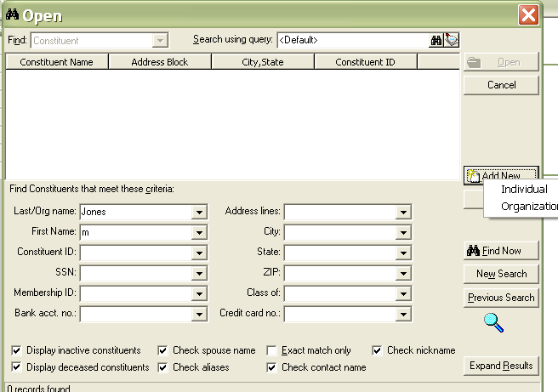

You may add an individual or an organization when you click on Add New

Below is a view of a new individual constituent record.

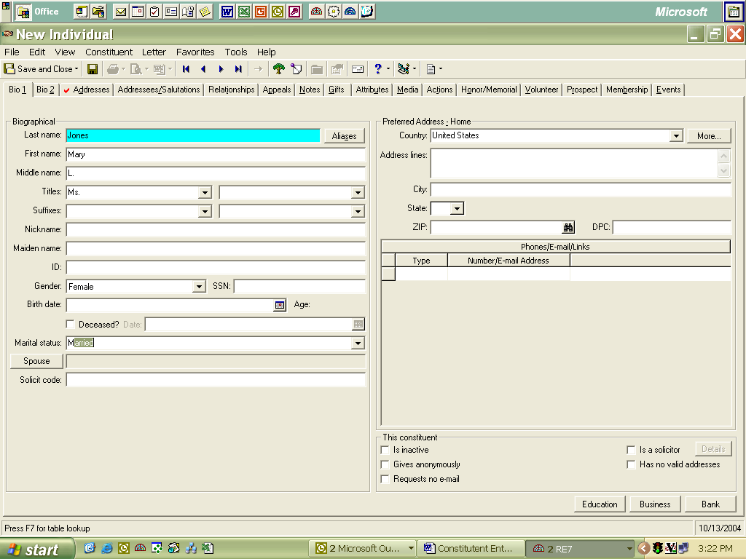

- Remember to add Nickname if appropriate Ex: Robert prefers to be called Bob
- Add gender and Marital status if it applies.
- Instead of entering the address onto the Bio 1 screen address block, click the “More” button and add the address there.

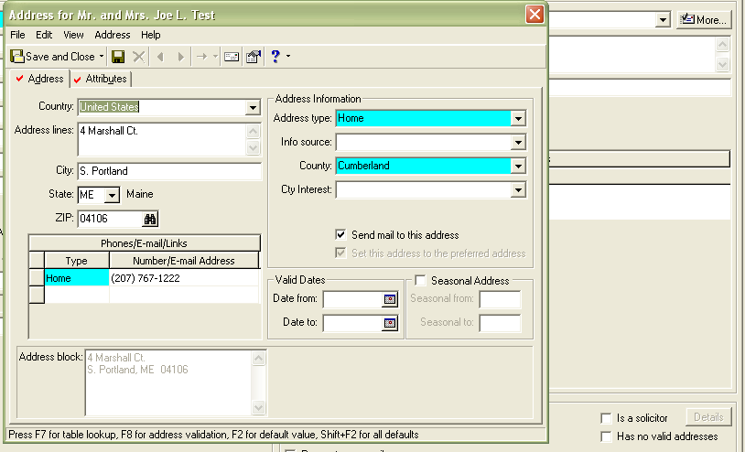
By pressing F2 or Shift+F2 all the address defaults will populate if setup.

We track the county people live in or are interested in, it is a required field, by using the “More” button it saves entry time.

- If the address is a post office box and a street address the street address should be listed first then the post office box. The Post Office “reads” envelopes from the bottom to the top.
- When entering phone type please use the drop down box. There is no need to put parenthesis in or hyphens as RE will provide correct formatting when you tab to next field. If there is an extension, just continue to enter the number at the end of the phone number and RE will format.
- Areas in blue (or highlighted) are required fields. Phone numbers require a phone type.

PLEASE use the Postal abbreviations format from the employee handbook. If you need a copy, see Karen H.
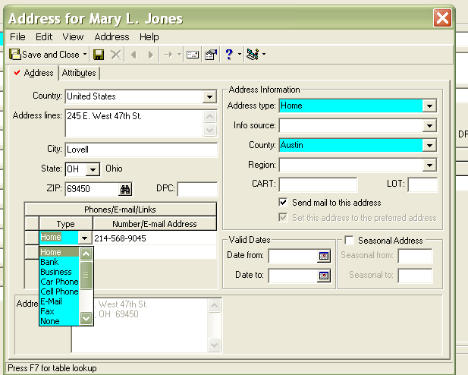
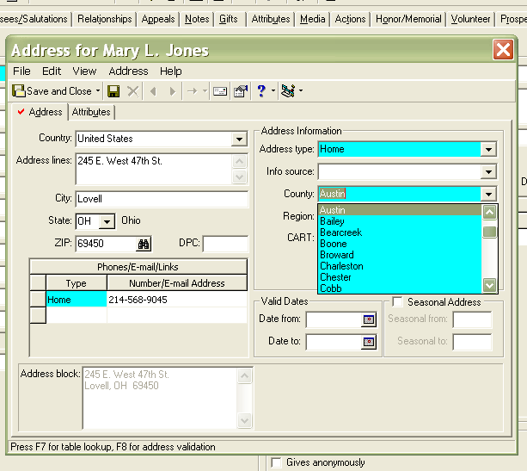

”More” Button - Bio 1
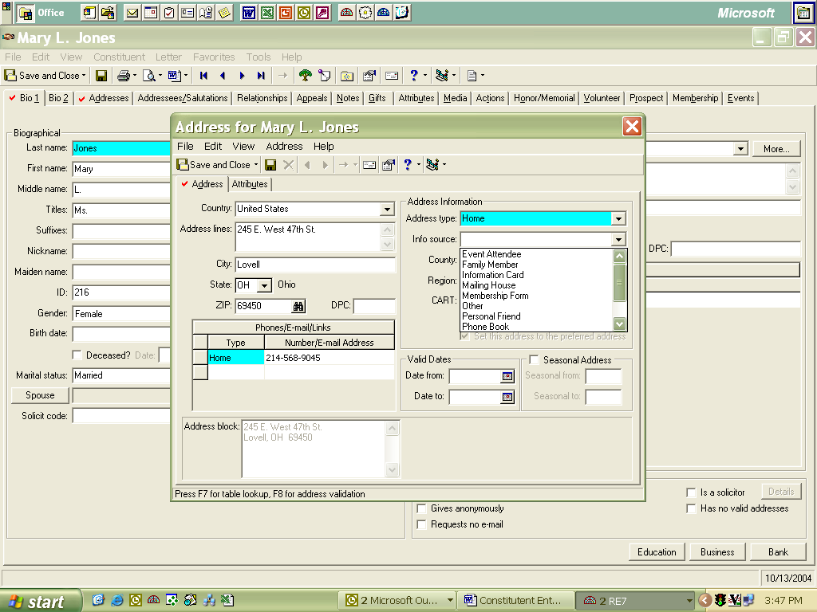
Info Source is used as an identifier for new fund establishers as to how they heard about the foundation.

Use the dropdown table to and select the appropriate code.

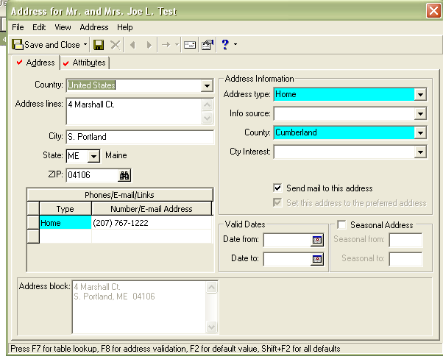
The Region (we have changed to County Interest) is for Out of State constituents that are interested in a particular county in Maine. May be entered either by personal knowledge or gift to a particular county.

If the address is the “Preferred” address the Send Mail box should be checked. If a person requests specific mail to go to a different address, the mail attribute tab should be filled in. Organizations should have send mail checked as well as the contacts. There is a feature in RE mail that allows you to specify who in an organization should receive mail, based on contact mail functions. (see Org area page 15) The contact or employee should have the mail function checked on their record under to “More” button.
Seasonal date ranges under the “More” button of the preferred address and should be left alone. The place to record seasonal address information is in the Alternate Address Button, where you enter Seasonal dates.

Addresses Tab:

- This is where address management takes place. Use this tab if there is an alternate address for a constituent or record an old address.

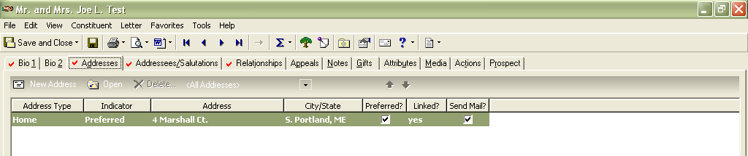
Adding an Alternate Address

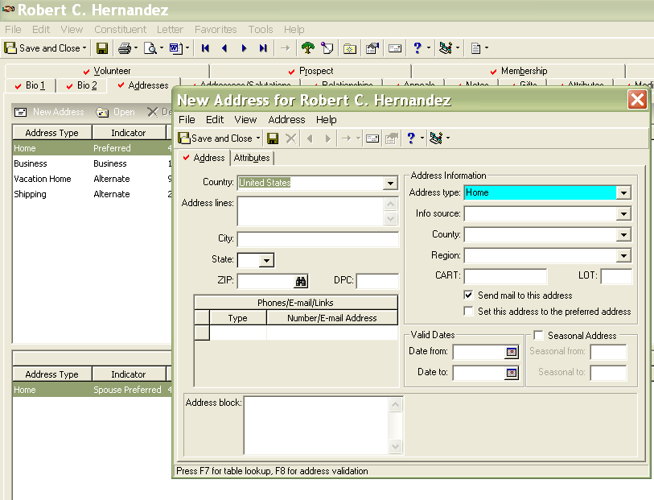
To add an alternate address click on New Address – the “New Address for …” appears. The address type should not be the same as any existing type on the record. Fill in the information the same as on page 3.

- The “Valid Date Range” is use for temporary addresses. The “Date to” fills in automatically when changing any address to the “Preferred” address. If this new address is a seasonal address check that box and fill in the months from and to. If no mail is to go to the alternate address uncheck “send mail”.
- Be sure to fill in “County” even if it is the same as on other addresses.

Bio 2 Tab
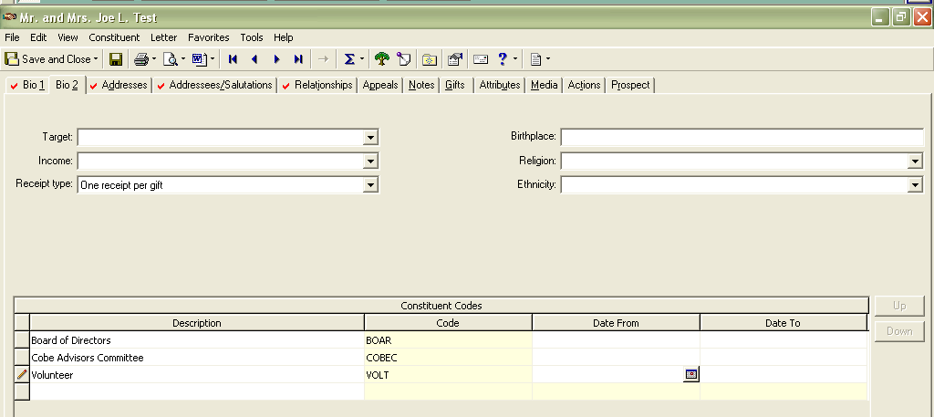

- Constituency is why someone is in our database. If they are an Attorney we use the ATTO code here. Examples of other important codes include: DONR1, FOBO, POT1, FINA, BEQU, and SPEC (See Karen H. for other codes and descriptions). This information is used in selecting audiences for mailings, events and for tracking other characteristics, such as planned gift donors.

Spouse Button

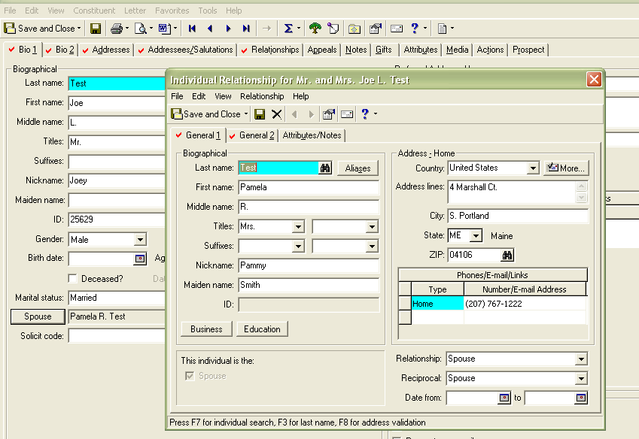

- Use the “lookup” button to do a search before entering a spouse as they may already be in the database. This lookup button will bring up a search field where you fill in last name and first initial. If there is no match then enter information.
- Please be sure to fill in the title and if a nickname is appropriate, along with any other information.
- Do not add the spouse as a constituent unless you know they will be making gifts in their own name. This field is an open option for change.
- You have the option of linking a business for the spouse as well as adding education information.

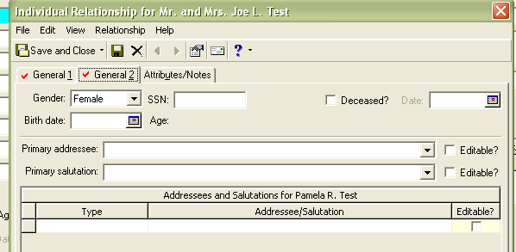
Be sure to fill in the General 2 tab on the spouse record with gender, you may add any additional information. Please do not enter SSN as we do not want this in the system

Addr/Sal Tab

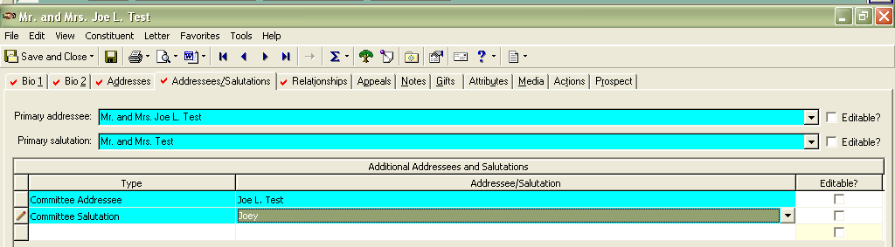

- The primary addressee and salutation are required fields and if you pressF2 the default will fill in (if the default is built). We use the formal as a default. If this information isn’t correct use the drop down table to adjust or click on the Editable box and make your corrections.
- Enter in all Additional Addressees/salutations any that are appropriate. If entering a committee member there is a committee addressee type as well as a committee salutation.
- There are addressee and salutations for all staff members as well.

Relationships

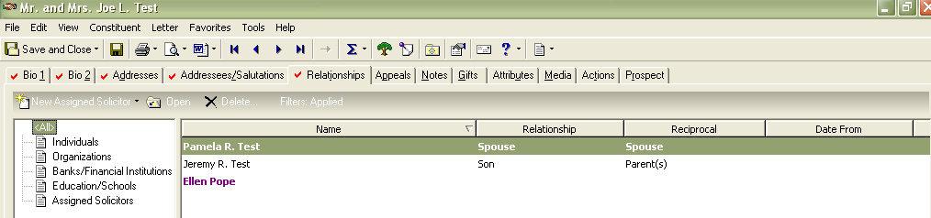

- We have the capability of tracking relationships i.e. organization/businesses, attorney or accountants, or any other type of relationship. Here we have the spouse, son and assigned solicitor (we use color to distinguish relationship types).

Notes

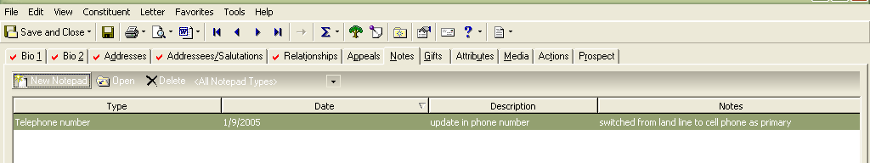
- Notes are a free text field that is unlimited for space.
- We can query on type, date, description and pull up the notes section, you can even query on the content of the notes section.
- We use notes a the place for general information – any notes that pertain to a specific action are recorded under the action. (See actions)

Example of Gifts Screen
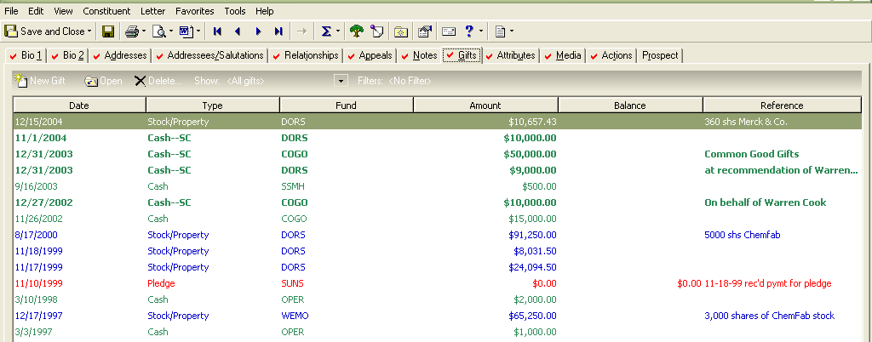

- Most cash gifts are entered into RE through a Gift Batch using the RE Batch module. This allows quick data entry in a excel type format.
- Gifts of stock are entered individually using batch entry – primarily for tracking purposes.
- Gift history is useful for research and is also used to segment donors and prospects (as in, mailing x is for donors of $5,000 or >).
- Again we use color to make different types of gifts stand out.

ACTIONS

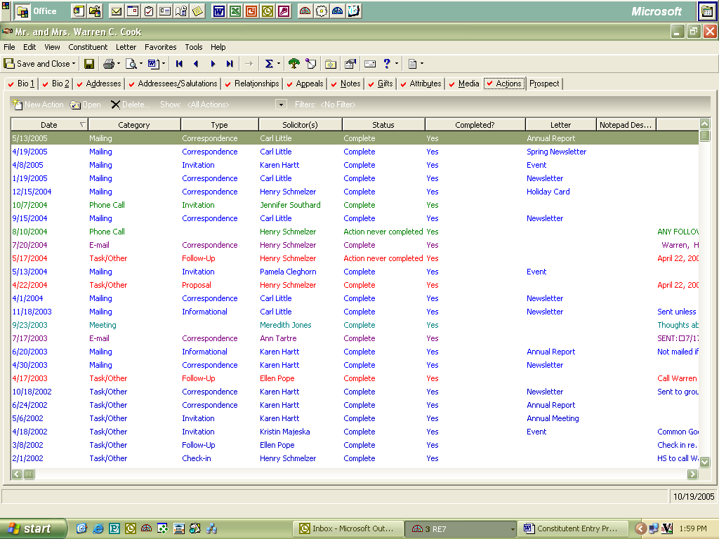

- This tab is a great way to keep track of any and all contact with a constituent.
- We can query on date, action type, status or assigned to.

Adding Actions
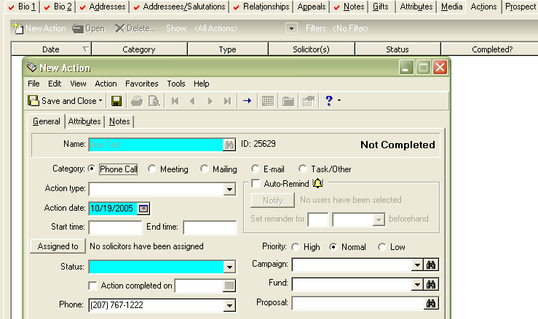
To add a new action – click on New Action

Fill in the required fields and add any notes you would like associated with the action. See next page on adding notes.

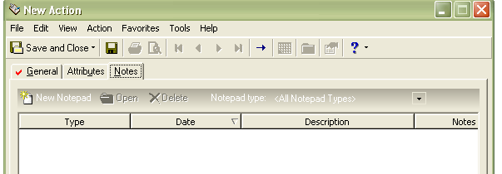
The notes field is a free text field that is endless. You can “copy” text from a word document and paste into this field.

Click on New Notepad

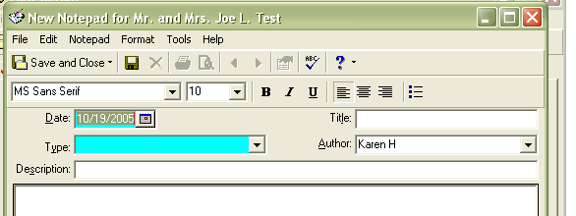
Fill in the date, type (using the dropdown) and a brief description. The author will automatically fill in using the person doing the data entry, but can be changed by picking a different name from the dropdown box.

Attributes
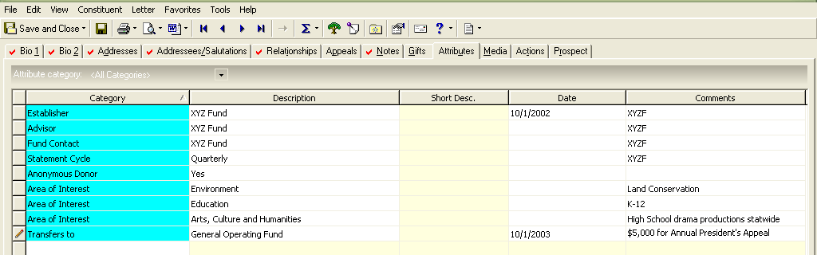

- The Attributes tab is a “catch all” for information associated with a particular donor. Statement information, areas of interest, fund advisor, fund establisher, anonymous donor, key contact, etc. “Category” covers a multitude of information and the description is linked to tables, text fields and yes/no boxes. The comment field is free text, is a content query field, and is limited to 26 characters.
- We use this tab in queries for fund statements, areas of interest, transfers etc.

Prospect Tab

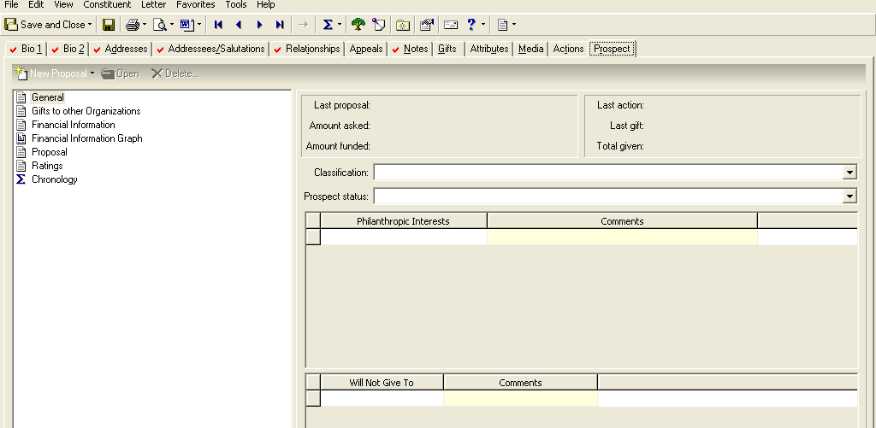

- The prospect tab keeps track of prospective donors. This information is generally added by the Philanthropic Services staff or the database manager.
- Classification is for Outright or planned gifts.
- Prospect status allows us to track the status of the gift.
- There are “search” companies that can provide financial, Philanthropic interest, and gifts to other organizations. The information from these companies would reside here.
- The Proposals Tab has its own step-by-step entry procedure, see Shared Data.

Adding Orgs:
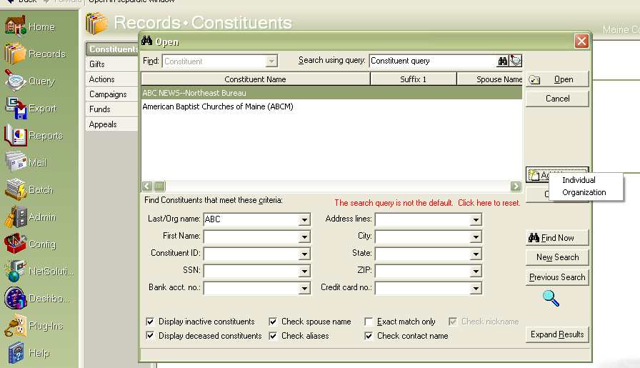
After doing a search for the organization (using various spellings and punctuation as needed) add the organization by clicking on add new then organization.

When doing your search, be sure the check Aliases box is checked.

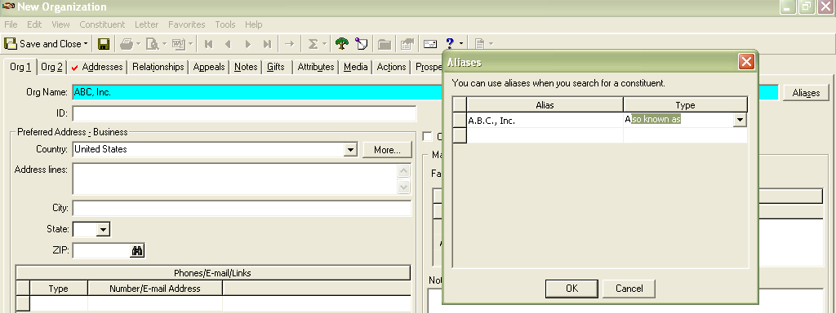

Enter the organizations name and click on the aliases box and add what you think would be the most common aka. If the organization name is unusual, enter what you think would be a common miss-spelling of the name. If a law firm, add an entry that uses or doesn’t use the , in the entery.

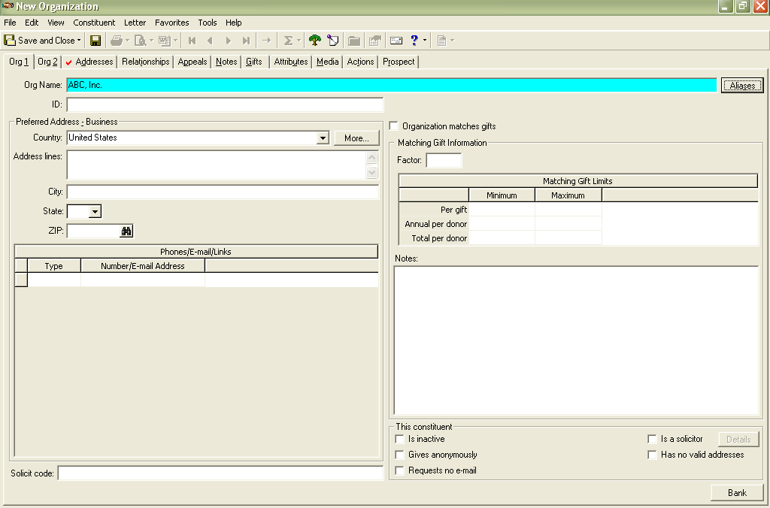
You have the opportunity to add information about the organization right in the notes field. We use this primarily for when a business has closed.

- The rest of the data entry on a organization is the same as an individual except there is no addressee/salutation tab. That information is on the individual relationships to the organizations.
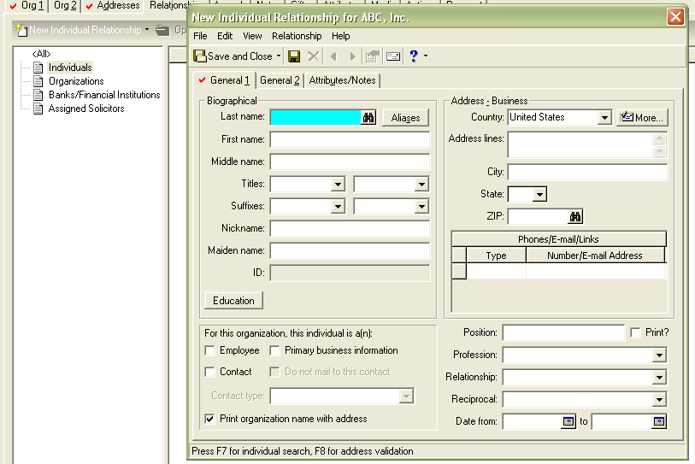
For example, the President/Executive Director of the organization should be listed as the primary contact. You would do a search to see if they are in the DB and link them, if not in the DB then you add just like any other relationship.

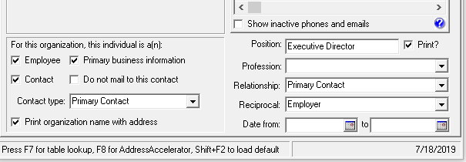
Make sure to check the contact box if the contact is more than employee. All orgs should have a primary contact as they receive mailings.

Make sue the Print Org box is checked.

Fill in the position and check the print box.

Fill in the Relationship and reciprocal boxes using the dropdown table.

Be sure to fill in the General 2 tab, this is where you record the addressee/salutation information.

That is RE7 data entry in a nutshell.

This procedure manual is designed to help enter and update information in RE. If you have questions not addressed here see Karen H. or check out the other procedures in shared data.

