Gift Batch Entry

The Finance department will give the database assistant copies of the checks with an adding machine tape attached with the # of checks and the total amount. Finance codes each check with a 4-letter Fund Code and attaches relevant correspondence.

Security gifts - See Gift of Securities prep work procedures - generally we receive notice from a brokerage firm or the donor. Batch entry for securities is noted within the cash gift process below (in italics).

Open Raiser’s Edge
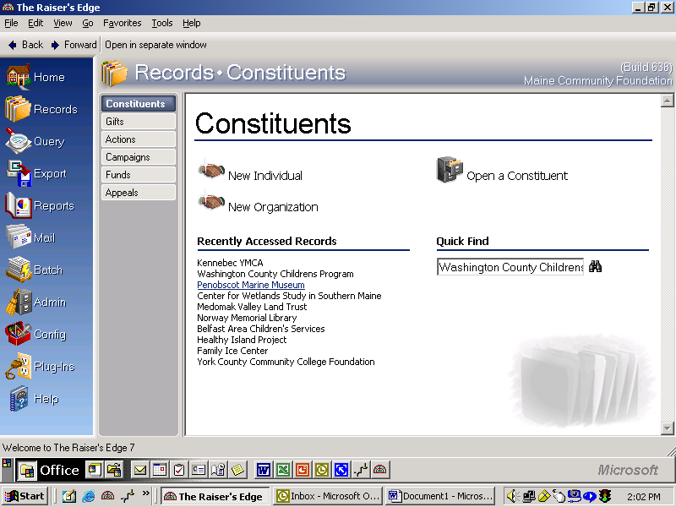
Click on Batch

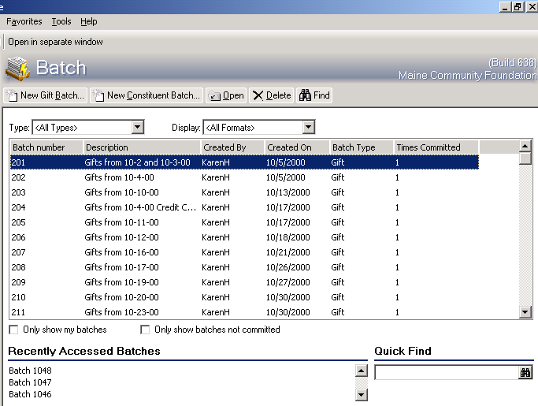
Click on New Gift Batch

Generally clicking creating a New Batch will automatically assign the batch #. If more than one staff member is entering gift batches the batch number needs to be suffixed with the data entry person’s initials. Don’t worry if the Batch numbers are out of sequence or if you have to delete a batch. Write the Batch #, the date you are entering the batch and your initials on the top sheet of your copied checks.

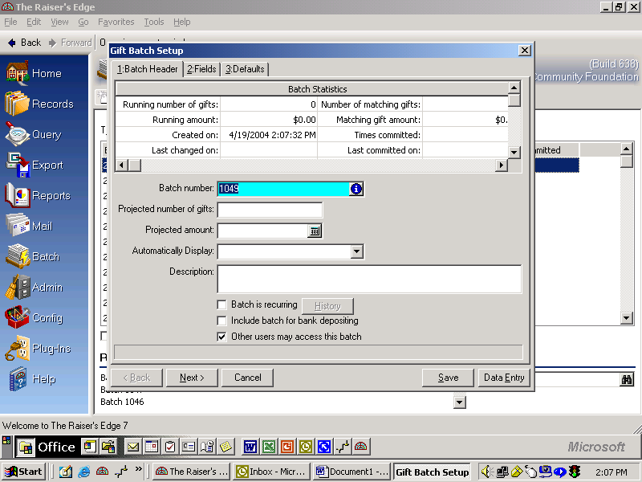
Gift batch number, automatically generated or manually entered with entry person’s initials (1050 KH)
# 1 - Fill in number of gifts
# 3 - Gifts from 1/25/11

(received date). If a stock gift use the # of shares and stock name, for credit card or wire transfer use those terms then the date (Credit card gift from received date).
# 2 – $ amount from tape, or use pledge total, or net proceeds from stock gift.

# 4 - Click Next

The Fields screen is where you load the gift data fields for the batch. This section is set up for you by clicking on the “Load from existing batch”.
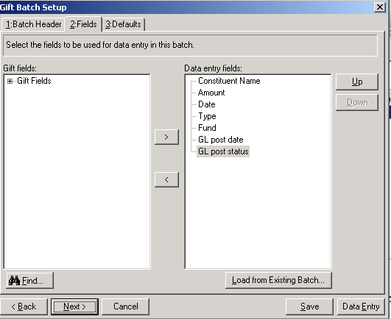
Click Load from Existing Batch

Note: Use the Template for Daily Gift Entry not the Template for Constituent Entry.

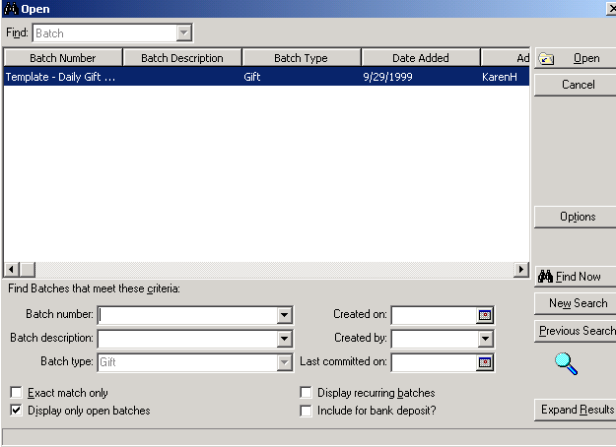
Double click on Template – Daily Gift Entry or highlight the template and click Open.

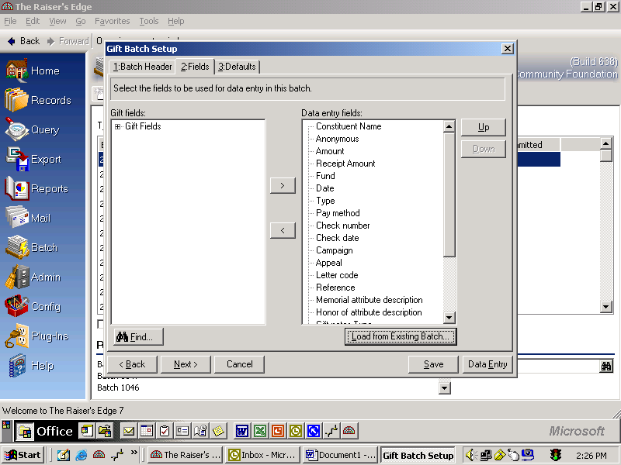
Click on Next
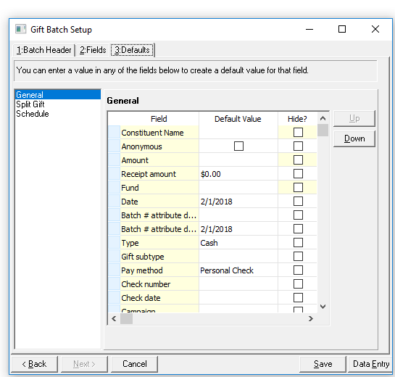
Default information is typed within this template. See note below
Once defaults are entered, click on Data Entry to begin entering your batch.

Note: Defaults are a good way duplicate data on all gift records saving key strokes. If there are more than one gift I set up the defaults other wise enter the information manually. Defaults to add are:
- Batch Number Attribute Description is the Batch number for the gifts
- Batch Number Attribute Date – Is the date you are entering the gift batch
- Date – Use the Received stamped date copied checks
- Type – if adding a batch of pledges default to that type. (Credit cards are cash gift; payment method is where you’ll record that information. Stock gifts use Stock, with Sub-type of stock, and pay method of Cash)
- Reference Field this field is used for gifts for distribution, Memorial/Honoree names and stock gift information. When entering stock gifts the format is # of shares, Ticker symbol, Stock description. If the gift(s) are for distribution, For Dist should be at the beginning of the line.
- Hide Memorial Attribute and Honor of attribute unless the batch is in memory or honor of
- Hide any field pertaining to stock or unusual assets unless the batch is for those asset types
- GL post date – Use the date the batch is the Received date. Note: End of the year gifts received in the first few days of the new year would be a Dec. 31st date.

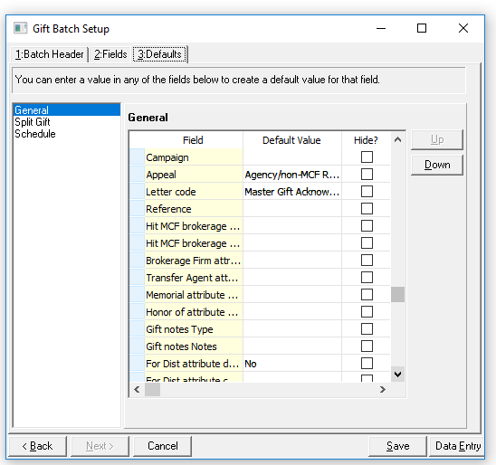
Other defaults for stock gifts:
- Reference (shares)
- Mean value, date & comments
- Cusip Number
- Ticker Symbol
- Brokerage Firm
- Transfer agent and
- Gift note type (Gift information)
- Gift notes (Mean: $; GV: $)
Determine which fields to default from looking at the checks. For example, if you have a lot of checks from one fund, FRAG, put that fund code in as the default code. If your batch is all gifts for distribution, check YES for distribution.

Click on Data Entry, which will open the entry window.

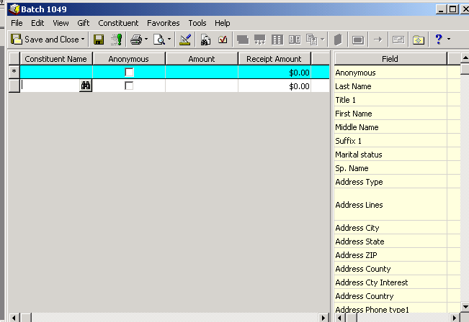
Binoculars – click on them to find a constituent

DO NOT TYPE IN THE BLUE ROW – THIS IS THE DEFAULTS ROW.

When you click on the first field, “Constituent Name” binoculars will appear. Click on the binoculars to search for the first constituent. ALWAYS CLICK ON THE BINOCULARS. Do not type the name directly into the Constituent Name field.
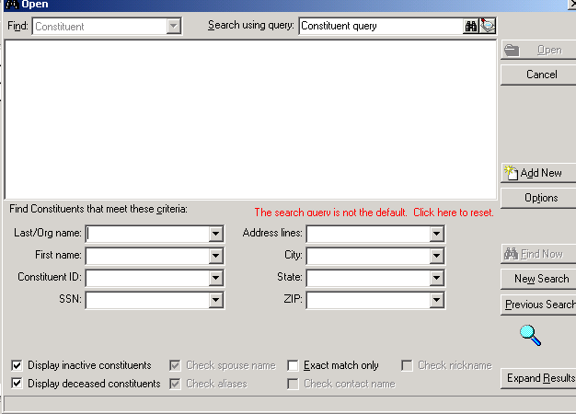
# 1 - Enter Name Here
# 2 – Click on Find Now to search the database for the name.
# 3 - Click on Add New if the person you are searching for is not found.
(Last Name, Tab and put in
First Initial)

Enter the last name of the person you’re looking for, or the name of the organization into “Last/Org Name” field and click on Find Now.

If the name you are looking for is already in the database, you will either be returned to your batch entry, and you will be able to enter the other gift information into the template, or you will be given a list of options if there are multiple people with the same name. Double clicking on the name you need will enter it into your gift batch and return you to your batch template.

If the name you are looking for is not in the database, then nothing will come up. You will click on the “Add New” button and choose whether you are adding a person or an organization from the drop-down box.

A constituent record appears; fill the new record in as completely as you can, based on the information you have from the check or any accompanying correspondence. Remember that County under the More button is a required field.
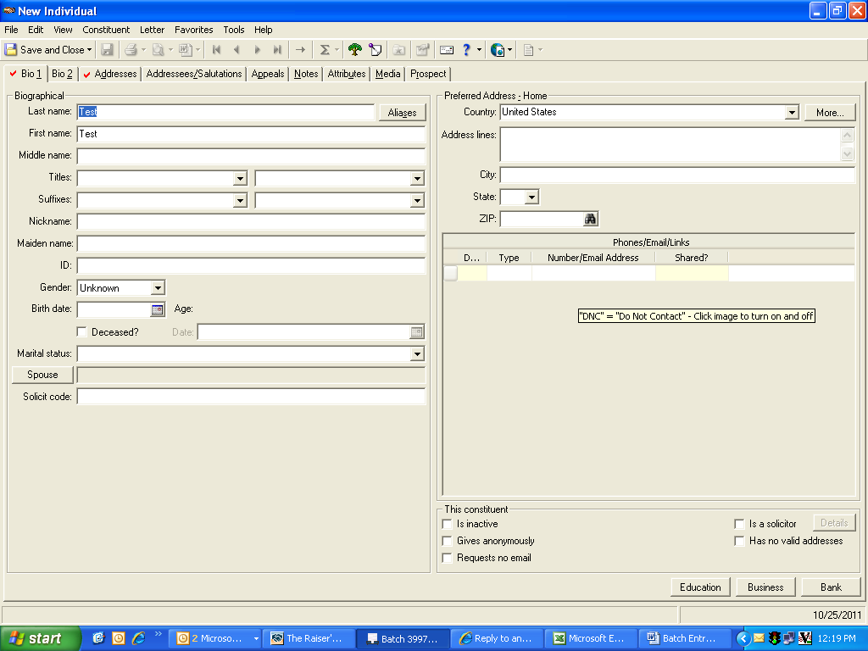
Click on Bio 2 and enter “Donor” and date.

Click on Address/Salutations, then Constituent, click on informal salutation.

Once you are done you will be returned to your batch entry template at the left of the screen where you can finish entering the pertinent information regarding this particular gift.

Tab through the fields and enter information. Familiarize yourself with the choices in the drop-down menus and be alert to changes, especially money that should be marked “for distribution”. Double check by reading through any materials or letters included with the copied checks.

To soft credit a gift to another record, click on the check icon. (note: automatic soft credits are done for linked spouses)
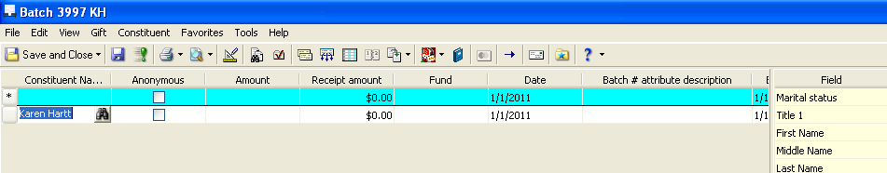

The Soft Credit dialog box appears – click in Constituent Name and search for the soft credit constituent. This is generally used when check is from an organization such as Fidelity etc. INO: “Donor”
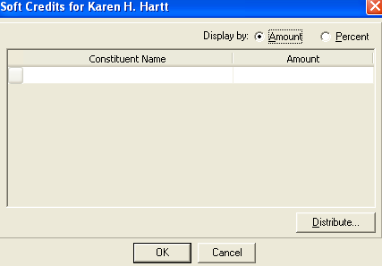

See additional procedures called Gift Entry Special Instructions for coding of gift appeals and gift acknowledgment letters.

When processing stock gifts don’t forget to populate the Reference line
Example: 245 shares (T) AT&T Corp, if the gift is for distribution For Dist should be listed before the number of shares.
Other fields to record are Mean value, Cusip Number, Ticker Symbol (the T in the example above), as well as Sending brokerage firm and Transfer agent if known.

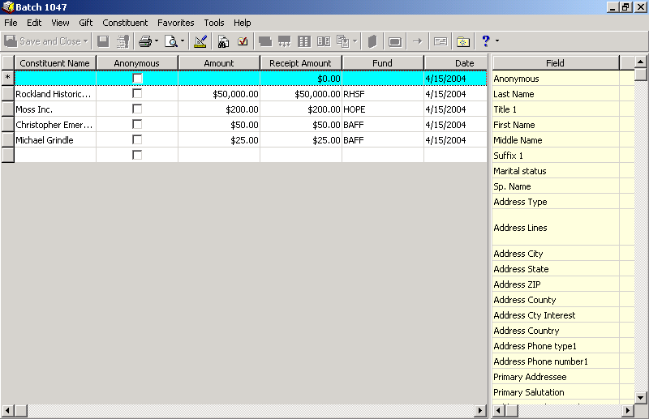
Click on the
Validate Button
The Validate Button looks like a folder with a red check mark on it

Once you’re done with your batch, and you’ve checked that there are no discrepancies between the number of gifts and totals you have entered and the Receptionist has noted, validate the batch by clicking on the red check mark on the toolbar. Click Validate Now, you will see a recap of your entries as a final check on your totals. Close and save if OK.

Do not commit the batch until you hear from Finance that it is okay to commit (post). Finance will alert us via email when we can commit the next batch.

Once Finance has given the Okay click on Commit. If you have exited RE Batch go back to Batch and look for your batch # - you can either scroll through the list, but your most recently opened batches are listed at the bottom. Open up your batch, and click on the Commit button.

Click on
Commit Button

Once you’ve clicked on the commit button a Commit Gift Batch window will come up.
Click Commit Now.
Validate Batch # ______ Totals Box comes up.
Hit Commit Now again.
Save static query box comes up, hit Save.
A Batch Control Report comes up. Print two copies, one for Lorre Webster Ames and one to be stapled to the back of check copies. Before you deliver report to Lorre Webster Ames, go over checks to see if you need to mark any of the gifts for Distribution on her report.
Donor Acknowledgement Letters

Open Raiser’s Edge and click on the “Mail” icon at the left of the screen.

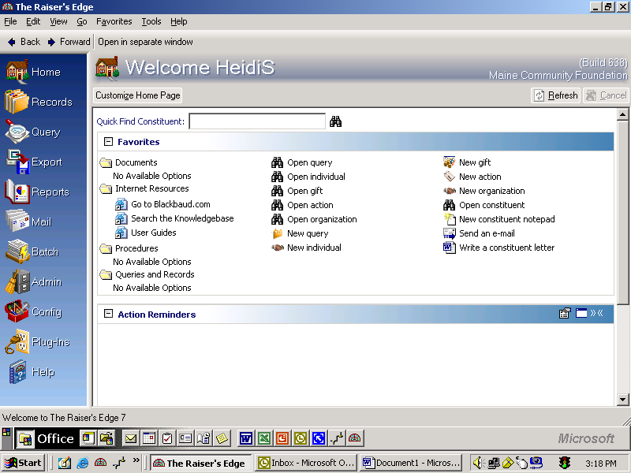

Click on Mail

Once you’ve clicked “Mail”, the Mail options will open.

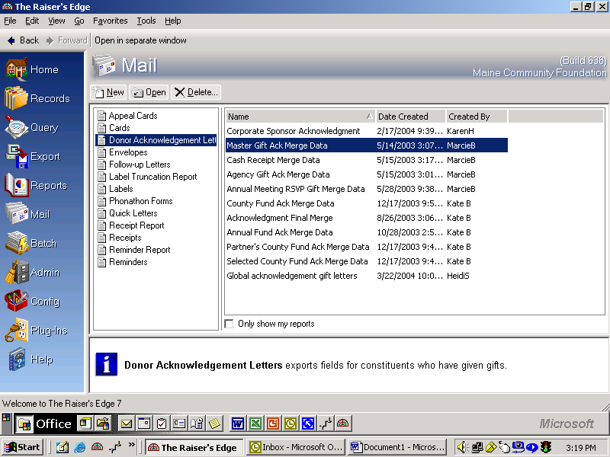
Donor Acknowledgement Letters
Different Types of Letter Templates
Master Gift Ack Merge Data
(Example)

Once you’ve clicked on “Mail”, make sure the “Donor Acknowledgement Letters” option is highlighted on the left side of the screen. On the right side of the screen, there will be listed the different types of letter templates that you can use based on the types of letters your batch needs for acknowledgements.

Double click on whichever type of acknowledgement letter you need to use.
Click on Export button

Donor Acknowledgements Letters (Cont.)

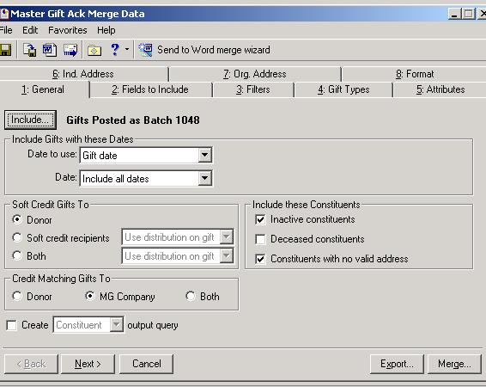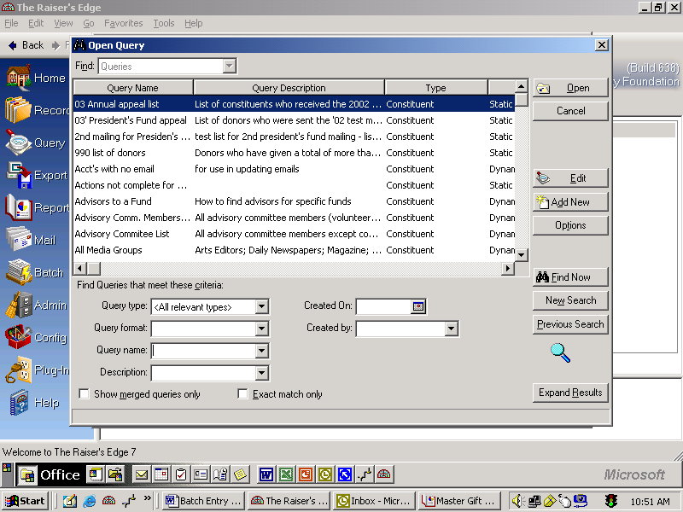

# 1 - Click on Include
and then click on
Selected Records
# 2 - Type *1116 (Star + Batch #)
in Query Name Box
# 3 – Double Click on your Batch #

# 4 - Click on Export button

~~~~~~~~~~~~~~~~~~~~~~~~~~~~~~~~~~~~~~~~~~~~~~~~~~~~~~~~~~~~~~~~~~~~~~~~~~~~

Raiser’s Edge

Go into Raiser’s Edge
Click on Mail
Donor Acknowledgement Letters is highlighted
Click on Master Gift Ack Merge Data (Pick type of letter needed)
Click on Include – a dropdown box will appear
Click on Selected Records
Put *1116 (Batch #) in Query Name
Click on highlighted Gift Posted as Batch 1116

Export

Export Now
Already exists…Do you want to replace it? Yes
Do you want to mark gifts …as Acknowledged? No
(You will do this after you are done printing the Ack Ltrs & Env)
Verify that the #s on the report match the # of letters you need for that type of letter
(You’re checking to see if the merge was successful)
X out of boxes
The record has changed. Do you want to save your changes? Yes

Microsoft Word

Go into Microsoft Word
Click on Open File icon
Click on Favorites
Click on Master Ack Templates
Click on Ack Master Gift Templates.doc (Type of letter)
In Template, change Date only to the day EP/HS will sign letters
Go to Tools
Go to Mail Merge
Click on Merge
Click on Merge (Letters will merge)

File

Save As

Fund Files/ Ack by Batches/ Ack Batches Letters/ 2004
Click on last one, put in new batch # & Date in file name

Save
Look at letters carefully – check addresses, salutations, fund names
and name on gift receipt
Save when you make changes & when you are done

Print Letters
Put Letters in folder for EP/HS to sign

.

