VLOOKUP is a formula in Excel that enables you to compare two sets of data and find duplicates.
- This is very helpful when you export data out of Raiser’s Edge into Excel and then need to identify where you have duplicates so you can review or delete the duplicate data.
- You can also use this to combine data together in some very creative ways.

Here are some examples:

  - I’ve exported out a list of individuals and want to see if any of their spouses are also on the list.

  - I’ve exported out a large mailing list that has both individuals and organizations (with contacts). I need to find anyone who is on the list as an individual but may also be on the spreadsheet as a contact at an organization. I’ll then look at these and decide if I want to mail to them as an individual, a contact, or both.

  - I’ve exported out a list but forgot to add some data. Instead of starting all over again, I can export out the missing data, match it up and add it to my list.

Using VLOOKUP, you can use data within a single worksheet or data that’s on multiple worksheets within the same workbook. You can access other data by copying it into your workbook on its own sheet. But as noted below, you need certain key fields in order to perform the lookup so that data must be available in all your sources.

Using the VLOOKUP formula
You can find instructions for VLOOKUP in Excel, but they are rather confusing so we’ll give you simpler instructions and some examples below.

    - ex: I have a mailing list and want to see if anyone’s spouse is also on the list. So I want to look at the spouse ID, and see if it’s anywhere in the column of constituent IDs. I’ll use the ID fields to identify constituents and spouses.

A few rules:
- In your initial export, you must make sure you have the fields you need for your comparison.
    - ex: Since I’m comparing the spouse and constituent IDs, I need both the constituent ID and spouse ID fields.

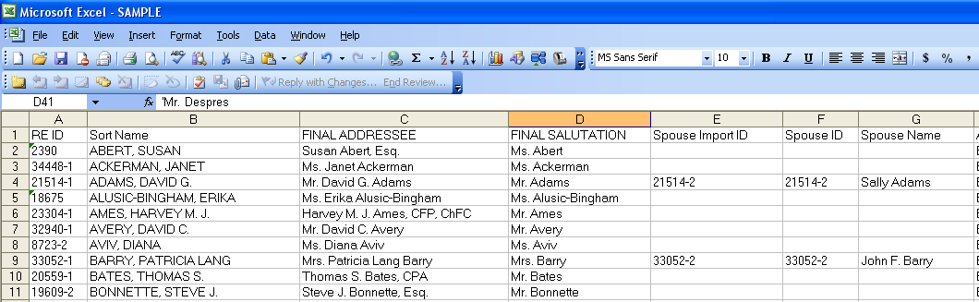

- The field you are looking up on (here it’s our constituent ID) must be in the lefthand column.
- The data must be sorted alphabetically (low to high) on this field.

Sort the list - Sort the entire sheet on your lefthand column.
- You may get this warning (if you’re sorting on something that looks like a number). Just choose the default (sort.. as a number) and hit OK.

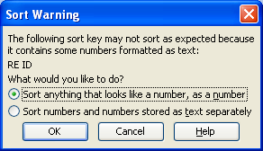

    - ex: Here’s the sheet now sorted alpha on the constituent ID:

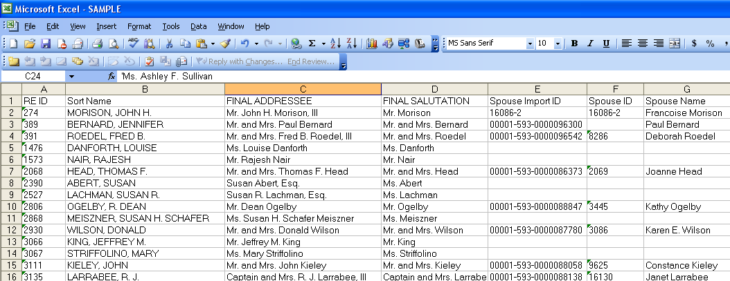

Add a new column – You can add this anywhere after the 1st two columns.

    - ex: We’ll add it in the 3rd column.

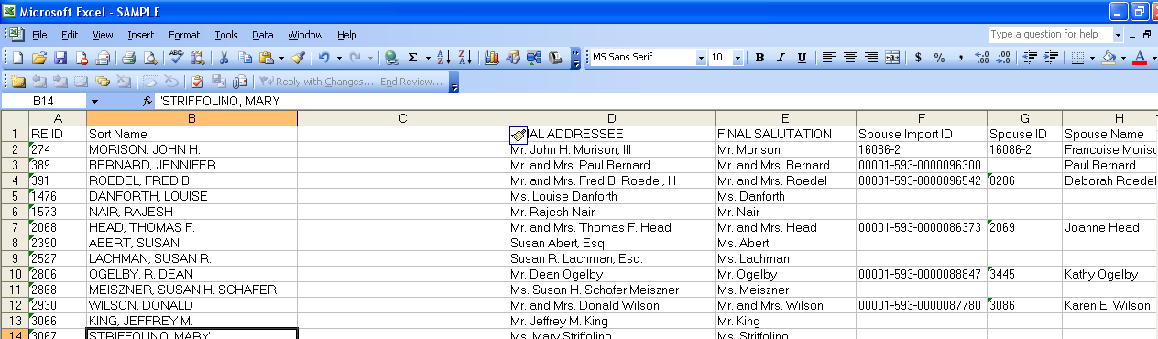

VLOOKUP formula syntax
Here’s the syntax: =VLOOKUP (reference cell, array cells, column of results, match)
Reference cell = the cell you want looked up
Array cells = the block of data you’ll use for looking up (this MUST be 2 columns or more)
Column of results = the column of the array that you’ll pull over for results
Match type = 0 will give you an exact match

- Starting your formula – In the first cell in your new blank column (under the title row), enter =VLOOKUP(

- Reference cell – Point to the reference cell (or enter the value manually) as the next part of your formula, followed by a comma.

    - ex: We want the spouse ID looked up so that will be our reference cell.
In the formula, we’ll now point to the Spouse ID cell which is G2, and then type in a comma. The formula now says =VLOOKUP(G2,

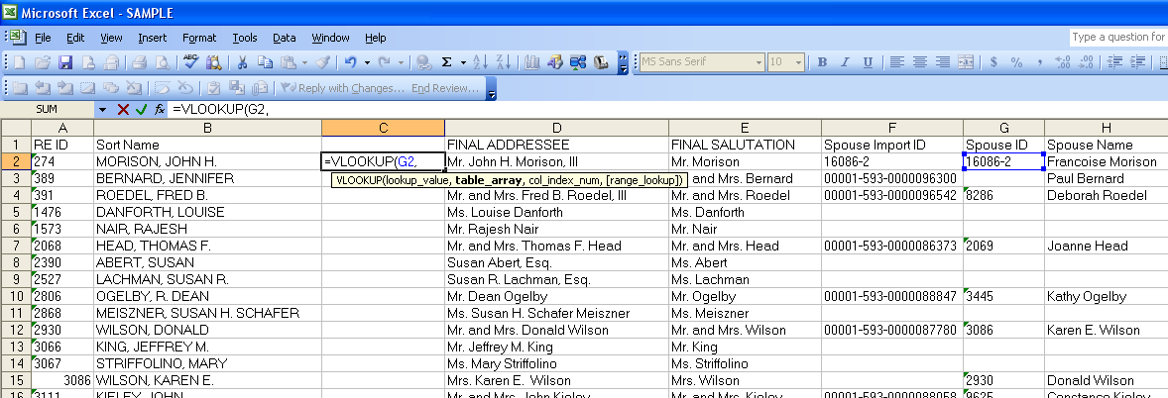

- Array cells – Now highlight the block of cells that contain the data you want to use for lookup. You can highlight entire columns, or specific blocks of cells (usually you highlight columns).

    - ex: We want to compare the spouse ID to the constituent ID which is the left column. Since this is an array, by definition it has to include multiple columns so our array will be columns A and B. To continue the formula, I’ll highlight both columns A and B, then type a comma. The formula now says =VLOOKUP(G2,A:B,

- Column of results – When we find a value that matches, specify the column in your array that you want to see as the result. Then add another comma.

    - ex: We want to see the results as the constituent ID, so we’ll type in “1” which means the 1st column of the array. The formula now says =VLOOKUP(G2,A:B,1,
    - ex: If I want to see the results as the Sort Name, I would type in “2” which would give me the 2nd column of the array.

You can specify your array to include many columns of your data if you want to pull in different results.

Match type – We want an exact match for our lookup, so choose “0” (zero). Finish the formula by typing an ) (end paren).
    - ex: Here’s our finished formula: =VLOOKUP(G2,A:B,1,0)

Formula results – When you hit enter, you’ll see the results of your lookup in the cell. But you’ll see the actual formula in the edit bar.
  - If the lookup does find a match, it will return whatever array column you specified in your formula.
  - If the lookup did not find a match, it will return the value of “#N/A”.

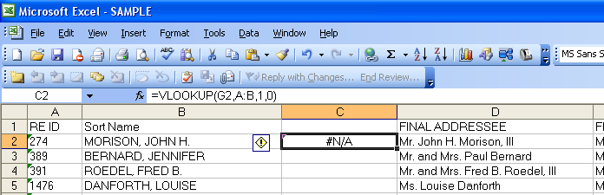

Adjust formula - If your array was a specific block of cells, then you need to adjust the formula before you can copy it. You need to make your array “fixed” by entering a $ before the column and row references.
    - ex: If our array was A2:B13, we need to edit it to $A$2:$B$13. When you copy the formula, this will always be the array reference.

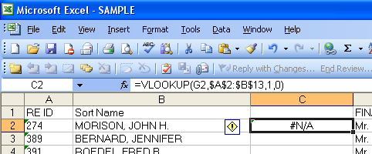

If your array were entire columns, then you do not have to adjust.

Copy formula – Now copy your formula down the entire blank column.
  - A shortcut for doing this is to highlight the cell with the formula, then hover your cursor over the very small corner black block until your cursor turns into a black cross shape. Then double-click to automatically copy the formula all the way down the column.

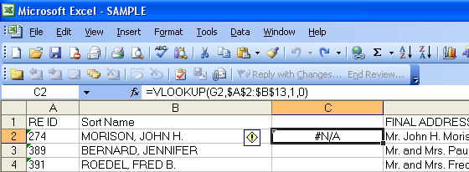

Results – Now look at the results.
  - You asked the system to show you the constituent ID field as the result, so look down the column until you see a result that is not “#N/A”. This will be the constituent ID lookup.

    - ex: Our formula has looked up Donald Wilson’s spouse (in cell G12), found her ID number in our array, and returned her constituent ID as a result (in cell C12). Notice it’s also done the same on her record.

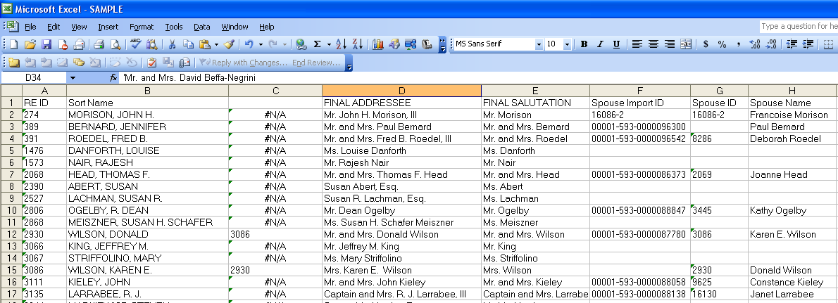

Secure your results – It’s always a good idea to convert your lookup results from formula-based to just showing the results. That way, if you adjust or move your data you won’t lose your formula results.
  - To do this, copy the column with your lookup formula.
  - Then choose Edit/Paste Special and choose Values.

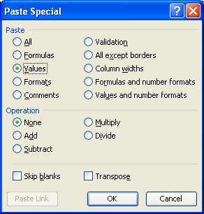

Nothing will look different, but you’re now free to resort your spreadsheet without corrupting your lookup formula.

Sort your results - You can now sort your spreadsheet on your lookup column, which will show you the matches and show you the all the “N/A” values together.

    - ex: I sorted my list and it looks like only one couple, the Wilsons, were spouses on my list.

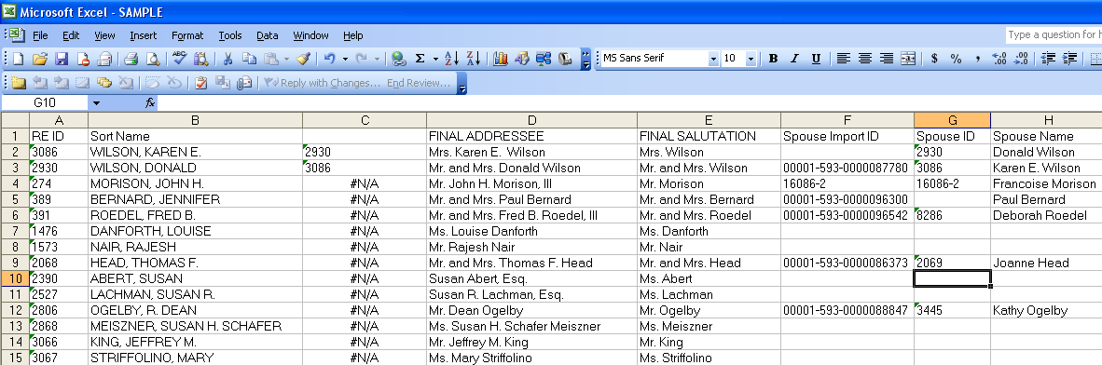

I may then choose to delete duplicate records, or analyze my matched records and treat them in a specific way.

