You can change what displays in your search window by using the Search using query feature.

- This is a very useful feature that’s worth the time to learn. It makes identifying records much easier and lets you tailor your search screens to your specific needs.

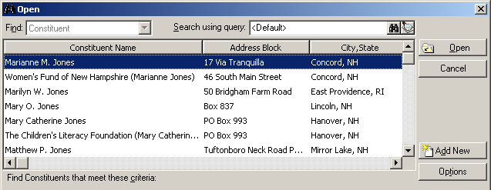

In the Search window, notice Search using query in the upper right-hand corner with the setting of <Default>. This default query is determining the columns you see – Constituent Name, Address Block, City/State, etc.

Load a Search Query
You can load a different query that has different columns.
    - ex: Let’s load the query SEARCH-Constit w/Pri Bus Org Name.

- Hit the binoculars
  - In the query name field, type in ^SEARCH-
  - You’ll see a list of all the search queries in the system (SEARCH-….).
  - Select the query ^SEARCH-Constit w/Pri Bus Org Name and hit Open (or Enter).

- You’ve now loaded this query and will see it in the Search using query window.

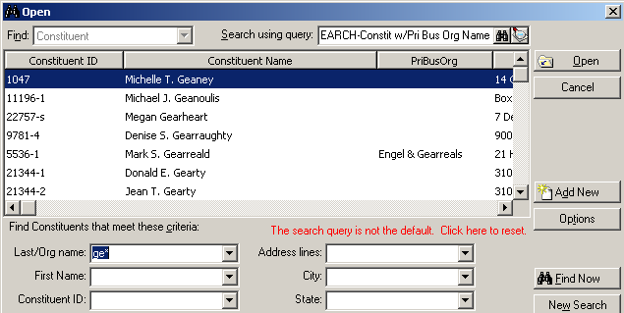

- Now type in your search criteria and hit Find Now.

- Notice that the columns displaying in the window are different.

Create your Search Query
You may want to create your own SEARCH queries that have the columns of data you’d like to see.

- Go to Query and create a New Query (dynamic)
  - In Criteria, leave blank – this will include all records in the system.
    - Make sure you check all three boxes so that you include inactive, deceased and no valid addresses.
  - In Output, specify the columns that you want to see in your search window.
  - In Sort, specify the sort order for your results (usually alphabetic; use Sort Key field).

- Run the query
    - This will take a long time since it’s pulling all records – give it some time.
TIP
Create as many search queries as you want to meet your specific needs.
- Save your query in the ^TEMPLATES folder and name it starting with ^SEARCH-

- Your query will then be available in the system for you to search on and load.

Edit your Search Query
If you want to make any changes or “tweaks” to your search query, there’s a shortcut to do this:

- Hit the magnifying glass to the right of the binoculars.
  - This will open the query that is currently loaded.
- Make changes to the search query.
- Hit Save and you’ll return to the search screen.

Reset your search query
- When you have a search query loaded, notice the message in red The search query is not the default. Click here to reset.
- Click on the message to reset the search query to <Default>.

