Before creating a new record
TIP
You can also create a record directly from your search screen with this shortcut button:

- You must do a thorough search to make sure the record doesn’t already exist (see Searching for a constituent record).

Add an individual record
- On the blue bar, choose Records.
- In the submenu, choose Constituents.
- In the white screen area, choose New Individual.

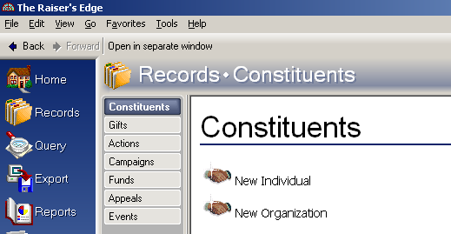

Bio 1 Tab

Here’s the Bio 1 screen.

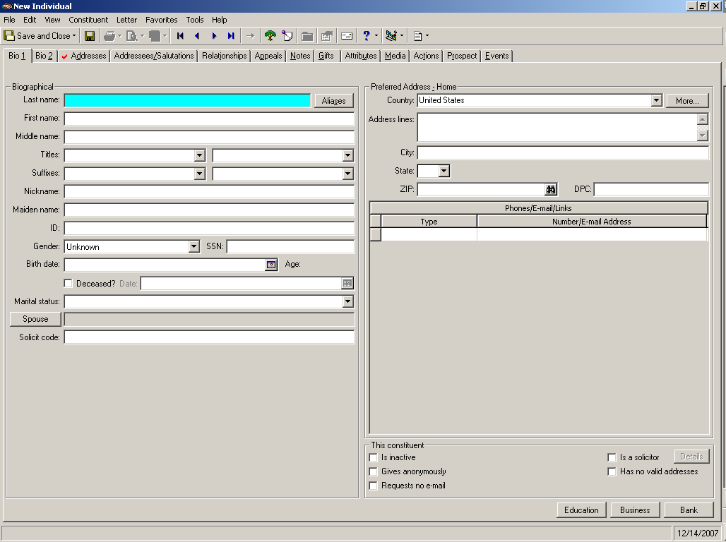

Name fields
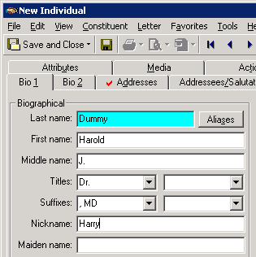

- Last name – This is a required field in Raiser’s Edge.

- First name
  - If person has a compound first name such as A. Edward, enter both parts as the first name (ex: Do not put in A. as the first name and Edward as the middle name).

- Middle name
TIP
See Naming Conventions & Address/Salutation Chart
for more information on entering names and choosing titles/ and suffixes
  - Enter full middle name if known (ex: James).
  - Otherwise, enter middle initial + period (ex: J.).

- Titles
  - In the first title field, select a title from the dropdown menu.
    - We currently don’t use the 2nd title field.

  - Always choose a title (unless you don’t know the person’s gender).
    - Even though you might not need the title for your own work, it will be useful.

- Suffixes (if applicable)
  - In the first suffix field, enter a non-professional suffix from the dropdown menu.
    - The non-professional suffixes are at the top of the table: ,Jr. ,Sr. ,II ,III ,IV ,V
    - Note that the suffixes include a comma and space.

  - In the second suffix field, select a professional suffix from the dropdown menu.
    - The professional suffixes are listed under the PROFESSIONAL SUFFIXES heading.
    - If you have multiple professional suffixes, both should go in the second Suffix field.
    - If the table does not have the value(s) you need, contact IT who can add them to the table.

  - Ex: James E. Waldron, III, CFP, ChFC
    - In the 1st suffix field, put the non-professional suffix: ,III
    - In the 2nd suffix field, put the professional suffixes: , CFP, ChFC

- Nickname (if applicable) - Enter constituent’s nickname.
TIP
Aliases work only for last names, not first names.
Aliases are primarily an aid in searching, and should not be thought of as informational.
If there’s something historical/unique about their name, capture this in a notepad.
  - Ex: Mike might be the nickname for J. Michael Doe.

- Maiden Name (if applicable) - Add last name of a maiden name.

- Aliases (if applicable) - Add one or more aliases.
  - Hit the Aliases button (to the right of the Last Name field).
  - In the grid, type your Alias.
  - Select Type from the dropdown menu, then hit OK.

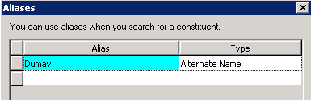

    - The maiden name and the spouse’s last name are automatically entered as Aliases (when the record is saved), so you don’t need to add these manually.

Here are some guidelines adding aliases for individuals:

Situation | Name | Alias type | Possible Aliases
Maiden Name (added automatically) | Marcy Collier | Maiden Name | Woods
Spouse Last Name (added automatically) | Ann Randolph | Spouse Last | Spaulding
Known names  (how the individual is typically known or referred to by the public) | Doris Haddock | Known name | “Granny D”
Two last names (in last name field) | Joan Wilson Smith  Joan Wilson-Smith | Alternate name | Smith
Former name  (may be a former married name, not necessarily a maiden name) | Josephine March | Former name | Lawrey
Estates | Marilyn Jones | Alternate name | Estate of Marilyn Jones  Marilyn Jones Estate  Jones Estate
Misspellings/  Alternate spellings | Robert De Angeles  Edward de Garay  JoAnn Van de Vate | Alternate name | DeAngelis  Garay  VandeVate  Vande Vate

Additional fields

- ID – Do not enter any information in the ID field; the ID is auto assigned upon saving of the record.

- Gender - Add the gender from the dropdown menu.
  - If you do not know the gender, leave the default value of Unknown in the field.

- SSN (social security number)
TIP
Dates can be entered as:
Exact date1/25/1950“Fuzzy” date1/1950
1950
  - AS OF 9/2014, WE ARE NO LONGER ENTERING DATA INTO THIS FIELD AND IT IS NOW HIDDEN FROM VIEW.
  - See the SSN number procedure for more information.

- Birth date – Enter the full/partial date, if known.
  - If only the age is known, enter the year that represents that age (ex: 1950).
  - The Age will calculate based on the date entered and display to the right of the date.

- Deceased & Date – see Deceasing a constituent record for this procedure.

- Marital status
  - Choose marital status from the dropdown menu.
  - If unknown, leave blank or choose Unknown.

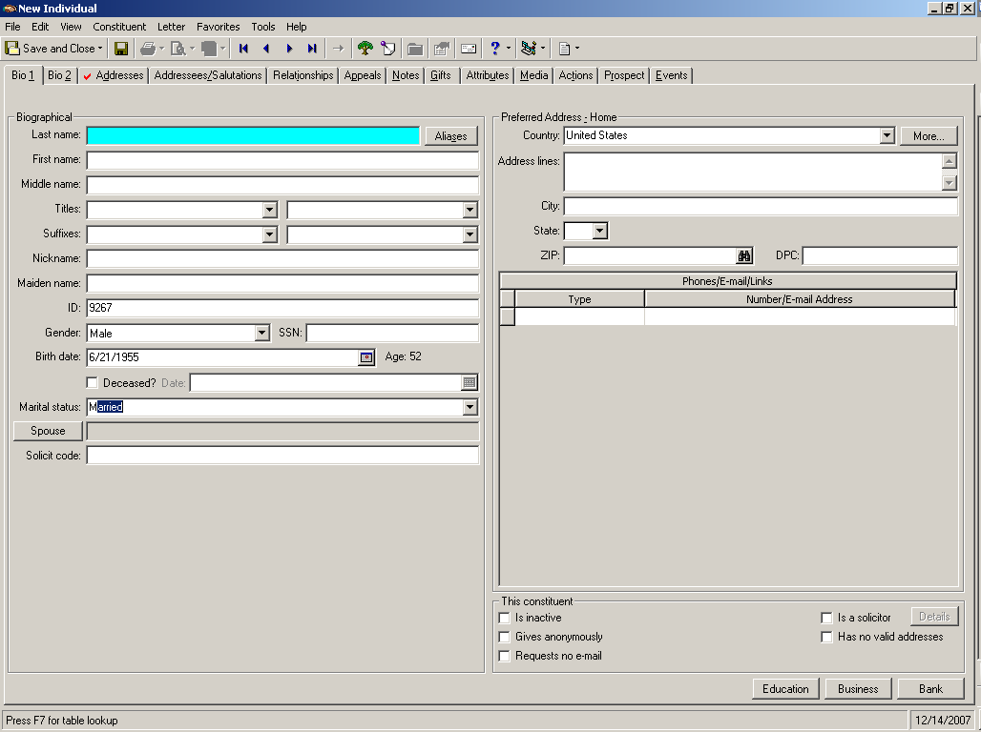

- Spouse - Do not fill out the Spouse yet, but move to the Preferred Address block on the right side of the screen.

Preferred Address
For an individual record, the default preferred address is Home.

- You may change the Address type by clicking the More button; change the type, then Save and Close to return to the Bio 1 screen.

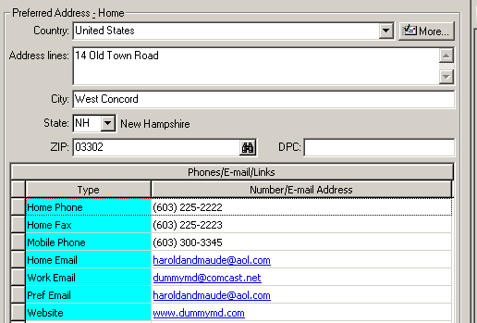

- Country
  - The default is United States.
  - For other countries, choose from the dropdown menu.
    - If you need to enter a country that is not on the dropdown menu, do not add it to the menu yourself; contact IT to add it for you.

- Address lines
  - Enter all the information you have on the constituent’s address.

    - See Rules for Entering Addresses on how to format your address information.

- City
  - Type in the city name.
  - If you’re unsure of the city spelling or format
    - Erase the city and enter the zip code. Then hit the binoculars and the city and state will autopopulate based on the zip.

- State
  - Choose the state from the dropdown menu.

- Zip
  - Type in the zip code.
  - If you’re unsure of the zip, use the binoculars to look up the zip code based on the city.

More button – for more details on the address

- Info source (optional) – Where did you get this address information?
  - Choose the general source of the information from the dropdown menu (if known).

- County – We’re not currently entering counties but hope to in the future.

- Ignore the DPC, Region, CART and LOT fields (not using).

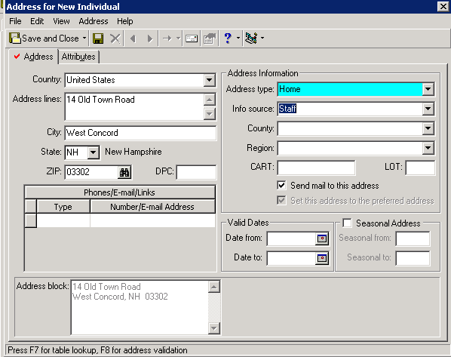

- Send mail to this address - Since this is the only address, the system assumes this is a mailable address.
  - If your address is incomplete or constituent has requested to not receive mail at this address, uncheck the ◻ Send mail to this address.

- Set this address to the preferred address – Note this selection is grayed out. The system sets the first address entered as the preferred address.

- Date from (optional) – Enter today’s date (F3) or the date you know the address was effective (F7 for calendar).

- Hit Save and Close and return to the Bio 1 screen.

Phones/E-mail/Links
Phone numbers, fax numbers, email addresses, and websites (links) are entered in the Phones/
E-mail/Links section (referred to as the phone grid).

- Phones
  - In the Type column, pick the phone type from the dropdown menu.

  - In the Number column, enter the numbers only and they will convert to the correct format.
    - ex: 6032252222 will convert to (603) 225-2222
    - If you type extra numbers at the end, they will convert to an extension (Ext 225).

  - You can only have one phone number of each type, so choose …2 if you have multiple.
    - ex: Home Phone 2, Business Phone 2, etc.

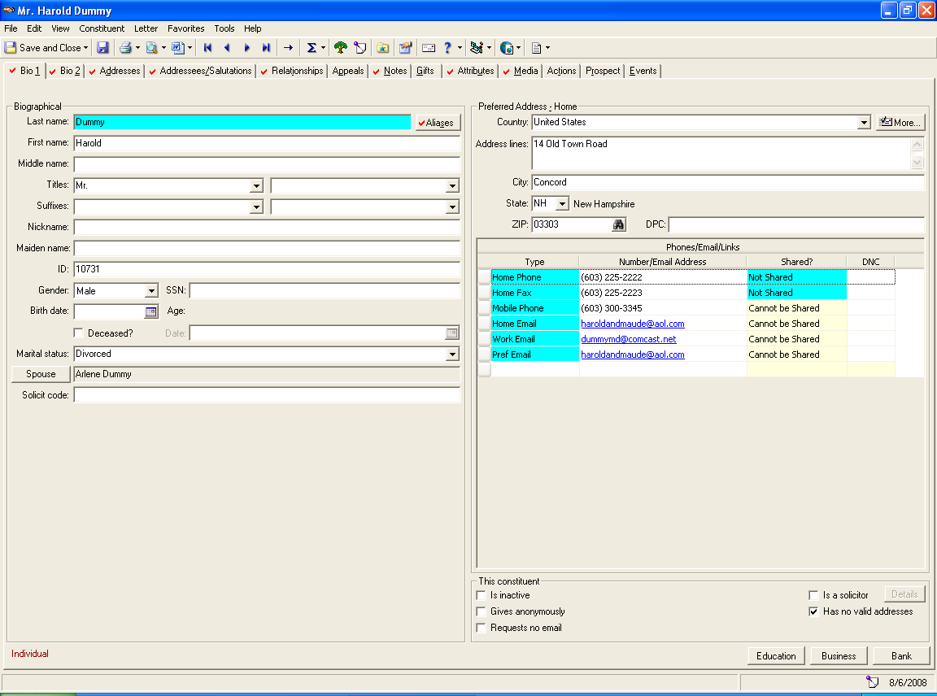

- Email addresses
  - In the Type column, pick the email type from the dropdown menu.

  - In the Email address column, enter the email/web address and it will convert to a hyperlink.

- Preferred email address - RE has no internal way of identifying which email address a constituent prefers, so we have created a “preferred” email type to do this.

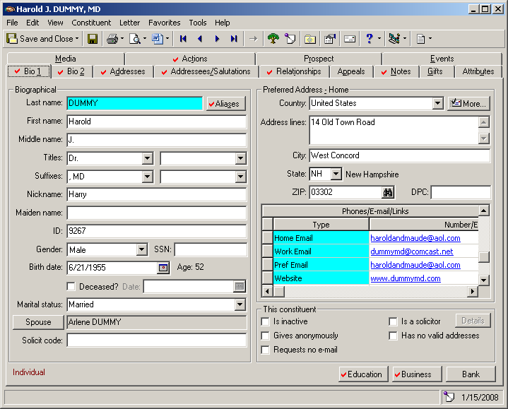
  - Decide which email is the preferred one.

  - Enter an additional email of Pref Email and duplicate the email address (use copy/paste).

  - If you don’t know which email is preferred, you must choose one; you can always change it later.

- EmailFinder email address – We recently contracted with Blackbaud’s EmailFinder service and the results are brought into RE using the phone type of EmailFinder.
NEW

  - Please leave this EmailFinder email address on the record; do not delete it!
  - If we get a bounceback on an existing email address, we might choose to replace the Pref Email with the EmailFinder address found by Blackbaud.

Which address do you put the phones/emails on?
You should enter phone numbers on the type of address they are related to:

Address type |  | Phone type
Home address | Enter all phones related to them personally | Home Phone  Home Phone 2  Home Fax  Mobile Phone (if it’s personal mobile)  Mobile Phone 2 (if it’s personal mobile)  Unlisted
Seasonal address | Enter all phones related to seasonal | Seasonal Phone
Business address | Enter all phones related to their business | Business Phone  Business Phone 2  Mobile Phone (if it’s business mobile)  Mobile Phone 2 (if it’s business mobile)  Website  Website 2

Emails are different; all email addresses should be added to whichever address is the preferred.

Preferred address | Enter all email addresses | Home Email  Home Email-2  Work Email  Work Email-2  Pref Email

Note: Because you enter all the emails on the preferred address, if the constituent changes their preferred address you must manually move all the emails onto the new preferred address.

NEW in RE v7.8 Phone Sharing and Do Not Contact
In RE version 7.8, two new features were added to the phone grid: the ability to share phone numbers and the ability to mark a phone number as Do Not Contact (DNC).

You will see two new columns on the phone grid. However, we are currently not using either of these features.

- In the Shared? Column, you’ll see Not Shared and Cannot be Shared assigned to specific phone types. Please do not change either of these values.

- In the DNC column, please do not select any values by clicking in the space.
  - If you do, this icon 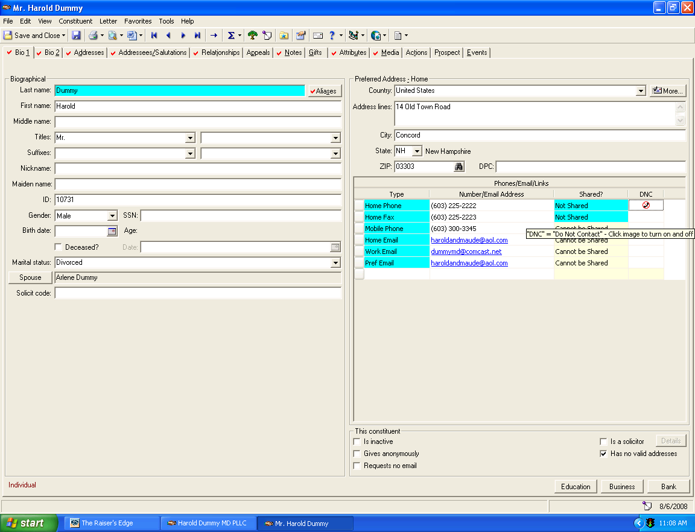 will appear. Please click again to remove the icon.
For information on how to enter additional addresses or more detailed information, see Adding an address on a constituent record.
TIP
Remember, Outlook data is not linked to our RE data.
You are responsible for keeping this information up-to-date and consistent in both sources.

Spouse
If constituent is married or partnered, you can now add the Spouse (partners are treated as spouses for system purposes).

- Click on the Spouse button (bottom left-hand corner of screen) to open a New Individual Relationship screen.
  - Note there are three tabs: General 1, General 2, and Attribute/Notes.

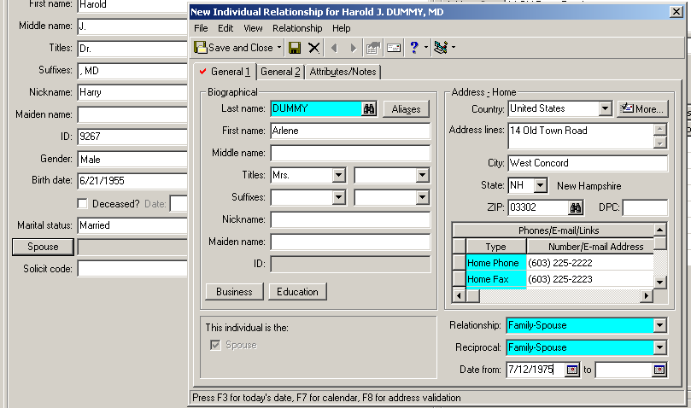

Spouse - General 1 tab
If you think the spouse may already have a record in Raiser’s Edge
- Click the binoculars and search for spouse record.
    - Make sure your search checkboxes are set for the broadest search possible
(see Searching for a constituent record for more info).

- If the spouse already has a record - Highlight the record and click Open.
  - The name and address data will automatically populate on the relationship screen.
  - Continue entering the other basic information in the fields.

- If the spouse does not have a record – Continue entering the spouse’s basic information in the fields.

- Last Name - If spouse has the same last name as Bio 1, hit F3 to automatically copy.

- Address - Note that if you linked to an already existing record, the address automatically copied over.
  - If this is not the correct address for the spouse, change the address.
  - Follow the Changing an address on a relationship procedure exactly when you do this. If you make the wrong selection, you can overwrite the constituent’s address (probably not what you want to do).

- This individual is the – Note that Spouse is already selected (grayed out).

- Relationship/Reciprocal - Choose Family-Spouse for both Relationship and Reciprocal.

- Date from – Enter date of the marriage/partnership, if known.

Spouse General 2 tab

- Gender - Add the gender.
- Birth date – Add birth date.
- Deceased – Add deceased and date (see Deceasing a constituent record for this procedure).
- Addressee/Salutations – Add these addressee/salutations.
  - Primary addressee/salutation
  - First Name
  - Joint addressee/salutation

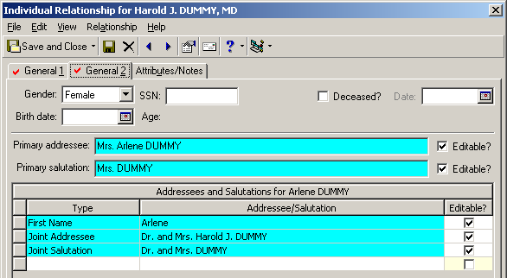

TIP
As an option, consider using a Default Set to help enter your Spouse info:
On the spouse relationship top menu, go to Relationships/Load Defaults From and you’ll get this window:

Make your selection (for female or male) and it will automatically enter Relationship/ Reciprocal, gender, and populate your addressee/salutations.
See Using Defaults Sets for more information on this time-saving feature.
Spouse Attributes/Notes – do not enter any data here

- Hit Save and Close when done entering spouse info, and you’ll return to the Bio 1 screen
  - You’ll now see the spouse name displayed in the Spouse field

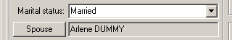

For more information on creating the spouse record, see Individual-Individual relationships.

If you want to create a separate record for the spouse, see Create a constituent record from a relationship.

Solicit Codes
Solicit codes are exclusion codes relating to mailings or other foundation activity.

- You probably will not be entering solicit codes when you create a record. They usually come into play during the lifecycle of the record, as constituents communicate their preferences.
- If you need to add a solicit code, see Solicit Codes for definitions and how to enter.

This Constituent Grid
In the right-hand corner of the screen there is a box called This constituent with five checkboxes.

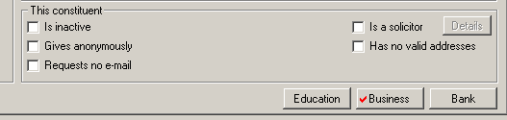

- ◻ Is Inactive – We are currently not using this feature but may do so in the future

  - When you check ☑ Is Inactive, the constituent record becomes inactive throughout the entire program. The record still exists in the system but is easily excluded from any automatic program searches like Query, Mail or Reports.

    - Examples of possible inactive: a company that has gone out of business, a person no longer a prospect
    - Do not mark a deceased constituent as Inactive; these are separate functions
- ◻ Gives anonymously
  - This is a very important option that indicates the constituent chooses to be an anonymous donor.
  - Checking the ☑ Gives anonymously box will create a pop-up box that appears every time the constituent record is opened.

- ◻ Requests no e-mail
  - Check ☑ Requests no e-mail if constituent does not want to be contacted by email. They can then be removed easily from all email functionality throughout the system.
  - If constituent has asked to be excluded from only certain types of email correspondence, this is handled in Solicit Codes.

- ◻ Is a Solicitor
  - By checking ☑ Is a Solicitor, you tell Raiser’s Edge that the constituent is a solicitor. The record may now be associated with gifts, funds, etc.
  - Solicitors are staff as well as certain professional advisors.
  - For details, see Marking a constituent as a Solicitor.

- ◻ Has no Valid Addresses
  - When you check ☑ Has no Valid Addresses, you indicate that even though addresses are present on the record, none of them are valid. The record can then be eliminated easily from Mailings and Reports.
  - For details on making address changes, see Changing an address on a constituent record.

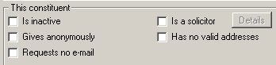
TIP
Please be careful with your cursor in this area. It’s easy to accidentally click something you didn’t intend to.
These selections are very important!

Shortcut buttons
The buttons at the bottom of the screen are shortcuts to specific areas of Raiser’s Edge - Education, Business and Bank. Please do not use the buttons when you are creating a record.

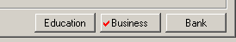

You’ve now completed the information on the Bio 1 screen. You now want to move to the other tabs.

