What are addressees and salutations?

- An addressee is a full version of the constituent name (ex: The Honorable James J. Aldrich, Mrs. Shirley A. Jones, Robert A. Hernandez).

- A salutation is the greeting you include on mailings; it’s what follows the “Dear” (ex: Judge Aldrich, Shirley, Bobby).

Raiser’s Edge allows you to maintain multiple sets of addressees and salutations. These sets of addressee/salutations allow you great flexibility in addressing and greeting your constituents, and tailoring your communications to their preferences.

So you have the ‘hard’ data of last name, first name, etc. in the constituent record but you can ‘tweak’ the addressees and salutations to allow for specific formats.

Primary Addressee and Salutation

The primary addressee and salutation you select for an individual is how they will be addressed the majority of the time. Every individual record is required to have a primary addressee and salutation. Organization records do not have the option for addressee/salutations.

The foundation has established these standards for the primary addressee.

  - The primary addressee is the formal version of the sole constituent that appears on the Bio 1 screen.

  - Use a title, first, middle initial, and last name with appropriate suffixes.
    - ex: Mr. Ralph P. Edwards, III

  - Do not use both a title and a professional suffix.

Correct | Incorrect
Mr. Ralph P. Edwards, III | Ralph Phillip Edwards, III
Robert E. Saunders, MD | Dr. Robert E. Saunders, MD
John E. Wells, Esq. | Attorney John E. Wells, Esq.

  - Initials or abbreviations indicating degrees, certifications and other honors are sometimes placed after the name of the person. Use only the initials of the highest degree; more than one degree may be used, however, if the degrees are in different fields.

TIP
If a constituent has informed us that they wish to be addressed in a specific way, we will adjust our addressee/salutations to conform with their request.
ex: Mr. Edwards has requested that we use his full middle name to address him as Ralph Phillip Edwards, III.
ex: Mr. Saunders has requested that we not refer to him as Jr.
The foundation has established these standards for the primary salutation.

  - The primary salutation is the formal version of the sole constituent that appears on the Bio 1 screen.

  - Use a title and last name; do not use the suffix after the name
    - ex: Mr. Edwards, not Mr. Edwards III

  - Use professional titles only in certain cases (ex: Attorney General, Senator).
    - Some professions (mostly government and judicial) have an alternate format for the salutation different than the title (ex: Judge, not The Honorable)

  - For most cases, use Mr., Mrs., Ms. or Miss.

Correct (Dear …) | Incorrect (Dear …)
Mr. Edwards | Mr. Edwards III
Professor Saunders | Professor Saunders, PhD
Mr. Wells | Attorney Wells
Judge Davis | The Honorable Davis

  - Do not include the word Dear as part of the salutation.

Refer to the Naming Convention & Addressee/Salutation Chart for detailed information on formatting for specific professions and situations.

Adding a primary addressee/salutation
- On the Addressees/Salutation tab, click in the blank area next to Primary addressee.
- Hit the arrow to open the dropdown menu.

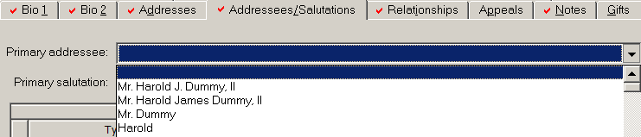

- Choose the addressee/salutation value you want from the dropdown menu.

- The values that appear are formula-driven based on data in the record.
  - The most common formats for the primary addressee & salutation are at the top of the list.
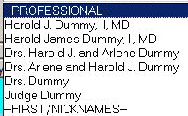
  - Other formats are under Category headings (in CAPS).

    - The headings are intended to provide some guidance to help you make the proper selections.

Here’s a full list of all the addressee/salutation formats as they appear on the dropdown, and when to use them:

 | Addressee/Salutation Formats | When to use
 | Mr. Harold J. Dummy, II | Most common format for primary addressee; middle initial
 | Mr. Harold James Dummy, II | Full middle name
 | Mr. Dummy | Most common format for primary salutation
 | Harold | First Name
--JOINT (Bio 1=Male) |  | For joint versions when Bio 1 is male
 | Mr. and Mrs. Harold J. Dummy, II | Most common format for joint addressee; middle initial
 | Mr. and Mrs. Dummy | Most common format for joint salutation
 | Mr. Harold J. and Ms. Arlene Dummy | Spouses have same last name but differentiate between them (ex: spouse is a Ms.)
 | Mr. Harold J. Dummy and Ms. Arlene Smith | Different spouse last names for joint addressee
 | Mr. Dummy and Ms. Smith | Different spouse last names for joint salutation
--JOINT (Bio 1=Female) |  | For joint versions when Bio 1 is female
 | [same formats as above]
-- PROFESSIONAL -- |  | For professional version of name (Esq, MD etc.)
 | Harold J. Dummy, MD | Professional suffix w/middle initial
 | Harold James Dummy, MD | Professional suffix w/full middle name
 | Drs. Harold J. and Arlene Dummy | Joint when both are Drs. and same last name; Bio 1 first
 | Drs. Arlene and Harold J. Dummy | Joint when both are Drs and same last name; Spouse first
 | Drs. Dummy | For salutation when both are Drs.
-- FULL NAME -- |  | Complete version of full name (system name often isn’t correct)
 | Harold J. Dummy, II | Full name with middle initial and personal suffix (not prof)
 | Harold James Dummy, II | Full name with middle name and personal suffix (not prof)
 | Harold J. Dummy, II (deceased) | Full name with middle initial plus deceased
 | Harold James Dummy, II (deceased) | Full name with middle name and deceased
--FIRST/NICKNAMES-- |  | Nicknames; joint versions of first & nicknames
 | Harry | Bio 1 nickname
 | Arlie | Spouse nickname
 | Harold and Arlene | Joint combinations of first names & nicknames
 | Harold and Arlie | Joint combinations of first names & nicknames
 | Harry and Arlene | Joint combinations of first names & nicknames
 | Harry and Arlie | Joint combinations of first names & nicknames
 | Arlene and Harold | Joint combinations of first names & nicknames
 | Arlene and Harry | Joint combinations of first names & nicknames
 | Arlie and Harold | Joint combinations of first names & nicknames
 | Arlie and Harry | Joint combinations of first names & nicknames
--- ANNUAL RPT/SP-- |  | For Annual report listing and Spaulding Potter
 | Harold J. Dummy, II | No title; suffix 1 only; middle initial
 | Harold James Dummy, II | No title; suffix 1 only; full middle name
 | Harold & Arlene Dummy | Same last names
 | Arlene & Harold Smith | Same last names
 | Harold Dummy & Arlene Smith | Different last names
 | Arlene Smith & Harold Dummy | Different last names

-- DONOR REPORT -- |  | For Donor report listing
 | Harold Dummy | no suffixes
 | Arlene Smith | Spouse; no suffixes
 | Harold and Arlene Dummy | Joint combinations of names
 | Arlene and Harold Dummy | Joint combinations of names
 | Harold Dummy and Arlene Smith | Joint combinations of names
 | Arlene Smith and Harold Dummy | Joint combinations of names
-- GENERIC --
 | Sir or Madam
 | Harold Dummy 12345 | Name plus constituent ID
-- ANONYMOUS -- |  | For all anonymous name formats
 | Anonymous
 | Anonymous Donor

- As a general rule, choose the first value on the list gives you the correct format.

- The list does not have every possible name combination (there are too many of them!)

- If you can’t find the format you need on the dropdown
  - Double-check to make sure all the data fields are there on both the Bio 1 and the spouse record.
  - Add any missing data to the record(s).
  - Look again at the dropdown list to see if the correct format is now listed.

- If you still can’t find the format you need
  - Choose the format from the dropdown menu that is the closest.
  - Check ☑ Editable and adjust the text how you want it to read.
  - Only check ☑ Editable when it is an exception to the rule or you want to guarantee that the value will never get changed.

- For Anonymous formats, always check ☑ Editable (we want to be sure these are never changed).

TIP
Previously, you were always supposed to check ☑ Editable.
Now, we’re asking you to only check when necessary.

Precaution when changing name fields
Because the addressee/salutations are now directly linked to the data on the record, please be careful when changing or adding any new name data.

If you need to change or add any of the name fields:

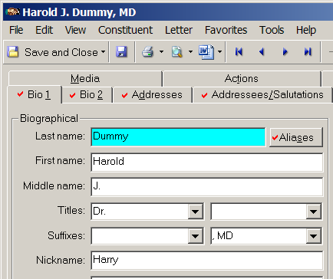

- Check all the addressee/salutations to see if any of the values were changed.
- Make any adjustments as needed.

What’s the Foundation’s protocol for joint versions of the names?
For joint versions of addressees and salutations, we’ve chosen to use the general protocol of listing the male’s name first.
- One general exception to this is for our internal staff members.
  - If the staff member has a different last name, then we would list the staff member’s name first.
    - ex: Ms. Linda Gray and Mr. David Gotjen
  - If the staff member has the same last name, we’d treat them as a regular married couple.
    - ex: Mr. and Mrs. David Cochran (not Mrs. Ellie Cochran and Mr. David Cochran)
- Another exception is if the constituent has specific circumstances or requested to be listed first.

→IMPORTANT: The joint addressee/salutations should be IDENTICAL on both the parties. Do NOT adjust the addr/sals on each record to put one person before the other.

Record | Joint Addressee | Joint Salutation | First Name (joint)
Mr. John Smith  Mrs. Jane Smith | Mr. and Mrs. John Smith  (on BOTH records) | Mr. and Mrs. Smith  (on BOTH records) | John and Jane (on BOTH records)
Mr. Joseph Long  Ms. Becky Short | Mr. Joseph Long and Ms. Becky Short  (on BOTH records) | Mr. Long and Ms. Short  (on BOTH records) | Joseph and Becky (on BOTH records)

Additional Addressee/Salutations
There are other addressee/salutations that you can add in the Additional Addressee/Salutation grid. Some are required; some depend on other data in the record; some depend on if the constituent is known personally by staff.

- First Name (required on all individual records)
  - Choose the value to be used when addressing the constituent informally by first name on general mailings.

    - Ex: The constituent’s first name is A. Harold. He generally uses the first name of Harold but some staff know him as Harry. On a general mailing, you need to decide if generally we would use Harold or Harry. Enter the one you choose as the First Name salutation.

- First Names (joint informal) (required on all records with spouses/partners)
  - This is the joint version of the First Name (see section above).
  - The order of the names should follow the order in the Joint Addressee & Joint Salutation (see below).

- Full Name (required on all records)
  - RE provides a system <Name> field but it doesn’t always give us the desired format for use throughout the system. So we are creating a “generic” version of the name which can be used on many reports and on the website to display the name.
  - Here is the format for the Full Name:

Format | Full Name
Use middle initial OR full middle name (if used by constituent) | Perry F. Williamson  Paul Scott Holloway
Do not use any title | John H. Lynch (even though he’s Governor)
Use BOTH the personal and professional suffix (if used in other salutations) | Richard F. Morse, Jr.  Alexandra T. Breed, Esq.  John H. Smith, III, MD

Note: Someone may have a suffix in the Professional Suffix field but doesn’t actively use it (they’ve chosen not to or are using another suffix instead). In this case, use the suffix that they are actively using in their Primary addressee/salutation

- Joint Addressee and Joint Salutation (required on all records with spouses/partners)
  - Choose the formal joint addressee.
  - Put on both spouses/partner records.
  - Joint addressee/salutations should include the word “and”, not an ampersand (&).
  - Refer to the Foundation protocol on joint version of names.
  - See the Naming Conventions & Addressee/Salutation Chart for formatting joint addressee & salutations for different scenarios.

- Annual Report Name (required on all donor records) - Used in producing annual report donor list
  - Relationship Managers are responsible for adding this addressee format for all constituents they anticipate making a gift. Accounting will verify this format when the gift is processed.
  - It has a different format than all other addressees.

Format | Scenario | Annual Report Name
Do not use a title or professional suffix | single person | Richard F. Morse, Jr.
Use ampersand  Do not use titles or professional suffixes | couple/partners | Richard & Betsy Morse  Richard Morse & Betsy Jones

  - There will be exceptions to this format if constituent has a specific way they have requested to be addressed (ex: use of full middle name instead of initial).

- Donor Report, Donor Report Combined, Org Donor Report - Used in producing donor statements. These are entered and maintained by Fund Manager only.

- Spaulding Potter - Used for specific mailings. These are entered and maintained by staff responsible for the mailing.

- Staff specific salutations - AS OF 6/2010, WE ARE NO LONGER USING staff specific salutations except for Lew Feldstein. These types have now been deleted from the system.

Adding an Additional addressee/salutation
- In the Additional addressee/salutation grid, click in a blank line of the Type column.

- Choose the addressee/salutation type you want from the dropdown menu.

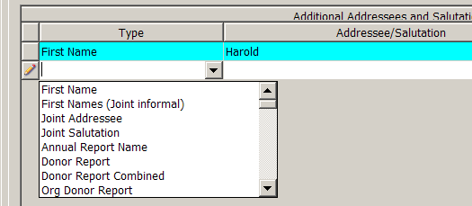

- Then move to the Addressee/Salutation column and hit the arrow for the dropdown menu.
- Choose the first value from the dropdown menu that is the correct format.
- If you don’t find exactly the format you need
  - Check ☑ Editable.
  - You can now adjust the text to make any needed corrections or adjustments.

- Continue entering additional addressee/salutations as needed.

Remember that the primary addressee, primary salutation, First Name and Full Name are required on an individual record.

If the constituent is married, the joint addressee, joint salutation, and First Names (joint informal) are also required.

TIP
If you’re not sure about which addressee/ salutation formats to use or how to format them, consult the Naming Conventions & Addressee/Salutation Chart or contact IT who can help you
It is important that all our addressee/ salutations are correct; all our external contact/correspondence, annual reports, etc. use this information

