Subject line: Put a smile on Chloe’s Face

Dear [Constituent First Name],  For most kids, Christmas Day is a time to wake up early and eagerly open their presents. But 2-year-old Chloe showed no signs of waking up on Dec. 25, 2006.  Help us treat children like Chloe who are in the hospital this holiday season.  Worried that she could be having a reaction to a new medication, her parents called their doctor at Children’s National. “Instead of driving to see our relatives, we were told to take Chloe straight to the emergency room,” her dad says.  “I hope we never have to spend another holiday at any hospital, but once I walked into Children’s National, I knew everything would be okay. The nurses and doctors gave Chloe wonderful care.  “And they also helped make being in the hospital on Christmas a little easier for her.”  It doesn’t take much to make a difference to a child like Chloe who is spending this holiday season at the hospital.  - $25 provides a patient with a package of UNO cards, the most-requested game this holiday  - $50 can help keep a child in the hospital entertained with DVDs or video games  - $100 covers the cost of a soft and cozy “nest” specially made for the tiniest preemies  I hope we can count on your support!  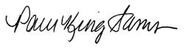  Pam King Sams  Executive Vice President for Development  P.S. Tell a friend about this campaign and help us bring a smile to a child’s face this holiday season. | Bring a smile to the face of a child who’s in the hospital this holiday season.  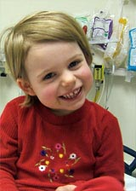    Every $25 you give provides one package of UNO cards for kids like Chloe this holiday season.

