Add your content to the eAppeal template below.
Create eAppeal Kick-off

CAMPAIGN KICK-OFF SUBJECT LINE | Put a smile on Daisy’s face

Dear [Constituent First Name],  At 5 a.m. on Christmas Eve, Daisy’s family found out that she had leukemia. She started treatment immediately.  Help us provide the best possible care to kids like Daisy.  For her first round of chemotherapy, she spent the holidays in the hospital. It was a frightening time, but the staff at Children’s National helped make it her family’s home away from home.  “All of the Children’s employees from the first floor up have never done anything but their best to make Daisy’s stays and visits here welcoming,” her mom says. Daisy finished her last round of treatment one year ago.  Your donation today will allow us to provide a playful, welcoming environment to kids like Daisy, especially during the holidays.  It doesn’t take much to make a difference:  - $25 provides a patient with a package of UNO cards, the most-requested game this holiday  - $50 buys a soft and cozy “nest” specially made for the tiniest preemies to simulate the baby’s position the womb  - $100 helps us to bring the holidays into every child’s room  I hope we can count on your support!  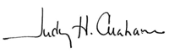  Judy Graham  Vice President of Development  P.S. Tell a friend about this campaign and help us bring a smile to a child’s face this holiday season. | Bring a smile to the face of a child who’s in the hospital this holiday season.      Every $25 you give provides one package of UNO cards for kids like Daisy this holiday season.
 Unsubscribe | Forward to a Friend | Visit our web site

[Your mailing address here]

Copyright © 2009 All rights reserved

Add your stewardship content to the eCard template below.
Create your stewardship eCard – non-donor version
ECARD SUBJECT LINE | You can help save lives like Olivia’s
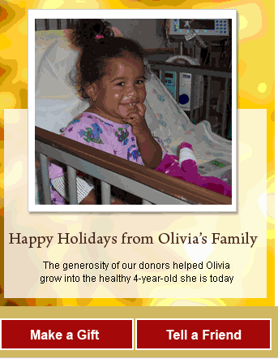 | [Your Logo will go here]  When you’re sick, all you want is to feel better again—especially when you’re a child spending the holidays in the hospital.  After a life-saving heart transplant at 9 months old, Olivia soon had enough energy for two children, just as her doctors had predicted.  “Our family is forever grateful to the medical staff that cared for Olivia,” says her mom.  “They helped our entire family make it through.”
Unsubscribe

[Your mailing address here]

Copyright © 2009 All rights reserved

Add your stewardship content to the eCard template below.
Create your stewardship eCard – donor version
ECARD SUBJECT LINE | Thank you for helping kids like Olivia
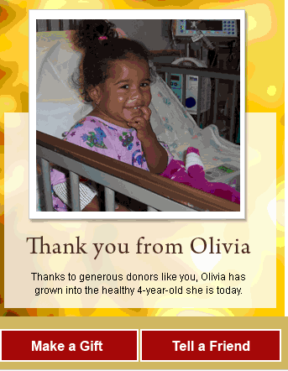 | [Your Logo will go here]  When you’re sick, all you want is to feel better again. After a life-saving heart transplant at 9 months old, Olivia soon had enough energy for two children, just as her doctors had predicted.  “Our family is forever grateful to the medical staff that cared for Olivia,” says her mom.  “They helped our whole family make it through.”  From the entire Children’s family, we wish you a joyous holiday season.
Unsubscribe

[Your mailing address here]

Copyright © 2009 All rights reserved

Add your content to the last-chance eAppeal template below.
Create Last-Chance eAppeal

CAMPAIGN SUBJECT LINE | Give hope to families like Ryan’s
Dear [First Name],  Today is your last chance to give a gift that will be tax-deductible for 2009. Help us give health and hope to families in the hospital right now.  With the generous support of our donors this year, we have been able to:  - Ensure every child in our community gets world-class care, regardless of their family’s ability to pay  - Invest in future cures for some of life’s most devastating diseases.  Your gift before 2009 comes to a close will help us prepare for all the challenging work we face in the New Year.  Won’t you give one last gift this year and help us continue to make sick kids well.  Thank you for helping Children’s National provide world-class care for all the kids who come through our doors.  Wishing you a safe and happy New Year,  [Signature Graphic, if already on file with Convio]  [Signature Name], [Title] | “It’s so hard to put into worlds how grateful we are. Children’s is never willing to quit fighting,” says Ryan’s dad.  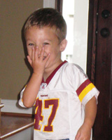  Watch Ryan’s story>>  Your gift gives hope to families like Ryan’s who depend on Children’s National—during the holidays, and every day of the year.
Unsubscribe | Forward to a Friend | Visit our web site

[Your mailing address here]

Copyright © 2009 All rights reserved

