CONVIO GO!TM END-OF-YEAR FUNDRAISING GUIDE

Sender Address: [your organization’s general email address]
(HINT: Your supporters will see this in the “from” line - constituent replies and out-of-office notifications go here; a general NPO address is preferred)
Sender Name: [your Executive Director, CEO, or just the name of your organization]
(HINT: Your supporters will see this in the “from” line - your sender should be generic or the same name as the signature.)
OBJECTIVE/OVERVIEW
The End-of-Year Campaign asks your constituents for their financial support, stewards existing donor relationships, and generally keeps your organization top-of-mind with your constituents during the holidays. This campaign includes:

- Two Email Appeal Messages
- One eCard Stewardship Message
- A campaign promotion on your website homepage

This guide collects your content for the two email appeal messages and one eCard stewardship message:

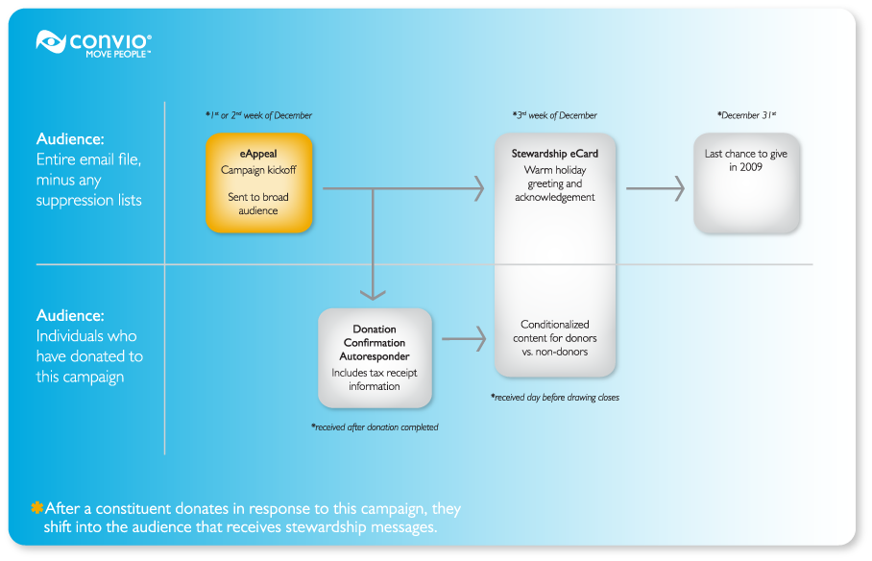

CONTENT BRAINSTORM
CAMPAIGN THEME
Requirements
Describe, in your own words, the theme of this campaign. The best campaign themes are short, to the point, and can be expressed in a single sentence. This theme should be easily woven through your entire campaign, including subject lines, calls to action, and campaign images. If you already have an offline fundraising campaign planned for year-end, you should consider using the same theme so that your online campaign complements your offline activities. Some examples:

- “Make them cry this Christmas” – a year-end campaign by the Paul Anderson Youth Home to promote their fundraising onions, hot sauces, and giving in general over the holidays.
- “Spread Joy to the World” – a year-end campaign by Riverwalk Jazz to promote support for their online jazz programs as a way to bring an appreciation for classic jazz to an international audience
- “Bring light into a senior's life this Chanukah” – a holiday campaign by DOROT to remind their constituents about the need to visit and support the homebound elderly during Chanukah

[Enter your Theme Here]

CAMPAIGN NARRATIVE
Requirements
Describe, in your own words, the story you’d like to tell your constituents in the course of this campaign. Keep in mind that your campaign will have multiple email messages and should convey a beginning (launch), middle (stewardship) and end (last chance to give in 2008). Unless you write out each message for us in the “optional content” section, we will use portions of the text you provide to create your actual email messages and related content. Please answer questions like:
- What is the most compelling need your organization will address during the holidays?
- What is the most moving personal story you’d like to share about the work you’re doing?
- What is happening right now or what will happen in December to make this campaign timely?
- What is the impact you hope to have in the coming year?

[Enter your Narrative Here]

CONTENT – CAMPAIGN BEST PRACTICES
Subject Lines
Your subject lines are the first part of the email that your readers see. A compelling appeal subject line should speak directly to both your donors’ interests and their impact. You should vary your subject line from message to message over the course of your campaign.

Some examples:
- Jazz to the World
- Fill Chanukah with light for our seniors
- Make them cry this Christmas

Appeal Content
The content for this sequence of messages should provide the “beginning”, “middle”, and “end” of a compelling, three-part story. These message should answer the following questions:

- What problem are you working to address?
- How does a donation help solve this problem?
- Why is it important to give right now?
- What is the impact that a gift will have?
Keep your text copy to a minimum, and make sure that your readers know where they can go to get more information.
Appeal Call-out Text
For constituents who do not read the entire appeal message, the call-out text in the right column of the message is intended to catch their attention with a short statement about this campaign and why it is important. Many people skim their email messages, so having a clear and concise statement increases click and make a gift.

Examples:
“Every ten dollars you give allows us to provide one patient with a medical first aid kit”
“Every donation counts! Our programs need your support”

Donation Levels
You can provide 1-3 donation levels which appear in the email message. Please make sure to provide the level amount and the text to be displayed next to each amount. These donation ask levels will be linked to a donation form with corresponding levels. Explaining different giving levels helps your constituents connect their gift to their impact.

For example:
$20 covers the cost of providing valuable health information to 10 individuals.
$35 allows us to provide one family with flu vaccinations for their children
$50 sponsors one clinic visit for an individual who is in need

Images
Your appeal image should be resized to no more than 160 pixelsound 200 pixels tall. For your eCard, images should be 220px wide by 220 px tall. wide by ar

Add your content to the eAppeal template below.
Create eAppeal Kick-off

CAMPAIGN KICK-OFF SUBJECT LINE | [enter your subject line here – 55 Characters or less]

Dear [Constituent First Name],  [1-2 sentence description of the problem you’re working to address]  [Call-to-action link to donation form]  [2-3 sentences describing background and history of the problem you’re addressing]  [1-2 sentence description of the impact donors can have]  Your donation today will allow us to [impact statement]. It doesn’t take much to [make a difference]:  - $XX will pay for [impact statement]  - $XX covers the cost of [impact statement]  - $XXX allows us to [impact statement]  I hope we can count on your support!  [Signature Graphic, if already on file with Convio]  [Signature Name], [Title]  P.S. Tell a friend about this campaign and help us [impact statement]. | [Appeal call-out text – keep it short! 20 words or less.]      [Additional appeal call-out text or mission statement – keep this under 20 words also.]
 Unsubscribe | Forward to a Friend | Visit our web site

[Your mailing address here]

Copyright © 2009 All rights reserved

Add your stewardship content to the eCard template below.
Create your stewardship eCard – non-donor version
ECARD SUBJECT LINE | [enter your subject line here – 55 Characters or less]
   | [Your Logo will go here]  [Copy and paste your text and links here:  You have very little space for content so make it count.  Word count is around 70, character count is around 450 with spaces.  Lorem ipsum dolor sit amet, consectetuer adipiscing elit. Ut quis ipsum et sem malesuada fringilla. Curabitur odio neque, pharetra eu, mollis vitae, tempor id, nulla. Lorem ipsum dolor sit amet, consectetuer adipiscing elit. Proin lobortis convallis velit. Maecenas justo massa, viverra et, viverra ut.]
Unsubscribe

[Your mailing address here]

Copyright © 2009 All rights reserved

Add your stewardship content to the eCard template below.
Create your stewardship eCard – donor version
ECARD SUBJECT LINE | [enter your subject line here – 55 Characters or less]
[Your Logo will go here]
[Copy and paste your text and links here:
You have very little space for content so make it count.
Word count is around 70, character count is around 450 with spaces.
Lorem ipsum dolor sit amet, consectetuer adipiscing elit. Ut quis ipsum et sem malesuada fringilla. Curabitur odio neque, pharetra eu, mollis vitae, tempor id, nulla. Lorem ipsum dolor sit amet, consectetuer adipiscing elit. Proin lobortis convallis velit. Maecenas justo massa, viverra et, viverra ut.]
Unsubscribe

[Your mailing address here]

Copyright © 2009 All rights reserved

Add your content to the last-chance eAppeal template below.
Create Last-Chance eAppeal

CAMPAIGN SUBJECT LINE | [enter your subject line here – 55 Characters or less]
Dear [First Name],  Today is your last chance to give a gift to [brief statement of impact]. Your gift today is tax-deductible for 2009.  With the generous support of our donors this year, we have been able to:  [brief list of 2009 accomplishments]  Your gift before 2009 comes to a close will help us prepare for all the challenging work we face in the New Year.  Won’t you give one last gift this year and help us [restate impact]?  As always, thank you for your continued partnership in [brief statement of mission].  Wishing you a safe and happy New Year,  [Signature Graphic, if already on file with Convio]  [Signature Name], [Title] | [Appeal call-out text – keep it short! 20 words or less.]  [Additional appeal call-out text or mission statement – keep this under 20 words also.]
Unsubscribe | Forward to a Friend | Visit our web site

[Your mailing address here]

Copyright © 2009 All rights reserved

USE THE FOLLOWING SECTIONS ONLY IF YOU’RE SUBMITTING YOUR CAMPAIGN TO CONVIO
Submission instructions

If you have purchased Fundraising Booster Shot Services, please send this completed form to getready@convio.com.

If you currently use Convio Virtual Administrator Services, you may send this completed document directly to your VA.

If you do not have either of these services, you can use this guide to organize and prepare your content before building it yourself in your Convio tools.

You should receive a confirmation of your submission within one business day. If you do not receive a confirmation, please check in with us. You should receive a test message that contains your content within ten business days.

Your subject line should contain your organization’s Convio short name, the word “EOY FUNDRAISING”, and your content submission date. For example: “AHS – EOY FUNDRAISING – 7/29/2026”. If you submit your content multiple times prior to a deadline, all but your most recent submission will be ignored.

Please note that if you miss your submission deadline, submit an incomplete document, or if the subject line of your email submission is not clear, production of your campaign could be delayed or canceled.
Please allow ten business days from the date of your submission for Convio staff to process, build, and test your campaign based on the content you provide
SUPPRESSION LIST FOR THIS CAMPAIGN
Requirements – file must be in “.csv” file format.  Your suppression list must include these three pieces of information for each individual to be included in the suppression list:  - First Name  - Last Name  - Email Address | Suppression List Best Practices  Your end-of-year fundraising campaign is designed to be sent to your entire email house file. If you would like to include a list of people who should be suppressed from the recipients list for the campaign e-appeals, you can send us the list by using a secure file send service via the internet. In general, unless you specifically request otherwise, we will send your stewardship eCard to your entire housefile, even if you provide a suppression list. It is important not to send a large list of names to us via email because of the lack of security that email provides.  If you have any questions about sending a large list of names to Convio please contact getready@convio.com and we can answer any questions you might have.  Important: You do not need to send us a list of individuals who have opted out of receiving email on their Convio profile. The Convio-powered email tools will automatically exclude individuals who have expressed a preference to be opted out of email communication.
Suppression List Submission Instructions

When you are ready to send the list to Convio, please follow these instructions:

- Visit http://www.sendthisfile.com
- Set up a new account for free
- With your new account, you will be able to securely send large files using a secure link instead of sending the file through email
- Follow the instructions on the website to upload your file and then send the file link to getready@convio.com
- Please contact us if you have any questions about this process
- Please do not send lists of contacts via email
CONVIO SEGMENTS TO SUPPRESS FOR THIS CAMPAIGN
Requirements – pre-existing group segmentation defined in your Constituent360 database  The Convio group names you provide here must match the groups/segments that you defined in your Convio Go! Data Management Guide. Alternatively, you may manually create and populate groups in your Constituent360 database and provide the names of those groups here. | Segmentation Best Practices  Most organizations with small (under 10K) email lists have 5 or fewer key segments initially. This often includes segments like donors, major donors, volunteers, board members, event participants, etc. You may still want to include them in this solicitation so that they are aware of this campaign.  If, however, you intentionally do not ever solicit certain segments (online or off) and you have already identified these segments as groups in Convio, please list those groups here.
[Enter group/segment names here]

