**How to Upload Contacts from Gmail or Yahoo**

***NOTE: If you use Hotmail, Outlook or another email provider, please refer to the guide for uploading  
contacts with a CSV file.***

**STEP 1- Login to your Participant Center**

**STEP 2- On your Participant Center home page and click the “Email” tab to access the Email functionality.**  
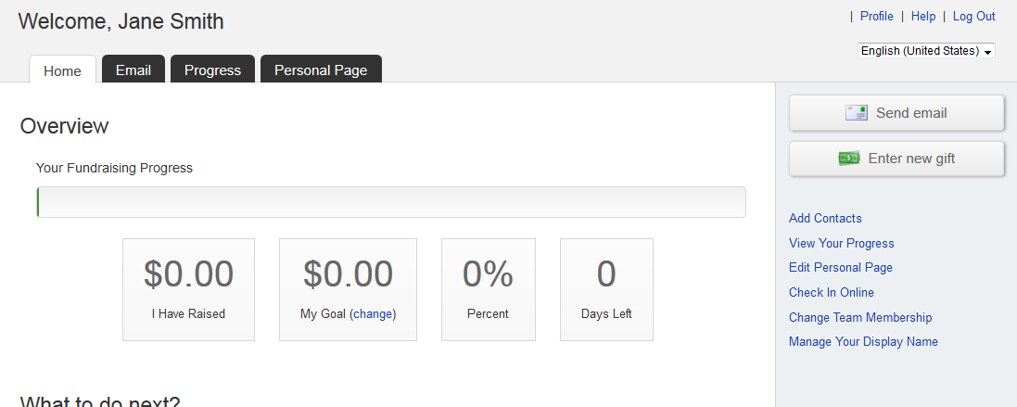

**-CONTINUE ON NEXT PAGE-**

**STEP 3-Click “Contacts” in the links on the right-side of the screen. 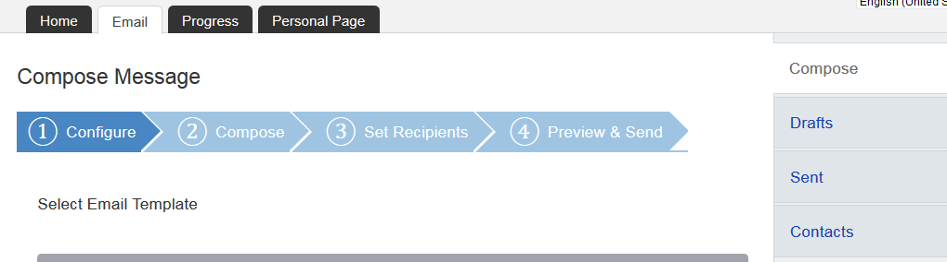STEP 4- Click “Import Contacts”** 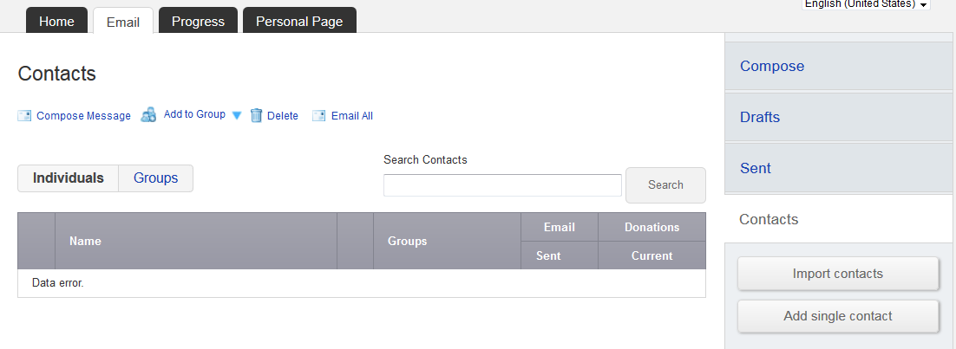

**-CONTINUE ON NEXT PAGE-**

**STEP 5-Choose the button next to either Gmail or Yahoo and click “Next”** 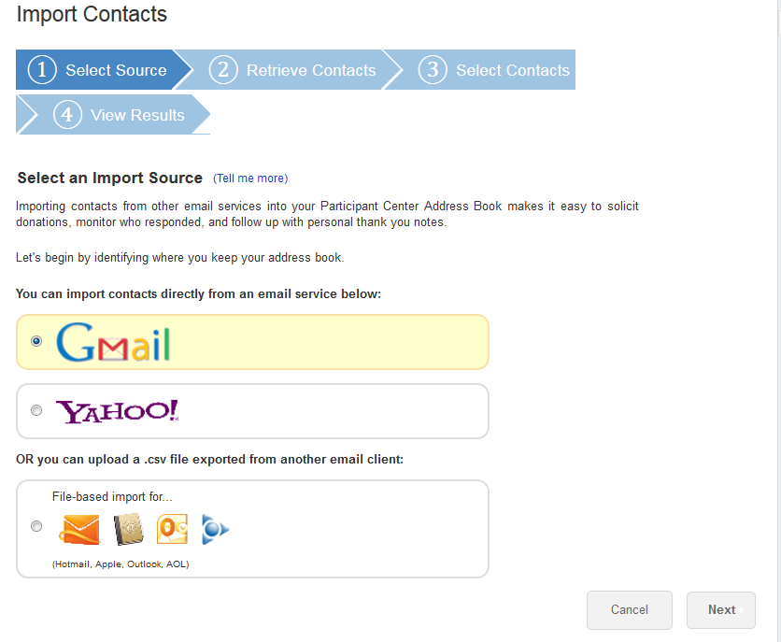

**-CONTINUE ON NEXT PAGE-**

**STEP 5-Login to your Yahoo or Gmail email account to link to the Participant Center**

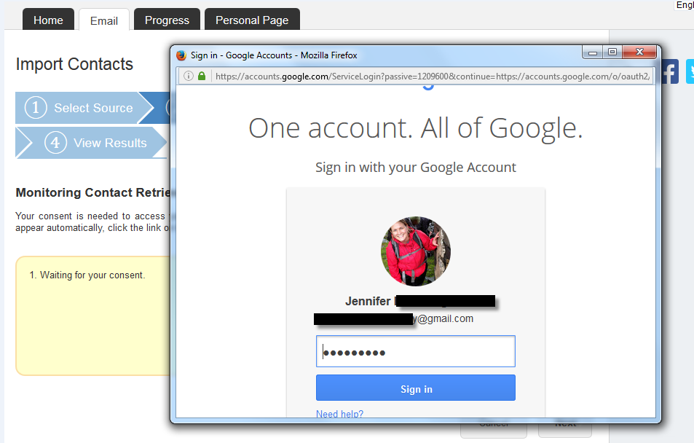 **Yahoo or Google may request for you to authorize access. Click “Allow access” so that you confirm permission for your Participant Center to access your email contacts:** 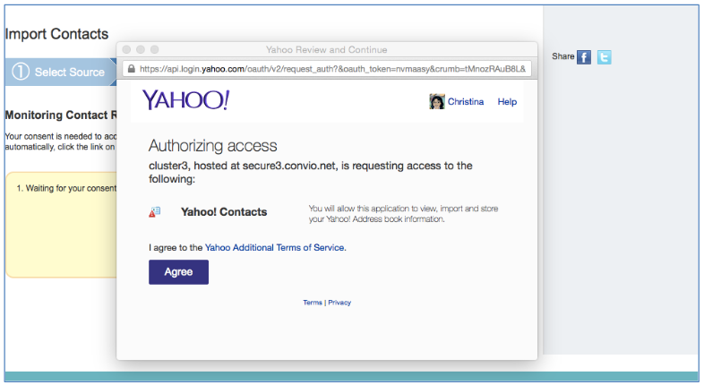

**-CONTINUE ON NEXT PAGE-**

**STEP 7- Select Contacts to Import  
You can opt to import ALL of your contacts from your email address book.** 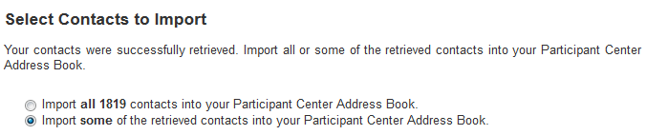  
***\*We recommend you review your contacts so you can select the email addresses that are current*.   
  
Click the check box next to the email addresses of the contacts you want to import into your Participant Center. Then, click the “Next” button.**

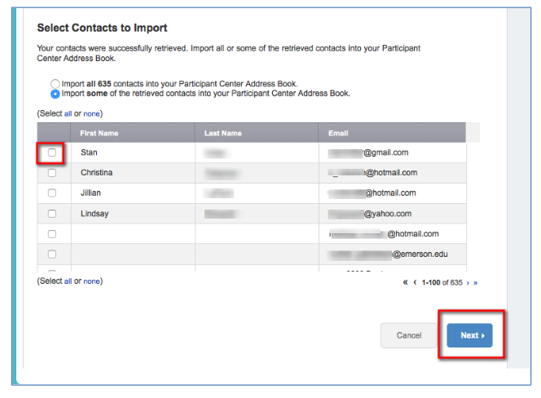

**-CONTINUE ON NEXT PAGE-**

**STEP 8- Confirm and complete a final review of the contacts that will be imported. Review your imported email addresses:**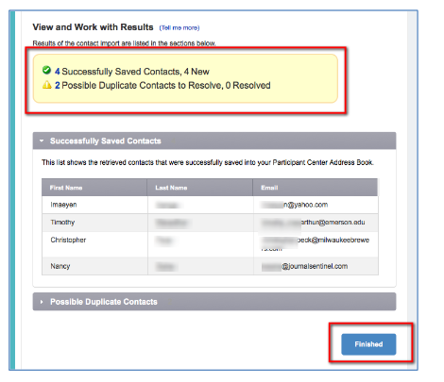

**-CONTINUE ON NEXT PAGE-**

**If you have any duplicates to resolve, be sure to review.** 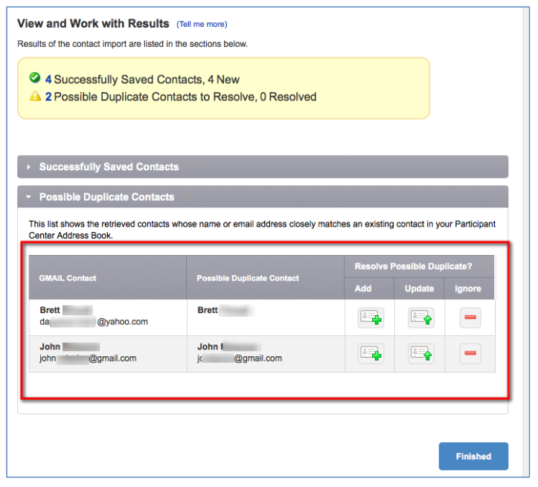

**Add-**add to your import for your Participant Center Contacts **Update-** Modify a current contact you have in your Participant Center Contacts **Ignore-** Do not add this contact to your Participant Center Contacts

**STEP 9- After you click “Finished” on the bottom of the page, you’re ready to start sending some emails.**