**How to Edit Your Unique Web Address**

**NOTE:** Your Participant Center is the online portal where you can check your fundraising progress, send email solicitations and thank you’s, update your Personal Fundraising Web Page and more!

**What is the Unique Web Address?**Once you’ve created your personal fundraising page, you have your very own URL address to get there. By default this can look quite lengthy, but there is a feature inside your Participant Center allows you personalize this URL which makes it easier to share with supporters. Paste the URL inside emails, on your Facebook and Twitter pages, or create business cards with this friendly URL to give supporters

**Step-1** Log into your Participant Center 

**Step 2-**Click “Personal Page” 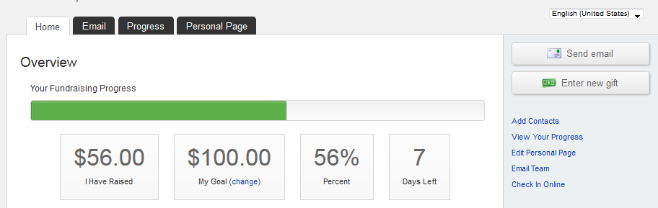

**-CONTINUE ON NEXT PAGE-**

**STEP 3-** Click “URL Settings” in the red outlined box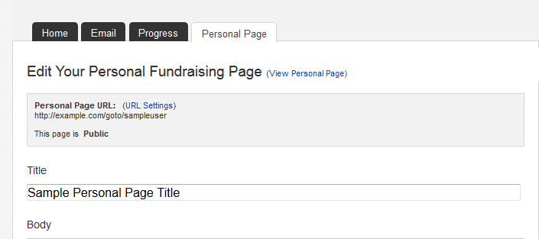

**STEP 3-**Insert your desired address in the text box (your name, nickname) and click “Save” to confirm changes.

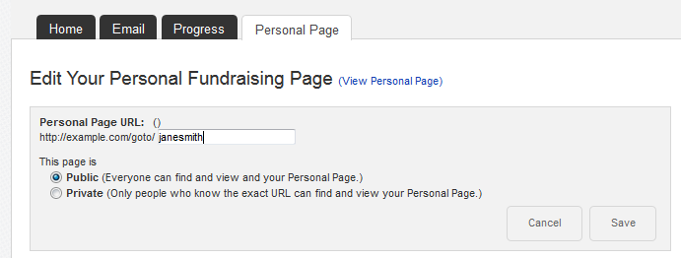

**-CONTINUE ON NEXT PAGE-**

**STEP 4-** A green confirmation message will appear on the page if your change was successful. 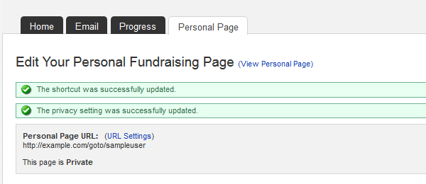

***NOTE: You may receive an error if your custom URL is already taken, so try a different word, phrase to create your address. Also avoid using spaces or special characters (e.g. %&^$, etc.)***

**STEP 5**-Copy and paste your new custom link to share with friends and family in your email messages or on social networks



**STEP 6-** If you are a team captain, repeat these same steps but on the “Edit Your Team Page” tab so that you can customize your Team Fundraising Page’s website address.