**How to Send an Email**

**STEP 1- Login to your Participant Center**

**STEP 2- On your Participant Center home page and click “Email” tab to access the Email functionality.**  
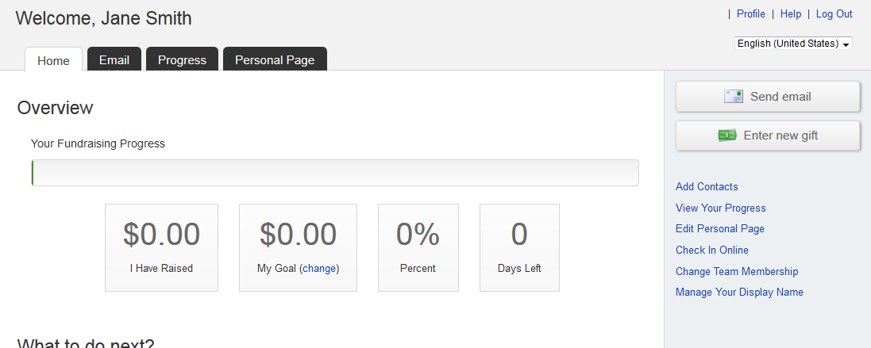

**STEP 3-Select an email message template.** 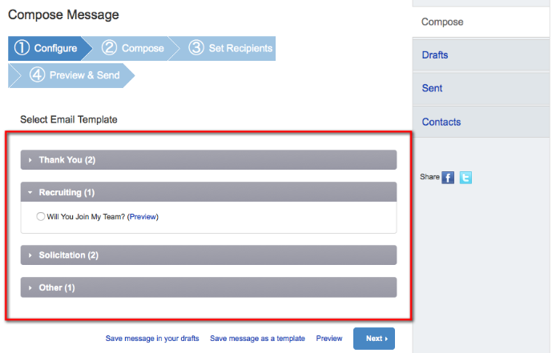

**-CONTINUE ON NEXT PAGE-**

**STEP 4- Compose your message**You can edit the SUBJECT line and the text in the BODY of the page. In our templates, you can just enter your personalized information before you’re ready to send. Otherwise, feel free to start from scratch and change all of the message to meet your specific needs.   
  
If you are sending this message in bulk to all of your contacts or a specific group, click the “Include personalized greeting”. This includes a default salutation and the first name of each recipient listed in the To line of an email message (for example, Dear Pat). If the recipient is not already a contact within your address book, the word "Friend" will display with the salutation instead. ***Note:*** If you select to include the personalized greeting in your message, do not manually type in a greeting as well. (That is, you do not want the message to start with two lines that say "Dear Sue" or a "Dear Sue" line followed immediately by a "Hey Sue" line.)

Be sure to put your name in the closing. You don’t have to worry about pasting the URL to your fundraising page as that populates automatically upon sending the email. Click **NEXT**.

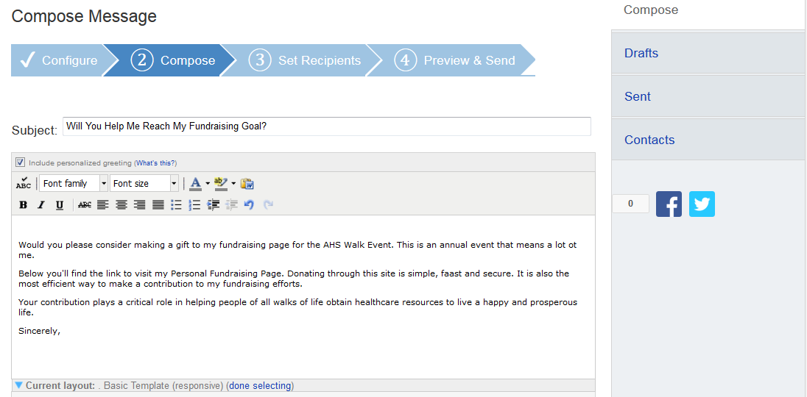**Remember to SAVE your message often to prevent losing your work in case your session times out from inactivity. (Click “Save Message In Your Drafts” to save your work, see below for “How to access your saved drafts.”)**

**-CONTINUE ON NEXT PAGE-**

Click **NEXT** if you are ready to **SEND** your email message and select recipients. 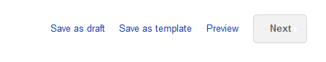

**How to Access Your Saved Drafts**

When you return to your Participant Center, click on the “Send an Email” tab and click **DRAFTS** to review your saved messages in draft status.

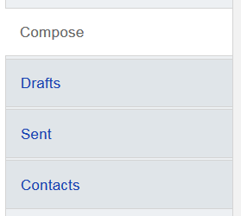

All of your **SAVED DRAFTS** will appear in a list by the date they are created. Click on the **SUBJECT** to continue editing and finishing sending a message.  
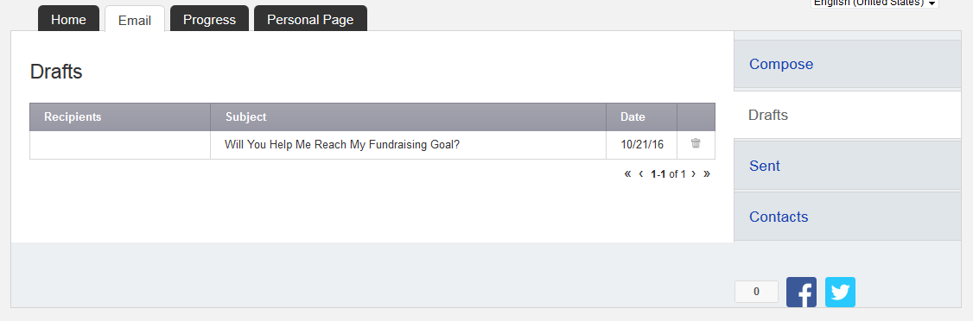**STEP 5- Select Recipients**Your available contacts will be available to select. If you want to add more contacts, you can import them from your Gmail or Yahoo accounts, or from a file upload for all other email service providers. (See our additional guide to complete this step, if needed)

**-CONTINUE ON NEXT PAGE-**

Otherwise, check the box next to the names of the recipients that you would like to receive your email message, and their names will show up in the **RECIPIENT LIST** on the right.  
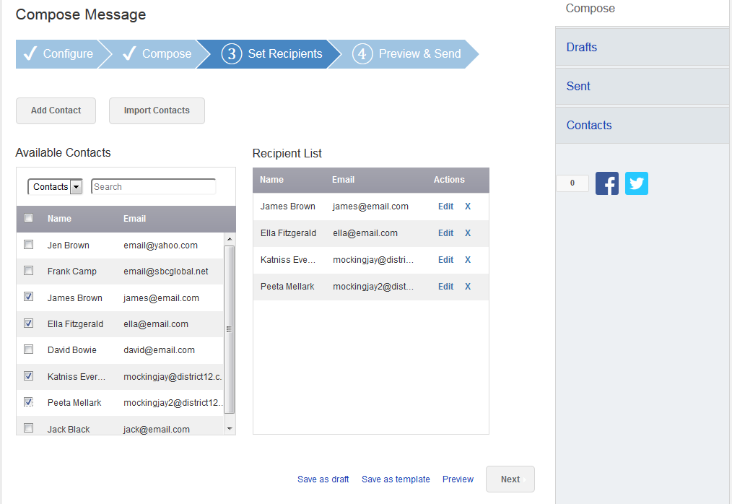 **Then, click the “Next” button.**

**-CONTINUE ON NEXT PAGE-**

**STEP 6- Final Preview**

You have a final opportunity to preview your message as it will appear to your email recipients. If you would like to make changes, click back on the **COMPOSE** step to make edits. Otherwise, click **SEND** at the bottom of the page to complete the email process and send your message.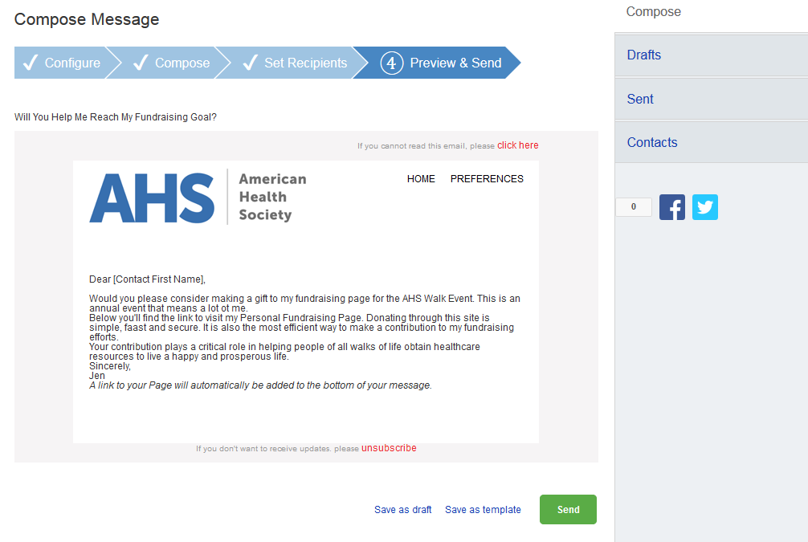If your message is one that you’d like to send frequently, you may want to create a **TEMPLATE**. A template provides you a starting point for your message so you don’t have to compose the entire message from scratch when you return to send another message.

**-CONTINUE ON NEXT PAGE-**

To create a **TEMPLATE**, click “Save message as a template” **BEFORE** you hit the SEND button.

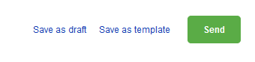

**Accessing your saved templates**

To access your SAVED TEMPLATES, click on SEND AN EMAIL. You will now see a section for YOUR SAVED EMAIL TEMPLATES. Select the appropriate template and complete the email creation steps as outlined above.

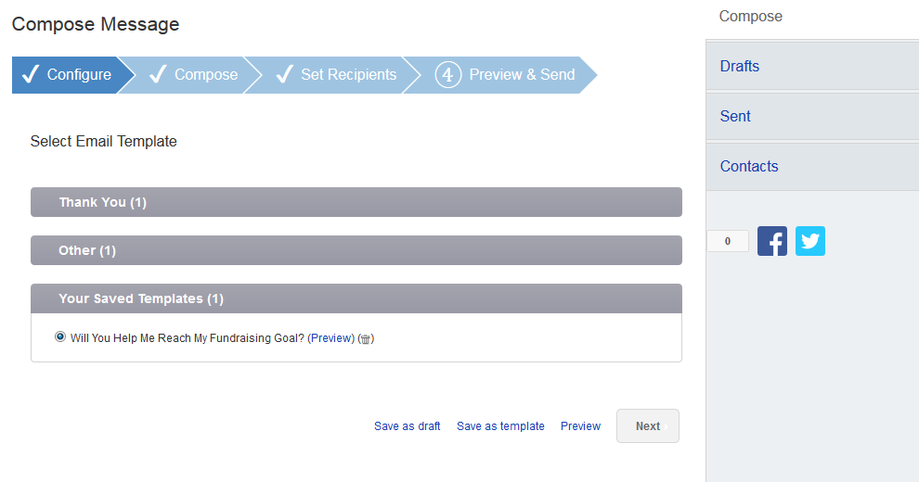

**-CONTINUE ON NEXT PAGE-**

**STEP 7- View Sent Messages**

Keep track of your sent email messages at any time. Just click the **EMAIL** tab and then the **SENT** tab on the right side of the page. All of your sent messages, along with recipients, and the date, will appear in a list.

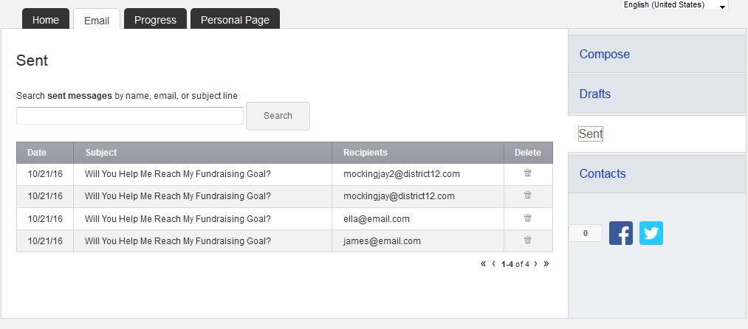

**Other Features-please see additional guides for instructions**

* **Add your contacts from Yahoo.**
* **Upload other email contacts via CSV file.**
* **How to Upload a Photo or Video**
* **How to Edit Personal/Team Fundraising Page Content**