**How to Upload a Photo or Video**

**Some things to consider:**

* Please be sure your photo is saved as a JPG, GIF, or PNG file type.
* Files must be smaller than 4 megabytes.
* Only YouTube video links are supported
* You may choose either a photo or a video link, but not both.
* You can add a different photo and video link on your Personal Fundraising Page, and if you’re a team captain, on your Team Fundraising Page.

**STEP 1- Login to your Participant Center**

**STEP 2- Click “Personal Page”** or **“Team Page”** depending on which page you want to edit. 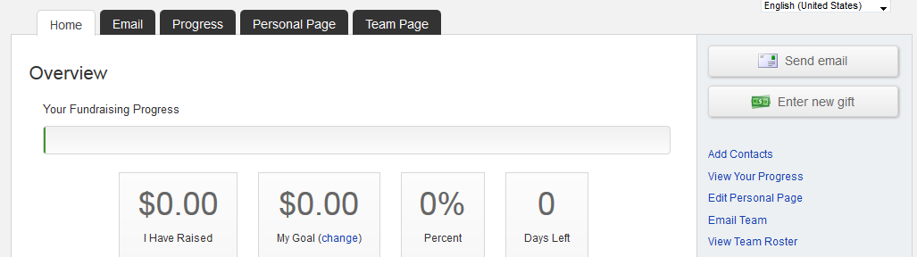

**STEP 3-On the links on the right, click “Photo/Video”** 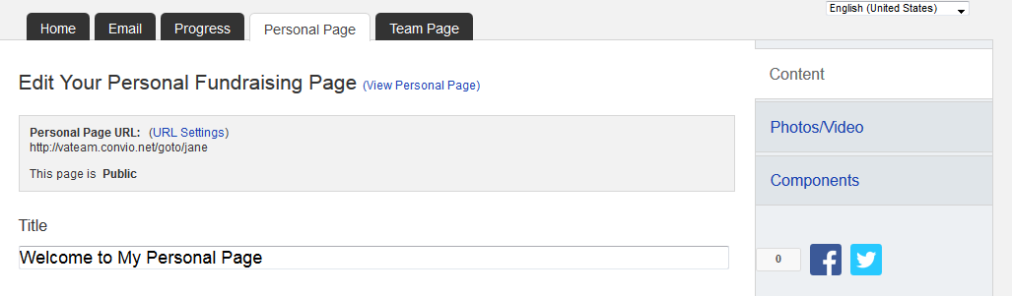

**-CONTINUE ON NEXT PAGE-**

**For a PHOTO**

1. Click the button next to **Photo.**
2. Click the **Browse** button.

Locate the file on your local computer or shared network resource and click it to display its name in the **Find/Open File** window.A green message saying, **“The Photo Information Was Updated”** will display across the top of the page if your photo successfully uploads.

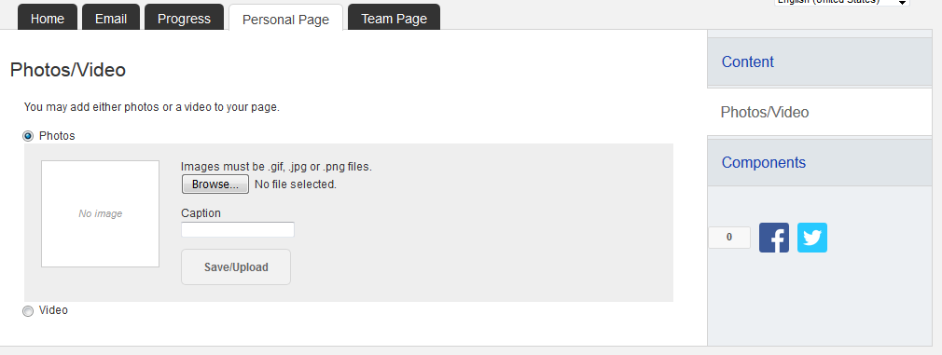  
If you wish to change the photo click the **Remove Photo** link in the **Photo** area. Then repeat the steps above.

**For a Video**

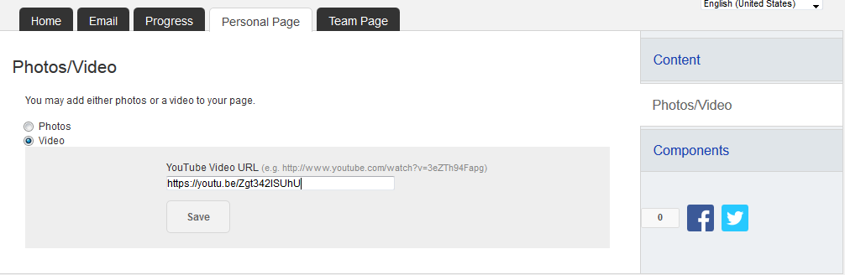

**-CONTINUE ON NEXT PAGE-**

**-CONTINUE ON NEXT PAGE-**

1. Click the button next to **Video.**
2. Enter a **YouTube website address** in the text entry field and click **“Save.”**

**STEP 4-Preview Your Changes**

1. Click the **“Personal Page”** tab at the top or click **“Content”**
2. Click **“View Personal Page”** or **“Preview”** to open a new tab (see red arrows in image on next page) with your Personal Page to review your changes on the site.

(If you are a team captain, follow the same steps for your Team Page if you made changes there.)

