**How to Edit Your Personal or Team Page Content**

**Things to consider:**

* Personal and Team Fundraising Pages have default content when you register for an event. However, we highly recommend that you personalize your page(s) to tell your own (or your team’s) story and why the event is important to you.
* Only team captains will have access to edit the Team Fundraising Page from their Participant Center.

**STEP 1- Login to your Participant Center**

**STEP 2- Click “Personal Page”** or **“Team Page”** depending on which page you want to edit (Remember if you are not a Team Captain, you will not see the Team Page tab. 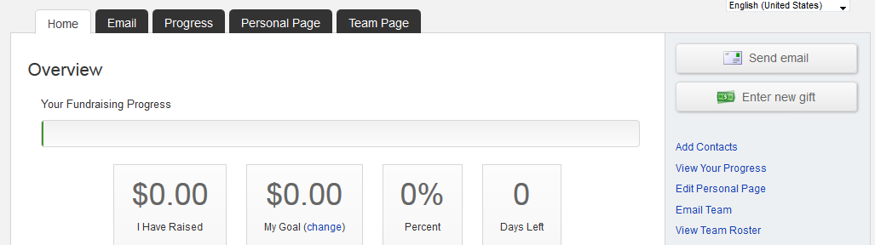

**-CONTINUE ON NEXT PAGE-**

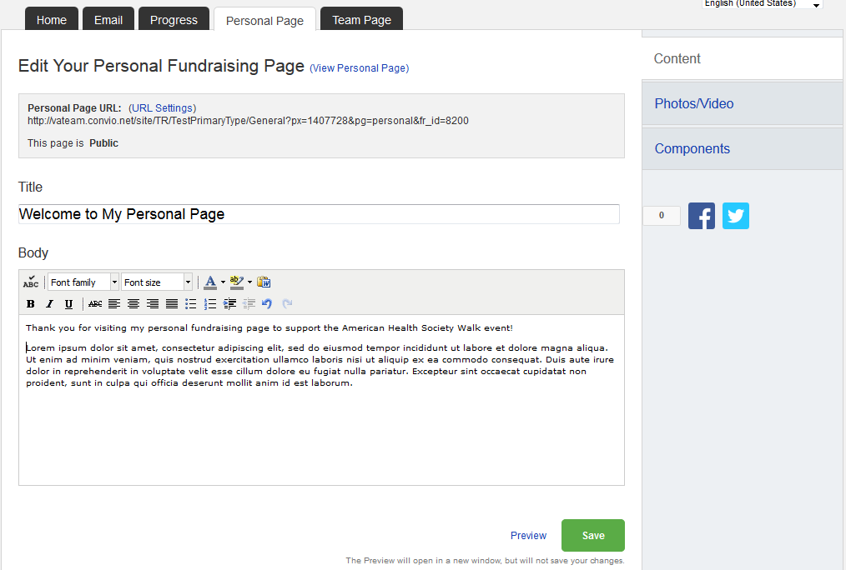**The Parts of the Page**

**6**

**3**

**4**

**2**

**1**

1. Click to preview your page in a new window.

**5**

1. Click to edit your web address to share with others.
2. Edit the heading/title of your page.
3. Edit your message/personal story that appears on the page.
4. Click “Preview” to view your edits in a new window. Click “Save to publish them and make them “live” on the website
5. Share your page link with friends on Facebook or Twitter

**-CONTINUE ON NEXT PAGE-**

**STEP 3-Edit your content**

You can edit the **TITLE** and **BODY** of your personal and/or team fundraising page content. Simply enter your text in the appropirate field.

**STEP 4-Preview and save your changes**

1. Click **“Personal Page”** or **“Preview”** to open a new tab (see red arrows below) with your Personal Page to review your changes on your site.
2. Click **PREVIEW** at the bottom of the page to view your edits in a new window. Click **SAVE** to publish those changes and make them “live” on the webpage for the public to view.

(Follow the same steps for your Team Page if you made changes there. Reminder:only Team Captains will see the link to “Team Page” in their Participant Centers.)

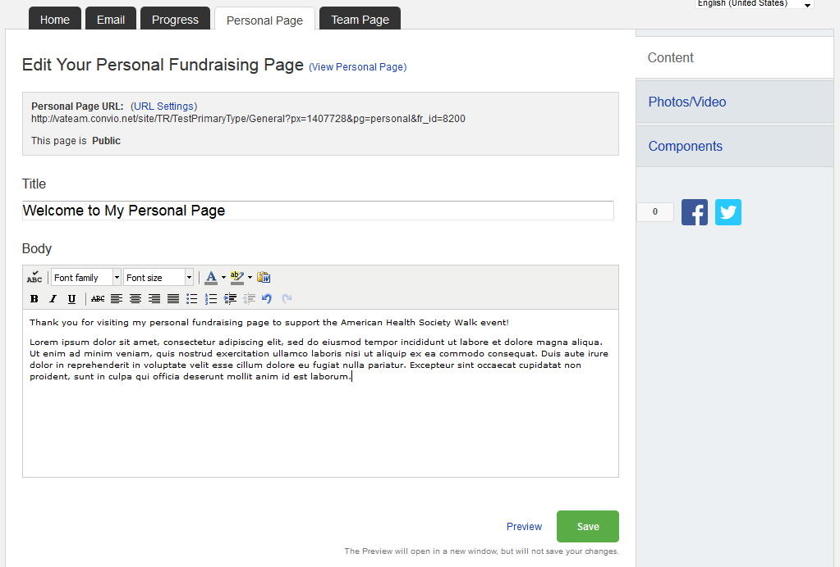

**-CONTINUE ON NEXT PAGE-**

**Other Features- please see additional guides for instructions**

* **Update your personal fundraising webpage address.** You can create a customized website address that is easier to share with family and friends via email and social networks.
* **Add a photo or video.** You can choose to add a photo or a video to your page to personalize your story more. **NOTE: You can pick either a photo or a video, but not both.**
* **Share on Facebook or Twitter.** Click the Facebook or Twitter icon to share your personal or team fundraising page directly with your family and friends on Facebook and Twitter.