**How to Access Participant Center Guide**

**What is the Participant Center?**

The Participant Center is the online portal where you can check your fundraising progress, send email solicitations and thank you’s, and update your Personal Fundraising Web Page.

On your Personal Fundraising Web Page, you can share your personal story, add a photo or a link to a YouTube video, and even add a blog. Then, you can share your webpage address with family and friends asking them to join you at the event or support your fundraising effort through a generous gift.

For our team captains, the Participant Center is a great place to send encouragement to your team members by emailing them reminder emails and best practices as the event date draws closer.

**Logging In From the Main Website**  
Step-1 Visit your event’s main website: [list website here]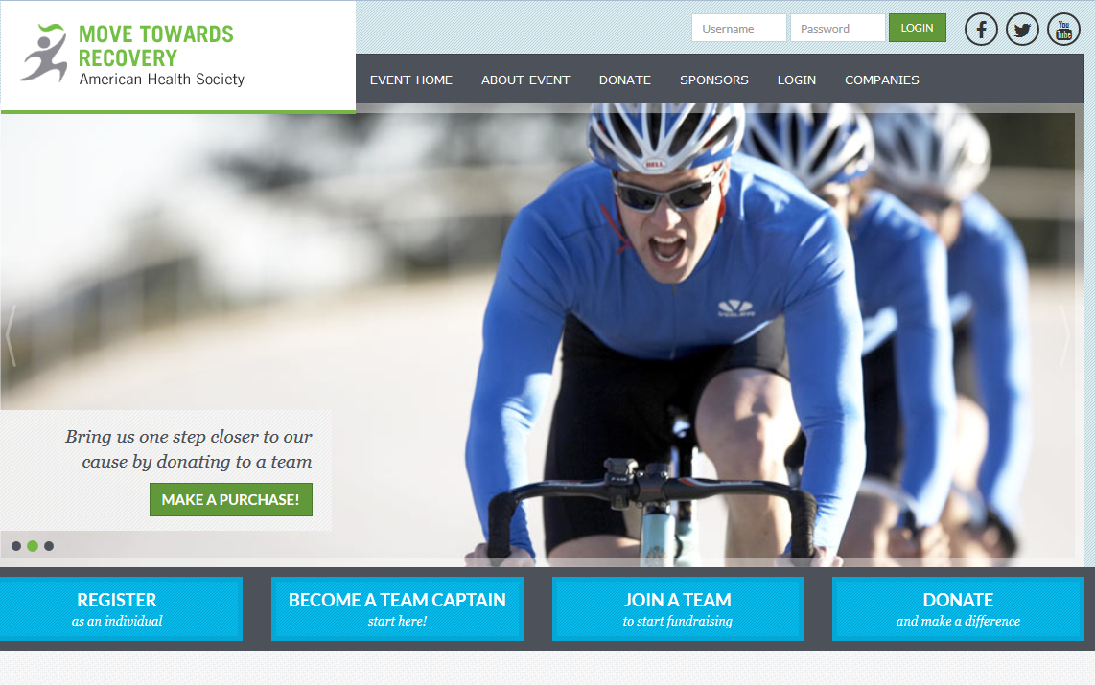

**-CONTINUE ON NEXT PAGE-**

**STEP 2-** Enter your username and password in the login area at the top of the page and tap enter on your keyboard.

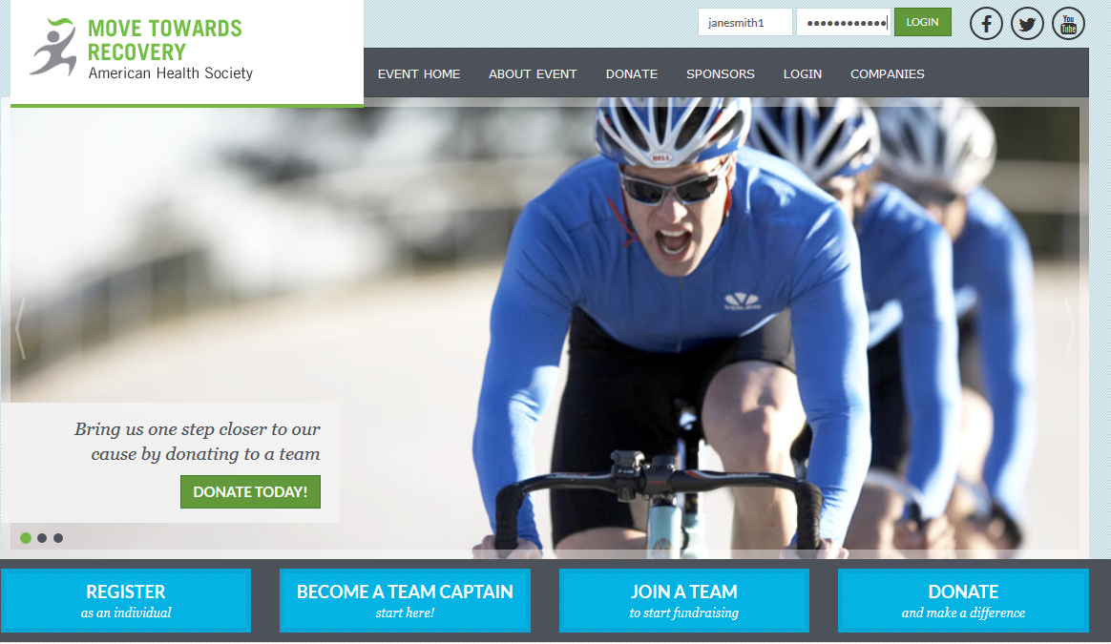

**STEP 3-** Once you login, you’ll see a welcome message at the top. Then, click “Participant Center.”



**-CONTINUE ON NEXT PAGE-**

**STEP 4**-Viola! Your Participant Center will open and you can begin to access its features.

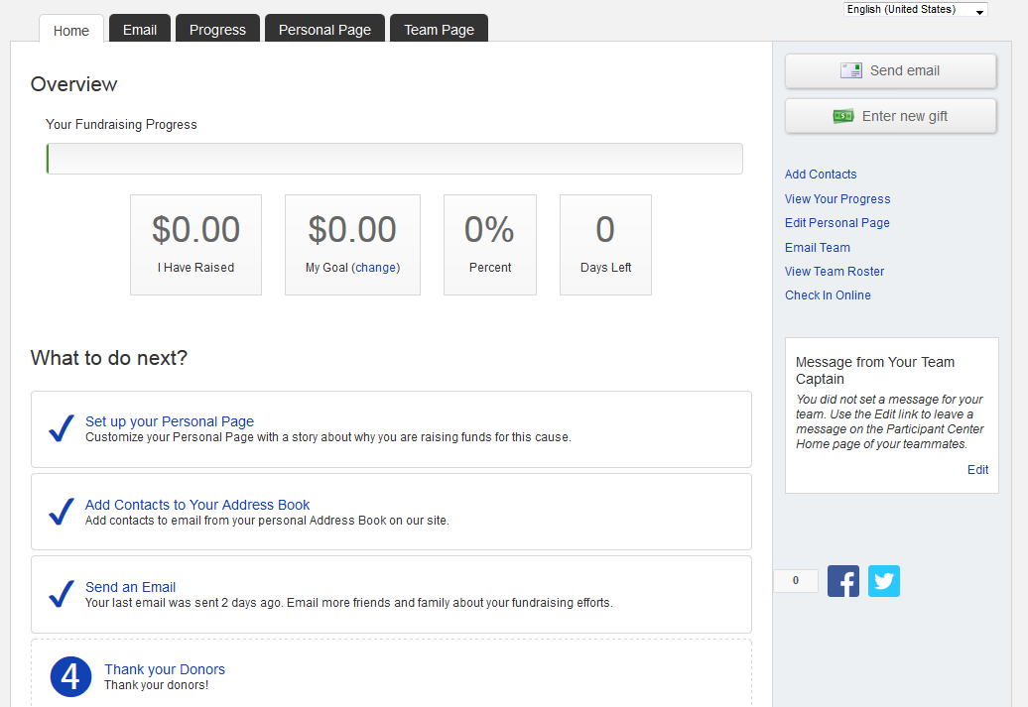

**Please see additional guides for instructions**

* **How to Upload a Photo or a Video to your Personal Page**
* **How to Edit Personal/Team Fundraising Page Content**
* **How to Edit Your Unique Web Address**
* **Add your contacts from Yahoo.  
  or**
* **Upload other email contacts via CSV file.**