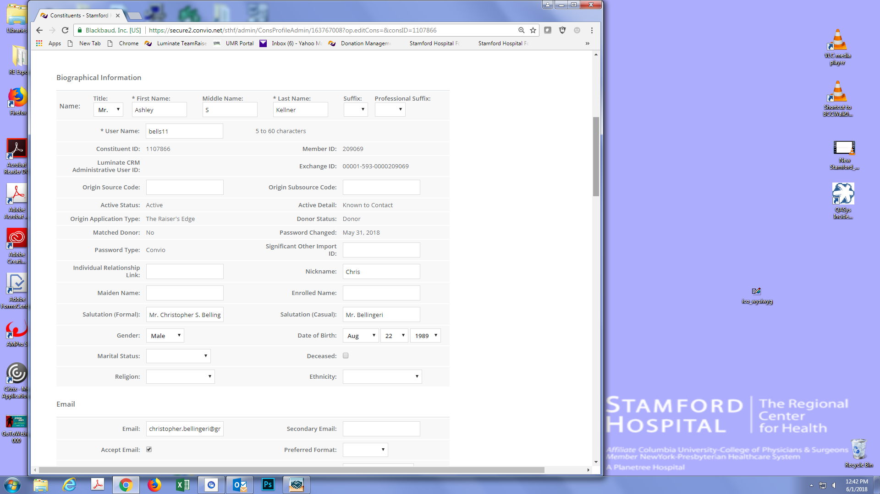

Record copied over. No duplicate email.

