**Fundraiser > Prospects and Plans (**part 1 of this now very wide list, recently added phone, city, state, zip**)**

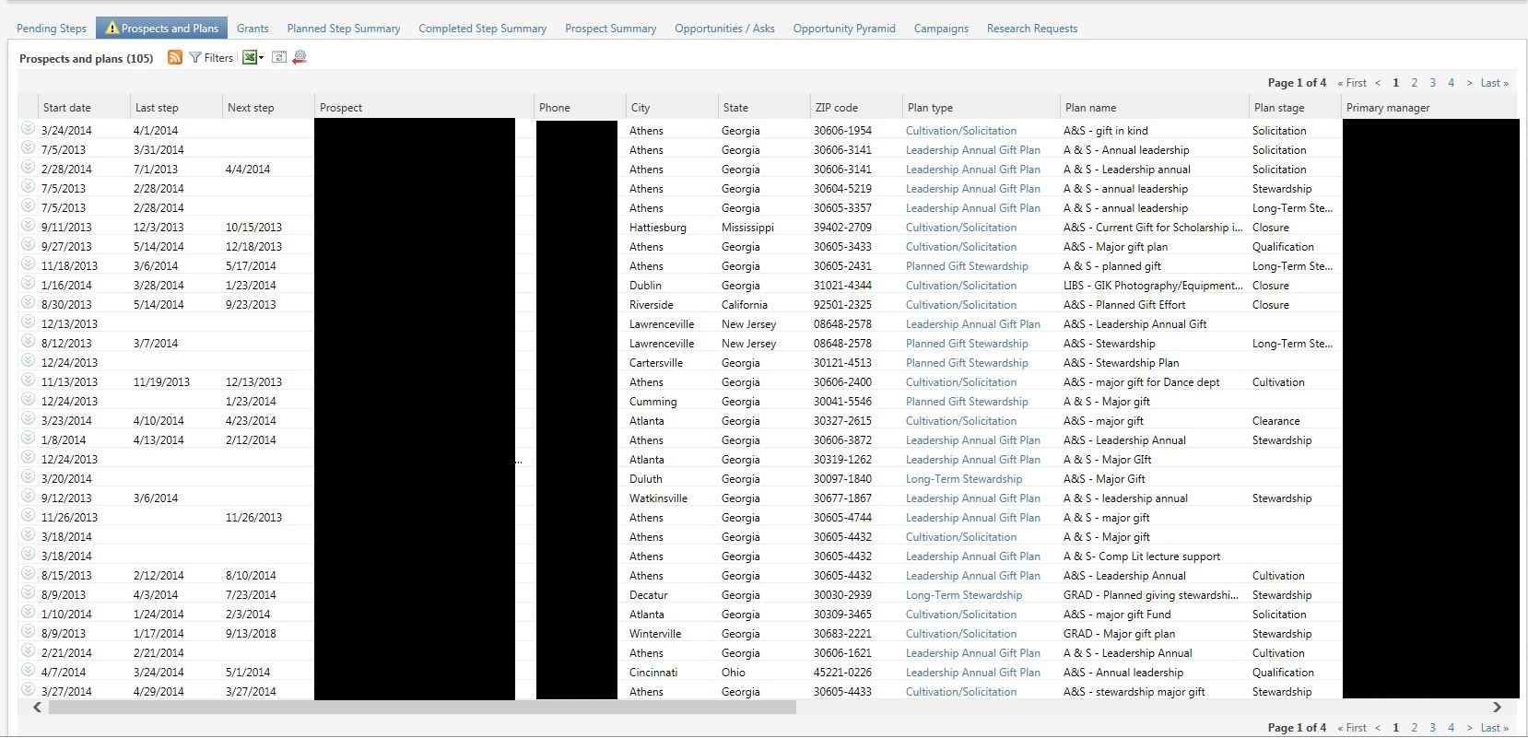

**Fundraiser > Prospects and Plans (**part 2 of this now very wide list – solicitors show as a semicolon delimited list, where appropriate**)**

