Convio Social Media – Facebook Service Module

Client: [your organization’s full name]
Client Convio Short Name: [your Convio short name]
Facebook page URL (if you have one already): [URL to Facebook Fan page]
HOW TO SUBMIT GUIDES TO CONVIO
- Fill out the guide for your specific project completely and save on your desktop.
- Prepare an email and attach the guide and all resized images as gif or jpg files.
- Your subject line should contain your organization’s Convio short name, a short description of your submission, and your content submission date. For example: “AHS – EOY FUNDRAISING – 11/07/2010” or “AHS – JULY ENEWS – 07/07/2010”.
- Send email to ServiceModules@convio.com.

You will receive a confirmation of your submission within one business day. If you do not receive a confirmation, please check in with us.

If you submit your content multiple times prior to a deadline, all but your most recent submission will be ignored.

Please note that if you miss your submission deadline, submit an incomplete guide, or if the subject line of your email submission is not clear, production of your campaign could be delayed or canceled.
Please allow 5-10 business days from the date of your submission for Convio staff to process, build, and test your campaign based on the content you provide.
OBJECTIVE/OVERVIEW
Social media offers numerous ways for nonprofits to listen and learn from online constituencies, as well as leverage marketing, advocacy and fundraising programs and opportunities to support their respective missions. By strategically focusing on key organization attributes and goals, nonprofits can more effectively harness social media to achieve pre-defined goals, as well as prove the return on investment in using these emerging tools.

Reasons for a Facebook Program
- Social Media, Facebook in particular, is growing in importance and scale with your constituents
- Facebook is increasingly being used as a channel for relationship building with nonprofits and a portal to take actions
- With new Convio integration, raising funds and taking action is now easier for constituents and more efficient on the Facebook platform

Why Focus on Facebook?
- More than 500 million active users and growing
- 50% of their active users log on to Facebook in any given day
- The average user spends 1 hr per day on Facebook
- …becomes fan of 4 pages a month.
- …joins 13 groups per month.
- …likes 9 pieces of content per month.
- …has 130 friends.

Facebook Benefits for Nonprofits

- Drive website traffic
- Reinforce campaigns to raise funds, build list
- Provide helpful information to supporters in real time
- Peer-to-peer sharing of brand, campaigns, information
- Engage supporters to become involved, build preference
- Drive participation, registration for events
- Create online discussion threads to learn from/engage with constituents

Key To Reaching All Demographics
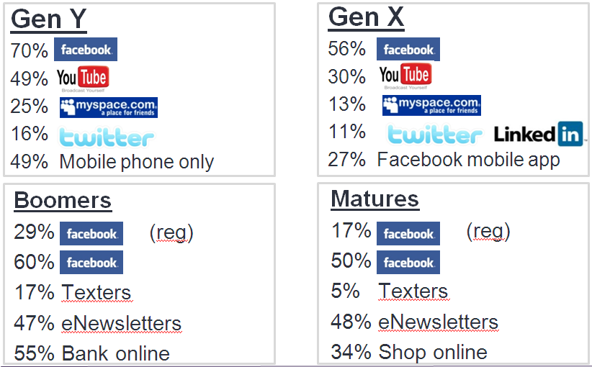

An Appropriate Solicitation Channel
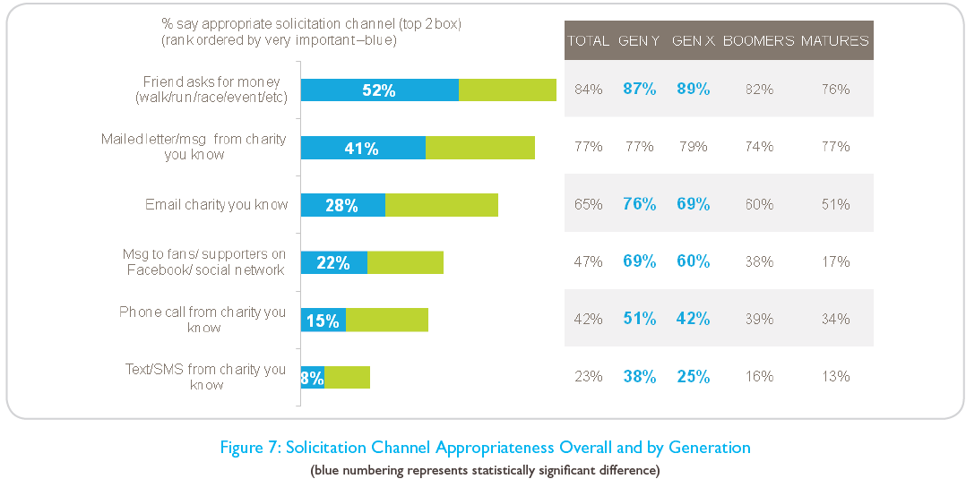

During this program we will be developing a complete Facebook presence that integrates with your Convio Online Marketing instance to drive awareness, housefile growth and donations. To do this we’ll be creating a Facebook Welcome Tab, eNewsletter or Pledge signup form tab, and finally a Donate tab which will allow constituents to make a donation that is processed through COM without leaving Facebook. See below for screenshot examples of each of these items:

Welcome Tab – When Facebook users first goes to your page this will be the first tab they see which will welcome them and help encourage different actions items to get them started.

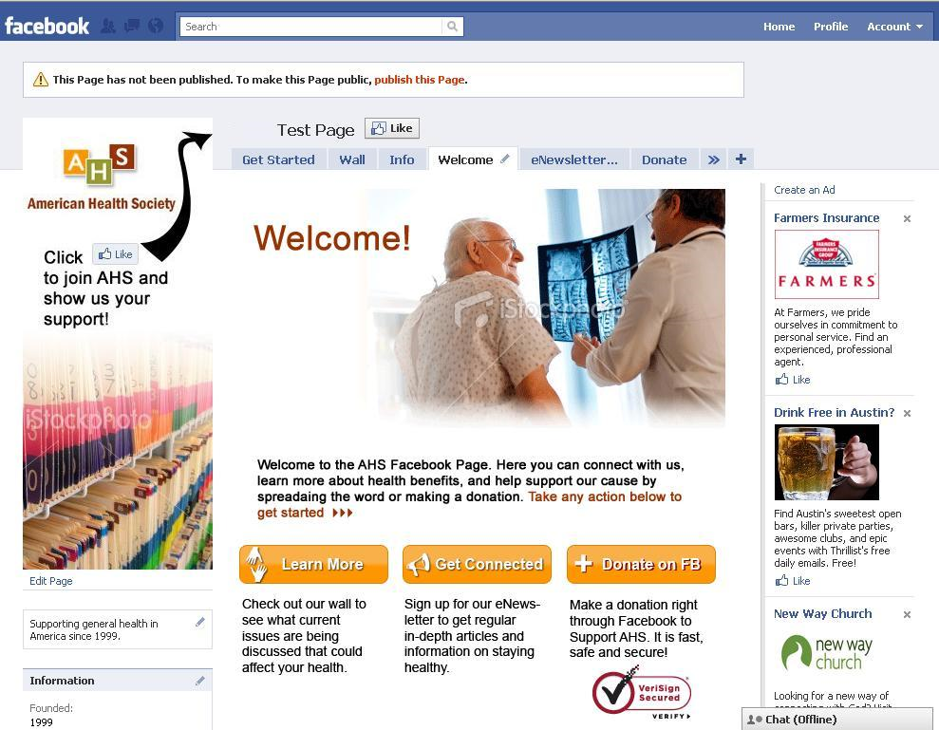

Donate Tab – This tab will have a donation form embedded in it which uses the Convio Donation API to process the donation through Convio. This allows you to report on the form as you would any other donation form in Convio.

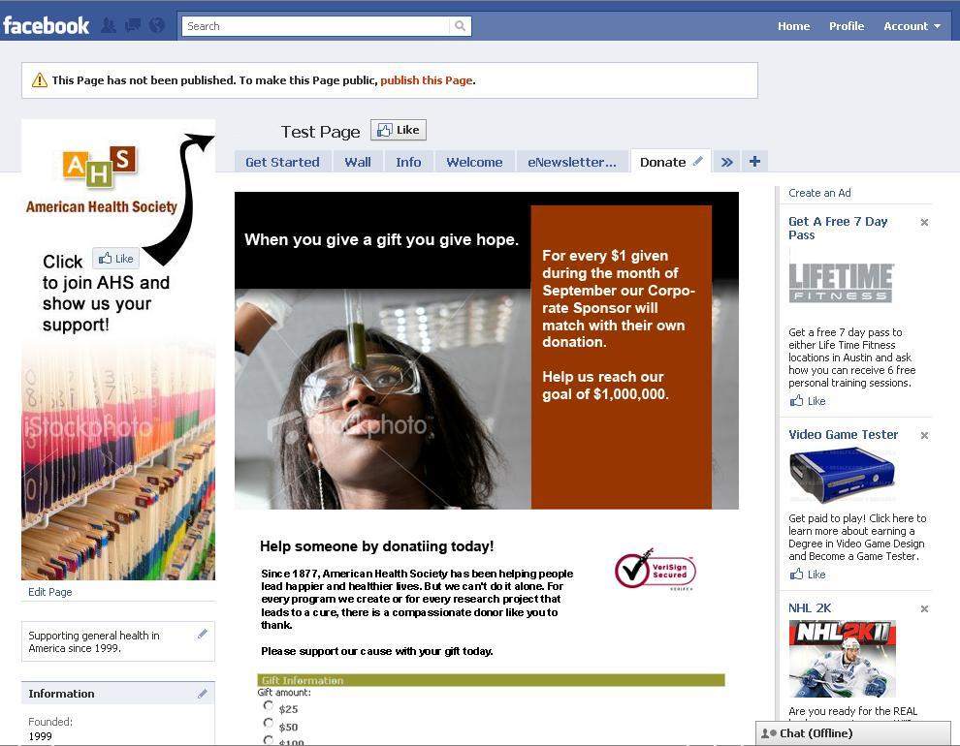

eNews Signup Tab – This tab will use an embedded Convio Survey to capture email addresses of those who are interested in receiving more information about your organization.

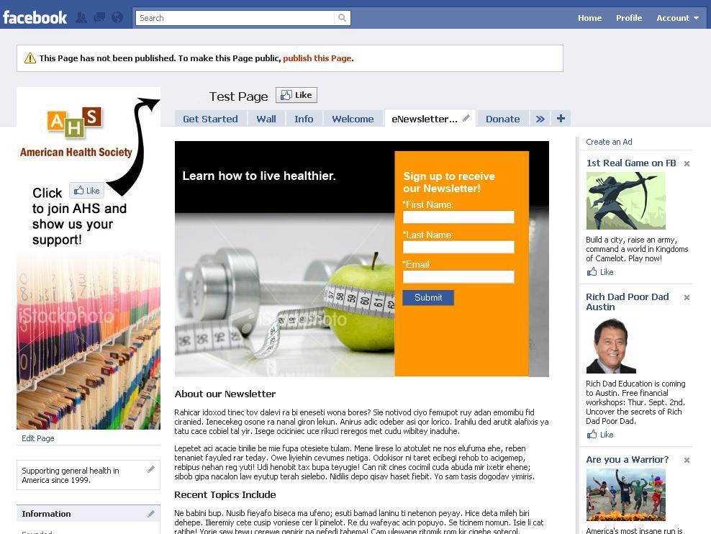

FACEBOOK PAGE CONFIGURATION – New Facebook Page (No need to fill out if you have an existing page):
Page Name (examples: http://www.facebook.com/greenpeaceusa, http://www.facebook.com/aspca). NOTE: HIS CANNOT BE CHANGED ONCE PAGE IS MADE. Please enter page name here:

[Insert Page name]
Read the Terms of Use (http://www.facebook.com/terms.php): You will have to agree to the terms of use for Facebook to continue with the page creation.

Do you agree with the terms of use and permit Convio to create an Official Facebook Page on your behalf?
[Yes, I have read and understand the terms of use, please create a Page for me./No, I have changed my mind and would like to not proceed with creating a Facebook page]
Year Organization was founded: [Year]
Organization’s main website URL: [Full website URL]
Organization’s mission: Please provide a short paragraph about your organization’s mission. This will go on the required “Info” tab on your Page.

[Mission paragraph]
GENERAL CONFIGURATION
Convio API Key Setup

NOTE: By providing a key to enable and begin using the Convio API Materials, You accept the terms of The Convio API License Agreement available at http://customer.convio.com/ConvioAPILicense. If You do not agree to The Convio API License Agreement, you won’t receive the Donation Form portion of this program.

Have you read and agree to the terms of the Convio API License Agreement? [Yes/No]
Specify Site-wide API Key (optional) - This key is an arbitrary value that must be passed when invoking Convio APIs, either from a server script or web form. This is not a secure password and it may be included in a hidden field of a web form, but it may impede certain types of spambots. You can enter any value for this key.

[Insert desired API Key, if you leave this blank Convio will generate one for you.]
Organization Logo
Provide a logo that will be used in the design of your page elements.

Requirements: Logo should be at least 200px wide by 125px tall.
Welcome page Image
Provide a logo that will be used at the top of your Welcome page.

Requirements: Logo should be at least 520px wide by 235px tall.
Survey page Image
Provide a logo that will be used at the top of your eNews Signup page.

Requirements: Logo should be at least 520px wide by 235px tall.
Donate page Image
Provide a logo that will be used at the top of your Donate page.

Requirements: Logo should be at least 520px wide by 235px tall.
Left Column Image
Provide a logo that will be used in the left column below your organization’s logo.

Requirements: Logo should be at least 200px wide by 275px tall.
Welcome Tab
The copy on this page should do 2 things: Welcome the visitor to the page and then promote their next actionable step.

The offers are designed to vary in engagement in order to allow very new users to get an introduction to the organization and topics being discussed by reading the wall or participating in one of the discussion questions. This is a very low investment of engagement. The second ask is to sign up to learn more in depth information (building upon what was being discussed in the first ask) by subscribing to the eNewsletter through its associated tab. Then finally for those who want to jump straight to donating we have an easily found donate ask step.
Welcome paragraph copy changes (Optional) – Make any changes to the welcome page copy below.
Default:

Welcome!

Welcome to the [Org name] Facebook Page. Here you can connect with us, learn more about [cause], and help support our cause by spreading the word or making a donation. Take any action below to get started >>>

Learn More | Get Connected | Donate on FB
Check out our wall to see what current issues are being discussed that could affect [cause]. | Sign up for our monthly eNewsletter to get regular in-depth articles and information on [cause] and how you can help. | Make a donation right through Facebook to support [Org]. It is fast, safe and secure. Donate today!

eNewsletter Signup Tab
eNews Signup Interest - If you already have an interest and/or group that you specifically target for your regular eNewsletter communications please specify it here. Users who take the signup survey will automatically be placed in this group to receive communications going forward.

[Insert Newsletter Interest name]
[Insert Newsletter Group name]
eNews Signup Header Tag-Line – This is a short sentence or phrase that catches the eye and ear and helps motivate people to sign up today. Should be less than 10 words and use active voice to promote immediate action.
[Insert tag line] ex: Learn how to live healthier!
Newsletter signup information paragraph – This will be a paragraph describing the Newsletter and general communication a user will expect to receive if they fill out their information. Please emphasis on the value of the communication to the end user and how often they can expect that information to arrive such as “monthly newsletter” or “quarterly bulletin”.
Default text –

By submitting the form above you will start to receive our monthly newsletter which will help you learn more about our cause and the impact we are having because of constituents such as yourself. Sign up today and start making a difference by learning more about the great work we do!
Donate Signup Tab
Donation Form

For this program the donation form will be using the following fields:
- 3 Standard Donation Levels
- 1 User Entered Amount Donation Level
- Billing Title
- Billing First Name
- Billing Last Name
- Billing Address 1
- Billing Address 2
- Billing City
- Billing State/Province
- Billing ZIP/Postal Code
- Billing Country
- Email Address
- Email Opt-In
- Payment Type
- Buttons

As you can see, this is a simple one-time gift form with no bells and whistles. If you wish to modify this template after the program you can do so and expend the functionality to include monthly giving options or perhaps designated or memorial giving. If you feel this is not something you want to do on your own then talk with your Account Manager about getting some help with the implementation.

Donate Header Tag Line – This is a short sentence or phrase that catches the eye and ear and helps motivate people to donate today. Should be less than 10 words and use active voice to promote immediate action.
[Insert tag line] ex: When you give a gift, you give hope.
Donate Call-out Information – This information appears in the right color-bar column of the header image and is meant to display short pieces of information that help increase chances of conversion to donation.

Examples:
- Every $1 you donate buys 5 blankets for those in need.
- All donations are matched by our corporate sponsor so your gift is doubled.
- Donating today will help the XXXXX relief effort that is happening right now.
- Give today and receive a free XXXX with every donation over $10.
[Insert any call-out information for use in header]
Donation Form Information
Donation Campaign – For each donation API form created there is a shadow regular donation form that lives in the Donations module. Please specify under which campaign you want this donation form to live:

[Insert name of campaign]
Giving Levels. Can alter amounts as necessary but they have to be single donation gifts (non reoccurring):
Default –
$25
$50
$100
User Entered Amount
Autoresponder Information – It is highly recommended that you copy this information from a donation form you already use and paste it below to save time.
Autoresponder Sender Address: [your organization’s general email address]
(HINT: Constituent replies and out-of-office notifications go here, so a general NPO address is preferred)
Autoresponder Sender Name: [your Executive Director, CEO, or just the name of your organization]
(HINT: Your sender should be generic or the same name as the signature.)
Autoresponder Subject Line - Requirements – 60 Characters or less (approximately 10 words) - [enter your subject line here – 55 Characters or less]
Autoresponder Stationary: [Name of pre-existing stationary to use for donation autoresponder]
Autoresponder Copy:

[Copy thanking clients for their donation.]

