Reporting on Email Providers for an Email Campaign

The following steps outline how deliverability to specific email providers can be monitored by using query generated groups and the standard email campaign report: “Group Performance Report.” This process will allow organizations to monitor spikes in hard and soft bounce rates from specific email providers. When significant changes in email deliverability are discovered promptly, you may be able to more quickly indentify and resolve the root cause of the issue.

Create Groups

The first step is to create query generated groups that will populate based on the domain of the email addresses that you wish to monitor. Groups may be added for each of the providers that have significant number of constituents or that have historically proven to have delivery issues.

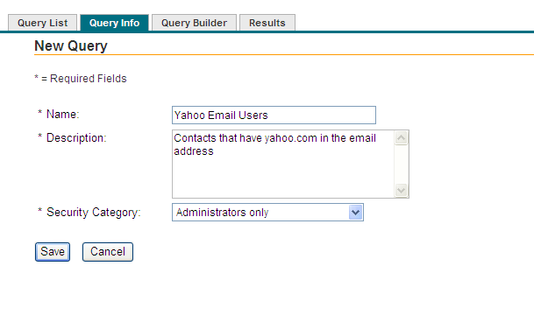
After saving the name, description, and security category for the query, enter the details for the criteria that will be used to identify constituents with a specific domain in their email addresses.

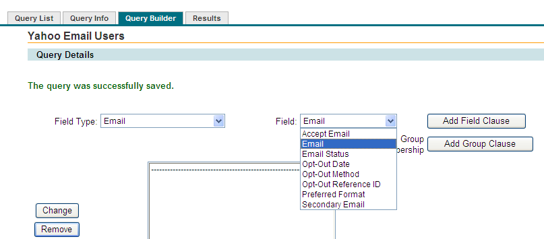

In the following example, the query will select any contact that has an email address containing the Yahoo.com domain.
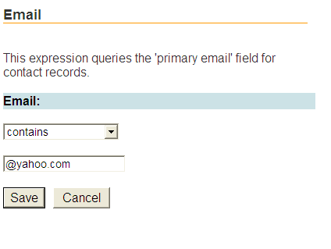

For some email providers, you may also want to enter other variations of the domain that they assign to email addresses. For example, Microsoft email addresses may include: msn.com and hotmail.com.

After the criteria has been saved, save the query and click on Run Query:

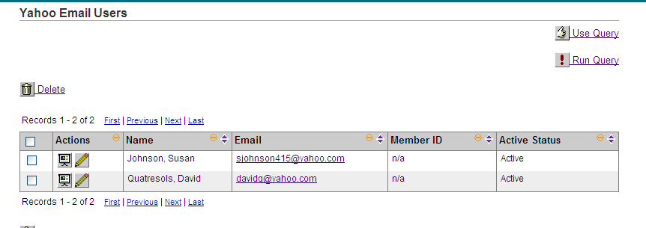

When the results of the query have been generated, you can use the query to create a group for the constituents. Click on the “Use Query” link and select: “Create a Group.”

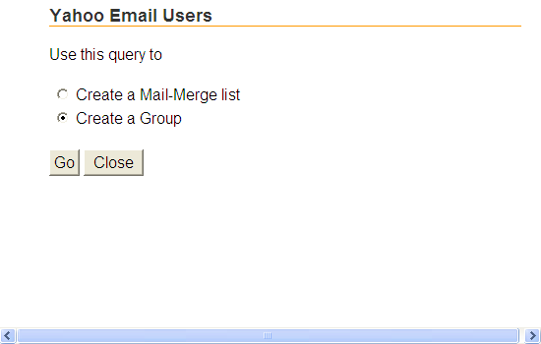

Options for the name of the new group, security category, type grouping, and rebuild options will be displayed. You may find it helpful when selecting the groups later to group together all of the declared email providers in a specific group type.
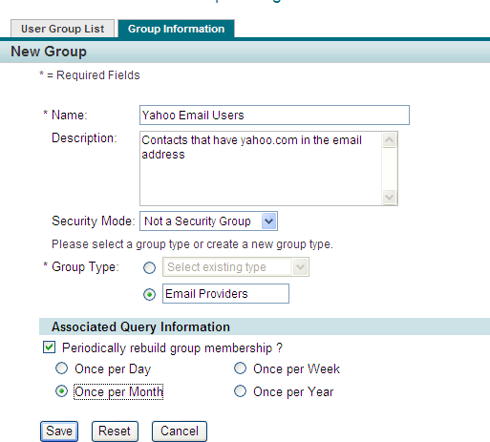

It is not necessary to rebuild the group on a daily basis since the group will be used only to monitor trends in email provider domains.

Repeat this process for each group of email providers that you wish to monitor.

Running Reports

The “Group Performance Report” for Email Campaigns will be found on the Reports tab when viewing a specific email campaign.
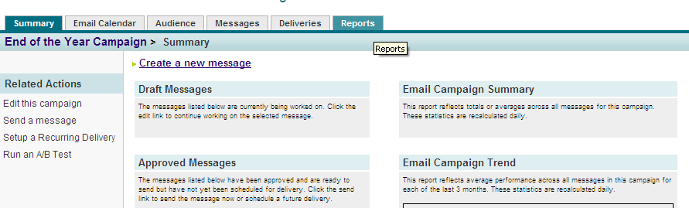

Select the Group Performance Report from the drop down box on the reports screen.

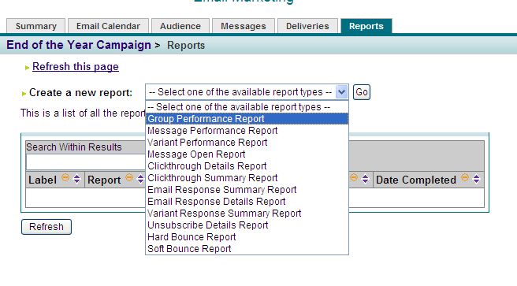
Select the Groups which you wish to review for email deliverability performance.

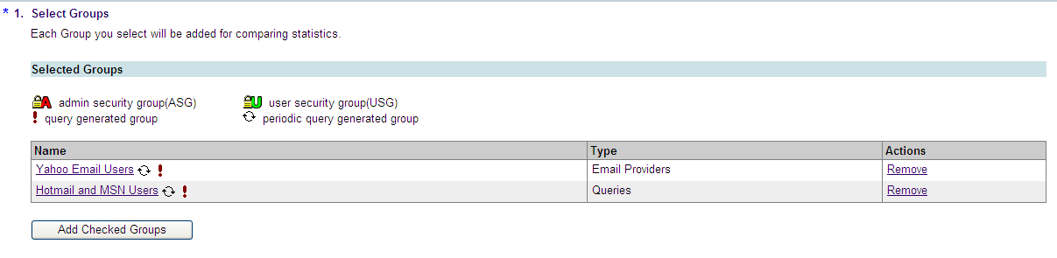

Save the selected groups.

Select the specific message which you wish to run the Group Performance Report on.

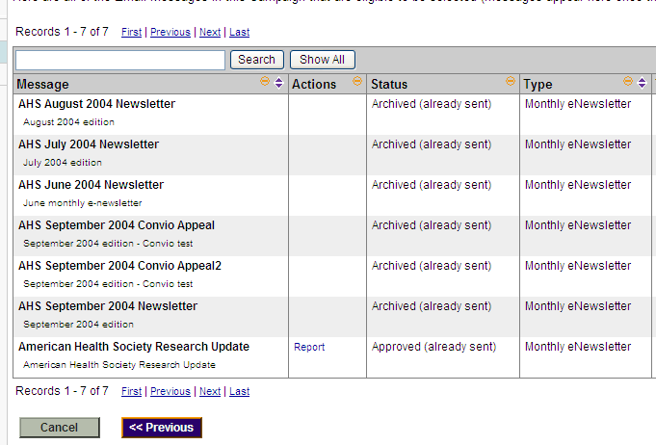

The report results will look similar to the following but listing each of the email provider groups that were built and selected for the report.

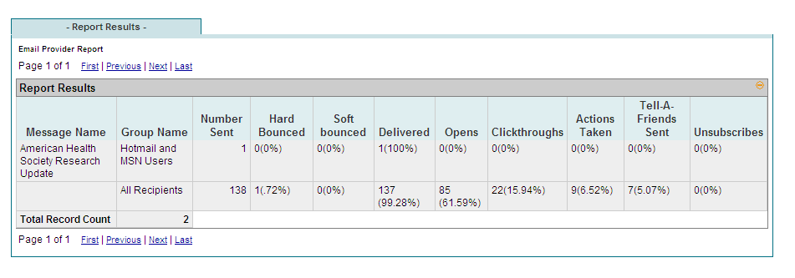
In particular, pay attention to the Hard Bounce, Soft Bounce, Delivered, and Open rates. These will be the strongest indicators of email deliverability success or issues. Compare the results of current message campaigns to historical rates to understand broader trends and changes.

