Configuring a Basic Welcome Series Campaign

Creating a basic welcome series email campaign can be the first step in developing appropriate engagement pathways for your organization. The complexity and types of welcome series you design will depend on the size of your organization, mission, types of constituents, and the content and registration methods available throughout your web presence. The purpose of this document is to outline the basic steps to configure a simple welcome series. As you learn more about the new constituents registering on your site the complexity of your engagement channels will also develop to more appropriately address specific interests.

An overview of the steps we will be taking to configure this welcome series:
- Identify the groups who will be receiving and who will be excluded from the messages.
- Develop the Email Campaign and messages which will be sent to the groups identified in Step 1.
- Test and Schedule the recurring delivery of the messages.

Step 1: Indentify the Groups
The most obvious criteria for people receiving a welcome message include newly registered constituents on your site. These can be identified based on the Creation Time of the constituent record. However there are some other fields that you might want to consider when creating a query to identify this group:

Accepts Email | This is the constituent facing preference if they would like to receive email. Though these will automatically be excluded, including this condition may help the message send more promptly at the scheduled time.
Email Status | Values include: Good, Unknown, Bad (Hard Bounce), Bad (Soft Bounce). Like Accepts Email, though these will automatically be excluded, including this condition for the group may help the message send more promptly at the scheduled time.
Active Status | Active vs. Inactive – All newly registered constituents should be active, but including this in the criteria for the group may help the message send more promptly at the scheduled time.
Origin Code | Indicates where the constituent record came from. Example values include: Advocacy Alert, Donation, Event Registration, Administrator Registration, etc.  More sophisticated welcome series may consider the origin code of the constituent and customize the series messaging based on how they were entered into the system.

For the purpose of this overview, we are going to keep the illustration simple and assume that all newly registered contacts will receive the same welcome series. They will receive one message within a week of registering on the site and a second message one week later. There will be two groups created to support this messaging.

Welcome Series Newly Registered (Week 1)
In the following example, the query will select any contact that has been created in the system in the last 7 days, has a good email address, has indicated that they wish to receive email, and who is active:

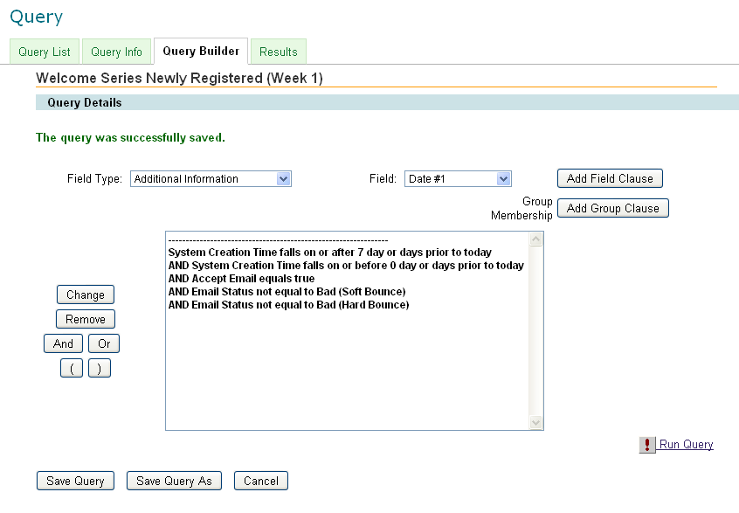

Save the query and then run the query. You can then use the query to create a Group. It is not necessary to “Periodically Rebuild the Group Membership” because the group will be rebuilt when the email message is scheduled to send. Do not check this box on the Group screen:
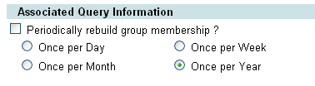

Welcome Series Newly Registered (Week 2)
The second query and group will be similar to the first but will include a different date range:
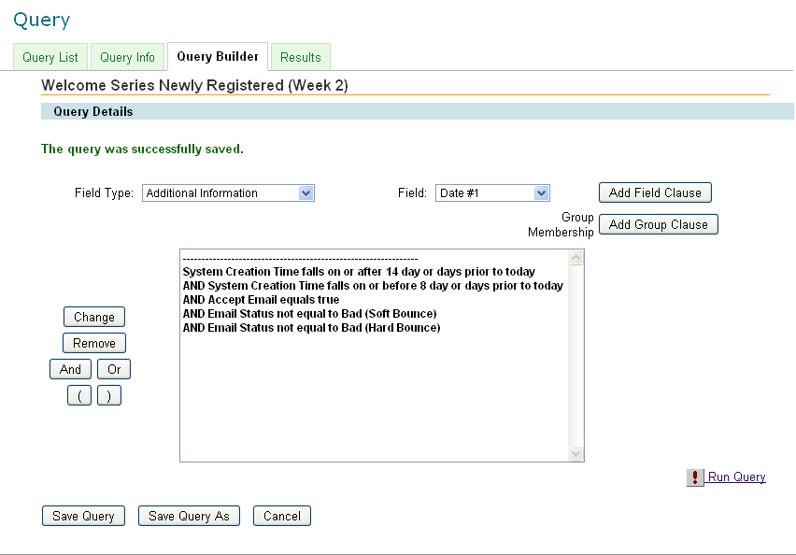

There may be other criteria that are added to the queries as you develop your engagement pathways, for example:
- Exclude contacts who have made a donation in the last 14 days (Last Transaction Date)
- Exclude contacts who have made a donation over a certain amount (Last Transaction Amount)
- Create separate messaging for those who have logged in vs those who have not (Last Login Time)
- If you have a data sync, exclude new online registrations who also have an offline record. This can generally be accomplished by excluding anyone with a Member ID (offline ID number) because this would only be added where the online contact has been matched with an offline record.
- Also consider excluding the contacts from other email appeals that may be sent while they are receiving messages in the welcome series. This can be accomplished by adding the groups that are being created for the welcome series to the “Do Not Mail List” for other Email Campaigns.

These are additional considerations that are beyond the scope of this overview.

Like the first query, the second query is used to create a group which will be used as the target group for the second message that will be sent.

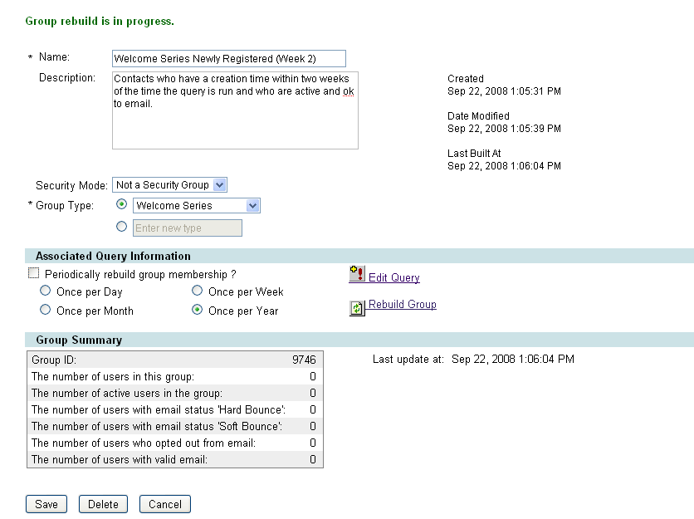

Step 2: Develop the Email Campaign and Messages
It is a good idea to create a separate Email Campaign for the welcome series so you can run reports that focus on the response rates and interactions generated for the messages in the series. There are three steps to create the Campaign:
- Give the Campaign a Name and Description
- Interest Opt-In / Opt-Out – You may not need to associate the welcome series with an Interest since the number of messages associated with the campaign is limited to the introduction to the organization. If you have an extended welcome series, you may choose to associate the welcome series with a newsletter or specific series to give the person an option to opt-out of the series without dropping out of all mailings.
- Set Optional Features – Do not enable web viewing and enable AutoLogin links.

Manage the Campaign and create the new Messages
After you have created the Campaign, click on messages to Create a New Message. Follow the 8 steps in the Process Navigator to create the message.

Step 1: Add the Message Information
The message name, information, and type will help you identify this message in the Campaign later.
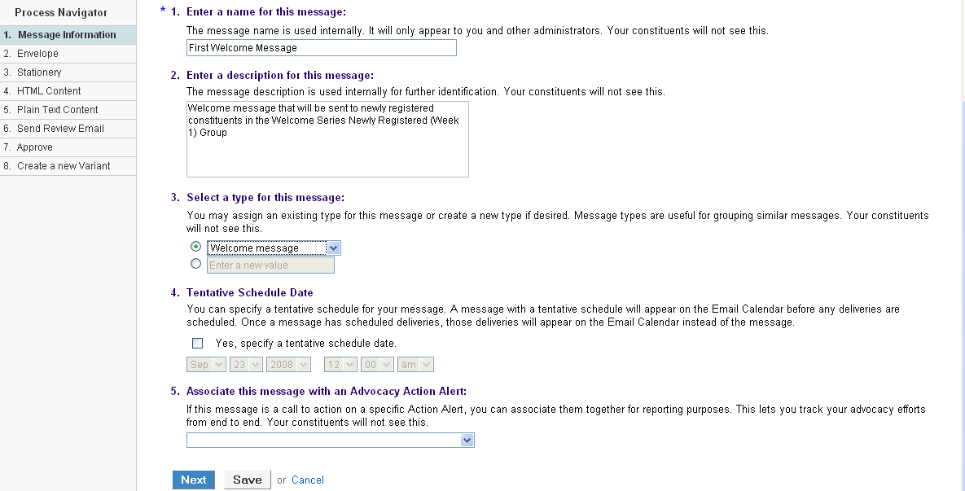

Step 2: Configure the Envelope Information
The name used on the message should be recognizable to newcomers being introduced to your organization. Consider the content of this first message when determining the sender’s name, email address, and subject.

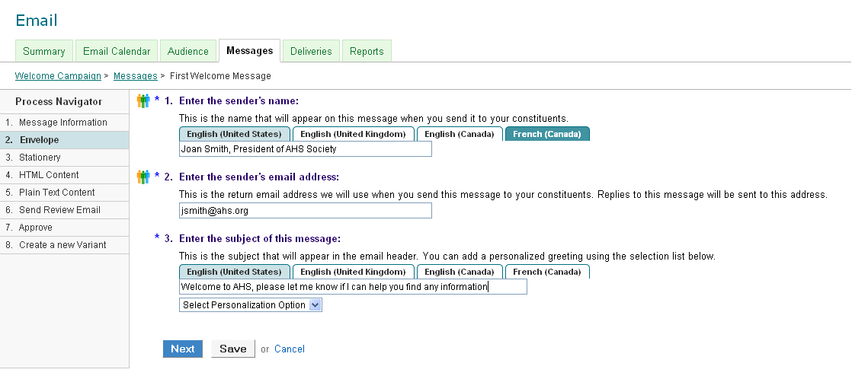
Step 3: Select Your Stationary
Your stationary should be consistent with the brand that the newly registered constituent has already been introduced to through their initial interactions with your website and organization.

Step 4 and 5: Write and design the message HTML content and update plain text
Designing the message layout and content is completed just as designing other email messages in Convio. See detailed resources in Convio help or training resources for more information.

Step 6: Run the Spam Check report and Send Review Emails

Step 7: Approve the Message
Approve the message but do not configure the delivery. This will be completed using the Recurring Delivery options in the message list.

Set up the Recurring Delivery
After the message has been approved, it is ready to be configured as a recurring delivery. In the message list, click on this Related Action:

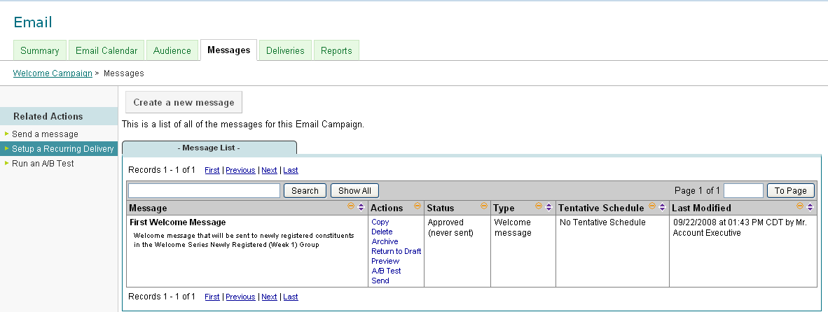

Schedule the recurring delivery according to the frequency that you would like to send the message to newly registered constituents. Generally it’s a good idea to schedule the message to be sent every day but keep in mind that if you have no new registrations the delivery may not find any contacts that qualify. Also remember that each message will only be sent once to each registered contact.

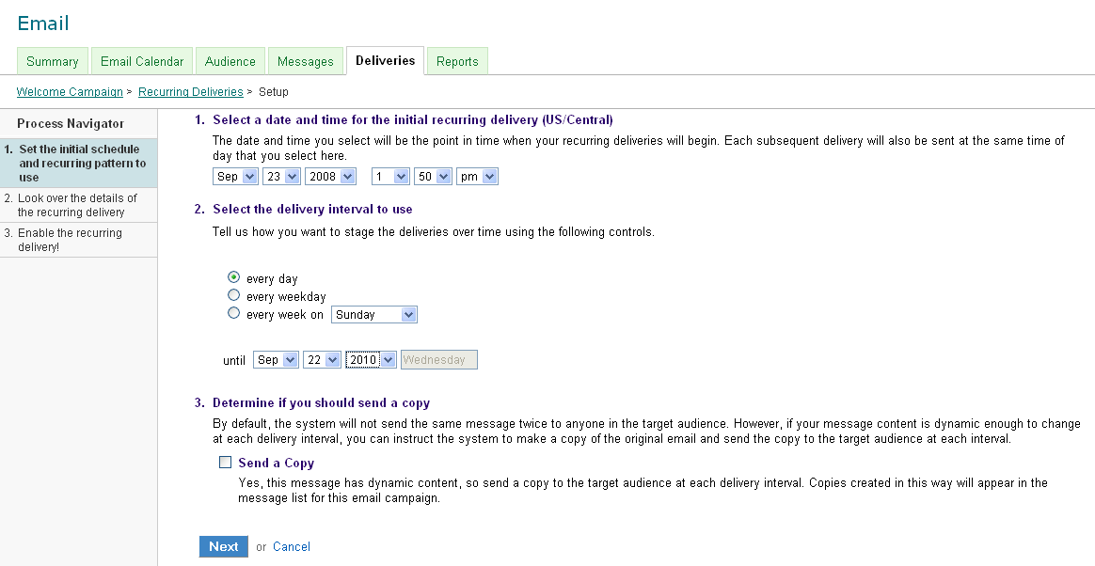

In Step 2, you will configure several related actions for the recurring delivery:
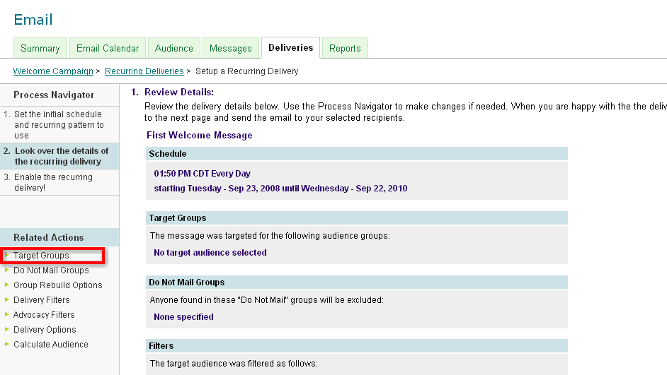

Select the Target Groups and search for the Week 1 Group that was previously created by the query. Save the target group and select next to add Do Not Mail Groups if necessary.

When adding your Target Groups, step 1.c will allow you to set the Rebuild Prior to delivery options for the groups.
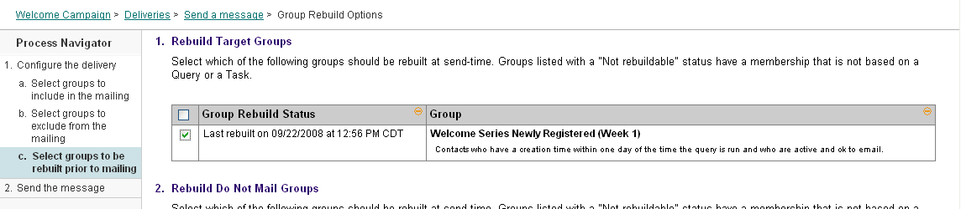
This setting will ensure that your target groups are up to date and it is the reason why you do not need to schedule the groups to rebuild periodically with a scheduled task.

After the recurring delivery has been configured, it will appear on the Recurring Delivery List tab in the Deliveries section of the Campaign:

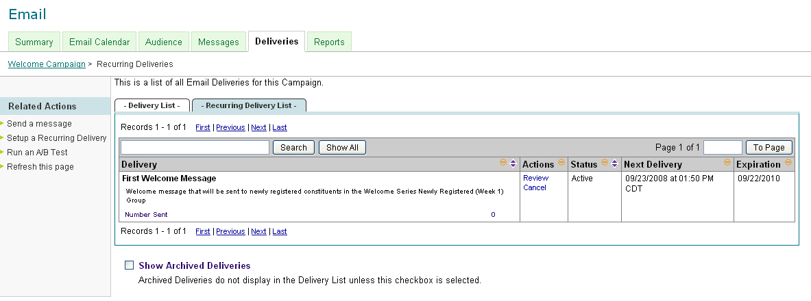

Repeat this configuration process for the second week email but include the second message in the message text and the target group will be the Week 2 group that was previously created.

Step 3: Test the Delivery
In addition to testing the messages by using the Reviewers group and the test emails that can be sent for each message, it’s also important to test the message delivery from the perspective of a constituent. Register on the site through different engagement pathways and confirm that the welcome message series is consistent with the experience that person would expect to have with your site. Consider making modifications to the target groups and query criteria based on what you find in testing.

Additional Resources:
Convio Community Best Practices:
http://community.customer.convio.com/community/bestpractices
The Convio Community is a resource powered by Convio staff and clients sharing information and advice on how to best use Convio tools.

Convio On-Demand Training:
http://customer.convio.com/site/PageServer?pagename=training_OnDemand
There are on-demand training sessions available for creating an email campaign, message, queries, and using the WYSIWYG. All of these pre-recorded tutorials contain content that is relevant to the steps reviewed in this document.

Marriage Today Case Study:
http://www.convio.com/files/MarriageToday-Case-Study.pdf
Learn from the documented success of another Convio client in this case study documenting the success Marriage Today had in revamping their welcome series with Convio.

Convio Summit 2008 Presentation: Engagement Pathways 102:
http://www.convio.com/summit-2008/
This session at the 2008 Convio Summit will delve deeper into the strategy and segmentation to consider when building your engagement pathways and welcome series.

Convio Help System
The Convio Help System always offers up to date information on the current Convio release and features. Consider reviewing the following topics for more information:
- Email Campaigns: http://help.convio.net/site/PageServer?pagename=Admin_Email_Campaigns
- Advanced Query: http://help.convio.net/site/PageServer?pagename=Admin_Advanced_Query
- Groups: http://help.convio.net/site/PageServer?pagename=Admin_Group_Management

