HOUSEFILE BUILDING - PLEDGE GUIDE

Client: [your organization’s full name]
Client Convio Short Name: [your Convio short name]
Sender Email Address: [your organization’s general email address]
(HINT: Your supporters will see this in the “from” line - constituent replies and out-of-office notifications go here; a general NPO address is preferred)
Sender Name: [your Executive Director, CEO, or just the name of your organization]
(HINT: Your supporters will see this in the “from” line - your sender should be generic or the same name as the signature.)
Submission instructions

Send this completed form to ServiceModules@convio.com .

You should receive a confirmation of your submission within one business day. If you do not receive a confirmation, please check in with us. You should receive a test message that contains your content within ten business days.

Your subject line should contain your organization’s Convio short name, the word “PLEDGE”, and your content submission date. For example: “AHS – PLEDGE – 7/30/2026”. If you submit your content multiple times prior to a deadline, all but your most recent submission will be ignored.

Please note that if you miss your submission deadline, submit an incomplete document, or if the subject line of your email submission is not clear, production of your campaign could be delayed or canceled.

Please allow ten business days from the date of your submission for Convio staff to process, build, and test your campaign based on the content you provide

OBJECTIVE/OVERVIEW
The Pledge Campaign invites your constituents and site visitors to sign a personal pledge showing their commitment to take action on an issue that affects your organization and/or the people you serve. The focus of this campaign is viral housefile growth. Brand awareness, outreach, and raising funds are secondary goals. This campaign includes:

- Five email campaign messages
- A campaign promotion on your website homepage
- A pledge of personal support

Campaign Structure

Convio’s survey tool will track the number pledges.

This guide collects all the email content for your kick-off message, a reminder message, last chance messages (two versions – one for those who have pledged, one for non-pledgers), and a follow-up announcement:

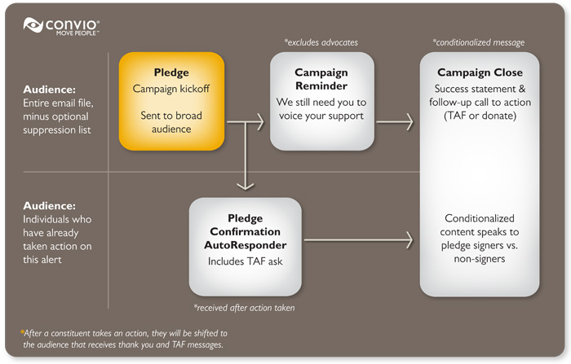

We will use the content you provide for these email messages to build a corresponding series of interactive landing pages. We will also create a viral eCard for constituents to send to their friends and family:

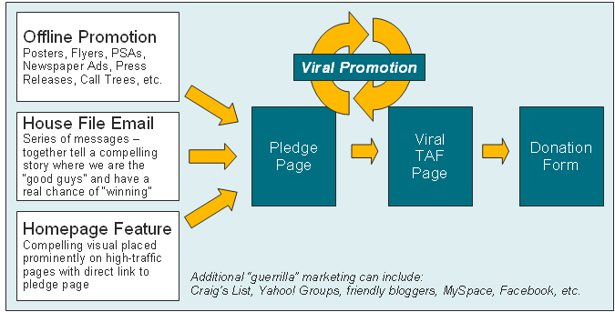

REQUIRED CONTENT
If you would like us to build your entire campaign using a minimal amount of required information, please provide:
CAMPAIGN THEME
Describe, in your own words, the theme of this campaign. The best campaign themes are short, to the point, and can be expressed in a single sentence. This theme should be easily woven through your entire campaign, including subject lines, calls to action, and campaign images. Some examples:

- “Remember Native Americans” – a pledge to stay informed, get involved, and remember the struggles of American Indians today (National Relief Charities).
- “Raise your hand, Texas” – a pledge to support Texas’ public schools (Raise Your Hand Texas)
- “Make Texas Safer” – a pledge in support of full funding for domestic violence programs in the state of Texas (Texas Council on Family Violence)

[Enter your Theme Here]

PLEDGE TEXT
Please provide the text of the statement that your constituents will be asked to endorse. This statement should represent a clear stance in support of or in opposition to a current/timely issue. This statement may also give your constituents the opportunity to commit to taking specific actions (e.g. biking instead of driving, using cloth bags to carry groceries, etc.).

Requirements – 75 words or less
[Enter your Pledge Text Here]
INCENTIVE IMAGE
Be conscious of image quality! An image that is low-resolution, too small, and/or pixilated will look unprofessional in your message. Convio cannot improve the quality of the images you submit. For example:
Good image Unusable Image



Requirements – Digital image of your incentive item
Max 250 pixels wide, 250 pixels tall – Convio cannot guarantee the resolution and dimensions of images that are not pre-cropped and sized to their final dimensions.
Incentive Image: [attach to email and add name of image file here]

CAMPAIGN NARRATIVE
Describe, in your own words, the story you’d like to tell your constituents in the course of this campaign. Keep in mind that your campaign will have multiple email messages and should convey a beginning (launch), middle (reminder) and end (last chance information). We will use portions of your text to create your actual email messages and related web pages. Please answer questions like:

- Why should people sign this pledge?
- Why is this pledge timely or important right now?
- Who is your “enemy” in this story and how will you overcome them?
- How will you use the signatures and the comments you get from constituents who sign the pledge?
- What is the impact you hope to have by reaching out to new supporters?
- What role do you want your constituents to play in promoting your organization to others?
- How many signatures or pledges are you trying to collect?

[Enter your Narrative Here]

OTHER INSTRUCTIONS
If you have additional information or instructions, please describe them here. While we cannot accommodate all requests, we will do our best to meet your needs.

[enter your comments here]

OPTIONAL CONTENT – CAMPAIGN BEST PRACTICES
If you would like to provide detailed content for your entire campaign, please review the following best practices and provide your content in the sections that follow.

Subject Lines
Your subject line should be enticing and set the stage for constituent action.

Some examples:
- Add your name to stop domestic violence
- Pledge to support all young women in sports
- Send your name to city council – Food for all [City] children

Message Content

The content for this sequence of messages should provide the “beginning”, “middle”, and “end” of a compelling, three-part story. These messages should answer the following questions:

- What problem are you working to address?
- How does promoting your work to others help address this problem?
- Why is it important to reach out to more supporters right now?
- What is the impact that participation will have?
- How is your incentive connected to your organization and mission?
Examples of viral HFB content are available in the Convio Go! area of Convio Community. Click here to see examples.
Suppression & Segmentation

If you would like to suppress a list of people from receiving this campaign, you can send us the list by using a secure file send service via the internet. It is important not to send a large list of names via email.

If you have any questions about sending a large list of names to Convio please contact ServiceModules@convio.com .
Important: You do not need to send us a list of individuals who have opted out of receiving email on their Convio profile. Convio’s email tools will automatically exclude individuals who have opted out of email communication.
Most of your constituents should be invited to participate in this viral campaign to raise awareness for your cause. If, however, you have specific segments who should not receive this campaign and you have already identified these segments as groups in Convio, please provide a list of those groups at the end of this document.
Add your content to the template below. Keep in mind that we will not make substantial changes to this template – what we build for you may not be an exact match of your work.
Create Kick-off (Optional)

KICK-OFF SUBJECT LINE | Requirements - 55 Characters or less
KICK-OFF SUBJECT LINE | [enter your subject line here]


Dear [Constituent Name],  With the recent [description of recently or timely developments], it’s time for us to take a stand.  Add your name to our online pledge to [short pledge description].  We’re asking you to speak out on [short description of problem]. When you sign this pledge, you add your voice to our [theme] statement:  [Pledge text]  You can also add your personal comments along with your signature. We’ll use your signature and comments to [description of how pledge signatures will be used].  To [description of desired outcome], we need to bring together as many supporters as possible before [urgent deadline].  Please add your signature today.  Sign the pledge.  As always, thank you so much for your ongoing support.  Sincerely,  [Digital Signature Image]  [Name of sender], [Title of sender]  PS. We respect your email preferences and privacy – If you’d rather not receive updates on our pledge drive you can opt out of future email. |   [Additional call-out text or mission statement – keep this under 20 words.]

Unsubscribe | Forward to a Friend | Visit our web site

[Your mailing address here]
Copyright © 2009 All rights reserved

Add your content to the template below. Keep in mind that we will not make substantial changes to this template – what we build for you may not be an exact match of your work.
Create Reminder (Optional)

REMINDER SUBJECT LINE | Requirements - 55 Characters or less
REMINDER SUBJECT LINE | [enter your subject line here]
Dear [Constituent Name],  Don't miss your chance to add your signature to our [theme]. There are only [number of days left] to sign before we [description of how the signatures will be used]!  Add your signature now  [optional timely campaign update – add 2-3 examples of constituent comments to date]  Add your signature and comments  [Additonal short description of desire outcomes from this campaign]  Sincerely,  [Digital Signature Image]  [Name of sender], [Title of sender]  PS. We respect your email preferences and privacy – If you’d rather not receive updates on our pledge drive you can opt out of future email. | [Additional call-out text or mission statement – keep this under 20 words.]
Unsubscribe | Forward to a Friend | Visit our web site

[Your mailing address here]
Copyright © 2009 All rights reserved

Add your content to the template below. Keep in mind that we will not make substantial changes to this template – what we build for you may not be an exact match of your work.
Create Last Chance – Not Pledged (Optional)

LAST CHANCE – NOT PLEDGED SUBJECT LINE | Requirements - 55 Characters or less
LAST CHANCE – NOT PLEDGED SUBJECT LINE | [enter your subject line here]
Dear [Constituent Name],  Today is your last chance to add your signature to our [theme]. Tomorrow we will [description of how the signatures will be used]!  Add your signature now  We’ve already received over [number of pledges to date] pledges to [theme]. Please add your voice to our effort to [reminder of desired outcome].  [Brief reminder of the impact we hope to have].  Sincerely,  [Digital Signature Image]  [Name of sender], [Title of sender] | [Additional call-out text or mission statement – keep this under 20 words.]
Unsubscribe | Forward to a Friend | Visit our web site

[Your mailing address here]
Copyright © 2009 All rights reserved

Add your content to the template below. Keep in mind that we will not make substantial changes to this template – what we build for you may not be an exact match of your work.
Create Last Chance – Pledged (Optional)

LAST CHANCE – PLEDGED SUBJECT LINE | Requirements – 55 Characters or less
LAST CHANCE – PLEDGED SUBJECT LINE | [enter your subject line here]
Dear [Constituent Name],  Thank you for supporting [theme of campaign].  You can multiply your impact by telling your friends and family about our pledge drive.  Tell a Friend now »  As always, thank you so much for your ongoing support and generosity.  Sincerely,  [Digital Signature Image]  [Name of sender], [Title of sender] |   [Additional call-out text or mission statement – keep this under 20 words.]
Unsubscribe | Forward to a Friend | Visit our web site

[Your mailing address here]
Copyright © 2009 All rights reserved

Add your content to the template below. Keep in mind that we will not make substantial changes to this template – what we build for you may not be an exact match of your work.
Create Follow-Up Announcement (Optional)

FOLLOW-UP ANNOUNCEMENT SUBJECT LINE | Requirements – 55 Characters or less
FOLLOW-UP ANNOUNCEMENT SUBJECT LINE | [enter your subject line here]
Dear [Constituent Name],
We're pleased to announce that we collected [number of pledges] and [description of how the signatures were used].
We are so grateful for your participation in the pledge drive and your help spreading the word about [campaign name and goal description]. Together with our other online supporters, you helped us send over [eCard count] eCards to family and friends promoting our [pledge goal].
When you help us bring the mission of [organization name] to others, the [description of the people/community we serve] who truly benefit.
Thank you for supporting and promoting our mission.
Sincerely,
[Digital Signature Image]
[Name of sender],[Title of sender]
Unsubscribe | Forward to a Friend | Visit our web site

[Your mailing address here]
Copyright © 2009 All rights reserved

Add your content to the template below. Keep in mind that we will not make substantial changes to this template – what we build for you may not be an exact match of your work.
Create Viral eCard (Optional)

VIRAL ECARD SUGGESTED SUBJECT LINE | Requirements – 55 Characters or less
VIRAL ECARD SUGGESTED SUBJECT LINE | [enter your subject line here]
OPTIONAL GREETING (10 word max.):  [Lorem ipsum dolor sit amet!]  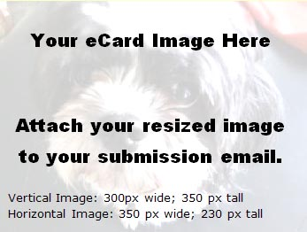  About [Organization] »  About [Campaign] »  [Note: we will modify the button to match your branding;  you can design & submit your own if you prefer] | [Copy and paste your suggested message text here:  You have very little space for content so make it count.  Word count is around 70, character count is around 450 with spaces.  This message should be written from the perspective of a supporter telling their friend about your organization and this campaign/pledge opportunity.]
Mission: [Add your mission statement here Lorem ipsum dolor sit amet, consectetur adipiscing elit. Sed ante. Proin at eros. Proin turpis. Vestibulum neque lorem, laoreet et, rutrum eget, porta egestas, nulla. ]
Visit Our Website | Donate | Forward to a Friend | Get Involved

TELL A FRIEND – SHARE OPTIONS
Requirements:  Twitter/Facebook prepopulated text – 140 characters or less (including link) | Facebook/Twitter Prepopulated Share Text:  This is the text that will appear on Facebook or Twiiter when you click the related icon. The user will have the option to edit this text before submitting to those services.  Best Practice - It is best to keep this under 140 characters including the link because 1) Twitter has a character limit and 2) short and quickly absorbed information is more effective and gets better viral traction.
[enter your revised Facebook/Twitter Share content here]

(optional)

[Default text]

I just signed the pledge to support [Cause]. Join me! [link to viral signup page]

Email To/Forward To/Tell A Friend Share

With the Convio tool a site visitor can send a text email message to a friend about a specific page. The person sending the email can keep the default message or subject line or they can choose to change the copy as they want. The page they will be sent a link to will be the viral signup page.

Using the template below please provide any custom copy for the subject or message body that you want forwarded when someone chooses the Email share option.

It is suggested that this message be very short (space is limited to 512 characters for message and the subject is limited to 40 characters), include a brief explanation about the cause for signing the pledge.
Subject line Requirements - limited to 40 characters for subject line. |  | [Default text]  Your friend wants you to sign the pledge for [organization short-name or abbreviation]
Message Requirements - limited to 512 characters for message body. |  | [Default text]  I wanted to let you know that I recently signed [organization]'s online pledge to support [organization mission] and I wanted to encourage you to as well. By just signing I'm already helping their cause and learning more about what great work they do. Please take a look at this page and consider helping them too by signing up to learn more and receive timely and important information about their great cause.

SUPPRESSION LIST FOR All CAMPAIGN MESSAGES
Requirements – file must be in “.csv” file format.

Your suppression list must include these three pieces of information for each individual to be included in the suppression list:
- First Name
- Last Name
- Email Address

When you are ready to send your list to Convio, please follow these instructions:

- Visit http://www.sendthisfile.com
- Set up a new account for free
- With your new account, you will be able to securely send large files using a secure link instead of sending the file through email
- Follow the instructions on the website to upload your file and then send the file link to ServiceModules@convio.com .
- Please contact us if you have any questions about this process
- Please do not send lists of contacts via email
CONVIO SEGMENTS TO SUPPRESS FOR THIS CAMPAIGN
Requirements – pre-existing group segmentation defined in your Constituent360 database

The Convio group names you provide here must match the groups/segments that you defined in your Convio Go! Data Management Guide. Alternatively, you may manually create and populate groups in your Constituent360 database and provide the names of those groups here.

[Enter group/segment names here]

