CONVIO WELCOME SERIES EMAIL GUIDE

Client: [your organization’s full name]
Client Convio Short Name: [your Convio short name]
Sender email address: [your organization’s general email address]
(HINT: Constituent replies and out-of-office notifications go here, so a general address is preferred)
Sender name: [your Executive Director, CEO, or just the name of your organization]
(HINT: Your sender should be generic or the same name as the signature.)
SUBMISSION INSTRUCTIONS
Send this completed form to getready@convio.com.

You should receive a confirmation of your submission within one business day. If you do not receive a confirmation, please check in with us. You should receive a test message that contains your content within five business days.

Your subject line should contain your organization’s Convio short name, the word “Welcome Series Guide”, and your content submission date. For example: AHS – Welcome Series Guide – 7/29/2026. If you submit your content multiple times prior to a deadline, all but your most recent submission will be ignored.

Please note that if you miss your submission deadline, submit an incomplete document, or if the subject line of your email submission is not clear, production could be delayed or canceled.
OBJECTIVE/OVERVIEW
The Welcome Series email campaign will consist of two emails that are sent to all new constituents who register on your Convio-powered site. The first of these two emails will be the Personal Greeting from the Executive Director of your organization. The second email message will highlight ways to get involved to encourage your online constituents to take additional actions to support your mission.

For some examples of Welcome Series messages, see this post on Community:

http://community.customer.convio.com/thread/1793

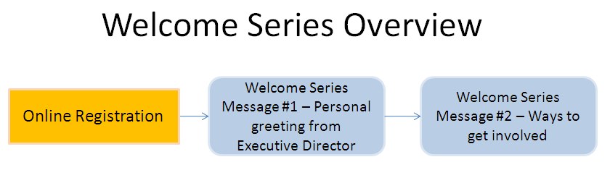

The above chart shows that the Welcome Series emails will be sent out shortly after they have become a newly registered user on your Convio powered site. New Constituent should receive the welcome series email messages before being included in Newsletter campaigns or other communication. Each message of the Welcome Series will be sent out on a recurring basis to ensure that all newly registered users will receive a proper welcome before being included in ongoing communication such as monthly newsletters.

Going Viral With Your Welcome Series
You can make your welcome series have a housefile building effect by expanding the standard best practice of including a “Forward This Message To A Friend” link in Message #2 to include options to share a new constituent’s involvement with your organization via Facebook and Twitter in addition to Email.

Welcome Series Message #2 will ask for new registrants to spread the word about joining the organization’s online community via their preferred social sharing medium and direct those new people to an online registration form. This will sign new constituents up and start the welcome series flow over again. Your organization does not need a Facebook or Twitter account to offer this functionality.

Here is the detailed flow of Welcome Series Emails and Viral registration parts we’ll be creating and how they will interact:

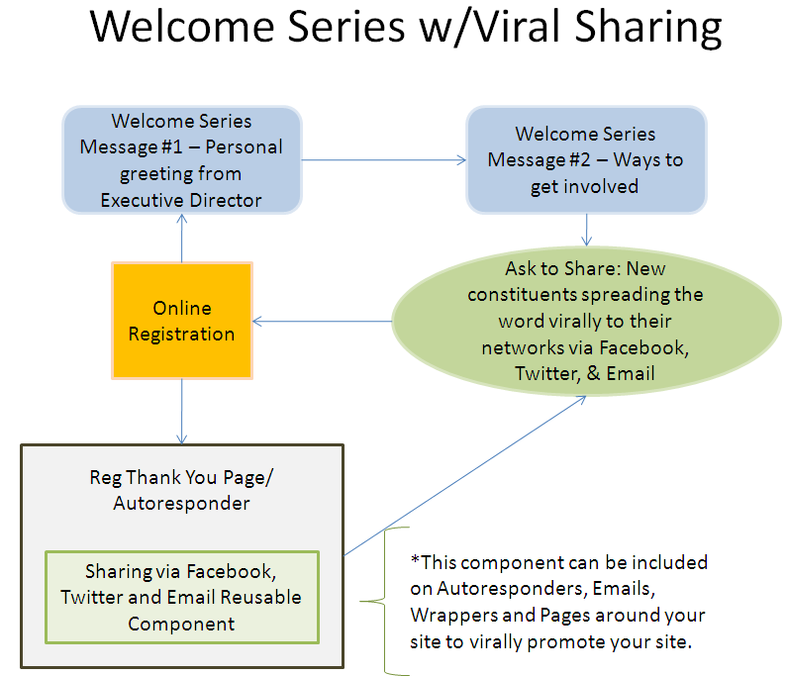

In this guide, we would like you to provide Convio with the content for the two emails that will be part of the Welcome Series, content for a reusable share-the-message component that you will be able to add to any page, and content for a quick online registration page.

MESSAGE #1
INITIAL AUDIENCE - PERSONAL GREETING (MESSAGE #1)
Requirements: Indicate who should receive your initial welcome series. | Best Practices – Audience  If your list hasn’t been messaged regularly (or never before), send your welcome series to the entire list initially and send to only new registrants thereafter. If you do regularly message your list, sending the welcome series to past registrants is not recommended.  Note: If you choose YES, both messages of the welcome series will be sent to your whole list on the initial send.
Send to your whole list on the initial send?
[enter yes or no]
PERSONAL GREETING SUBJECT LINE
Requirements: 55 Characters or less (approximately 9 words) | Best Practices – Subject Line  The subject line will be the first part of the email that your readers see. Think about what impression you would like to give them when they see the message in their inbox.  Some examples:  - Welcome to AHS Online  - Strengthening Our Connection to You  - Org Name | We Want to Welcome You
[enter your subject line here]
GRAPHIC SIGNATURE OF EXECUTIVE DIRECTOR (OPTIONAL)
Requirements – Image of Executive Director’s Signature  Max 300 pixels wide, 75 pixels tall | Best Practices – Signature  It adds a nice personal touch to have a graphic of the hand written signature from your Executive Director at the end of an email which comes from the desk of the director. This is not a requirement.  Example: 
[attach image to email and add name of image file here]
PERSONAL GREETING CONTENT AND IMAGE BEST PRACTICES
Personal Greeting Content
Maximum word count is 400 words or less.

The content for this letter should be a personal note from your Executive Director announcing the new online initiatives that your organization is planning. This letter will begin to build interest in the types of communication that your constituents can expect to receive from you in the future. This letter should be written in the first person in the voice of your Executive Director or another well-known spokesperson. It should convey warmth and a personal interest in the supporters who are reading this letter. You want to entice your constituents to keep their eyes open and ready for the next email that will come from your organization. If you find yourself hunting for topics, try highlighting your past successes and then pull attention to your organization’s efforts to grow.

Don’t forget to include URLs you want to link to from your message.

Executive Director Photo
Your images should be resized to no more than 160 pixels wide by around 200 pixels tall. This image will be used in both welcome series messages.

Typically the Executive Director photo will be a head shot photograph of the Executive Director. If your organization doesn’t have a head shot, then consider cropping a photograph that has a good image of your Executive Director. A professional, studio photo projects a more polished or serious brand. An informal photo in a context that conveys your mission (outdoors, at a service facility) can project a more youthful or casual brand.

Be conscious of image quality! An image that is low-resolution, too small, and/or pixilated will look unprofessional in your message. Convio cannot improve the quality of the images you submit. For example:

Good image Unusable Image



Feature Headline and Content
Feature Headline should be 20 characters or less (approximately 3 words).
Feature Content should not exceed 80 characters or less (approximately 14 words)

The Feature Headline and Content is located in the sidebar of the email, just below the photo of the Executive Director. Use this space to provide information about your organization and the past successes that have been accomplished. The feature headline should be used to pull attention to your organization.

Example:

Feature Headline: 2008 Successes
Feature Content: In 2008, the AHS was able to deliver over $1 Million of patient services to individuals across the nation.
Add your content to the template below. Keep in mind that we will not make substantial changes to this template – what we build for you may not be an exact match of your work.
Create Personal Greeting Message


Dear [Constituent First Name],  [ ADD YOUR MESSAGE CONTENT HERE  Word Limit for message content is 400 words or less.  ]  Sincerely,  [Signature Graphic, if available]  [Signature Name], [Title] | From the Desk of    Name of Sender      [FEATURE HEADLINE  Additional call-out text or mission statement – keep this under 20 words.]
 Unsubscribe | Forward to a Friend | Visit our web site

[Your mailing address here]

Copyright © 2009 All rights reserved

MESSAGE #2
WAYS TO GET INVOLVED SUBJECT LINE (MESSAGE #2)
Requirements: 55 Characters or less (approximately 9 words) | Best Practices – Subject Line  It is important to let your readers know that there is more than one way that they can get involved with your initiatives. The focus of this email should be action oriented letting your readers know that they can easily become involved.  Some examples:  - More ways than ever to get involved  - Org Name | You can make a difference
[enter your subject line here]
WAYS TO GET INVOLVED CONTENT PRACTICES
Ways to Get Involved Content
Maximum word count is 400 words or less.

The content for this letter should highlight the opportunities that are available for your constituents to support your organization’s efforts. It’s important to provide links back to your site or directions on how they can take action. Make sure that the different opportunities have some variety to appeal to a wide range of individual interests.

Don’t forget to include the URLs you want to link to from your message.

Examples:
Make a Donation: Your financial contributions help fund our programs and make our work possible. Donating has never been easier! Use this link to visit our site and make an online donation today: Donate Now >>

Stay Informed: Visit our website for the latest news. We keep our website up to date with information about key issues affecting our patients’ rights: Explore our website >>

Get Involved: Mark your calendars! Our special events are great ways to support our mission and get involved: View our upcoming events >>

Spread the word: You can tell your friends and family about the great work we’re doing to protect patients’ rights! Share a message via Facebook, Twitter or Email to your friends that the AHS needs their support today.

Spread the word links
These share links will point to a viral specific page with simple embedded registration survey (First name, last name, email).
Forward email to a friend will be its own email message which will also require some basic copy. Fields to provide that copy are supplied later in this document.

Feature Headline and Content
Feature Headline should be 20 characters or less (approximately 3 words).
Feature Content should not exceed 80 characters or less (approximately 14 words)

The Feature Headline and Content is located in the sidebar of the email, just below the photo of the Executive Director. Features should be action-oriented and speak to something your constituents can do right now.

If you are not providing a link to more information or to take action, then the feature content must be entirely self-contained. For example:

- Headline: RSVP for Winter Gala
- Content: For tickets to our Jan 10th event, call 1-800-OUR-GALA or email info@foo.org

Including a link to more detailed information gives you more flexibility. Using links allows click-through tracking to provide a better indication of the interests and level of engagement of your constituents. For example:

- Headline: Volunteers Needed
- Content: Deliver care packages to homebound seniors this holiday. Click to learn more >

Add your content to the eLetter template below. Keep in mind that we will not make substantial changes to this template – what we build for you may not be an exact match of your work.
Create Ways to Get Involved Message

Dear [Constituent First Name],  [ ADD YOUR MESSAGE CONTENT HERE  Word Limit for message content is 400 words or less.  ]  Sincerely,  [Signature Graphic, if available]  [Signature Name], [Title] | From the Desk of  Name of Sender  [FEATURE HEADLINE  Additional call-out text or mission statement – keep this under 20 words.]
Unsubscribe | Forward to a Friend | Visit our web site

[Your mailing address here]

Copyright © 2009 All rights reserved

WAYS TO GET INVOLVED – SHARE OPTIONS
Requirements:  Reusable component - 75 words or less | Reusable Component Share  We will create a reusable component in the Pagebuilder module that you will be able to insert into any of your Autoresponders, Emails or on Pages which will encourage people to reach out to their social networks to help promote and build your housefile through registration. This will be used in welcome message #2 under Spread the Word.  We can change the text of both the component message and what is prepopulated on Facebook and Twitter Share if you want to customize it, otherwise we will use the Template default below.  Best Practices - Make sure to keep the language generic enough to be used in multiple places on your site (meaning not campaign specific).  Template Default Resuable Component:  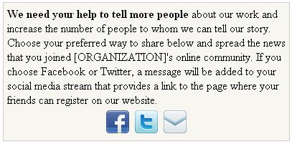  Example:  Spread the word: You can tell your friends and family about the great work we’re doing to protect patients’ rights! Share a message via Facebook, Twitter or Email to your friends that the AHS needs their support today.  It is recommended that this component also be placed on any Registration Autoresponders if you have them enabled or on Thank You pages or other Autoresponders (Donations, Action Alerts, Ecards etc) after a site visitor takes an action.
[enter your revised reusable component content here]

(optional)

Requirements:  Twitter/Facebook prepopulated text – 140 characters or less (including link) | Facebook/Twitter Prepopulated Share Text:  This is the text that will appear on Facebook or Twiiter when you click the related icon. The user will have the option to edit this text before submitting to those services.  Best Practice - It is best to keep this under 140 characters including the link because 1) Twitter has a character limit and 2) short and quickly absorbed information is more effective and gets better viral traction.
[enter your revised Facebook/Twitter Share content here]

(optional)

[Default text]

I am now part of the [organization] online community. Join me! [link to viral signup page]

Email To/Forward To/Tell A Friend Share

With the Convio tool a site visitor can send a text email message to a friend about a specific page. The person sending the email can keep the default message or subject line or they can choose to change the copy as they want. The page they will be sent a link to will be the viral signup page.

Using the template below please provide any custom copy for the subject or message body that you want forwarded when someone chooses the Email share option.

It is suggested that this message be very short (space is limited to 512 characters for message and the subject is limited to 40 characters), include a brief explanation about the organization and encourage them to become a member of your online community (make sure to let them know what that means such as “will receive monthly newsletters, alerts to important information” etc.)
Subject line Requirements - limited to 40 characters for subject line. |  | [Default text]  Your friend wants you to help [organization short-name or abbreviation]
Message Requirements - limited to 512 characters for message body. |  | [Default text]  I wanted to let you know that I recently joined [organization]'s online community to support [organization mission] and I wanted to encourage you to as well. By just signing up I'm already helping their cause and learning more about what great work they do. Please take a look at this page and consider helping them too by signing up to learn more and receive timely and important information about their great cause.

VIRAL LANDING PAGE/REGISTRATION
Landing Page Copy

This will be the registration landing page linked to from any viral activity. Unless otherwise specified below it will use the following default content.

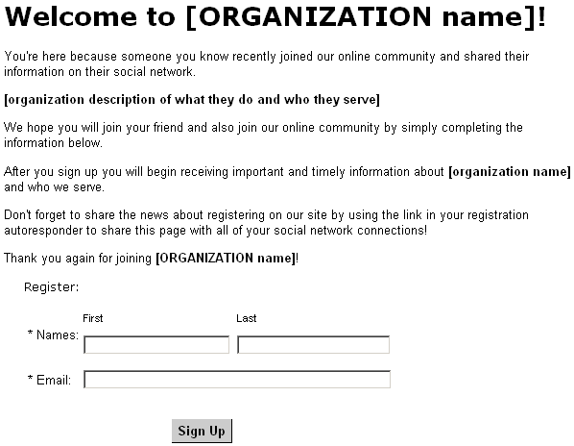

Optional - Add/change your content to the landing page template below. Keep in mind that we will not make substantial changes to the template layout – what we build for you may not be an exact match of your work.
[Make any copy changes here to the text here]

Welcome to [ORGANIZATION name]!

You’re here because someone you know recently joined our online community and shared their information on their social network.

[organization description of what they do and who they serve]

We hope you will join your friend and also join our online community by simply completing the information below.

After you sign up you will begin receiving important and timely information about [organization name] and who we serve.

Don't forget to share the news about registering on our site by using the link in your registration autoresponder to share this page with all of your social network connections!

Thank you again for joining [ORGANIZATION name]!

Page Title Best Practice – This is the text that shows in the top bar of your browser but is also pulled in by Facebook as is the first few words of a page when you reference a URL in the Share functionality. Therefore the goal is to make this title a little more customized to those seeing it on Facebook as well as a clear title for this page.
[Default text] – Join [organization]'s online community!
Sidebar Image (optional) - Though having a sidebar image is optional it is strongly encouraged because Facebook Share functionality will pull in that image as an option for the user to associate it with their share comment.
Requirements - Sidebar image should be no bigger than about 160px wide and 200px tall.
[provide side bar image]
Copy for Viral Registration Survey Autoresponder– The survey autoresponder should be enabled, use a basic or blank stationary, and include a short message thanking the constituent for registering. Below the thank you we will insert the Reusable Share Component to continue to viral flow.
[Customize autoresponder default copy below]

Thank you for signing up to receive information from the [organization]. You are now a part of the compassionate network of dedicated people who work to [mission statement].Thank you again [first name] for signing up with the [organization]’s online community.

[reusable share component]

OTHER INSTRUCTIONS
If you have additional information or instructions, please describe them here. While we cannot accommodate all requests, we will do our best to meet your needs.
[enter your comments here]

