Convio Go!™ ADDITIONAL DONATION FORM GUIDE for American Lung Association

Use this guide as one of your monthly submission opportunities to have Convio produce

an additional donation form for a dedicated fundraising project.

Charter: [your organization’s full name]
Center Name: [your Convio center name]
Fundraising Campaign Title : (HINT: If you require a new fundraising campaign, please indicate that here. If a campaign already exists and you just require a donation form to be added to the existing campaign, please indicate the existing title here.) | [ ] Yes, this is a brand new fundraising campaign.  [ ] A fundraising campaign already exists. I only need a donation form. The campaign is titled: [Enter Campaign Title here]
Donation form type : (HINT: Select the type of form you require. Keep in mind that some form types require additional content and/or imagery from you. Be sure to read the individual form requirements below.) | [ ] Standard donation form with monthly giving option  [ ] Standard donation form without monthly giving option  [ ] Dedicated honor/memorial form  [ ] Dedicated honor/memorial form with one donation eCard stationery  [ ] Dedicated monthly giving form  [ ] Simple event ticket purchasing form
Large gift notification email address: [one or more email addresses for gift notification]
Large gift notification amount: [large gift amount for notification]
(HINT: If you would liked to be notified by email of all online gifts, make this the same amount as your minimum donation amount)
SUBMISSION INSTRUCTIONS
Send this completed form to getready@convio.com.

You should receive a confirmation of your submission within one business day. If you do not receive a confirmation, please check in with us. You should receive a test message that contains your content within five business days.

Your subject line should contain your organization’s Convio short name, the word “Additional Donation Form Guide”, and your content submission date. For example: AHS – Additional Donation Form Guide – 2/17/2012. If you submit your content multiple times prior to a deadline, all but your most recent submission will be ignored.

Please note that if you miss your submission deadline, submit an incomplete document, or if the subject line of your email submission is not clear, production could be delayed or canceled.

ONLINE GIVING BEST PRACTICES

Your Online Giving donation form will be a Convio-powered donation form and it will include:

Information regarding your cause and why someone should support you

Up to 6 donation giving amounts

A Donation Thank You page

One donation autoresponder

This guide will focus on developing content for the donation form. The chart below shows the donation flow whether the donor visits the website or receives an email promoting your organization.
Potential donor visits site or receives an email
Potential donor is now a “donor” and is in Constituent360 and receives “thank you”
Potential donor clicks “Donate” link on site or in email.
Potential donor is in donation form; enters donation amount, personal information and credit card number and processes donation
Step 1
Step 2
Step 3

DONATION FORM HEADLINE
Your page title should not exceed 10 words. It should be concise and convey the urgency of or your enthusiasm for your mission.

Examples:
- Become a monthly donor today!
- Support parks – Donate Now!
- Annual New York City Gala

DONATION FORM PITCH TEXT
Constituents who are considering making a gift to your organization will often use your website not only to make their gift, but to do their diligence as a potential donor. Your donation form is an opportunity to reinforce your credibility and underscore that you are good stewards of the funds you receive. You also want to briefly summarize your mission and how their gift will help.

If you don’t provide this information elsewhere on your site already, consider including:

- A simple pie chart showing the percentage of your funds that support programs.
- Your Charity Navigator rating, the BBB logo, or any other endorsements you have received
- A link to your most recent 990 form or annual report

If your form is for a special giving program or event, you should also include specific information such as giving program requirements and benefits or dates/times/location of event.

DONATION FORM GIVING LEVELS
Requirements – 6 or less  You can provide text to be displayed next to each amount to explain how each gift is used, but it is not required. | Best Practices  If you already have established giving levels, note those here.  If you are creating a form for a specific donor program that has customized giving levels, indicate them here.  If your form is for an event, indicate the event registration or ticket price. Please note that Convio’s donation forms are not able to calculate a total. If you want your donors to be able to purchase several tickets at once, include a specific giving level for that. For instance:  Donation Level 1: 1 event ticket = $20  Donation Level 2: 2 event tickets = $40
Donation Level 1: [enter the donation level dollar amount]

Donation Level 2: [enter the donation level dollar amount]

Donation Level 3: [enter the donation level dollar amount]

Donation Level 4: [enter the donation level dollar amount]

Create your donation form


[Provide a Donation Form Headline Here]

Every dollar counts! [Org] has received a favorable rating from [Charity Navigator/BBB/etc.] for the last [number of years]. To make a tax-deductible donation right now to our organization, please fill out and submit the form below.

To make a gift by mail, send your check made out to [Organization Name] to [Organization Address]. To make a gift by phone call 1-800-888-8888.

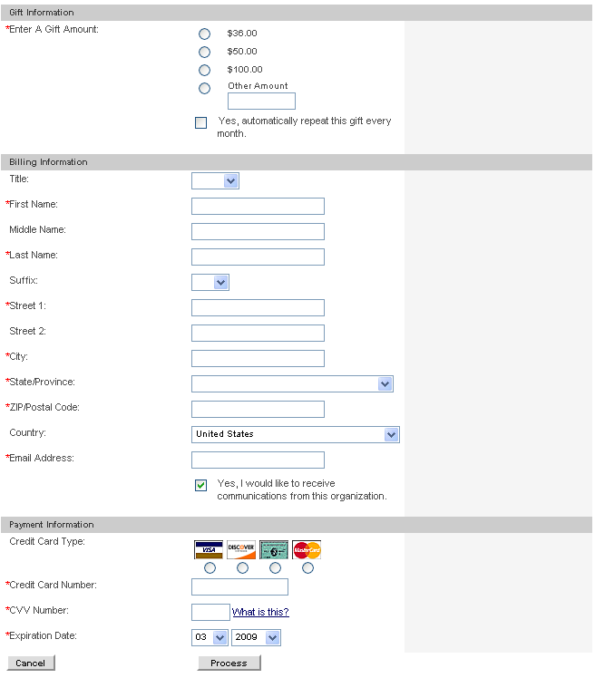
[Your organization name here]

[Your mailing address here]

Copyright © 2009 All rights reserved

DONATION THANK YOU AUTORESPONDER AND TAX RECEIPT
Subject Line
Examples:
- Your donation receipt from [Organization Name]
- Thank you for your donation

Thank You Email Content
This email is an expected reply to making an online transaction. Offer your deepest thanks and reiterate how their gift will make a difference.
Add your content to the autoresponder template below to help you visualize what the message will look like when sent to your donors. Keep in mind that we cannot make substantial changes to this template – what we build for you may not be an exact match of your work.
Create your autoresponder
Use my existing general autoresponder content: [Yes] or [No, use the custom content below.]
Thank You Email Sender Address :  (HINT: Constituent replies and out-of-office notifications go here, so a general address is preferred) | [your organization’s general email address]
Thank You Email Sender Name :  (HINT: Your sender should be generic or the same name as the signature.) | [your Executive Director, CEO, or just the name of your organization]
SUBJECT LINE : | [enter your subject line here – 55 Characters or less]

Dear [Constituent Name],
[Enter your thank you content here. Below is some sample text to get you started.]
We are deeply grateful for your generosity and support of our efforts. Your gift makes a difference — it enables us to continue our work. We count on the ongoing support of donors like you to ensure that we can fulfill our mission.
Did you know that you can follow us on twitter or ‘Like’ us on Facebook? Help spread our mission to family and friends by connecting with [Org name] at [twitter URL] and [Facebook URL].
Once again, thank you for your support.
Sincerely,
[Organization name or Signature of CEO]
Please print or save this message for your personal records.
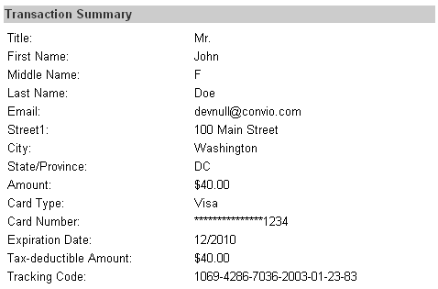
[Note: Convio will automatically include a transaction summary with the above fields for the donor’s taxes.]
[Your organization name here]

[Your mailing address here]

Copyright © 2009 All rights reserved

DONATION FORM ECARD (FOR DEDICATED HONOR/MEMORIAL FORMS ONLY)
Donation Form eCard Content
The donor ultimately decides what the subject line and message content will contain since they are sending the honoree the message. However, you should make the design of the card inviting to a potential new constituent by including links to learn more, join, and get involved in your organization.
Add your content to the eCard template below to help you visualize what the eCard message will look like when a donor sends it to their honoree. Keep in mind that we cannot make substantial changes to this template – what we build for you may not be an exact match of your work.

Create your eCard

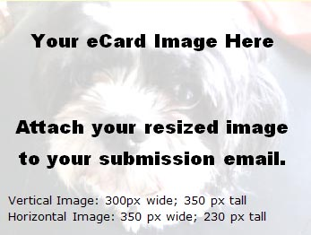  OPTIONAL GREETING (10 word max.):  [Lorem ipsum dolor sit amet!]    [Note: we will modify these buttons to match your branding; you can design & submit your own if you prefer] | THIS SPACE IS RESERVED FOR THE DONOR’S PERSONAL MESSAGE TO THE HONOREE
Mission: [Add your mission statement here Lorem ipsum dolor sit amet, consectetur adipiscing elit. Sed ante. Proin at eros. Proin turpis. Vestibulum neque lorem, laoreet et, rutrum eget, porta egestas, nulla. ]
Visit Our Website | Donate | Forward to a Friend | Get Involved

OTHER INSTRUCTIONS
If you have additional information or instructions for your donation form, please describe them here. While we cannot accommodate all requests, we will do our best to meet your needs.
[enter your comments here]

