CONVIO – HOUSEFILE BUILDING – GIVE-AWAY GUIDE

Client: [your organization’s full name]
Client Convio Short Name: [your Convio short name]
Sender Email Address: [your organization’s general email address]
(HINT: Your supporters will see this in the “from” line - constituent replies and out-of-office notifications go here; a general NPO address is preferred)
Sender Name: [your Executive Director, CEO, or just the name of your organization]
(HINT: Your supporters will see this in the “from” line - your sender should be generic or the same name as the signature.)
Submission instructions

Send this completed form to getready@convio.com.

You should receive a confirmation of your submission within one business day. If you do not receive a confirmation, please check in with us. You should receive a test message that contains your content within ten business days.

Your subject line should contain your organization’s Convio short name, the word “GIVE AWAY”, and your content submission date. For example: “AHS – GIVE AWAY – 7/29/2026”. If you submit your content multiple times prior to a deadline, all but your most recent submission will be ignored.

Please note that if you miss your submission deadline, submit an incomplete document, or if the subject line of your email submission is not clear, production of your campaign could be delayed or canceled.

Please allow ten business days from the date of your submission for Convio staff to process, build, and test your campaign based on the content you provide

OBJECTIVE/OVERVIEW
The Give-Away Campaign invites your constituents earn chances to win an incentive item. The focus of this campaign is viral housefile growth. Brand awareness, outreach, and raising funds are secondary goals. This campaign includes:

- Five email campaign messages
- A campaign promotion on your website homepage
- A promotional item or opportunity as an incentive

Viral Incentive Structure

Constituents who participate in this campaign can “earn” entries to win the incentive. Convio’s survey and eCard tools will track the number of entries each constituent has earned. Constituents can increase their number of entries, and therefore their odds of winning, as follows:

- One initial entry just for updating or providing their complete contact information.
- Additional entries for inviting others to enter into the drawing. (1 entry for every 5 eCards sent)

This guide collects all the email content for your kick-off message, a reminder message, last chance messages (two versions – one for entrants, one for non-entrants), and a winner announcement:

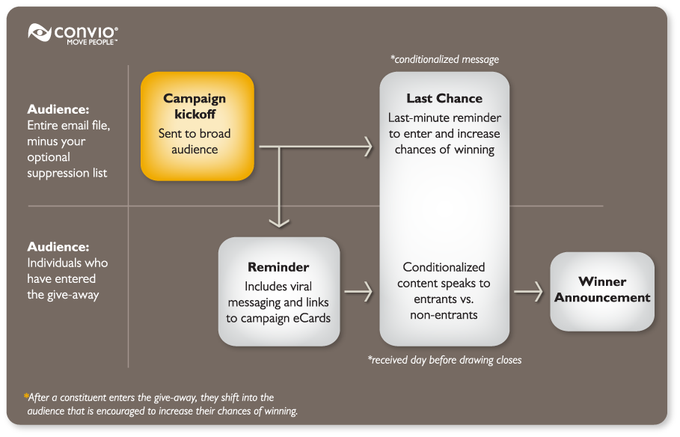

Add your content to the template below. Keep in mind that we will not make substantial changes to this template – what we build for you may not be an exact match of your work.
Create Landing Page Content

G_LP
Your Convio site PageWrapper will automatically be included around this landing page content.
[Page Headline – Enter to Win]  [Use the form below to enter our contest. Contest Rules  - Entry is free – just fill out the form below to get started  - Once entered, you can increase your chances of winning by sending eCards (1 additional entry for every 5 eCards that you send)  - We’ll pick our winner on [Drawing Date] |  | Increase your chances of winning an [prize_name] by spreading the word.  
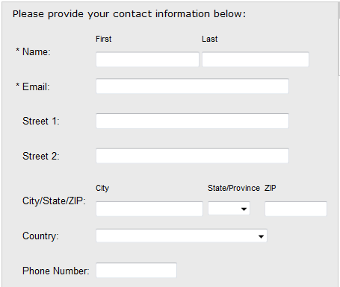 | 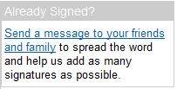

Add your content to the template below. Keep in mind that we will not make substantial changes to this template – what we build for you may not be an exact match of your work.
Create eCard Page Content

G_LP
Your Convio site PageWrapper will automatically be included around this eCard page content.
Increase your chances to win  Help us get the word out about our campaign [description here]. Don't forget - you can increase your chances of winning by sending eCards to family and friends.  You can send up to 30 eCards per day (3 messages to 10 recipients at a time) using our online form. Every time you send another 5 eCards, you earn another entry in our drawing for the [prize description]. | Increase your chances of winning an [prize_name] by spreading the word.
[eCard form will be inserted here – will include fields for the following]
- First Name
- Last Name
- Email
- Send to (maximum 10 recipients at a time)
- Subject line
- Message body

Add your content to the template below. Keep in mind that we will not make substantial changes to this template – what we build for you may not be an exact match of your work.
Create Kick-off Message

G_KO
KICK-OFF SUBJECT LINE | [enter your subject line here – 55 Characters or less]

Dear [Constituent Name],  As a special thank-you to our online supporters, we would like to invite you to enter to win [description of incentive]. You can enter in our drawing right now online »  Entry in the drawing is free. Once you’ve entered, you can improve your chances of winning by helping us promote [campaign description].  [Additional description of the prize and impact constituents have by participating].  Enter in our free drawing »  As always, thank you so much for your ongoing support and generosity.  Sincerely,  [Digital Signature Image]  [Name of sender]  P.S. We respect your email preferences and privacy – If you’d rather not receive updates on this drawing you can opt out of future email about this contest. |   [Additional call-out text or mission statement – keep this under 20 words.]  The deadline to enter is [insert date]. The drawing will be held on [insert date].

Unsubscribe | Forward to a Friend | Visit our web site

[Your mailing address here]

Copyright © 2010 All rights reserved

Add your content to the template below. Keep in mind that we will not make substantial changes to this template – what we build for you may not be an exact match of your work.
Create Reminder

G_RE
REMINDER SUBJECT LINE | [enter your subject line here – 55 Characters or less]
Dear [Constituent Name],  Thank you for entering in our [give-away campaign name]!  Don't forget – you can increase your chances of winning [incentive description] by sending eCards to family and friends. There are only [number] days left - we'll pick our winner on [date of drawing]!  You can send up to 30 eCards per day (3 messages to 10 recipients at a time) using our online form. Every time you send another 5 eCards, you earn another entry in our drawing.  [2-3 paragraph description of the incentive and how this give away is connected to your organization’s mission]  Again, thank you for helping us spread the word about [give-away campaign name]  Sincerely,  [Digital Signature Image]  [Name of sender]  [Title of sender]  P.S. We respect your email preferences and privacy – If you’d rather not receive updates on this drawing you can opt out of future email about this contest. |   [Additional call-out text or mission statement – keep this under 20 words.]  The deadline to enter is [insert date]. The drawing will be held on [insert date].
Unsubscribe | Forward to a Friend | Visit our web site

[Your mailing address here]

Copyright © 2010 All rights reserved

Add your content to the template below. Keep in mind that we will not make substantial changes to this template – what we build for you may not be an exact match of your work.
Create Last Chance – Not Entered

G_LCNP
LAST CHANCE – NOT ENTERED SUBJECT LINE | [enter your subject line here – 55 Characters or less]
Dear [Constituent Name],  Don't miss your chance to win [incentive description]. Today is your last day to enter - we'll pick our winner tomorrow!  Entry into our Give-Away is free. Visit our Give-Away page to enter in our drawing.  Once you've entered, you can improve your chances of winning by helping us promote this event and taking action to [campaign goal]. The winner in our drawing will receive [additional description of give-away incentive].  Enter our free drawing »  As always, thank you so much for your ongoing support and generosity.  Sincerely,  [Digital Signature Image]  [Name of sender]  [Title of sender] | [Additional call-out text or mission statement – keep this under 20 words.]  The deadline to enter is [insert date]. The drawing will be held on [insert date].
Unsubscribe | Forward to a Friend | Visit our web site

[Your mailing address here]

Copyright © 2010 All rights reserved

Add your content to the template below. Keep in mind that we will not make substantial changes to this template – what we build for you may not be an exact match of your work.
Create Last Chance – Entered

G_LCP
LAST CHANCE – ENTERED SUBJECT LINE | [enter your subject line here – 55 Characters or less]
Dear [Constituent Name],  Don't miss your chance to increase your number of entries to win [incentive description]. Today is your last chance to earn more entries by sending eCards!  We’re excited to be picking our winner tomorrow. Visit our site to send more eCards today. And don’t forget, for every 5 eCards that you send, you’ll earn an additional entry in our drawing!  We’ll send out our winner announcement soon after our drawing – good luck! And thank you for your support in [campaign description].  Sincerely,  [Digital Signature Image]  [Name of sender]  [Title of sender] | [Additional call-out text or mission statement – keep this under 20 words.]  The deadline to enter is [insert date]. The drawing will be held on [insert date].
Unsubscribe | Forward to a Friend | Visit our web site

[Your mailing address here]

Copyright © 2010 All rights reserved

Add your content to the template below. Keep in mind that we will not make substantial changes to this template – what we build for you may not be an exact match of your work.
Create Winner Announcement

G_FU
WINNER ANNOUNCEMENT SUBJECT LINE | [enter your subject line here – 55 Characters or less]
Dear [Constituent Name],
We're pleased to announce that [name of winner] from [city/location] has won [incentive description]!
We are so grateful for your participation in the Give-Away and your help spreading the word about [campaign name and goal description]. Together with our other online supporters, you helped us send over [eCard count] eCards to family and friends promoting our [organization or event].
When you help us bring the mission of [organization name] to others, the real winners are [description of the people/community we serve].
Thank you for supporting and promoting our mission.
Sincerely,
[Digital Signature Image]
[Name of sender]
[Title of sender]
Unsubscribe | Forward to a Friend | Visit our web site

[Your mailing address here]

Copyright © 2010 All rights reserved

Add your content to the template below. Keep in mind that we will not make substantial changes to this template – what we build for you may not be an exact match of your work.
Create Viral eCard

VIRAL ECARD SUGGESTED SUBJECT LINE | [enter your subject line here – 55 Characters or less]
OPTIONAL GREETING (10 word max.):  [Lorem ipsum dolor sit amet!]  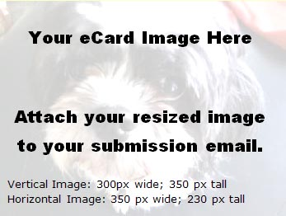  Contest Rules »  About [Organization] »  About [Campaign/Event] »  [Note: we will modify the button to match your branding;  you can design & submit your own if you prefer] | [Copy and paste your suggested message text here:  You have very little space for content so make it count.  Word count is around 70, character count is around 450 with spaces.  This message should be written from the perspective of a supporter telling their friend about your organization and this campaign/give-away opportunity.]
Mission: [Add your mission statement here Lorem ipsum dolor sit amet, consectetur adipiscing elit. Sed ante. Proin at eros. Proin turpis. Vestibulum neque lorem, laoreet et, rutrum eget, porta egestas, nulla. ]
Visit Our Website | Donate | Forward to a Friend | Get Involved

CONTEST RULES
Requirements
The following represents boilerplate content that you are welcome to modify as needed. We will update this boilerplate language on your behalf if you do not provide revisions. This boilerplate language does not constitute legal advice – if in doubt about the structure of your contest or the adequacy of this language, please consult an attorney.

Official Give Away Contest Rules and Prizes

1. NO PURCHASE NECCESARY TO ENTER OR TO WIN. ALL FEDERAL, STATE, LOCAL AND MUNICPAL LAWS AND REGULATIONS APPLY. VOID WHERE PROHIBITED.

2. Eligibility: This Give Away is open to all legal residents of the United States, who as of [drawing date] are at least 18 years of age and have a valid e-mail account. Employees of [organization name] and the immediate family members of, and any person domiciled with such employees, are not eligible. [Organization name] is not responsible for contest form failures or errors in any promotional graphics or advertisements. Winner must be in compliance with all contest rules.

3. Method of Entry: The Give Away begins on [start date]. Each entry must include a valid e-mail address.

4. Selection of winners: The winner will be selected in a random drawing on [end date]. Odds of winning depend upon the number of entries received.

5. Prize: One (1) winner will receive [incentive description]. Value of this prize package is [amount].

6. Winner Notification and Acceptance: The winner will be notified by phone on [date of drawing]. Participants grant [organization name] the right to use their name in advertising and promoting the contest without further compensation.

7. Participation: All decisions regarding disqualification of entries shall be in [organization name]’s sole discretion. [Organization name] is not liable for lost, late, delayed, damaged, or incomplete email or transactions, for failure to receive entries due to transmission failures or technical failures of any kind, including, without limitation, malfunctioning of any network, hardware or software, whether originating with sender or [organization name]. In the event of a dispute, all email entries will be deemed to have been submitted by the owner of the email account from which they were sent. For these purposes, an email account holder shall mean the natural person assigned to such email account by the Internet access provider, online service provider or other organization responsible for assigning email addresses for the domain associated with such email account.

8. Limitations of Liability: By entering the Contest, entrant agrees that all disputes, claims, and causes of action arising out of or in connection with the contest, or any prizes awarded, shall be resolved individually without resort to any form of class action; any claims, judgments, and awards shall be limited to actual out-of-pocket costs incurred, including costs associated with entering the contest, but in no event attorney’s fees and under no circumstances will any entrant be permitted to obtain any award for, and entrant hereby waives all rights to claim, punitive, incidental or consequential damages and any and all rights to have damages multiplied or otherwise increased and any other damages other than damages for actual out of pocket expenses.

9. Construction: All issues and questions concerning the construction, validity, interpretation, and enforceability of these official contest rules, or the rights and obligations of any contestant and [organization name], shall be governed by, and construed in accordance with the laws of the [state where the organization is headquartered], without giving effect to any choice of laws or conflict of law rules or provisions that would cause the application the laws of any jurisdiction other than [state]. In the event that any such provision is determined to be invalid or otherwise unenforceable, these rules shall be construed in accordance with their terms as if the invalid or unenforceable provisions were not contained therein.

10. General Release: By entering the Contest, contestants release [organization name] and their affiliated companies and agents from any liability whatsoever for any claims, costs, injuries, losses or damage of any kind whatsoever arising out of or in connection with the Contest or with the acceptance or possession of any prize (including, without limitation, claims, costs, injuries, losses, or damages related to personal injuries, death, damage to, loss or destruction of property, rights of publicity or privacy, defamation, or portrayal in a false light).

11. Sponsor: The Give Away Contest is sponsored by [organization name], whose decisions regarding the selection of winner and all other aspects of the Contest shall be final and binding in all respects. [Organization Name] with not be responsible for typographical, printing or other inadvertent errors in these Official Contest Rules or in other materials related to the Contest. If you have any questions regarding this Contest, please contact [organization name] at [email address or phone number].

SUPPRESSION LIST FOR All CAMPAIGN MESSAGES
Requirements – file must be in “.csv” file format.

Your suppression list must include these three pieces of information for each individual to be included in the suppression list:
- First Name
- Last Name
- Email Address

When you are ready to send your list to Convio, please follow these instructions:

- Visit http://www.sendthisfile.com
- Set up a new account for free
- With your new account, you will be able to securely send large files using a secure link instead of sending the file through email
- Follow the instructions on the website to upload your file and then send the file link to getready@convio.com
- Please contact us if you have any questions about this process
- Please do not send lists of contacts via email
CONVIO SEGMENTS TO SUPPRESS FOR THIS CAMPAIGN
Requirements – pre-existing group segmentation defined in your Constituent360 database

The Convio group names you provide here must match the groups/segments that you defined in your Convio Go! Data Management Guide. Alternatively, you may manually create and populate groups in your Constituent360 database and provide the names of those groups here.

[Enter group/segment names here]

