**Add Image to Donation Level**

1. Navigate to Fundraising > Donation Management > Online Giving
2. Find the campaign you wish to edit.
3. 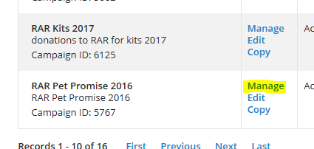Manage the campaign:
4. Edit the form:

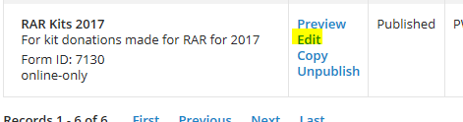

1. Click on #3 “Design Donor Screens”  
   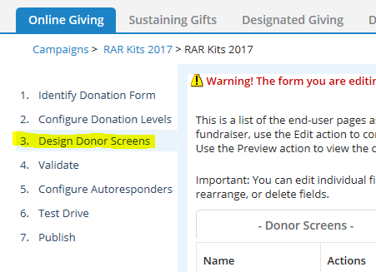
2. Click on “Edit” for Donation Form  
   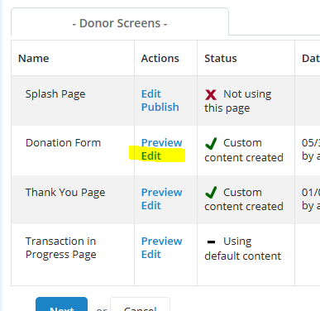
3. Click on the “Standard Donation Level” and then “Save Order and Edit Selected”  
   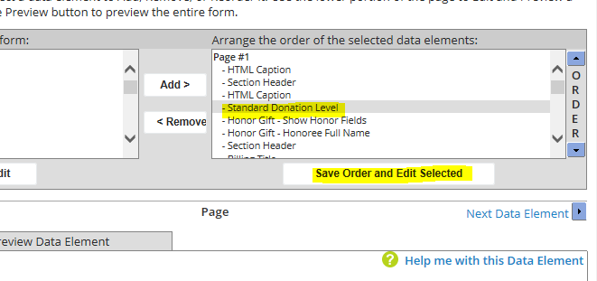
4. Click on “Ask Message.” If there is a dash, that means there is no ask message. If there is a checkmark, there is already an ask message which you can edit.  
   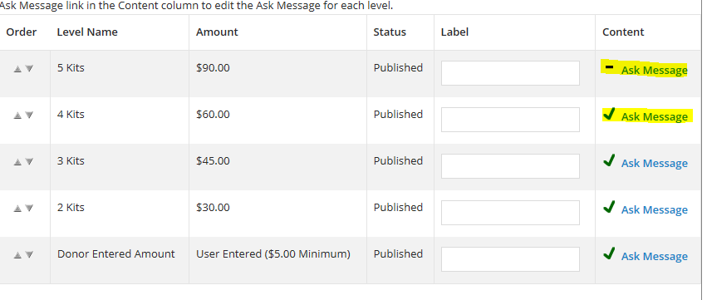
5. Either type in your HTML or use the WYSIWYG – and then click “Finish” at the bottom.  
   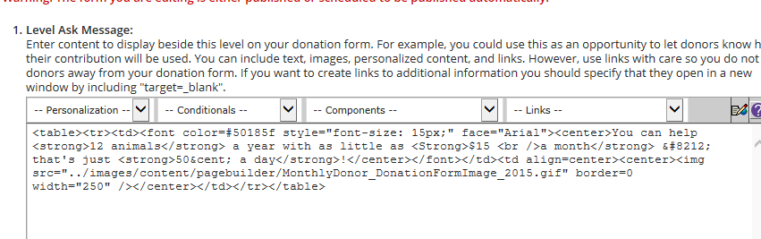
6. Either add other messages to other levels, or when done, click “Finish” (which will save your changes and go back to the main navigation within the form) or “Save” (which save your changes, but stay on this edit section for editing the donation form) at the bottom. (It is recommended you preview the changes and roll back anything that is not working.)  
   