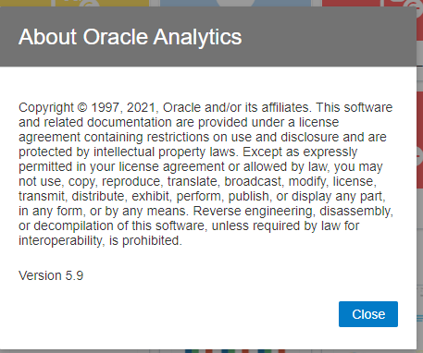

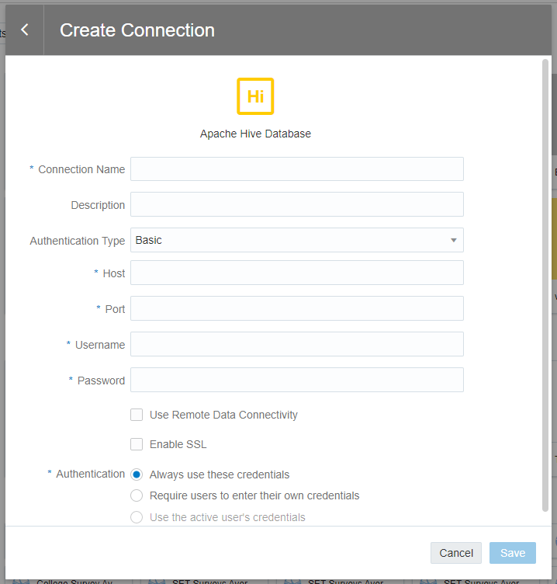
jdbc:hive2://vicuni-bdhub-master0.vu735.etpe-lobe.cloudera.site/;ssl=true;transportMode=http;httpPath=vicuni-bdhub/cdp-proxy-api/hive

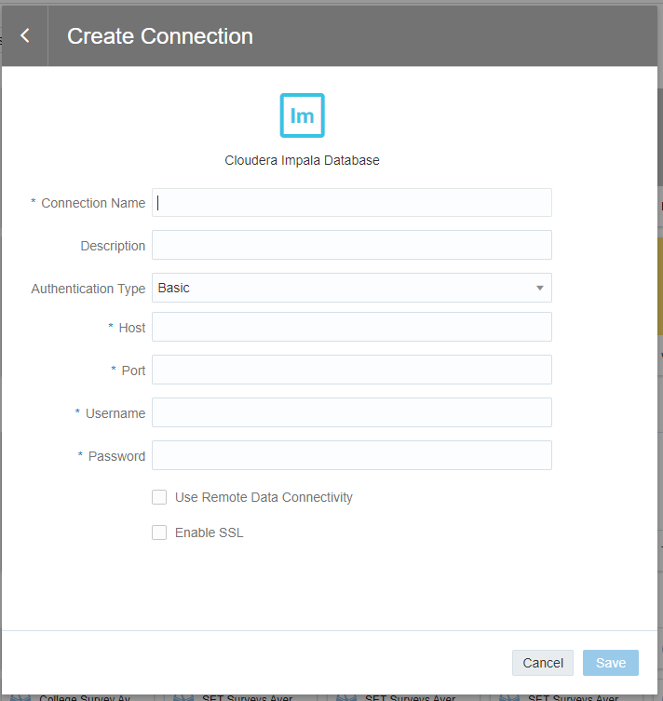
jdbc:impala://vicuni-bdhub-master0.vu735.etpe-lobe.cloudera.site:443/;ssl=1;transportMode=http;httpPath=vicuni-bdhub/cdp-proxy-api/impala;AuthMech=3;

