Example 1: Project 3 List:
URL gets redirected to Prod:
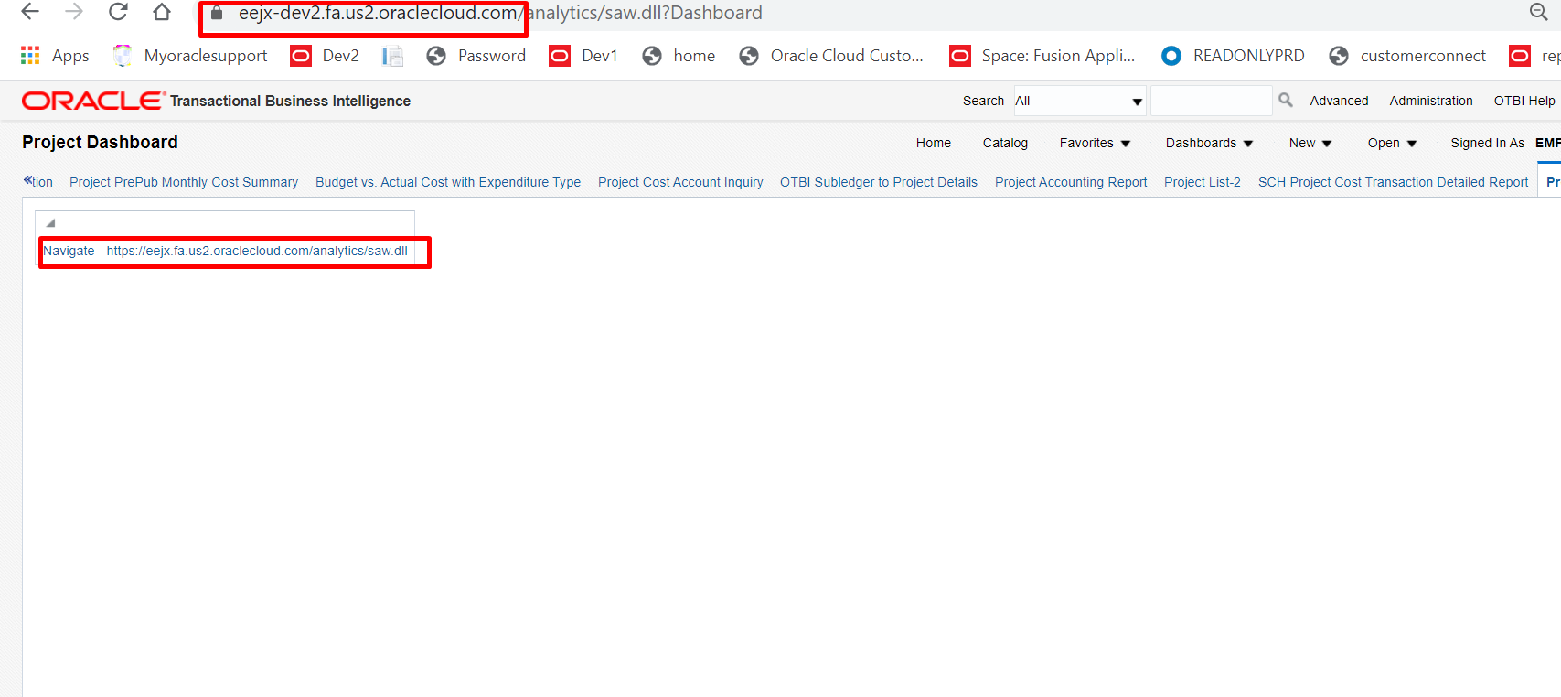

Example 2: SCH Account Inquiry Detail Report for Entered Currencies:

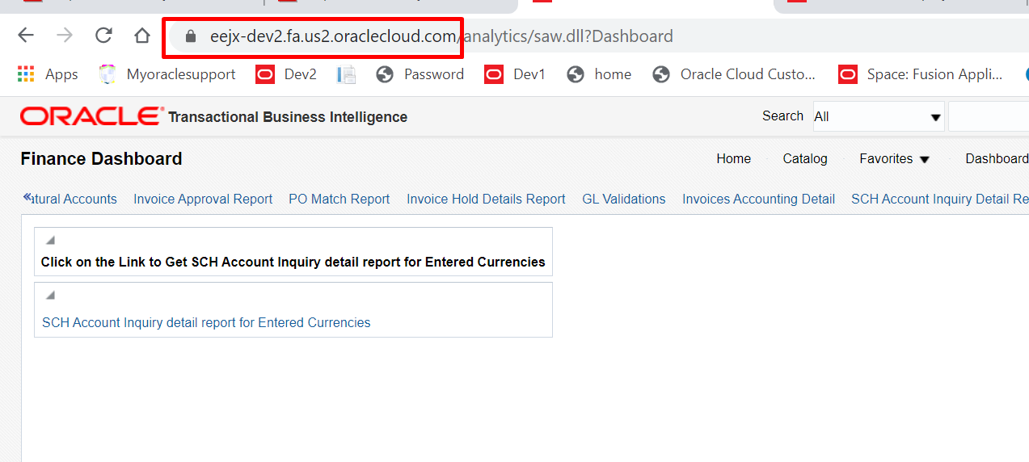
It gets directed to Prod:
