Crawl Job Status:
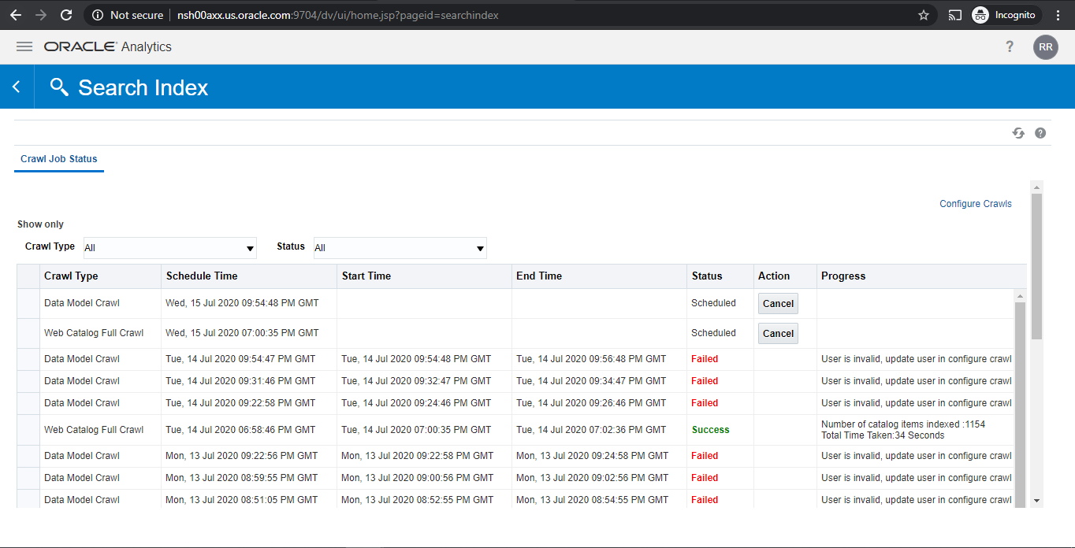

Datamodel crawl config:
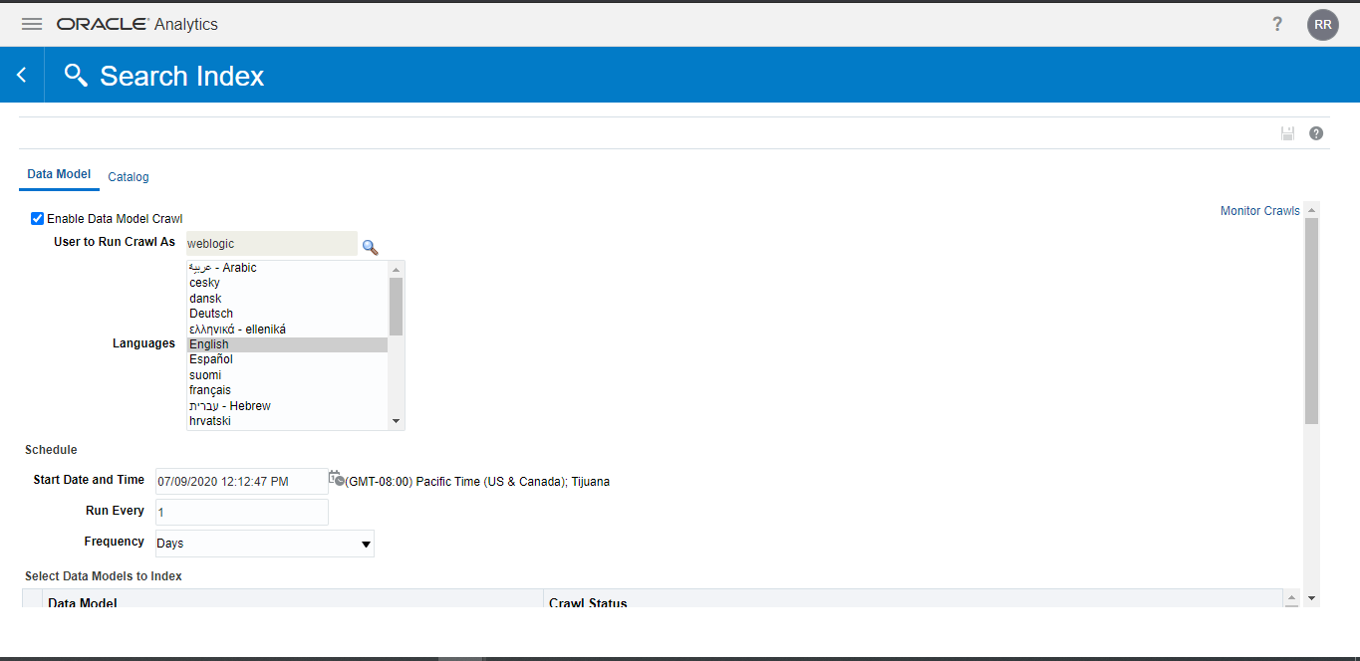

Catalog crawl config:
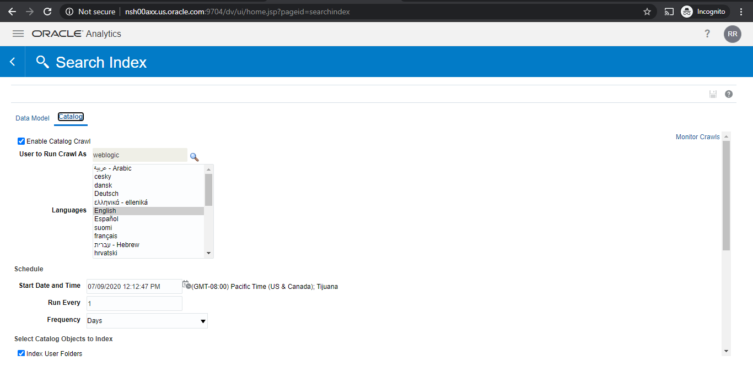

Search Contents not working : datamodel crawl Failed
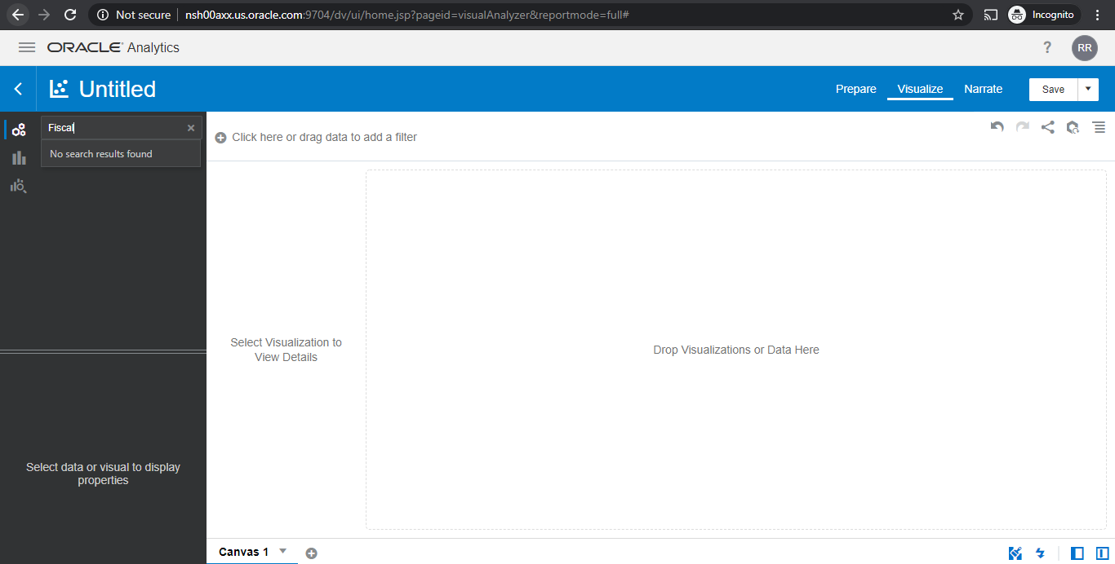

IDCS User: Valid
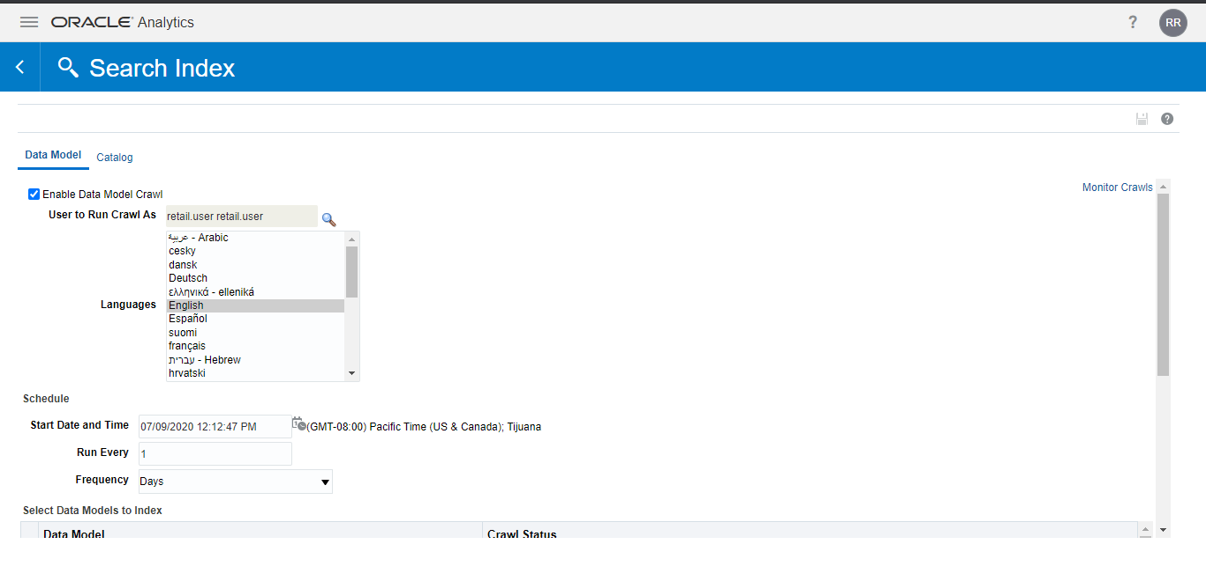
Montiro Crawl for Datamodel:
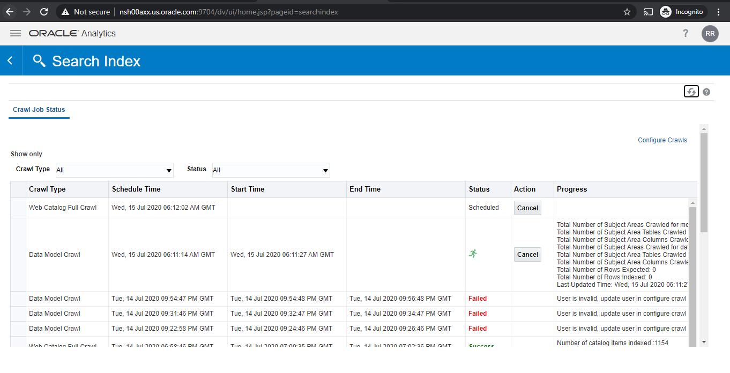

Search works post setting to IDCS User:Success

