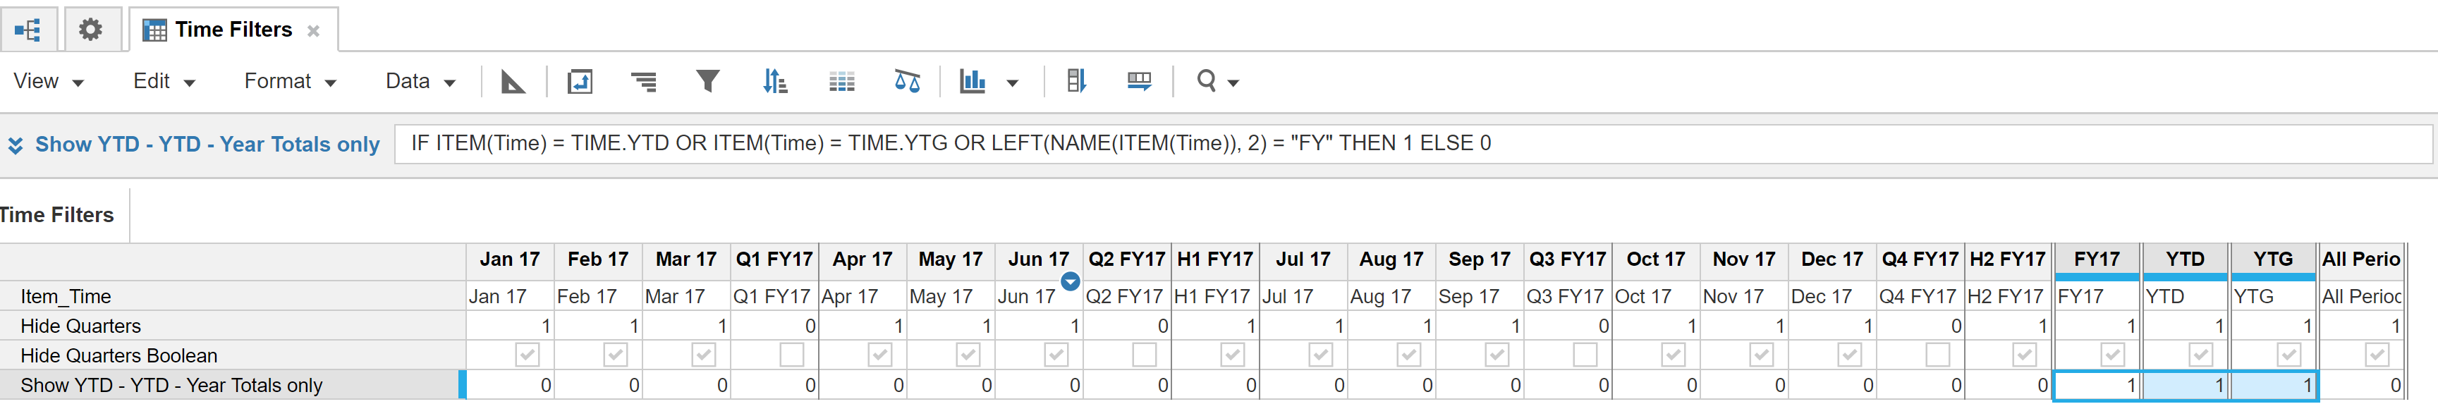
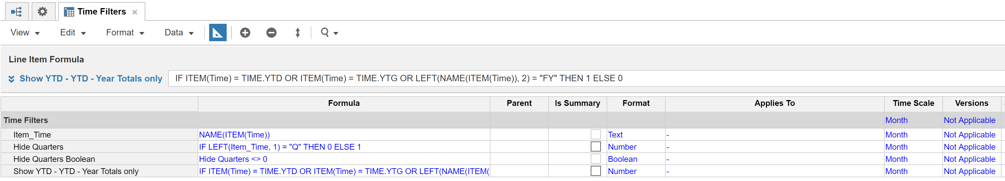
Notes:
- All of the line items have Summary = Formula
- “Item_Time” is an example to show how we can use the current time period, even summary time periods, in formulas
- Do you see how we can know, via formula, what time period we are in? For example, we know can check for Item(Time)=Time.YTD or Time.YTG…
- Knowing what time period we are in… and what we want to show/suppress with out filter, we can generate zeroes for quarters and (one’s or some other number for YTD, YTG… ), and either use the Number formatted row or a Boolean in our filter.

