2. Saved View of Source Data

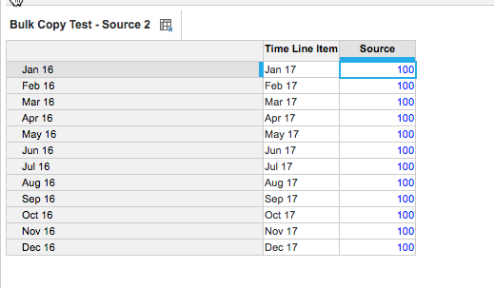

3. Target Data format

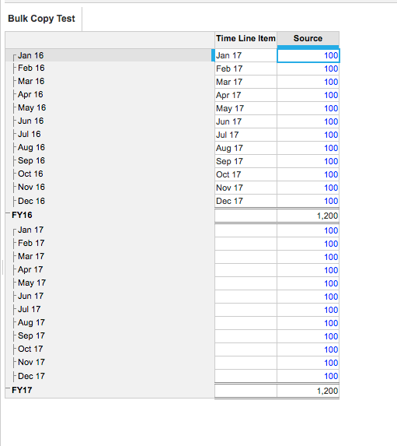

5. Map your ‘Time Line Item’ to the Timescale in the Target

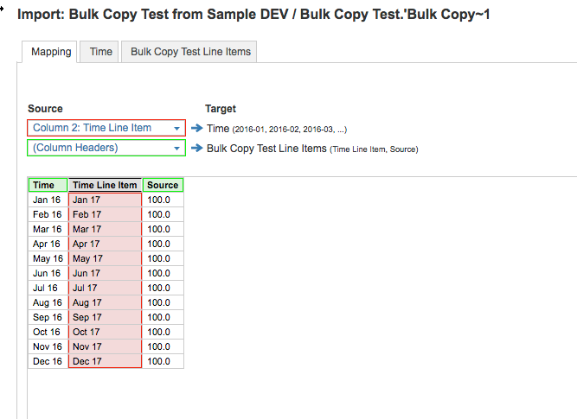

6. Map the Source Line Item to the Target Line Item and Ignore the Time entries

