In this example, the value is only off by 1 or 2, but as the values get larger, the difference also gets larger, which causes end users to flag these discrepancies.

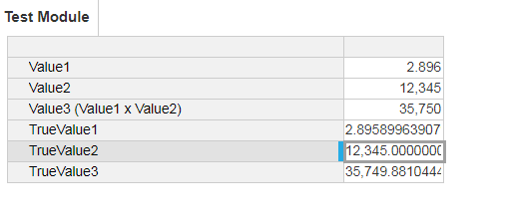

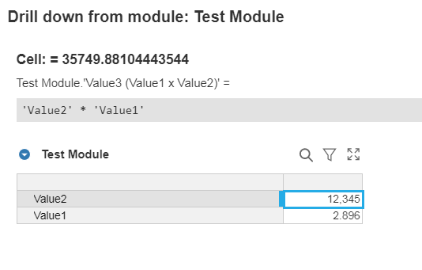

Actual Mathematical value of 12345 x 2.896

