Anaplan Connect – Import source file

- Import Process details
Import Process name: Import Department list from CSV file
Old source file: SG_CRC.csv
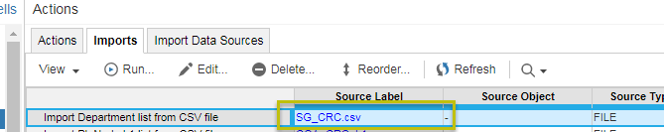

- Anaplan Connect Script
New source file: SG_CRC_v1.csv
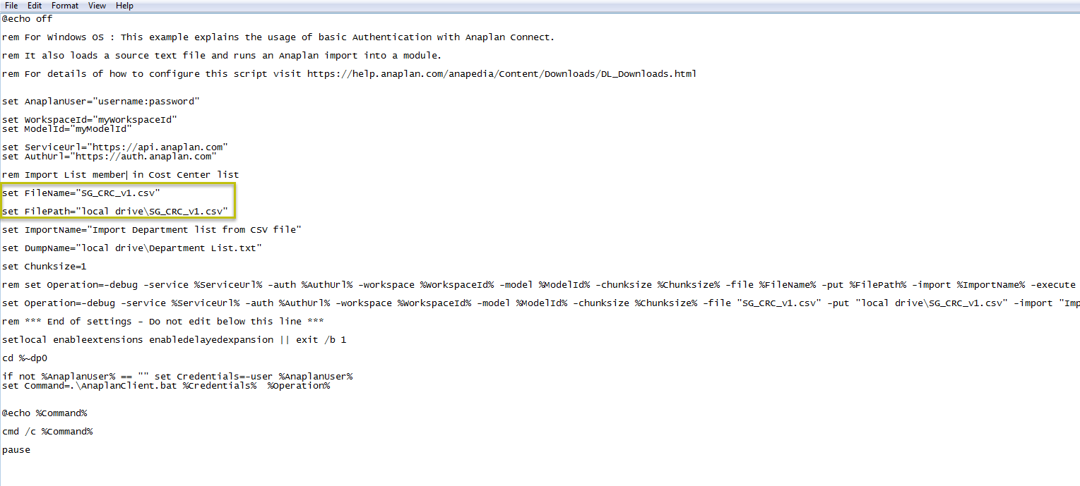

@echo off
rem For Windows OS : This example explains the usage of basic Authentication with Anaplan Connect.
rem It also loads a source text file and runs an Anaplan import into a module.
rem For details of how to configure this script visit https://help.anaplan.com/anapedia/Content/Downloads/DL_Downloads.html

set AnaplanUser="username:password"

set WorkspaceId="myWorkspaceId"
set ModelId="myModelId"
set ServiceUrl="https://api.anaplan.com"
set AuthUrl=https://auth.anaplan.com

rem Import List member in Cost Center list
set FileName="SG_CRC_v1.csv"
set FilePath="local drive\SG_CRC_v1.csv"
set ImportName="Import Department list from CSV file"
set DumpName="local drive\Department List.txt"

set Chunksize=1

rem set Operation=-debug -service %ServiceUrl% -auth %AuthUrl% -workspace %WorkspaceId% -model %ModelId% -chunksize %Chunksize% -file %FileName% -put %FilePath% -import %ImportName% -execute -output %DumpName%

set Operation=-debug -service %ServiceUrl% -auth %AuthUrl% -workspace %WorkspaceId% -model %ModelId% -chunksize %Chunksize% -file "SG_CRC_v1.csv" -put "local drive\SG_CRC_v1.csv" -import "Import Department list from CSV file" -execute -output "local drive\Department List.txt"

rem *** End of settings - Do not edit below this line ***
setlocal enableextensions enabledelayedexpansion || exit /b 1
cd %~dp0
if not %AnaplanUser% == "" set Credentials=-user %AnaplanUser%
set Command=.\AnaplanClient.bat %Credentials% %Operation%
@echo %Command%
cmd /c %Command%
pause

