Hi,

I have some clarification on the Anaplan Connect API 1.4.1. I was able to use this API before I think that was the older version. I also read the pdf for file import using Anaplan Connect API and encountered some problems. I contacted Anaplan support to point me to the right direction and they also referred me to the integration team which clarified some points particularly on the script part.

This is what I have currently:
This is the sample Process that I created for the Anaplan API testing.
File Name: BPM_BENCH TRAIN.csv (this is one of the csv source file that the client loads per month on their Data Hub)
Process Name: Sample BPM Bench

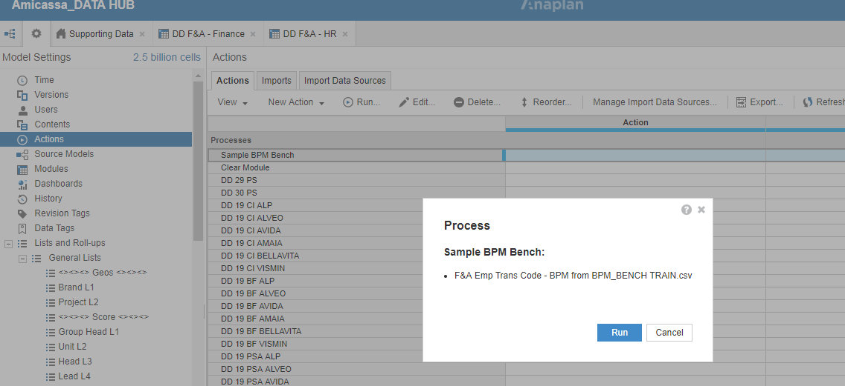

I run the Process independently to make sure this is working and below is the result.
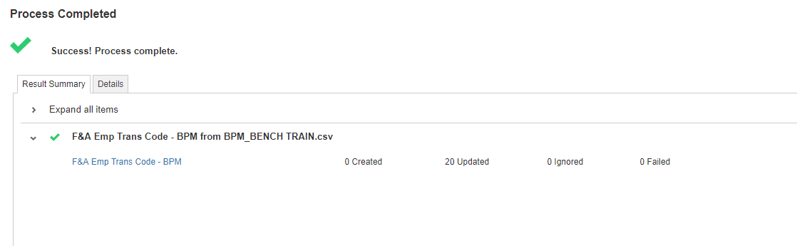

For this testing I saved the file on my PC as well as the Anaplan Connect API

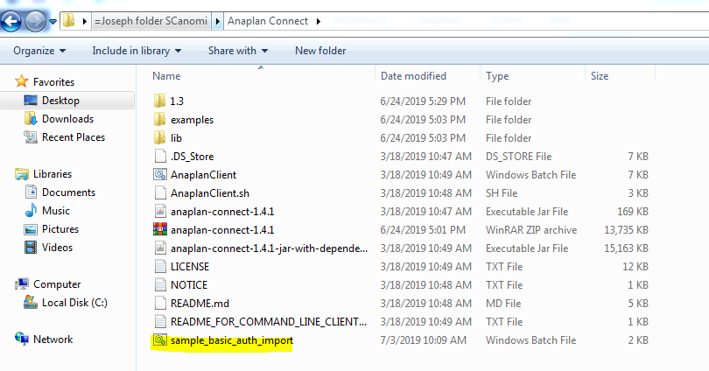

Once this is Live all csv source files will be saved in the clients designated server.

After talking to Anaplan Support this is what they told me to configure the script and have a Process defined under set Operation

So currently this is what my script looks like:

set AnaplanUser="joseph.sherwin@scanomi.com:Jsd@deloria27"
set WorkspaceId="8a81b00e67191af001672d4db52616de"
set ModelId="F20ABC53A2554AD79A8AC9B21F528770"
set ServiceUrl="https://api.anaplan.com"
set AuthUrl="https://auth.anaplan.com"
set FileName="BPM_BENCH TRAIN.csv"
set FilePath="C:\Users\User\Desktop\=Joseph folder SCanomi\Ayala Scorecard\F&A Folders\BPM\BPM_BENCH TRAIN.csv"
set ProcessName="Sample BPM Bench"
set DumpName="C:\Users\User\Desktop\=Joseph folder SCanomi\Anaplan Connect\Notes.txt"
set Chunksize=1

set Operation=-debug -service %ServiceUrl% -auth %AuthUrl% -workspace %WorkspaceId% -model %ModelId% -chunksize %Chunksize% -file %FileName% -put %FilePath% -Process % ProcessName% -execute -output %DumpName%
rem *** End of settings - Do not edit below this line ***

setlocal enableextensions enabledelayedexpansion || exit /b 1
cd %~dp0
if not %AnaplanUser% == "" set Credentials=-user %AnaplanUser%
set Command=.\AnaplanClient.bat %Credentials% %Operation%
@echo %Command%
cmd /c %Command%
pause

after running it this is my result:

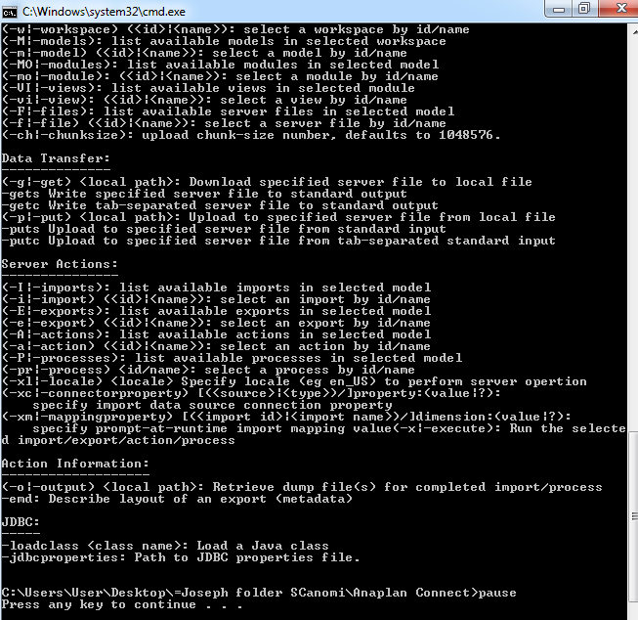

Question:
- What does “Load a Java Class” means?
- Is this a successful load or this is an error message?
- Can I load more than 1 import file using 1 script or do I need to create a separate script for every import file?
- Do I need to install anything on my PC to make this work?

Hope you can help me. I have been stuck with this for a while now.

Regards,

