IPSIS – D2L Standard CSV Error Playbook

Purpose
This document will list common errors that can be received when beginning to develop D2L Standard CSV files or while continuing administration of D2L Standard CSV after you have gone live with the integration. Note, this is not comprehensive for all possible error messages. More errors will be added to this listing as necessary to assist new admins with how to resolve issues with their integration.

Format used throughout this document

Error Message
<Top Level Error>
<Expanded Error>
<overview of the metadata provided with the error>
<screenshot of error within the IPSIS logs>

Cause
<description of why the error occurred>

Resolution
<steps to resolve the error. This could be firm steps or suggested next steps for investigating further>

Warning Message
<Top Level Warning>
<overview of the metadata provided with the warning>
<screenshot of warning within the IPSIS logs>

Cause
<description of why the warning occurred>

Resolution
<steps to resolve the warning. This could be firm steps or suggested next steps for investigating further>

Info Message
<Top Level Information>
<screenshot of information within the IPSIS logs>

Description
<description of what the message means>

Index
Errors 3
Malformed CSV 3
Invalid record length 3
invalid opening quote: a quote is found inside a field at line <line>, field:<name> 4
StandardCSV Spec Violation – OrgUnit 4
start_date" must be a string with one of the following formats [YYYY-MM-DD, YYYY-MM-DDTHH:mm:ss.SSS], "end_date" must be a string with one of the following formats [YYYY-MM-DD, YYYY-MM-DDTHH:mm:ss.SSS] 4
Missing Required Column(s) 5
StandardCSV Spec Violation - User 6
relationships” must be “|” separated for version 2.0.0. Please see documentation for more detail. 6
Missing required column(s) 6
No org unit mapping found for source system 7
Parent org unit mapping not found 8
No user mapping found for source system 8
No role mapping found for source system 9
Error processing message 10
RoleMapping not found for instructor 10
Replaceenrollmentreadimhandler.process – unable to find org unit specified in enrollment request. 11
user can not be created. errors: the username supplied is invalid or already in use. please choose a different username 11
Unable to save org user 12
request.d2lorguser.profile is invalid parameter name:request.d2lorguser.profile 13
OrgDefinedid contains invalid characters 14
invalid request typename provided. no mapping found for type:<type> in source system:<system>. parameter name:typename 15
Violation of unique key constraint ‘uc_im_user_mappngs_orgiduseridsystemid’. cannot insert duplicate key in object ‘dbo.im_user_mappings’. the duplicate key value is (<userid>, <Orgid>, <systemid>). 15
cannot insert duplicate key row in object ‘dbo.user_organization_memberships’ with unique index ‘ix_user_organization_memberships_Orgiduniqueidentifier’. the duplicate key value is (<Orgid>, <username>). 16
ReplaceEnrollmentReadIMHandler.Process – Unable to find org unit specified in enrollment request 17
Unknown file type. Headers do not match manifest version 18
Error threshold has been reached. 18
No handlers were found for type:<handler> in org:<orgid> with extension point:IPSIS 19
Warnings 20
<file> may have charset encoding issues, D2L Standard CSV supports UTF-8 encoding only. 20
SourcedId did not match a valid entry. The mapping may have been deleted. 20
User Mapping not found building relationships, skipping 20
Informational 21
OrgUnit translation started 21
OrgUnit translation finished 21
User translation started 21
User translation finished 22
Enrollment translation started 22
Enrollment translation finished 22
Completed CSV Job 22

Errors

Error Message
Malformed CSV
Invalid record length
The file the error occurred within is listed in the metadata. The error also lists the header length compared to the length expected and the line the issue occurred on.

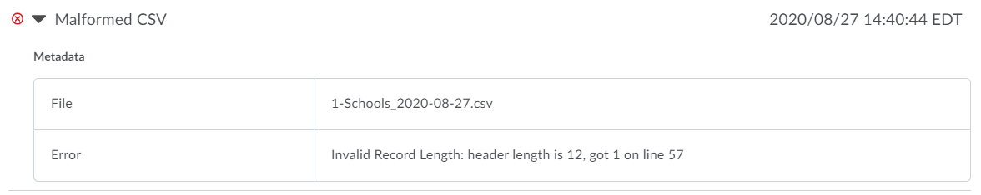Cause
This issue occurs when the number of columns on a row does not match the expected number for the file format. This can occur because not enough columns were included such as not including commas to denote empty columns or because too many columns are included such as including unescaped commas within the fields causing the parsing to detect more columns than required.

Resolution
Resolution will depend on the issue causing the error. Changing the extract code to include the correct columns including commas denoting empty fields or removing commas from data elements that should not contain it are two ways that this error may need to be resolved.

Error Message
Malformed CSV
invalid opening quote: a quote is found inside a field at line <line>, field:<name>
The file the error occurred within is listed. The line number and field with the invalid quote are listed in the error.

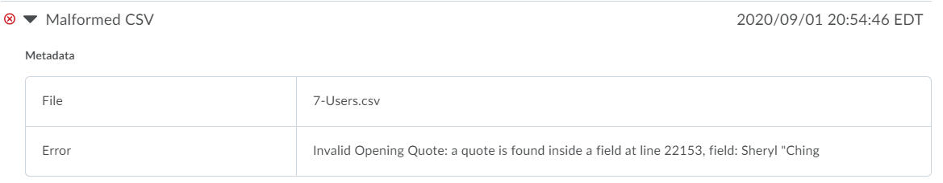Cause
This issue occurs when a quote has been included within a field. To escape special characters an entire field can be surrounded by quotes but quotes within fields is not valid.

Resolution
Updating the source data to remove the quote or changing the extract code to remove the quote character will be required to correct this issue.

Error Message
StandardCSV Spec Violation – OrgUnit
“start_date" must be a string with one of the following formats [YYYY-MM-DD, YYYY-MM-DDTHH:mm:ss.SSS], "end_date" must be a string with one of the following formats [YYYY-MM-DD, YYYY-MM-DDTHH:mm:ss.SSS]
For this error message, the log will list the error, the file it occurred within, the line the error occurred, and the columns affected. This error can only occur for Org Unit entities so the top level message will always refer to an Org Unit spec violation.
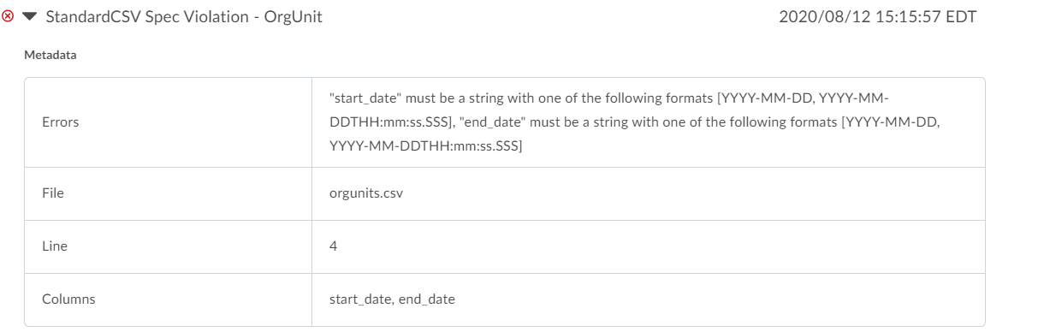

Cause
The date format within the files does not match the expected date format. In the example screenshot, both the start_date and end_date columns are affected for Line 4 in the file orgunits.csv. This most commonly occurs during initial file development and affects all rows although it can occur on a one-off basis.

Resolution
Updating all included dates to use either the format YYYY-MM-DD or YYYY-MM-DDTHH:mm:ss.SSS will resolve the error.

Error Message
StandardCSV Spec Violation – OrgUnit
Missing Required Column(s)
For this error message, the log will list the required column that is empty, the file affected, the line with the issue, and the error message. This error can occur for all file types, meaning the OrgUnit reference in the top level error could be different if the required column that is empty is within the Users or Enrollment files.

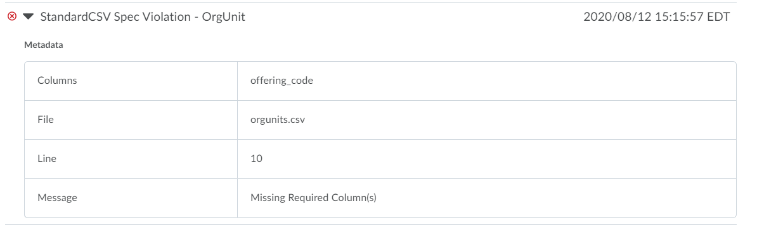Cause
This error occurs when a required column is empty. This most commonly occurs during initial file development. It can be caused by not following the D2L Standard CSV specification properly or because bad data that does not contain the required values has been included.

Resolution
To resolve the error, all required columns should be populated with a value.

Error Message
StandardCSV Spec Violation - User
“relationships” must be “|” separated for version 2.0.0. Please see documentation for more detail.
Multiple metadata fields defining the file, line, and column of the problem data are provided.

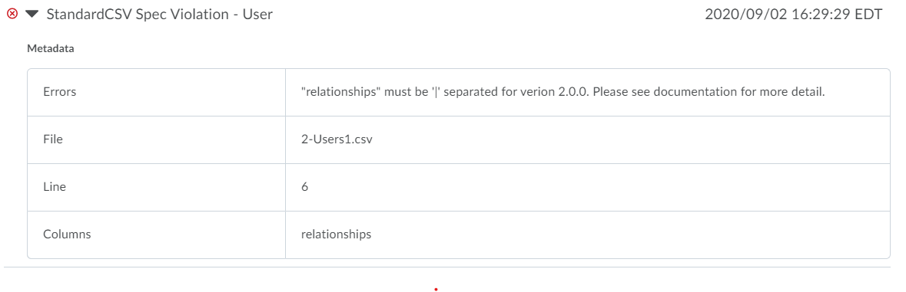Cause
This issue occurs if relationships are not separated by a pipe character, |, as expected. Parent:<some data> or Auditor:<somedata> followed by any character other than |would produce this error.

Resolution
Properly separating relationships with a pipe character will resolve this error. If invalid additional relationships are included they should be removed.

Error Message
Standard CSV Spec Violation - User
Missing required column(s)
When a required column or columns are missing, the relevant file, line, and columns will be listed to easily identify the problem.

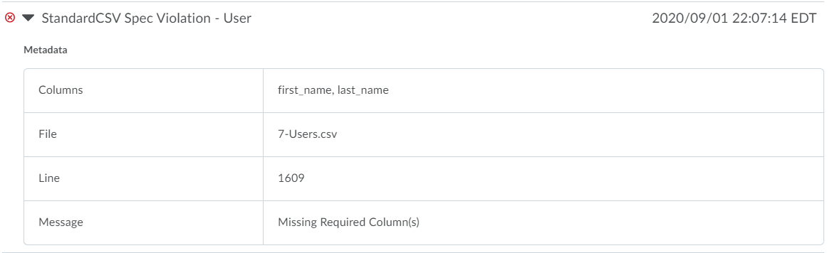Cause
Any field marked as required for a data entry must contain the required data to avoid this error.

Resolution
Ensure all required fields are always populated. If a data element does not contain all required fields, consider whether the source data should be updated or excluded.

Error Message
No org unit mapping found for source system
No org unit mapping found for source system
The OrgUnitCode of the org unit that is attempting to be used is provided in the IMIdentifier metadata field. The ID of the value that is attempting to use the specified org unit is provided in the SourcedId metadata field.

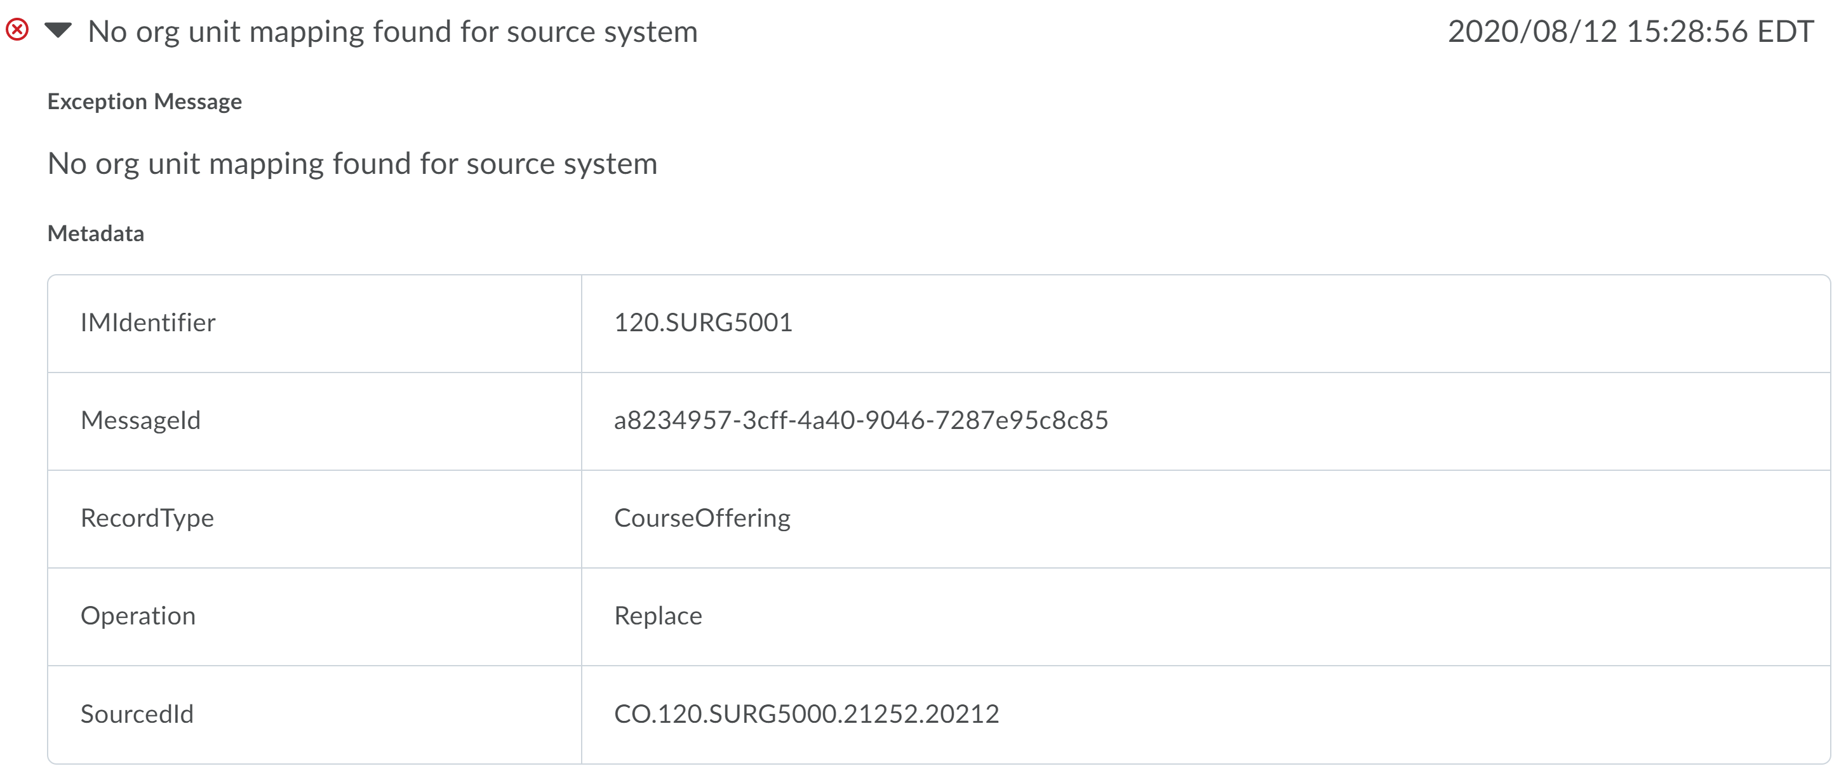Cause
The org unit specified either does not exist or has not been sent through IPSIS.

Resolution
If the correct ID is specified, send an UPDATE request for the org unit to either create the org unit or connect IPSIS to an existing org unit.

Error Message
Parent org unit mapping not found
Parent org unit mapping not found
The RecordType field within the metadata will describe the type of the org unit that received the error. The SourcedID is the Org Unit Code described in the CSV file for this record. The ParentSourcedID is the Org Unit Code of the parent org unit that has not yet been successfully processed by IPSIS.

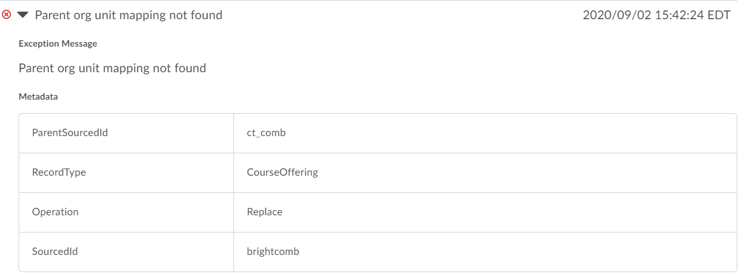Cause
This error occurs when a parent org unit is used that has not been successfully processed by IPSIS. Either the org unit with this exact org unit code has never been sent through IPSIS or it has been sent but received an error and has not successfully processed.

Resolution
If the org unit has not been sent through IPSIS, it must be included in its own CSV file prior to using it as a parent org unit. If it has been sent but received an error preventing successful processing, the error must be corrected prior to using the parent org unit.

Error Message
No user mapping found for source system
No user mapping found for source system
This error message will provide multiple data elements to identify the enrollment that did not process. The SourceSystem is the identifier for the SIS Configuration used. IMIdentifier is the OrgDefinedId value that would be required to have already been sent through IPSIS. SourcedId lists the Section and OrgDefinedId combination that should have processed.

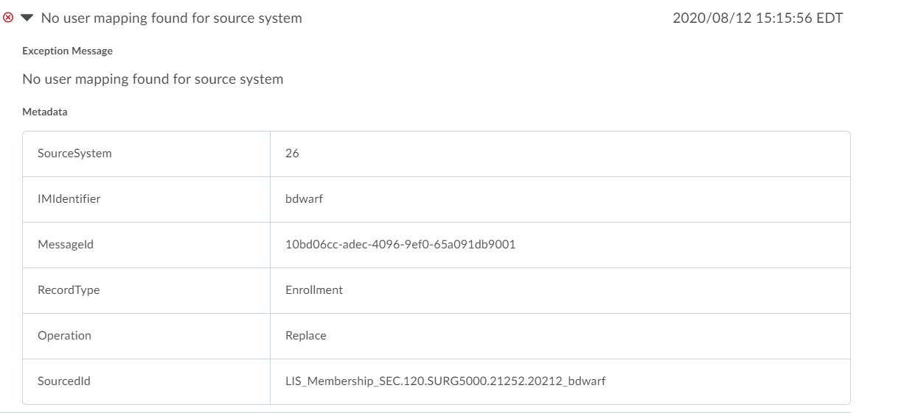Cause
This error occurs when the user specified in the enrollment request does not exist or has not been sent through IPSIS. For IPSIS to process an enrollment, the user and org unit must have first been processed by IPSIS even if they were created manually within the Learning Environment.

Resolution
An UPDATE record for the user should be sent to either create a new user or connect to an existing user with the Learning Environment with the same OrgDefinedId and Username.

Error Message
No role mapping found for source system
No role mapping found for source system
The role that is not currently mapped is listed in the IMIdentifier metadata field. The user record that could not process due to the missing mapping is specified in the SourcedId metadata field.

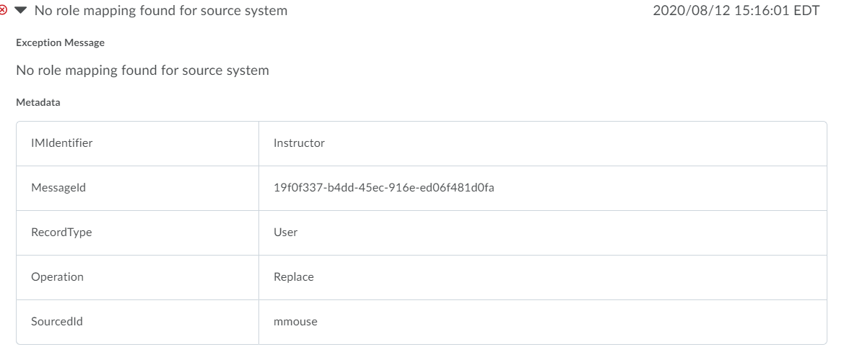Cause
This error occurs when an enrollment is sent for a role that is not mapped with IPSIS. The role mapping determines what role within Brightspace is used when a role code is seen in the CSV files.

Resolution
If the role within the CSV file is correct it needs to be added to the role mapping on the IPSIS Administration – Configuration page.

Error Message
Error processing message
RoleMapping not found for instructor
The Section code and OrgDefinedId for the enrollment record are provided in the SourcedId metadata field.

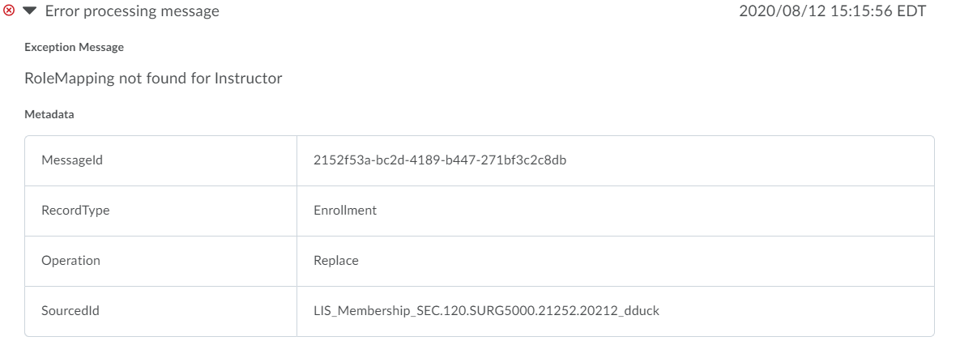Cause
This error occurs when an enrollment is sent for a role that is not mapped with IPSIS. The role mapping determines what role within Brightspace is used when a role code is seen in the CSV files.

Resolution
If the role within the CSV file is correct it needs to be added to the role mapping on the IPSIS Administration – Configuration page.

Error Message
Error processing message
Replaceenrollmentreadimhandler.process – unable to find org unit specified in enrollment request.
The org unit and user for the enrollment request are specified in the SourcedId metadata field.

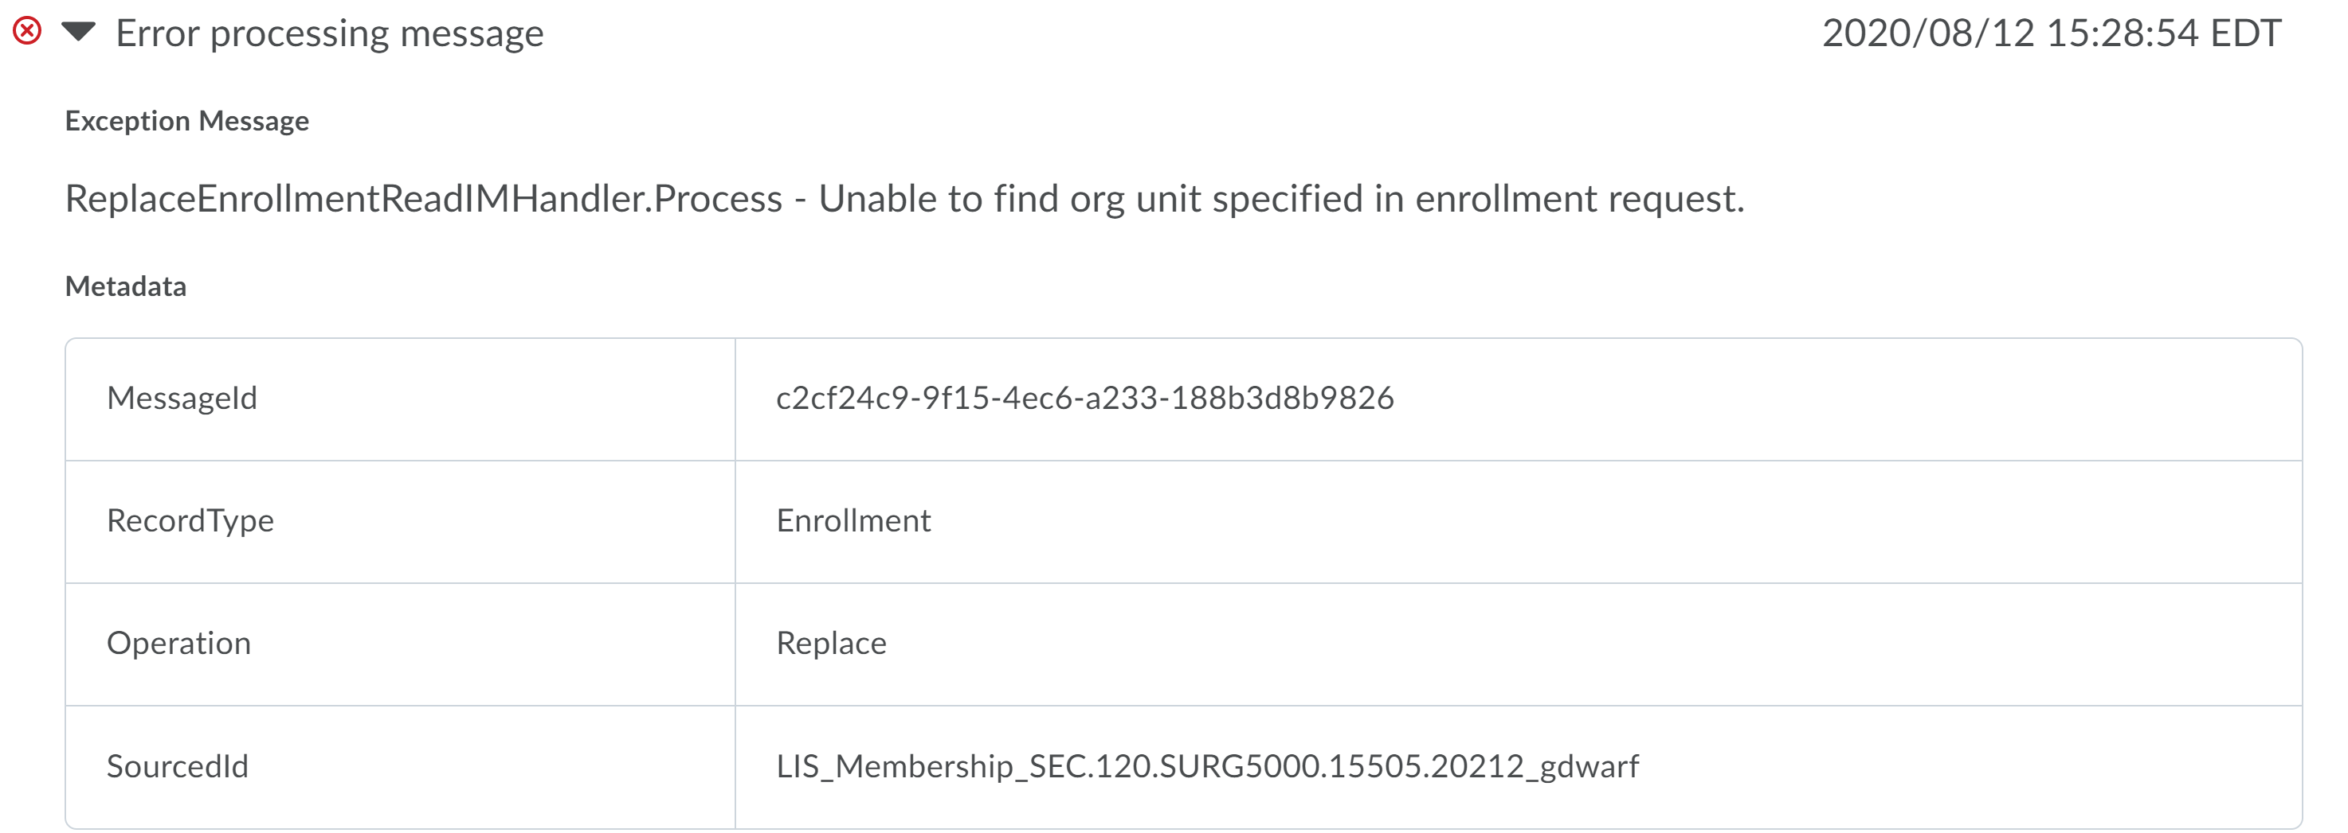Cause
This error occurs when the org unit specified in the OrgUnitSourcedId either does not exist in Brightspace or has not been sent through IPSIS.

Resolution
If the correct ID is specified, an UPDATE org unit record should be sent through IPSIS to either create the org unit or connect IPSIS to an existing org unit.

Error Message
Error processing message
user can not be created. errors: the username supplied is invalid or already in use. please choose a different username
The orgdefinedid is listed for the user record that received the error.

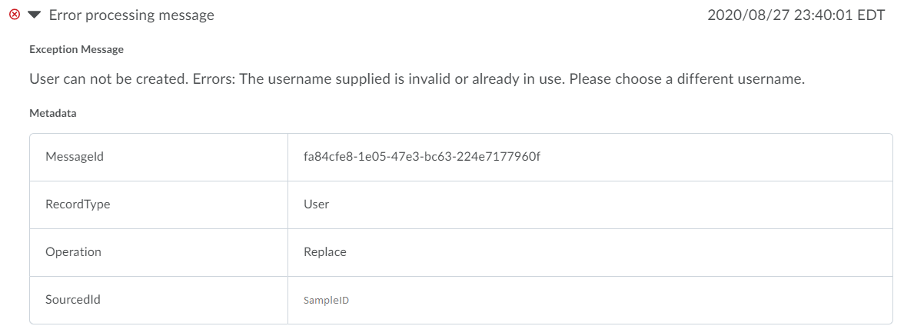Cause
The error occurs when the username in the user record already exists within Brightspace. Either the username can be used by a newly created record from earlier in the CSV file or the account could already exist within Brightspace from prior IPSIS usage or from manual creation. Username is a required, unique, case insensitive field.

Resolution
Resolving this error may involve a little investigation. The error can be caused by reuse of usernames, non-unique username generation from your SIS, changing the OrgDefinedId without updating the mapping, or other causes. The suggested solution is to verify what user is using the username within Brightspace with what OrgDefinedId. Then verify where the username is used in your SIS and which user is using it with which OrgDefinedId. Then determine if these are the same user or different users. If the same, update the user’s information either in your SIS or by updating the OrgDefinedId mapping in Brightspace. If different, correct by updating the username in your SIS or changing the existing user within Brightspace. The changes to be made will depend on your data.

Error Message
Error processing message
Unable to save org user
The orgdefinedid is listed for the user record that received the error.

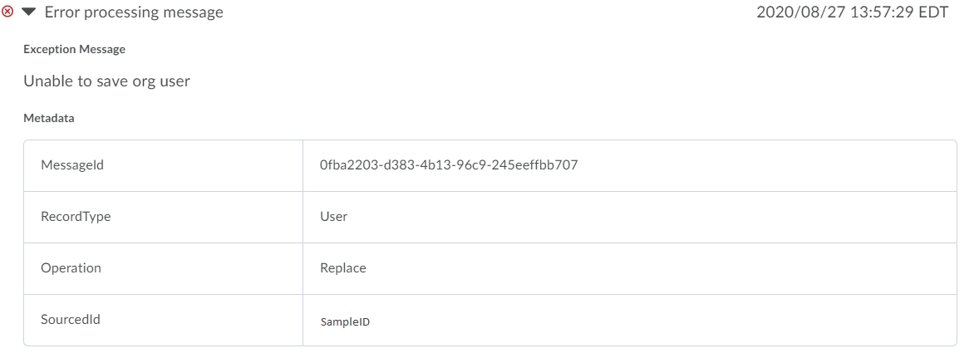Cause
The error occurs when the username in the user record already exists within Brightspace. Either the username can be used by a newly created record from earlier in the CSV file or the account could already exist within Brightspace from prior IPSIS usage or from manual creation. Username is a required, unique, case insensitive field.

Resolution
Resolving this error may involve a little investigation. The error can be caused by reuse of usernames, non-unique username generation from your SIS, changing the OrgDefinedId without updating the mapping, or other causes. The suggested solution is to verify what user is using the username within Brightspace with what OrgDefinedId. Then verify where the username is used in your SIS and which user is using it with which OrgDefinedId. Then determine if these are the same user or different users. If the same, update the user’s information either in your SIS or by updating the OrgDefinedId mapping in Brightspace. If different, correct by updating the username in your SIS or changing the existing user within Brightspace. The changes to be made will depend on your data.

Error Message
Error processing message
request.d2lorguser.profile is invalid parameter name:request.d2lorguser.profile
The orgdefinedid is listed for the user record that received the error.

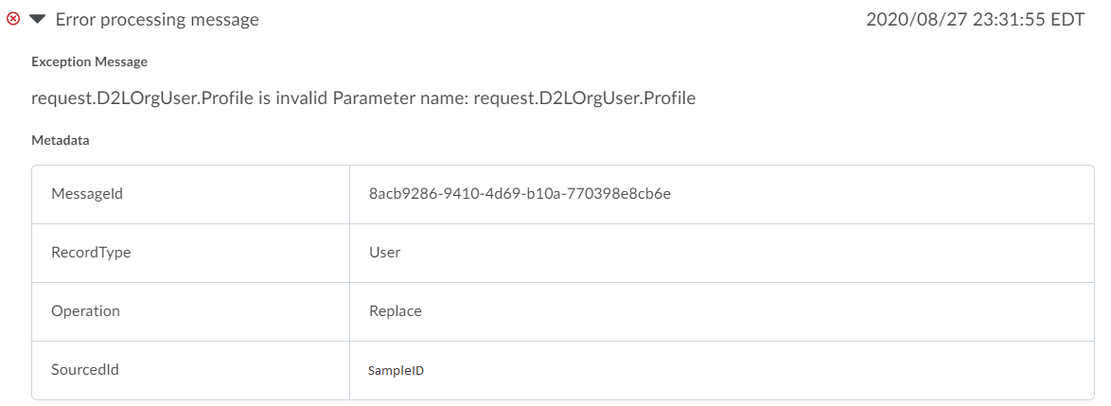Cause
This error occurs when the user’s profile has an error. The most common reason for this is the user has profile fields over the 4,000 character limit. Going to the profile and attempting to save will show further information about the fields that fail validation.

Resolution
Correcting the user profile validation errors by having the user go to their profile and attempt to save then resolve any errors that are shown will allow the user to process.

Error Message
Error processing message
OrgDefinedid contains invalid characters
The SourcedID metadata field that is included shows the OrgDefinedID that contains an invalid character.

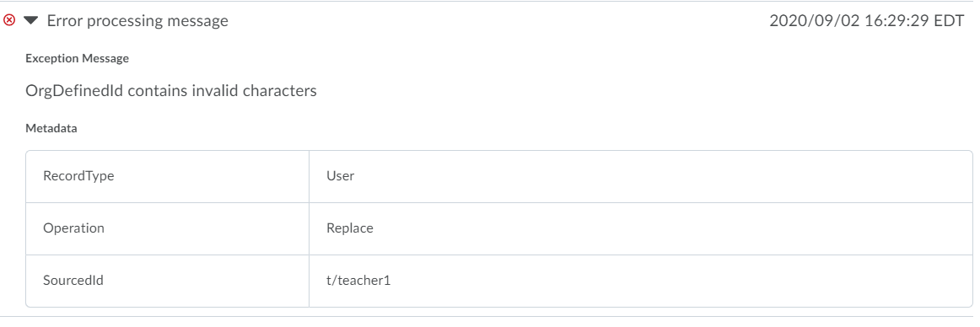Cause
An OrgDefinedID value has invalid character(s).

Resolution
Review the D2L Standard CSV documentation for the list of invalid characters. Either correct the source data to remove the invalid characters or update the extract code to remove the invalid characters.

Error Message
Error processing message
invalid request typename provided. no mapping found for type:<type> in source system:<system>. parameter name:typename
The RecordType will be the type included within the CSV files. The SourcedID is the org unit code of the org unit with the invalid org unit type.

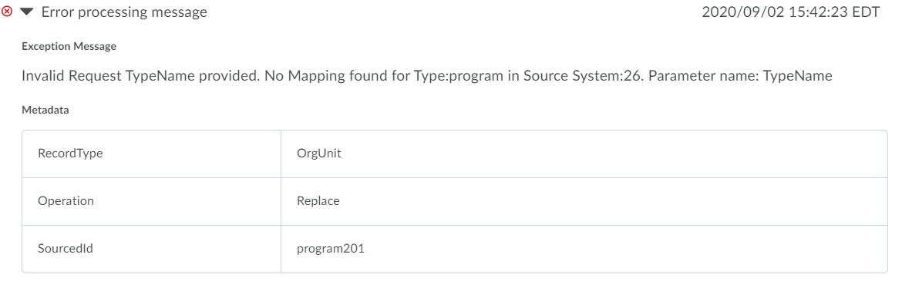Cause
This error occurs when a type of org unit is included in the CSV files that are not listed within the IPSIS org unit type mapping.

Resolution
Either the org unit type should be updated to a type that is mapped or within the IPSIS Configuration tab the org unit type mapping should be updated to map the type listed in the CSV to an existing org unit type within Brightspace.

Error Message
Error processing message
Violation of unique key constraint ‘uc_im_user_mappngs_orgiduseridsystemid’. cannot insert duplicate key in object ‘dbo.im_user_mappings’. the duplicate key value is (<userid>, <Orgid>, <systemid>).
<overview of the metadata provided with the error>

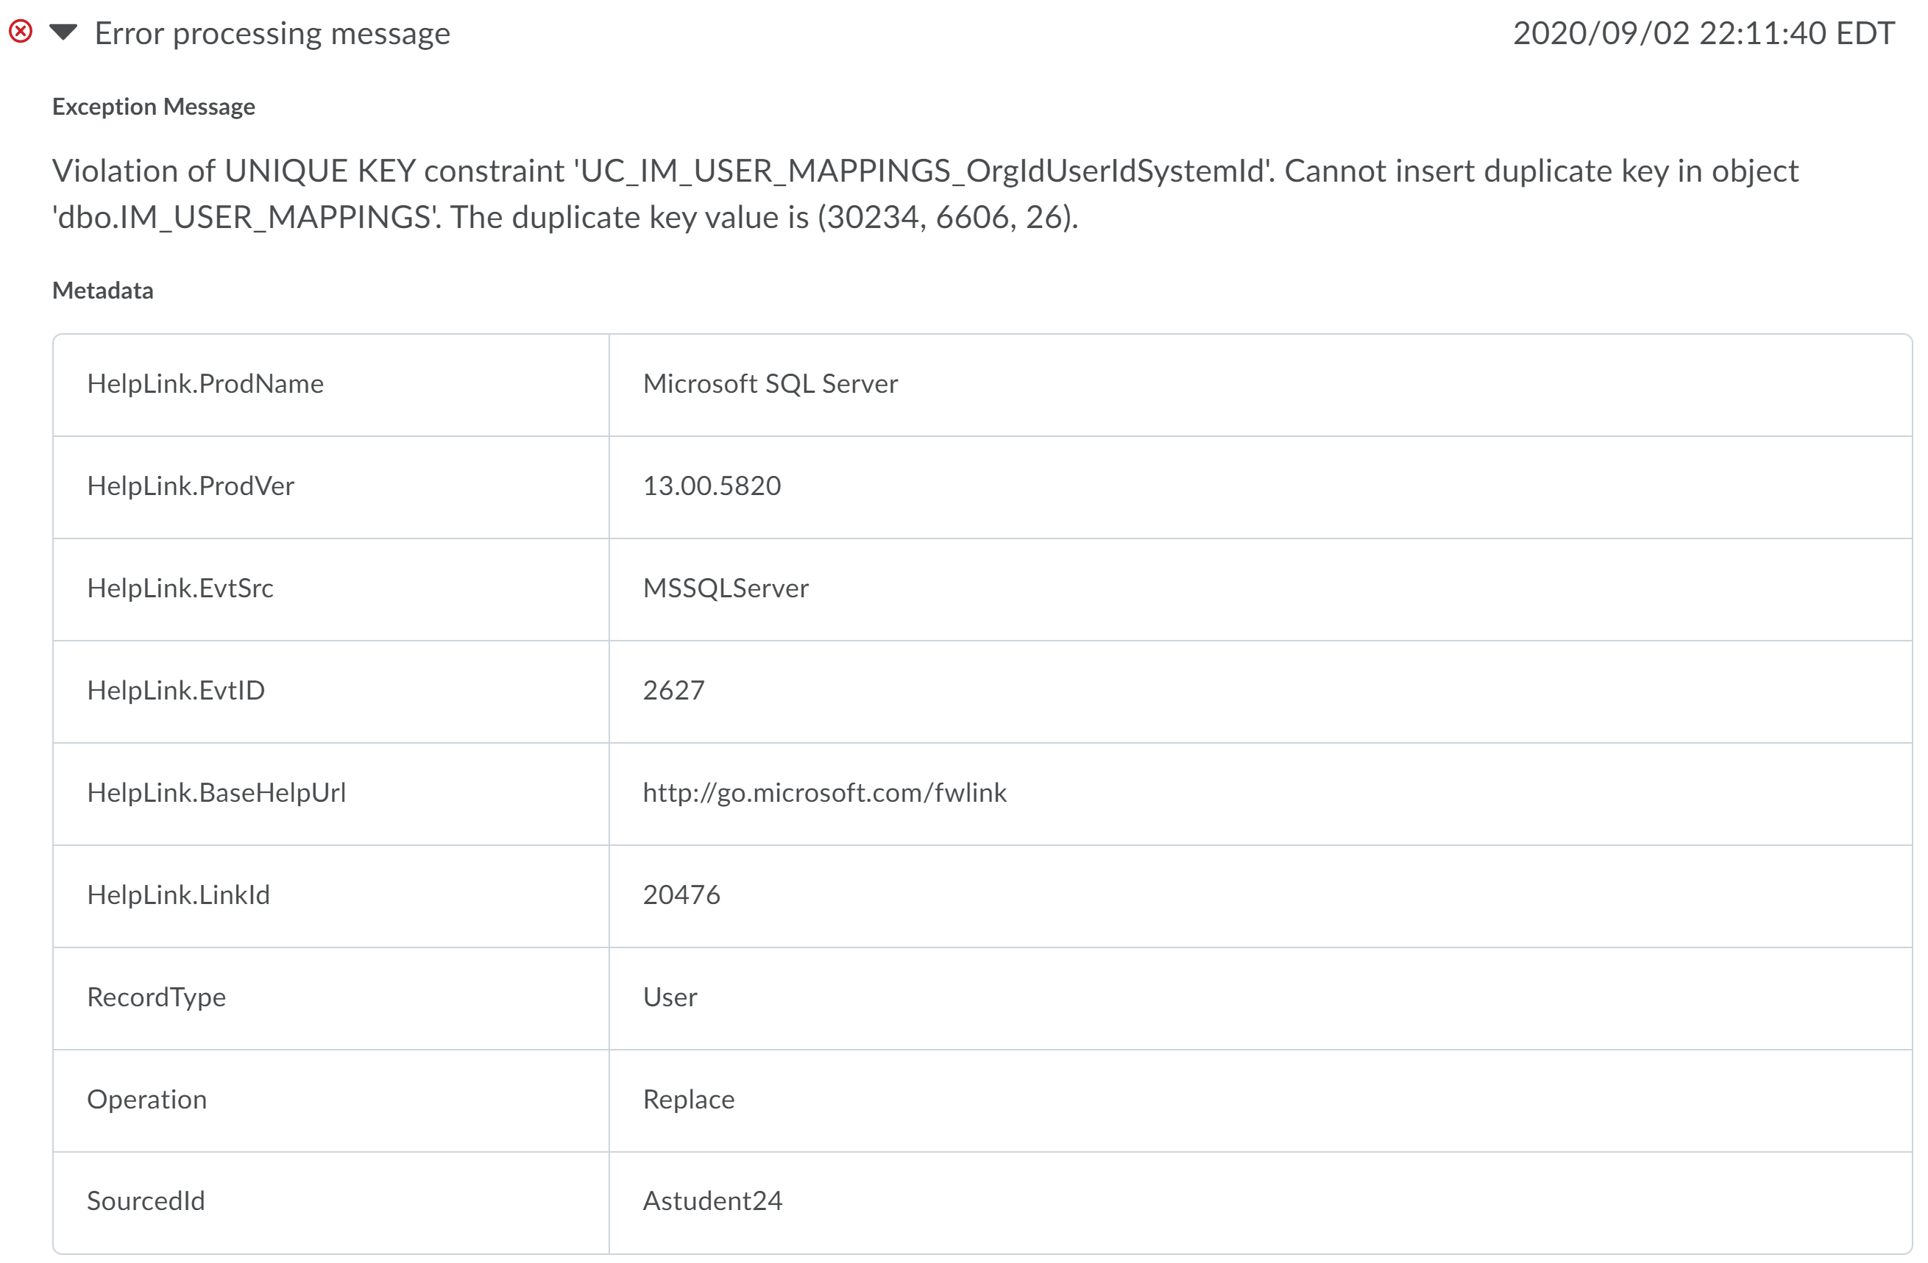

Cause
This error occurs when attempting to create a new mapping with a different OrgDefinedID for a user that has an existing mapping within IPSIS.

Resolution
Use the User Sourced ID tab to update a user’s OrgDefinedID mapping within IPSIS prior to sending any new OrgDefinedID values.

Error Message
Error processing message
cannot insert duplicate key row in object ‘dbo.user_organization_memberships’ with unique index ‘ix_user_organization_memberships_Orgiduniqueidentifier’. the duplicate key value is (<Orgid>, <username>).
The SourcedID included in the metadata will be the OrgDefinedID of the user record that received the error.

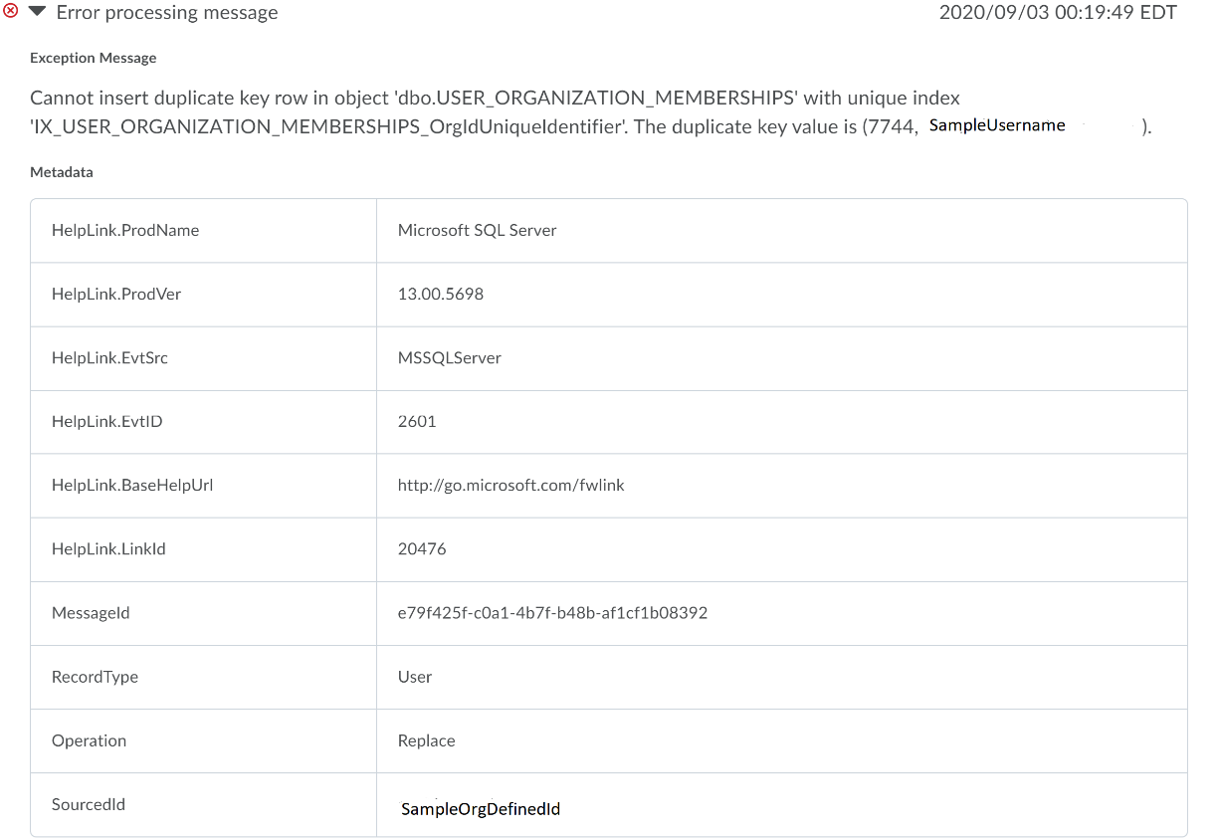

Cause
This error occurs when attempting to create a new mapping with a different OrgDefinedID for a user that has an existing mapping within IPSIS.

Resolution
Use the User Sourced ID tab to update a user’s OrgDefinedID mapping within IPSIS prior to sending any new OrgDefinedID values.

Error Message
ReplaceEnrollmentReadIMHandler.Process – Unable to find org unit specified in enrollment request.
The org unit and user for the enrollment request are specified in the metadata. The OrgUnitSourcedId contains the orgunitcode of the org unit for the enrollment. UserSourcedId is the OrgDefinedId of the user for the enrollment.

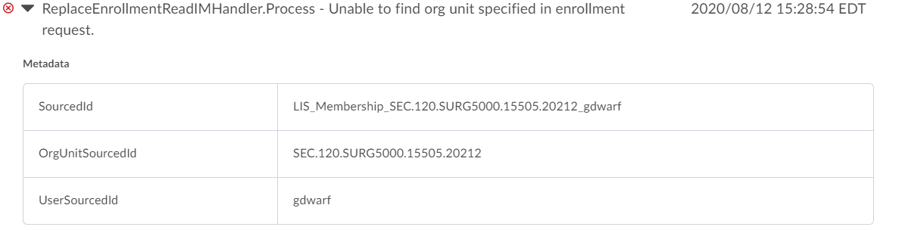Cause
This error occurs when the org unit specified in the OrgUnitSourcedId either does not exist in Brightspace or has not been sent through IPSIS.

Resolution
If the correct ID is specified, an UPDATE org unit record should be sent through IPSIS to either create the org unit or connect IPSIS to an existing org unit.

Error Message
Unknown file type. Headers do not match manifest version
The filename of the file where the error occurred as well as the manifest version used and the manifest version based on the specified headers are all provided metadata fields. If the manifest version is specified as 1.0.0, that either means that the manifest file was included and explicitly listed version 1.0 or that the manifest file was not provided.

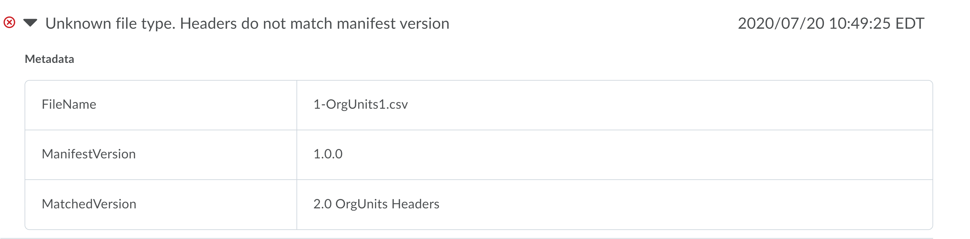Cause
The headers used with the CSV file do not match the expected fields for the version specified within this batch. Within a single batch, the CSV version must be consistent and must match what is specified within the manifest file or 1.0 if no manifest is included.

Resolution
Use only the allowed fields for the particular CSV version in use. If a version higher than 1.0 is in use, ensure a manifest file is included to specify the version.

Error Message
Error threshold has been reached.
The file that exceeded the error threshold and the error threshold in use will be shown with the error.

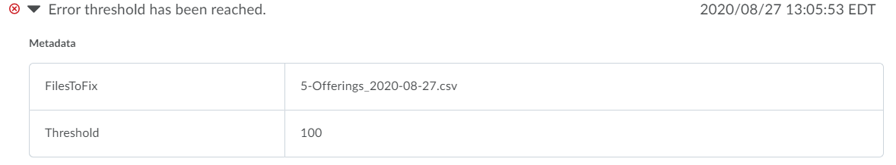Cause
Certain translation errors, such as missing required fields, not enough or too many columns, are subject to an error threshold. This threshold is not configurable by clients. When the threshold is reached the file will stop processing. The errors that caused the file to fail should be resolved before processing the file again.

Resolution
Correct the errors that caused the threshold to be reached.

Error Message
No handlers were found for type:<handler> in org:<orgid> with extension point:IPSIS
No handlers were found for type:<handler> in org:<orgid> with extension point:ipsis
The type of record affected and the SourcedID (org unit code or orgdefinedid) of the affected record are included.

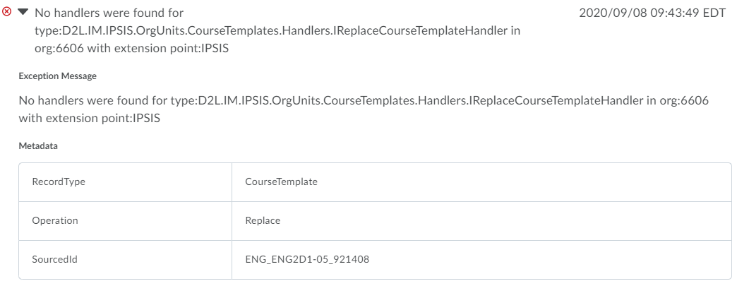Cause
This error typically occurs when an interruption in the availability of IPSIS configurations occurs. Normally, this would happen if the IPSIS configurations are changed while a batch is actively processing.

Resolution
If this error occurs, the batch should be re-run to ensure all data is processed successfully.

Warnings
<file> may have charset encoding issues, D2L Standard CSV supports UTF-8 encoding only.
The file that contained possible encoding errors will be listed.

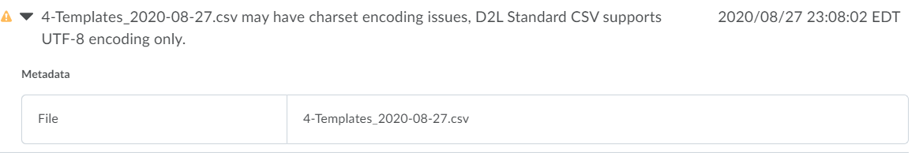 Cause
This occurs when the system detects encoding that is not compatible with UTF-8.

Resolution
Re-saving the file with the correct UTF-8 encoding (not including BOM) will correct the issue.

Warning Message
SourcedId did not match a valid entry. The mapping may have been deleted.
The sourcedid of the object that was marked to be deleted is listed in the metadata.

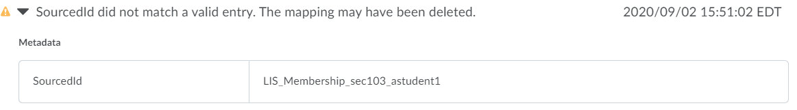Cause
This error can occur when attempting to delete any object type. The error means that the delete is being attempted on an object that IPSIS does not know about. In the screenshot, that means that a DELETE for this enrollment was sent but the enrollment was not sent through IPSIS to establish the mapping first.

Resolution
All objects must be processed by IPSIS before IPSIS can action anything related to them. That means that before DELETEs are sent through IPSIS, a CREATE or UPDATE must have been used. The UPDATE does not have to change anything about a manually created object but it does establish the mapping with IPSIS.

Warning Message
User Mapping not found building relationships, skipping
The SourcedID metadata included is the OrgDefinedID of the user whose relationships could not be added.

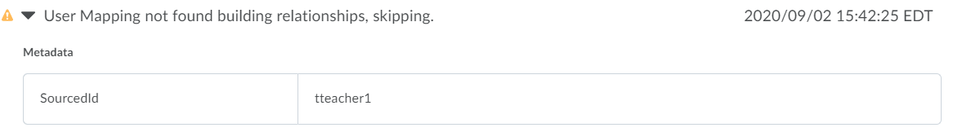Cause
This warning occurs when invalid users are added as relationships. This could mean that the user has never been sent through IPSIS or received an error that prevented them from being processed. Relationships are full replacements so this error would cause any existing relationships for this user to be removed.

Resolution
Ensure the OrgDefinedID of the user you are trying to add in the relationship field is a valid user that has already been processed by IPSIS. If the user received an error, that will have to be resolved before using them in a relationship.

Informational

Info Message
OrgUnit translation started

Description
This message indicates that processing of a CSV file containing org units has begun.

Info Message
OrgUnit translation finished

Description
This message indicates that processing of a CSV file containing org units has completed.

Info Message
User translation started

Description
This message indicates that processing of a CSV file containing users has begun.

Info Message
User translation finished

Description
This message indicates that processing of a CSV file containing users has completed.

Info Message
Enrollment translation started

Description
This message indicates that processing of a CSV file containing enrollments has begun.

Info Message
Enrollment translation finished

Description
This message indicates that processing of a CSV file containing enrollments has completed.

Info Message
Completed CSV Job

Description
The CSV batch that was running has completed.

