Big things to note
- Big thing to note there is that if a user has ever changed their account's notification settings, changing the default settings in a site's config will NOT change that user's settings. just for new users or for users that haven't tried to update their preferences yet (true for 0/1 in config but not T/F)
- one thing you can do is perform a /dba/counts on your site and tell it to recount categories
- Category ID shows in URL when you edit a category
- Category name then add “.json” to view json
- Dba/counts are mostly harmless but on big sites do 1 recount at a time. if you try to do them all at once, it can cause some time outs (DBA Counts are a ton of calculations happening at once)
- If swagger doesn’t work for client site, check their config if swagger-ui is false or true
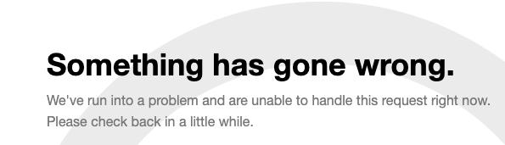
- When we see that above error somewhere, about 99% of the time, it's going to be something wrong with the product. That means we should be able to tap in someone on the product side (one of the devs working triage) to help us resolve those.
- If we see a massive Cloudflare error come up, like this (text may vary):
- 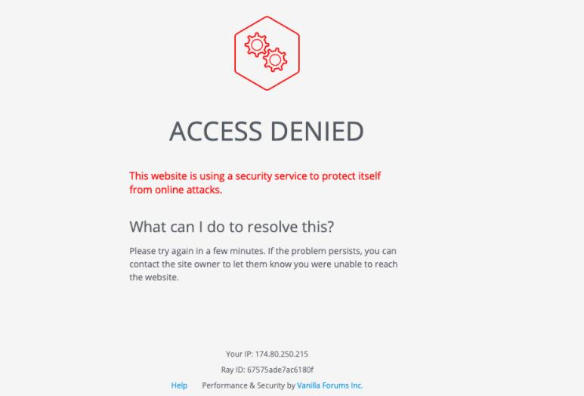
- It leans more toward the Ops side of things, but we still want to start the investigation on the product end. Once we get a bit more confirmation on the cause of the issue, then we may start tapping in the Ops team.
- If you ever aren't sure, don't hesitate to show me what you're seeing and I can help get it in the right place.
- HTML&CSS 1: https://higherlogicllc-my.sharepoint.com/personal/aphillips_higherlogic_com/_layouts/15/onedrive.aspx?originalPath=aHR0cHM6Ly9oaWdoZXJsb2dpY2xsYy1teS5zaGFyZXBvaW50LmNvbS86ZjovZy9wZXJzb25hbC9hcGhpbGxpcHNfaGlnaGVybG9naWNfY29tL0VzT0VNaXBiV09GQ2tld2hnTDBOam04QlZGNmcxQzM0R21RT29hT285UUI3RkE%5FcnRpbWU9UHlqNjVHbFQyVWc&id=%2Fpersonal%2Faphillips%5Fhigherlogic%5Fcom%2FDocuments%2FHTML%20%26%20CSS%20Series%2F101%20Level%2FHTML%20%26%20CSS%20Primer%2Emp4&parent=%2Fpersonal%2Faphillips%5Fhigherlogic%5Fcom%2FDocuments%2FHTML%20%26%20CSS%20Series%2F101%20Level
- Ticket triage: that's simply going through any new tickets, get an idea of their priority (is a site down? Is a major function down?) then give them a quick response saying that we're investigating the issue and we'll get back to them soon.
- Cache flush is pretty harmless (production sites)
As a reminder, here's how you can find out a site's version:
- Load the site and inspect element
- Go to Network > Doc > click the file under Name* > scroll down to x-vanilla-version
*You might need to reload the site to see anything under Name
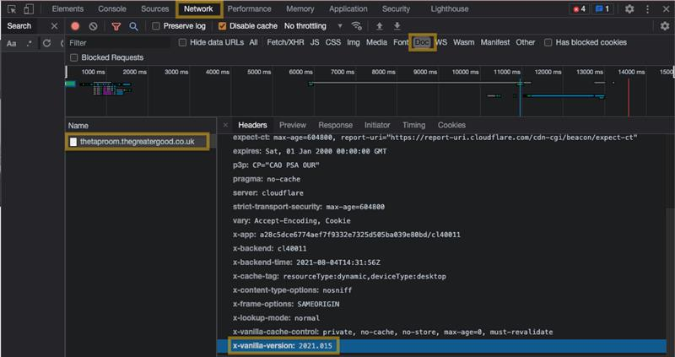
- pro tip - if ever a client has a ton of pockets with similar names, I like to embed a direct link to the pocket in question. You can get the direct link by right clicking the pencil icon on the pocket. It can avoid confusion
- This is whenever you use the <h2> tag within the article itself. It's an automated feature connected to the formatting.
- 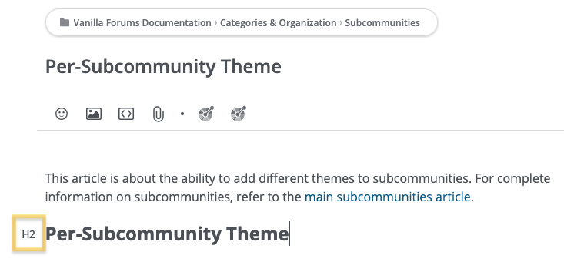
- https://staff.vanillaforums.com/discussion/1155/issue-isolated-to-single-site/p1?new=1
- I save low priority issues for problems Vanilla people find that no one else is reporting on yet (a bit of a judgement call) or for really low impact issues.
- But if you test something on multiple sites (including their own staging site) and you can't replicate, it's never a bad move to start considering user error. I find it's best to just be honest about what you've tried ("I've tested applying badges to multiple users at once on two different instances, and I'm not encountering a problem") and put the ball back in their court. You never want to do this without giving them some course of action, even if it's just answering a question. Just be reasonable and make it clear that we will definitely take the ball back if it looks like the issue is on us
- But if you're having trouble finding something in the Dashboard, you can always check your test site and use the same URL slugs - those don't change
- So /vanilla/settings/categories for categories
- Alena roles: moderator, corporate, employee, registered user
- For debugging from console go to event log after switching on DB logger addon then once you find the entry you're interested in, always switch the page to a json view. It shows way more information than what's shown in the dashboard UI
- Recommendations from Drew from his first html & css seminar:
- Html intro course Linkedin: https://www.linkedin.com/learning/html-essential-training-4/lists?u=2383138
- Css Linkedin: https://www.linkedin.com/learning/introduction-to-css/welcome?u=2383138
- https://vanilla.freshdesk.com/a/tickets/101358 : When we get a feature request like this, we email into product@vanillaforums.com - and it doesn't need to be a super formal thing.
- You want to identify the problem/ask that the customer has. Try to get an idea of the client's usecase for this feature (this is how they want to solve whatever problem they're hitting) and then put in the solution that the client wants or the one that you think would be better. Once or twice a month, Val will go through and check out what's been submitted, review and bring those ideas to sprint planning meetings.
- If a CSM forwards us a support issue from a client, and the client didn't originally try to CC support on it, after you start working out the problem, add a little line that says something like: "And don't hesitate to reach out to support@vanillaforums.com for any issues like this in the future!" OR “Please feel free to contact the support team directly at support@vanillaforums.com with all your technical questions and issues. We work around the clock to provide you with the help you need!”
- Github client pulls page example: https://github.com/vanillaforums/boards/pulls
- Secret extra 3 addons page: /dashboard/settings/applications
- If a ticket in Jira is “sprinted” best just to say it's with our product devs and scheduled to be in an upcoming sprint.
- Subcommunity Issue: https://github.com/vanilla/vanilla-cloud/issues/632
- Potential prospects? Point them here: https://pages.vanillaforums.com/demo-request-vanilla-forums
- Out of scope of support example ticket: https://higherlogic.zendesk.com/agent/tickets/251853
- Invisibility cloak does the same as adding a noindex tag more or less. Right click any community page and view page source then search “noindex” to see it’s working.
- Pockets CSS/HTML: Most times we can specify short path like .something but other times we need full path that starts with #page. To change padding/margins look at computed tab in dev tools.
- Sales demo sites are on same release as enterprise (for testing)
- To see if a PR that’s merged is in a release or not, search the GH issue number in the releases page.
- https://higherlogic.zendesk.com/agent/tickets/252658
- in release 025, before hitting the new re-index button ping a dev first so they know what it was like before the re-index.
- HSTS stuff exists in the security page of the dashboard
- ETA: “I'm not able to provide you any kind of ETA at the moment with regards to if/when this feature will be implemented.
For now the best I can offer is to stay in the loop on our latest release notes and to bookmark this post on our Success community to be notified of new additions to the Vanilla product. We also encourage you to submit ideas to our product ideas page where other customers vote on them and it helps our product team better organize them. https://success.vanillaforums.com/categories/product-ideas
- What helped Mila with understanding product: playing around with your demo site.
- Don’t get discouraged about number of tickets, focus on why numbers are what they are
- 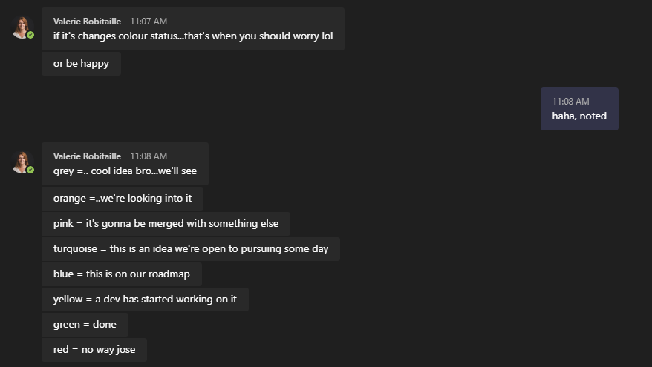
- If users need verification email re-sent, they can click on the pop up in bottom of screen when they log in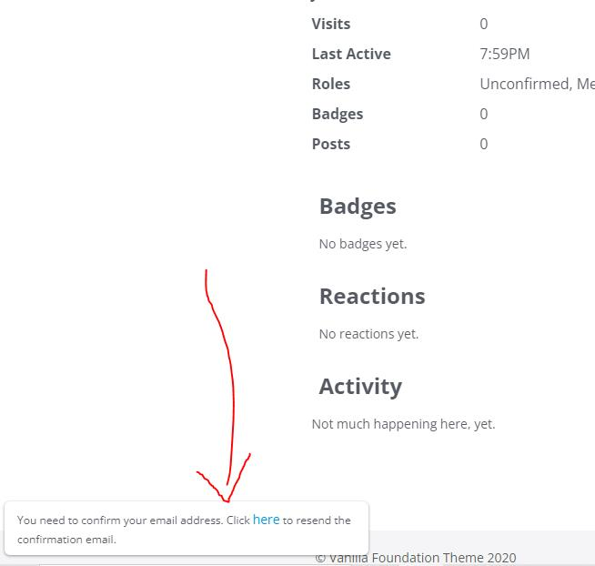
- Or they can go to /entry/emailconfirmrequest
- New change request process requires it to go through CSM: https://staff.vanillaforums.com/kb/articles/370-service-request-process#feedback-change-requests for example font changes (minor changes they want to their custom theme made by us. Broken stuff though after a recent release will go through support)
- last active is when they last logged in (might have left it open in a tab); if someone's using aggressive security blocker, blocks javascript from running properly. https://github.com/vanilla/support/issues/754#issuecomment-525868569
- Todd date last active work: https://github.com/vanilla/vanilla-cloud/issues/426
- Can’t make styling changes (pockets) to /search page or groups page or KB or registration page unless you use B’s workaround Javascript that inserts CSS into the page after it loads.
- For all SSO types, edit profiles is off by default. You need that config to turn it on.
- Use B’s custom domains if you need to test that: {firstname}.mormorhaxa.com Dashboard >> Settings >> Custom Domain
- B already has everything pointed in the right direction, but worth checking https://www.whatsmydns.net/ and checking where the CNAME is aimed
- Almost 95% of the time when a custom domain isn't working, it's because that's not set up correctly.
- Check out how https://higherlogic.zendesk.com/agent/tickets/256296 was solved
- If you need to see if some metric exists for it to be shown through analytics endpoint, try to find it in the new custom analytics dashboard builder. https://higherlogic.zendesk.com/agent/tickets/257451
- /utility/alive.json to see if a site is up or down
- (New Support Community) Better to point clients to knowledge base articles because they get updated regularly; Something like shifts for everyone to check on different days; Notifications (toggling on/off) for shifts for that community; Helps these clients become more self-sufficient; More for community management stuff; We’d be like moderators to handle best answers; It will just be Vanilla people we’re talking to; General entry level questions since they won’t have a CSM;
- Snagit editor lets you combine images to compare side by side (choose landscape), flatten all to make it one image
- Wanted to follow up on this because I realize I didn't really explain how SSL certs in Vanilla work well. Once upon a time, they were the clients' responsibility - whenever they needed to renew, there was a whole process about us getting the cert and passing it to Ops and they would apply the cert to the website. Now , we have it set up with cloudflare so all default vanillacommunities addresses are automatically protected by SSL certs (which renew every year) or if they follow the instructions in the Custom Domain tab of the Dashboard, Cloudflare will also protect client sites using custom domains.
- If a client comes at us with a security warning like that, we want the exact link where they saw the error so we can try to replicate. Chances are, it's a mixed content warning (they're embedding something on the page that isn't protected by https) - you can find those by opening the browser dev tools on whatever page is getting the security error.
- If you can't find mixed content, and they're following all the guidelines set by the custom domain tab, and we're still seeing a security issue, that'll be an Ops ticket. Probably an issue with how the new site is interacting with Cloudflare.
- Sometimes we have clients that push to take responsibility of the SSL cert. Every time so far, Ops has pushed back hard against that, but still probably something we'll need to take as a case-by-case basis. Probably more something the CSM will need to deal with than us.
- https://higherlogic.zendesk.com/agent/tickets/258387
- https://higherlogic.zendesk.com/agent/tickets/259676 Giving users access to git repo: best to reach out to ops for this. Make sure to get permission from site owner first as there’s a security risk.
- [5:03 PM] Andrew Dodson
- If you can't find a specific string in Transifex, you want to make a ticket
- [5:03 PM] Andrew Dodson
- say you're looking for this text in this location (screenshots help a lot)
- [5:03 PM] Andrew Dodson
- and the devs can update the code so we have access to those locales in transifex
- Changes you make to an existing word don’t go live immediately, they are part of the next scheduled release to production (if everything goes well, things can go wrong in which case write Jira ticket)
- Feature Request message to clients: If you want to keep track of our release notes to see if features make it in any release, you can do so here or check out the Releases overview page.
- Todd’s advice for Clients with scripts not working with API: I can’t troubleshoot Bitdefender’s script. There is not enough information in their script to tell me anything. They need to look at the response we send to help troubleshoot. The ticket originally gave a sample response and my answer was explaining what the response means. Now it seams like you are telling me the response they wrote in the ticket isn’t happening? What was that response then?
- In general, we are not likely to be able to help with issues like “it was working before and suddenly stopped working, but I didn’t change anything so figure out what you did wrong”. We have many developers making many changes all the time. The data is changes. Customers themselves make changes without realizing it. Customers may write code that sometimes works, but doesn’t handle edge cases. The customer may have been using an unsupported part of the API that then got fixed. Networks may have issues. Operating systems get updated. Python packages change. There are so many reasons why the behavior of an API may change
- If a client has a bunch of addon config flags missing, it’s probably because someone (implementation maybe) turned them on from the config instead of from the dashboard
- Linking ticket to Jira: Find source ticket, make my ticket an incident of that one.
- /utility/exportprofiles for downloading csv of user profiles (staff article)
- Data loss issues: We can restore data up to 2 weeks ago. Check backups section of their console page to see what we have stored. Request backup from Ops but for actions on it like restoring data, we send it to Olivier or devs.
- Going to do a quick rundown of what happened with Oracle this morning, because it may be good knowledge to have. Things to note:
- On Oracle, all SSO goes through the hub.
- On Oracle Production and Staging (not dev), Akamai is over everything. Whenever a request is made from the community, it goes to Akamai, then to Cloudflare and then to the Vanilla App servers, and then back when the response is ready.
- Caching can occur at basically all levels of this (Vanilla App, Cloudflare and Akamai).
- Vanilla has rules in place at the Cloudflare level so we do NOT cache anything from the /entry/ endpoint (where people sign-in at)
- Issue:
- It seems Oracle made a change to Akamai recently (Friday or over the weekend), and they were caching that /entry/ information (no rule against it). What that did was when someone logged into Oracle, Akamai would take the {target} from the SSO call, and save it. Then when someone else tried to login (no matter what node they were on), Akamai would see them using the same /entry/ endpoint, and drop the {target} part of the URL that it had cached. This was causing a situation where a user would try to log into Netsuite but Akamai would try to direct them to Mosc (where it had saved the {target} URL from). Not all users have access to all Oracle nodes, so this was breaking sign-in (people sending auth requests for netsuite but getting responses for mosc back, causing the whole thing to break).
- The solution was to have Oracle clear the Akamai cache and revert the change they made over the weekend
- We aren't data scientists. I can help with the specific messaging if you want to draft something first, but I'd ask what makes them think it seems low or if they're seeing inaccurate numbers for multiple users. If they give us a pattern of inaccuracies, we can work and test with that. https://higherlogic.zendesk.com/agent/tickets/262124
- I might suggest running a dba/count for comments and discussion. They might be showing a different number on their profile then analytics is displaying
- I'd probably lean towards analytics being more accurate since we don't ever need to run a recount on those numbers (at least not on our side)
- What's the process again for when customers request data from us that can't be retrieved from the dashboard (like all 10k+ users who have a certain badge)? -export with olivier; should be unlimited requests for enterprise, non-enterprise: 1 per month
- https://console.vanilladev.com/sites/view/overview/5022433/etss.vanillacommunity.com <-- if we hear from this client, they were put into maintenance mode because they're several months delinquent on their account and not responding to Carolina. If they message into Support, we want to get them to billing.
- John’s all analytics issues: https://higherlogicllc-my.sharepoint.com/:x:/g/personal/jmckenzie_higherlogic_com/EcPm_99WgN9NqGiOPvVxoJMBu0_lVqsX566AJKkiOh_ryg?e=IZMhJW&wdOrigin=TEAMS-ELECTRON.p2p.bim&wdExp=TEAMS-CONTROL&wdhostclicktime=1644420594232
- B’s Javascript injecting CSS code ticket: https://higherlogic.zendesk.com/agent/tickets/255324
- Our rank system does not support a "0" level and your first rank should start at level "1". The level "0" rank causes an issue due to it being automatically set to "1" and then the other level "1" rank never gets applied due to this. It's a bit confusing since there's no warning about this but I've let the team know.
- Login is easiest way to update ranks. The reason we don't constantly query if users meet rank criteria is for performance reasons (on large sites, it'll slow things down significantly)
- For calls, if we can't answer client questions on the spot, is it ok to ask them to give you some time to troubleshoot and continue the communication through email/ZD? Get site name, email.
- Example Client custom theme github link: https://github.com/vanillaforums/kaseya/tree/master/themes/kaseya
- If a locale is changed in the config, transifex won't touch it
- transifex only changes core Vanilla text
- Transifex login: with github
- If clients are bad with screenshots, have them send you a har file from dev tools; tick preserve logs; download/upload buttons on devtools. “Finished” means 500 errors (size will be 0). Could be used for problems with slow load speeds.
- Closing out forums(churn): “sorry to see you go” but we don’t do sales pitch, ping their CSM if there is one, see if they want a full export of forum (file ticket for that), once that’s done, transfer to billing (change form to finance and assign to Carolina) ping her directly too teams/slack
- For figuring out what theme variables affect (like button ones) check theme editor: 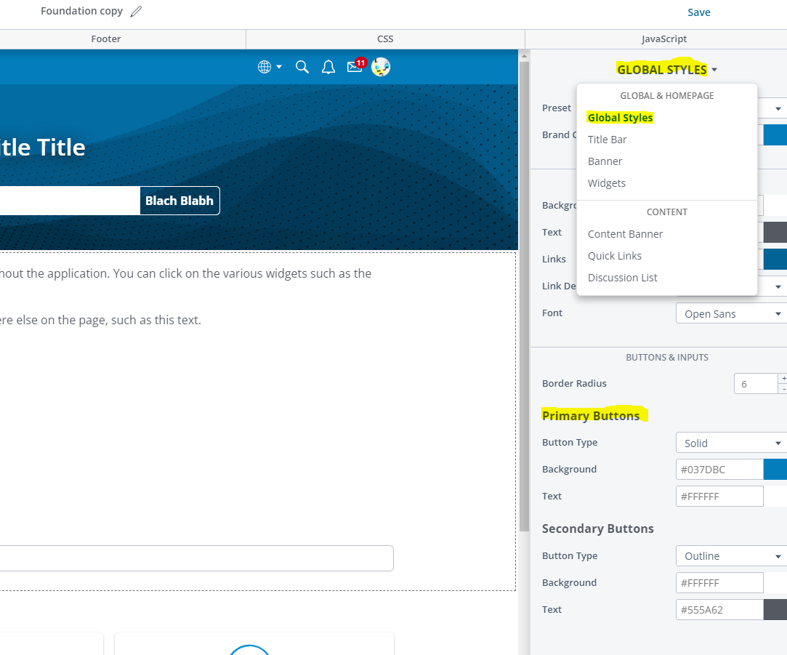
- /entry/password for manual sign-in if sso fails
- "[%s] Invitation" for invite registration type email subject title
- “Site slowness”: test load speeds with Kibana. Grab their host name, then add these filters
- (loadbalancer.time_duration > 20000 OR request.elapsed_ms > 20000) Check the last week or so for times over 3 secs
- Sendsafely export links are only valid for 10 days
- VanillaPop: If clients email replies to direct messages don’t get sent to Vanilla, they need to set up forwarding on their end to point their forum email address to the one set on their community. Look at the information paragraph at the very top of the VanillaPop settings. We don’t have any control over clinets forum domain or any of their email addresses. This is explained in the Success page on VanillaPop as well. Vanilla Pop will compare the senders email to the user list and only make that post if it matches the email of a user on your community.
- There was a problem a while back with debug when you hit it twice too fast, it would get caught in the log
- Clearing cache/cookies from specific site:
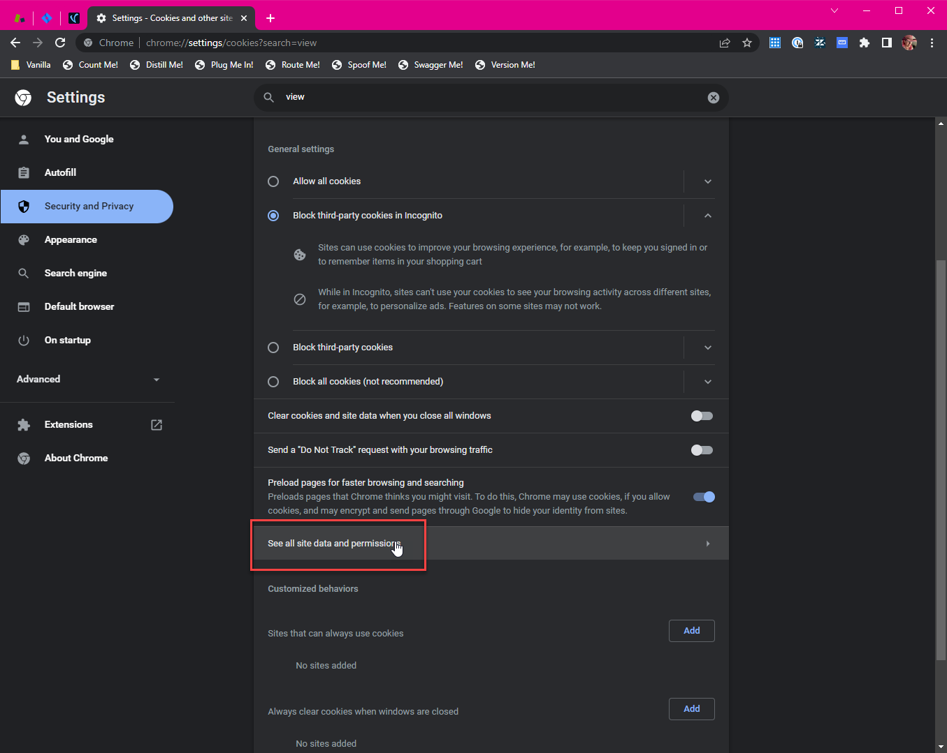
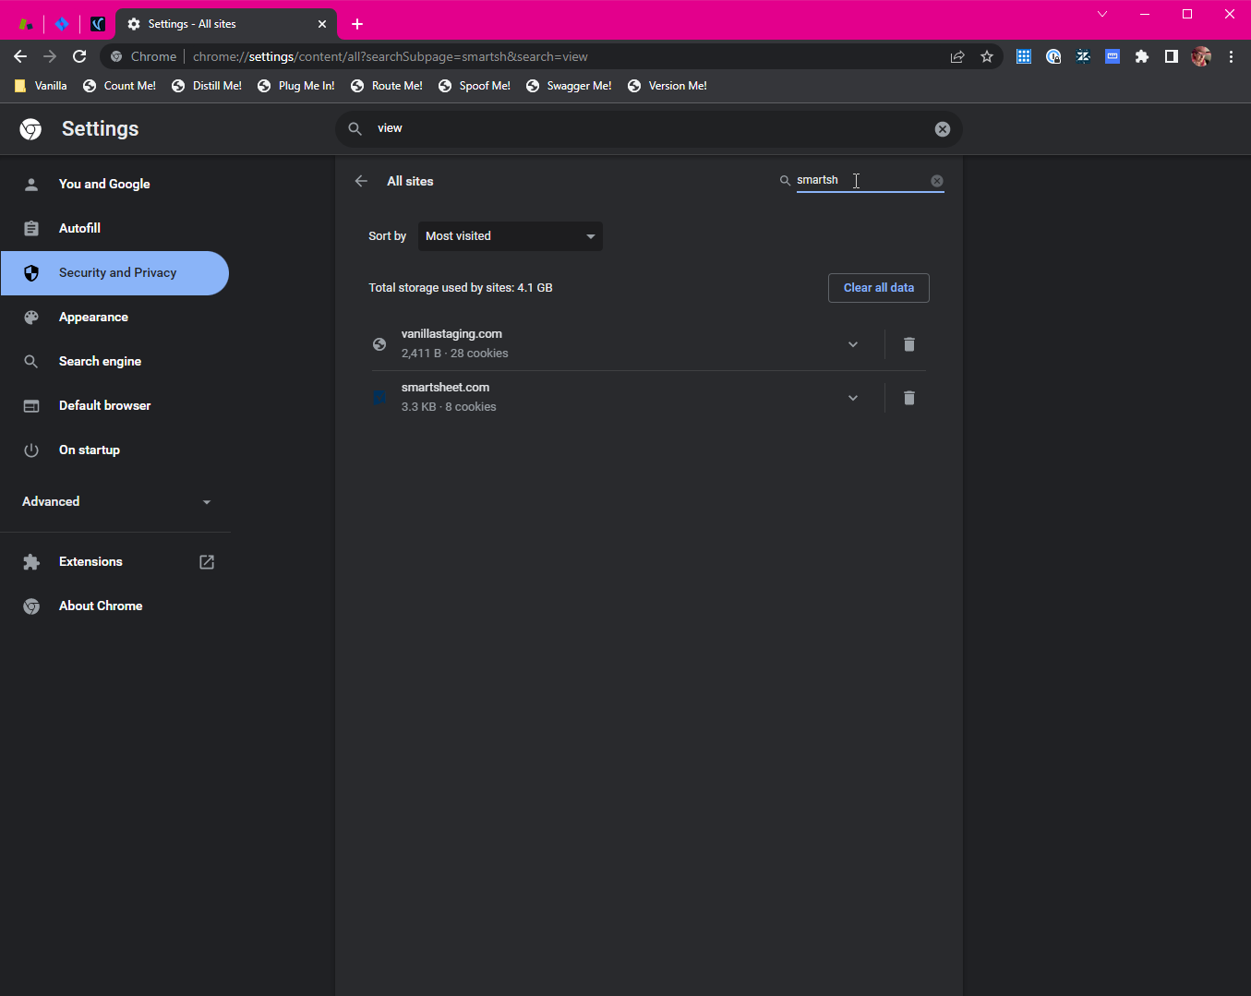
- If you look at the json of the moderation queue you can see if the keyword blocker flagged the post
- New infosec process: if they’re reporting some vulnerability then it goes to support. If they just need info on HL security or GDPR then straight to infosec
- Tiltingpoint client also goes by: disruptor beam
- Example URL to mobile themes for clients on old themes: https://forum.disruptorbeam.com/dashboard/settings/mobilethemes
- If you can’t spoof in via console and there’s a weird redirect to another site, good chance that client has a custom domain that’s causing it. They have to check their DNS settings.
- Kibana index patterns: vf-v2-nginx is application, vf-v2-CF is cloudflare, vf-v2 is everything
- Search engine indexing: https://higherlogic.zendesk.com/agent/tickets/273244
- new management dashboard: https://management-dashboard.vanilladev.com/
- adding hyperlinks to email body: <a href=\"[whatever URL]">Text you want to display with the link</a>
- Check if client has VIP deploy: It’s an addon, and a VIP deploy section should show on dashboard
- Troll management addon useful info: https://higherlogic.zendesk.com/agent/tickets/252952
- https://higherlogic.sendsafely.com/auth/ for creating sendsafely links for customers (sign in with HL credentials) (*LET THEM KNOW THEY HAVE 10 DAYS)
- Kanban Jira view (for success meeting) https://higherlogic.atlassian.net/jira/software/c/projects/VNLA/boards/325?selectedIssue=APPENG-16015
- Kibana example: 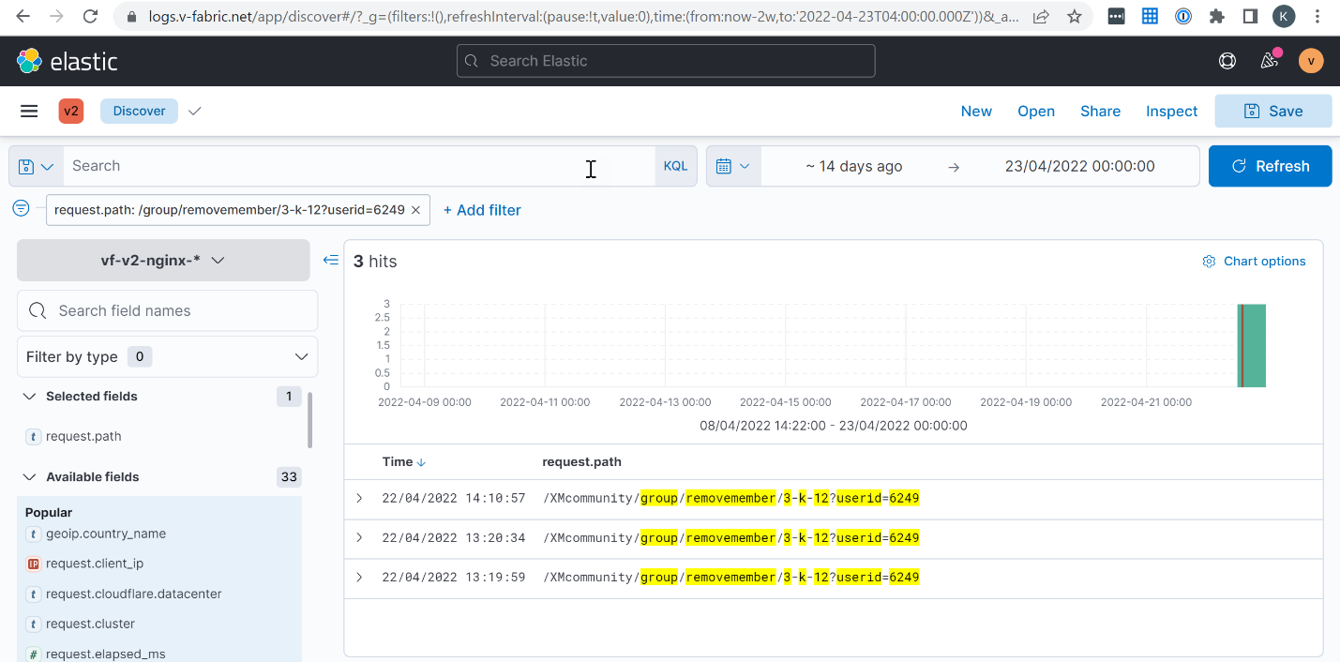
- Handy ops doc on rate limiting and the information that should be included if someone is being incorrectly blocked: https://higherlogic.atlassian.net/wiki/spaces/ENG/pages/3124035634/Traffic+filtering+and+rate+limiting
- Vanilla only supports 2 rss feed types (there are several); unfortunately there’s not a good standard to base everything off of so we’ll see situations where Vanilla doesn’t know how to pull specific feeds over.
- Sprint reviews get posted randomly in the HL staff product community
- If you aren't sure what's triggering on a page, you can load it with the network tab open and search for 'addon.' Sometimes that can help narrow down possibilities.
- 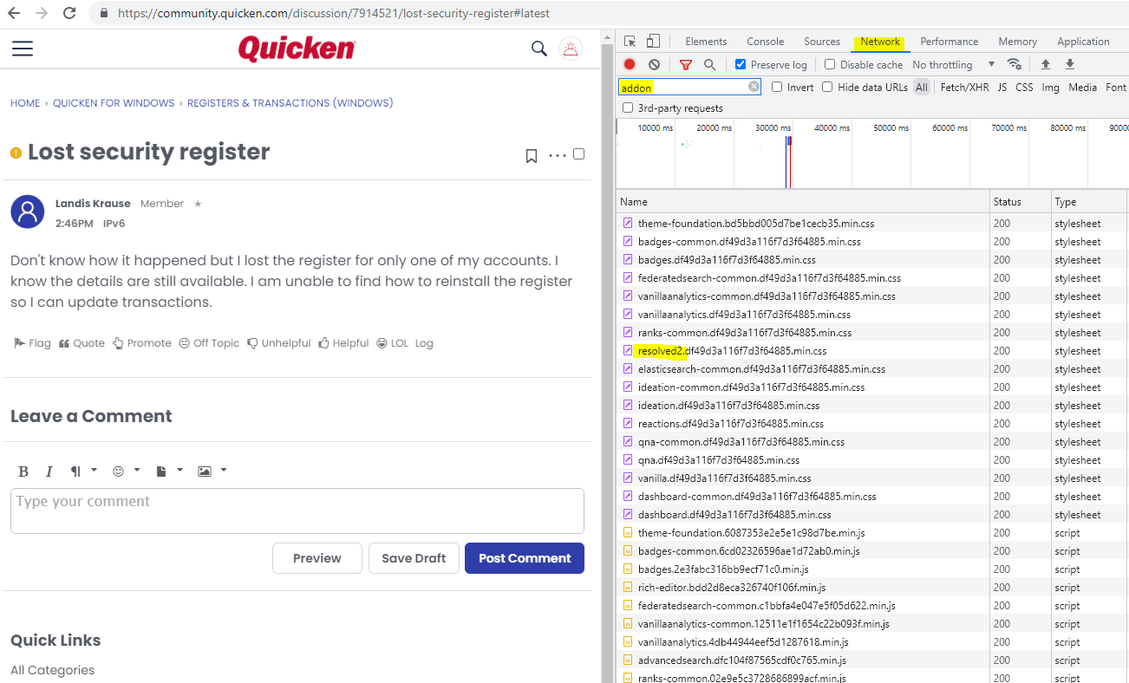
- Alternatively, inspecting the element itself can sometimes help:
- 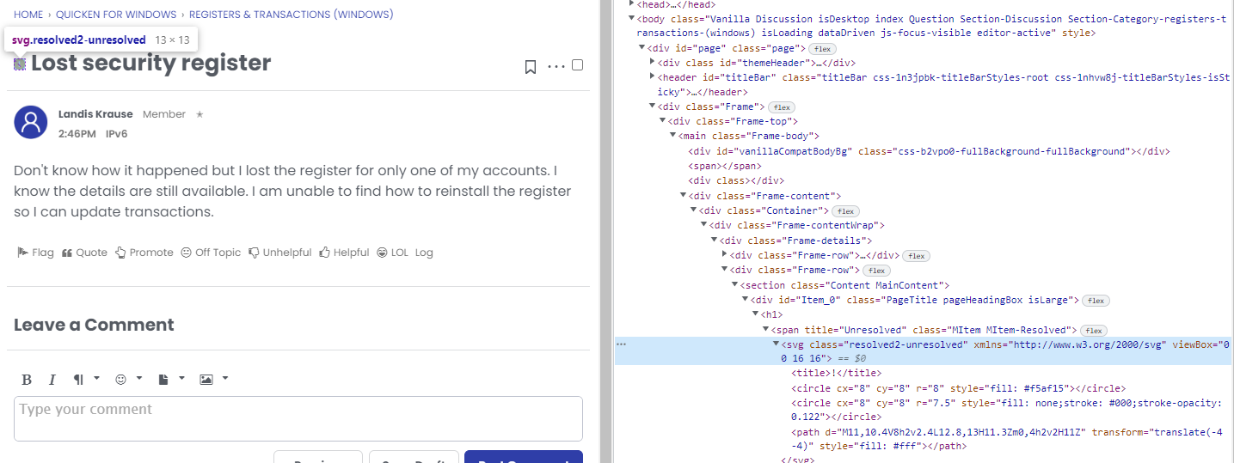
- Use that information and compare it to what's loading in the network tab
- Gather link: https://app.gather.town/invite?token=Q98bu1v9E-kGY41kymponLtr4Oo5lKbM
- https://app.gather.town/app
- 160 hours yearly vacation, 20 days
- If something seems wrong in kibana It might be a bug, report to ops plat
- If anything needs documentation @mila directly
- Nodes can have different themes just like subcommunities unless the hub enforces a theme.
- You can tell if hub enforces a theme by looking at the hub config for “Theme”: “Adobe” for example
- if you get an example of an item being removed from the CDN but you can still see it (maybe others can't), before making a ticket, let Matt know in the removal ticket. Maybe ping Andrew on it too so he can make sure it gets in front of him.
- And, if you have time, spend a little bit looking t hrough your backlog (especially things in VNLA) and retesting things that have been sitting for a long time. If you can still replicate the issue, leave a note. If it's resolved, comment that it's working and close it out.
- VanillaPop feedback https://vanillaforums.productboard.com/feature-board/264970-all/features/12865054/detail
- API issues on 012 release: https://higherlogic.atlassian.net/browse/VNLA-1786
- Analytics charts: it’s possible to group-by more than 1 field. Click on field box and add more.
- Question about security issues: https://higher-logic-llc.slack.com/archives/CCPNLKMGF/p1655411912445459 (gist of it: we prevent security issues with secure code practices, we have hackerone, tooling which does static analysis, we do some audits but depends on specifics, did a pen test recently, we encourage use of functions that don’t allow these kinds of vulnerabilities to happen, pretty much everything uses a CSRF token so your logged in session can’t be tracked, penetration tests annually, could ask infosec for latest pen test report – shows vulnerabilities and when we patched them)
- Mse gdpr requests: manually go through their activity if it’s not much; search their username and @ username in search
- Site owner change: get finance (use finance macro) to first confirm if new owner is correct and then make the change yourself in management dashboard
- creating a role on a site is fine but there shouldn't be a reason for you to have to make a role with the default type 'member.' If you do that, it's automatically assigned to every new user that registers on a site. Real easy way to accidentally give a ton of random people admin access if that's how you set up your test role. Please keep that in mind.
- If you want a config setting to sync across all nodes, put it in the “config” part of config of the hub. Something like Garden.Conversations.MaxRecipients: "1"
- Has customer always had invisibility cloak on? If they haven’t it’s very likely google bots hit the /entry/password URL; Google has its own process to remove site from search results – anywhere from a week to 6 months; Is their site setup that if someone finds a link to their forum, they’ll be sent to a login page? (helps hide content)
- Example of can’t replicate: https://github.com/vanilla/support/issues/2888
- Mid year check in: now I’ve become more patient with customers and choose my words more carefully. Customers have told me they were disappointed with ideation/resolved plugin but they knew I did everything I could. https://higherlogic.zendesk.com/agent/tickets/281802
- VNLA tickets that need to be closed: not enough to just comment “this can be closed”, ping someone like Andrew or Mila or close it yourself and leave that comment. For APPENG – ping someone
- Zenimax management dashboard: https://management-dashboard.vanilladev.com/site/5020507
- Bulk User Import invite limit: set registration type to invitation first and limit option appears there
- Matt Jira release ticket for every release: https://higher-logic-llc.slack.com/archives/CCPNLEJH5/p1660063165653969
- Possible for customers to pass over verification status data for users (bypassing spam filters)
- If customer was using SSO before migration, passwords won’t be migrated
- Reported posts remain in recent discussions. Ticket
- Triage example: https://higherlogic.zendesk.com/agent/tickets/324192
- Posts limit: From structure in db it’s 65,535
- To enable welcome email for SSO customers, string is: “EmailWelcomeConnect” if you want to see an example, see Qualtrics: https://management-dashboard.vanilladev.com/site/6030293?display=locale
- If a plugin is causing issues for a site, check the ‘plugins’ section of their config to see if an entry for that plugin is missing
- MSE GDPR: if user only has 2 posts/comments then remove their @mention or quote yourself as system “Deleted User”
- To check clients’ rss feeds: https://validator.w3.org/feed/
- Old username validation regex on demo site: "ValidationRegex": "\\p{N}\\p{L}\\p{M}\\p{Pc}\\- .=@\\[\\]\":;*+~"
- If issue is ideation, first check that there’s a default status set
- If profile extender field is removed in frontend, devs can still remove data from it in backend
- For Jira tickets copy-paste stack trace error instead of just image
- Reminder: Layout Editor Pages don't like it when you don't have a Banner Title entered on the Branding & SEO page and will throw an error
- Transifex: if you get server error, you probably have to join that language team first
- OAuth2 enable sso logging: https://staff.vanillaforums.com/kb/articles/159-config-101#:~:text=Registration%20%26%20SSO-,Enable%20SSO%20Logging,-This%20is%20only
- Updated analytics query inflated views article: https://staff.vanillaforums.com/kb/articles/414-analytics
- Ticket about messed up DNS and inaccessible site from Management Dashboard: https://higherlogic.zendesk.com/agent/tickets/328923 (turn autodomainswitch to false in config) for access while DNS gets fixed
- FamilySearch: They have written code that receives our webhook events and does moderation of posts containing images via the API. It doesn't run on our servers and we didn't write it. So whenever they ask about Image Moderation, that's an internal issue for them to investigate!
- Customer cancellation/churning: ticket from customer and not HL? Use Escalations>Finance macro and then HL will send in ticket if customer wants export. After Export, follow staff article for steps involving OPS for deletion.
- Issue with something theme related? Like page title: if legacy layout other than discussions is chosen, “recent discussions” shows as title even if you apply custom layout afterwards. Check legacy layout setting

Mention/quote anonymization issue: https://higherlogic.atlassian.net/browse/APPENG-18608

Appeng meeting issue to bring up: https://higherlogic.atlassian.net/browse/VNLA-2123
https://higherlogicllc-my.sharepoint.com/:x:/g/personal/adodson_higherlogic_com/Ec1ksdJvmZxKim2CqjIufZIBFWZQOi6m6T3_-nL-QDkltQ?e=LcqXoX
Out of scope topics that come up in tickets that B can help provide best practice on:
-
Custom font ticket: https://higherlogic.zendesk.com/agent/tickets/276882
B’s support doc: https://blog.vanillaforums.com/improv-rules-customer-support
Out of scope – add new information ^
Be as specific as possible when asking customers what they did exactly before encountering issue (instead of just “have you changed anything recently”)

Mike’s SSO Lesson
- Dig through github/Zendesk/jira. If issue you’re reading looks like it’s going in a similar direction keep going if not move on to next search result.
- Verify if what customer thinks the issue is is correct (SSO can’t log in issue for all users? Or can some users sign in successfully)
- Visit the eventlog.json page to find useful information. Search examples: SAML, session
- Ask client to provide more details such as what users is it happening to
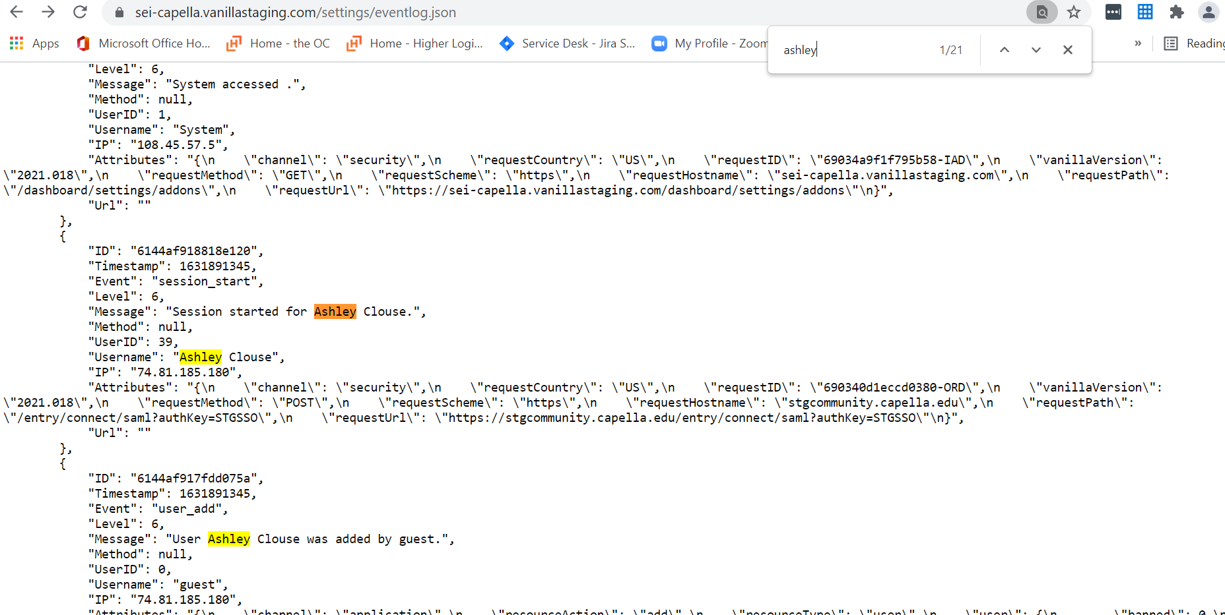
?Page=p2&
Troubleshooting Methodology
- When troubleshooting make sure to undo any changes you made while testing that didn’t fix the issue so that you don’t end up breaking stuff even further
- Ask customer about anything else unusual they’ve seen; sometimes something they think is unrelated could be a good hint as to what their main issue is
- BACKLOG PROGRESS: on 315037 Simply good foods-issue with notifications

Register URL: https://hlvanilla.us.auth0.com/authorize
Signout URL: https://hlvanilla.us.auth0.com/logout?returnTo=https://johnmckenzie.vanillademo.com
Request Scope: openid profile email
Prompt: none

Can close: https://higherlogic.atlassian.net/browse/VNLA-977
chart level or dashboard level category filter, test (create dashboard filter by category)
Let MASC know it’s most likely reply all causing issue, if not then it’s something on their end
Highlight that I’m able to balance work and same time personal studies.
Come up with a customer response spiel that you do often

Send to Slack r4m8w1m8w9o2m6g0@higher-logic-llc.slack.com

<a href="https://support.foundant.com/hc/en-us?utm_medium=website&utm_source=compass&utm_campaign=&utm_content=supporthubglm" target="_blank"><img src="https://info.foundant.com/rs/356-VHW-319/images/SupportHub-Sq-Pocket.png" alt="GLM Foundant SupportHub

Triage: it’s good if the new tickets are solved with 1 answer but since our support team is smaller compared to others, if there’s a large influx of tickets I feel like it slows us down. We don’t have to focus on reproducing the issue. Confirm that you observed it instead. If there are tons of tickets feel free to call that out and say if we can focus on queue.

Advent of code proof of account ownership: ownerproof-2244552-1668005927-03d65e6ab065

