Sandbox : BPM Worklist Change Order V4

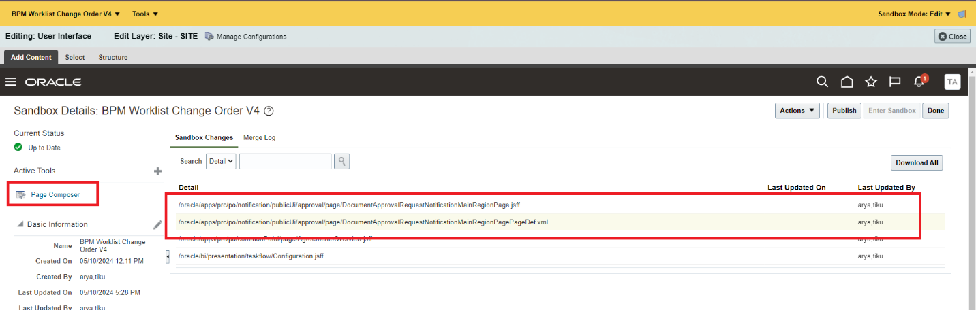

Page Customization Steps :

On the home page towards the top right corner click on Bell icon and click on “More Details”
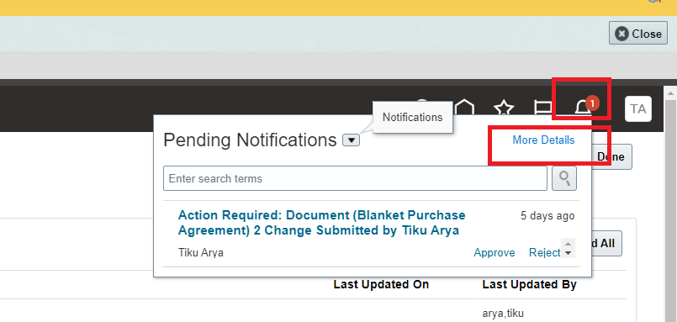

Once BPM worklist page open the pick up one of the notification called “Document (Blanket Purchase Agreement) 5 Change Submitted by XXXXX
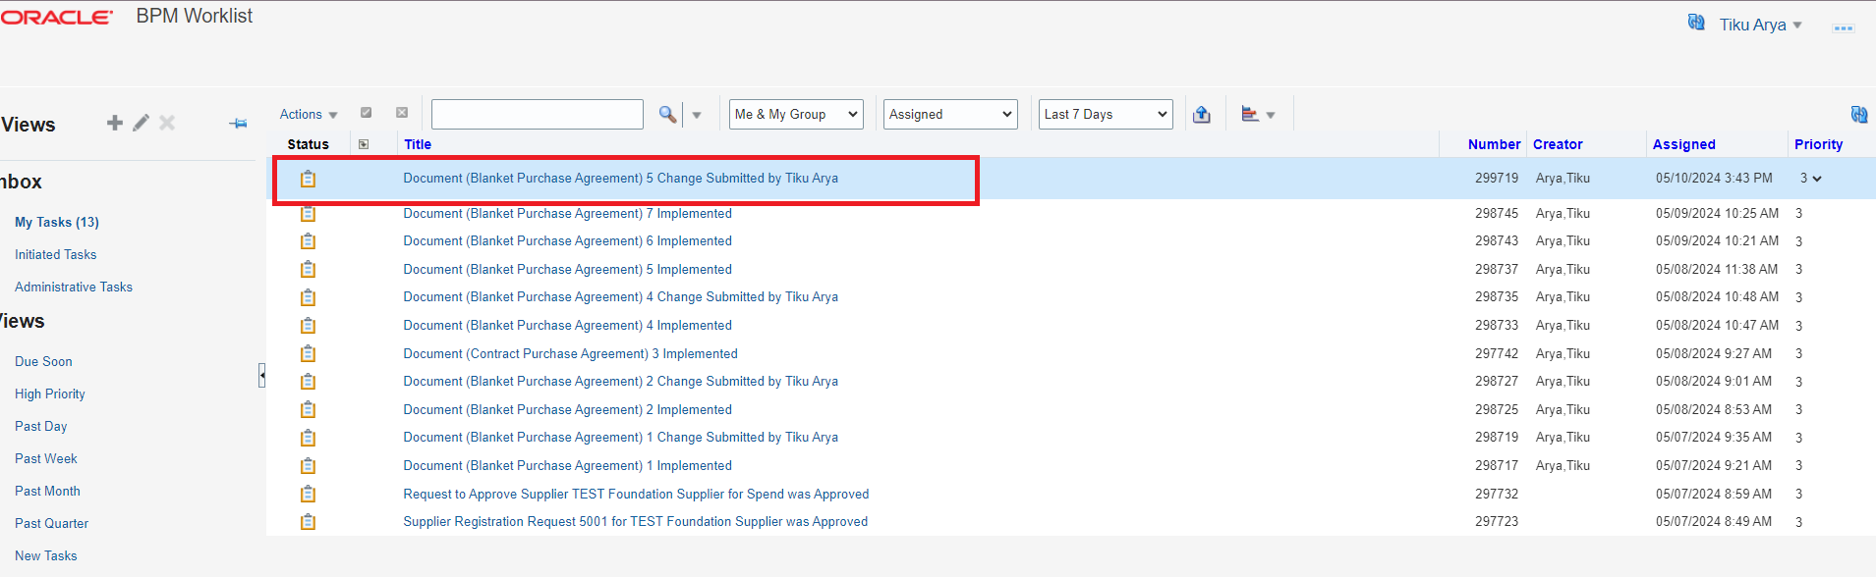

Once BPM worklist page open the pick up one of the notification called “Document (Blanket Purchase Agreement) 5 Change Submitted by XXXXX . The notification look like below
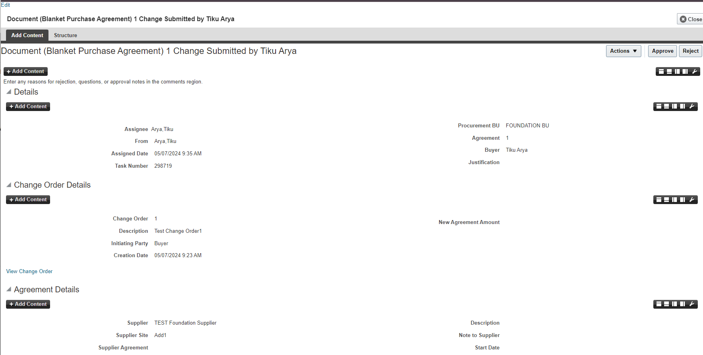

Click on Edit on top left and then following view is open. Red highlighted box is one which highlights the OTBI Analysis added

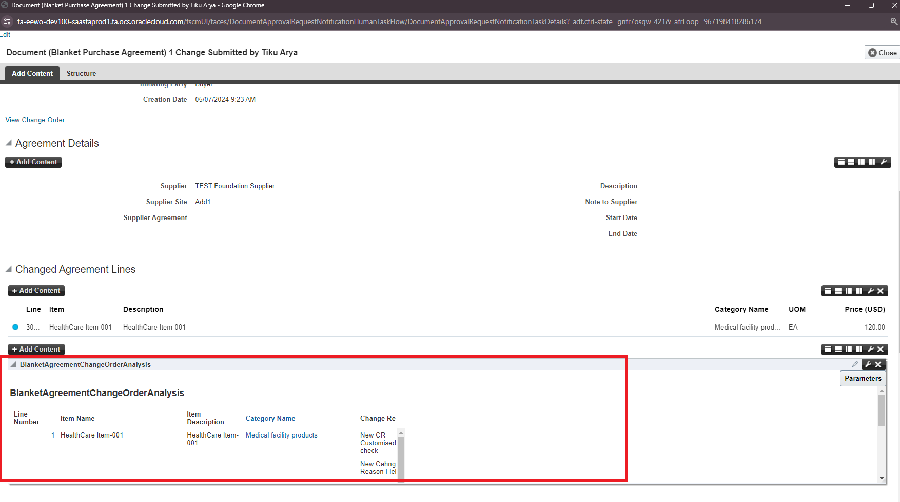

Click on Parameter Button on top right and get following view
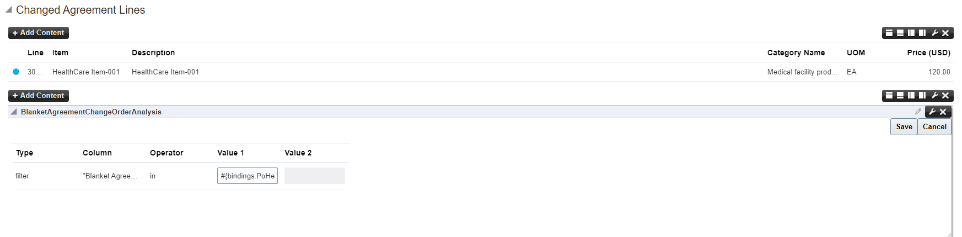

Click on Edit to open following

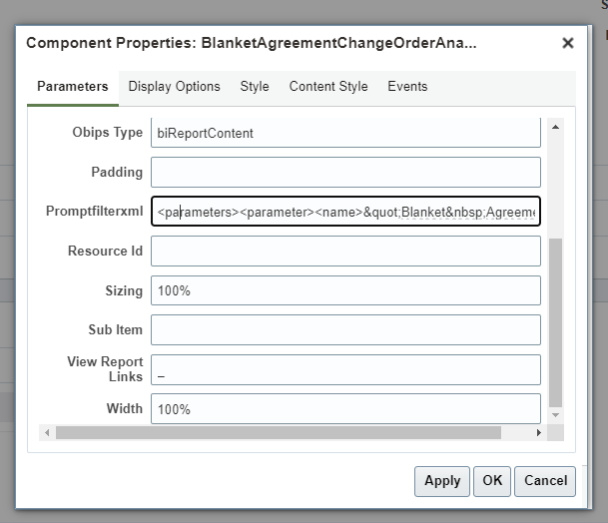

Open the Expression builder and following is added

<parameters><parameter><name>&quot;Blanket&nbsp;Agreement&nbsp;Pending&nbsp;Change&nbsp;Order&nbsp;Header&nbsp;Detail&quot;.&quot;Blanket&nbsp;Po&nbsp;Header&nbsp;Id&quot;</name><value>#{bindings.PoHeaderId.inputValue}</value><operator>in</operator><type>filter</type><dataType>double</dataType></parameter></parameters>

Click on Test : You can see the value is derived
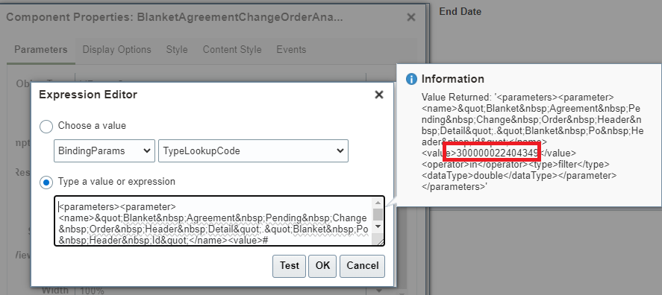

Go Back to report and validate if filter applied ? you can see filter is not applied
