Setup and Maintenance > Search Tasks: Manage Environment, Health and Safety Incident Events
We have renamed some incident event names –
Air Quality to Accident at Work
Fire or Explosion to Accident on the way to/from Work
Virus, illness, or injury to Illness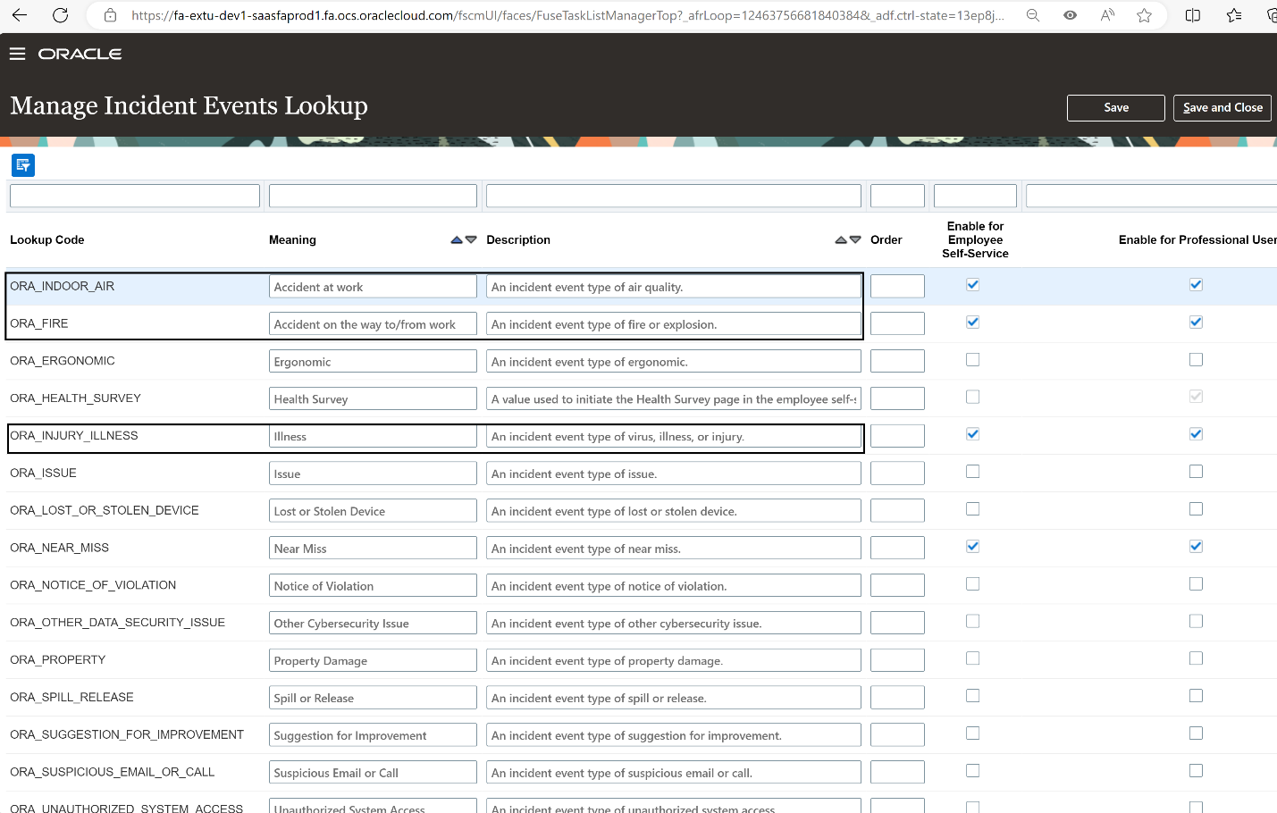

Logged in as Health & Safety Manager
