- The account combination rule for trade intransit valuation is created with source as “Transfer Order Charge Account”
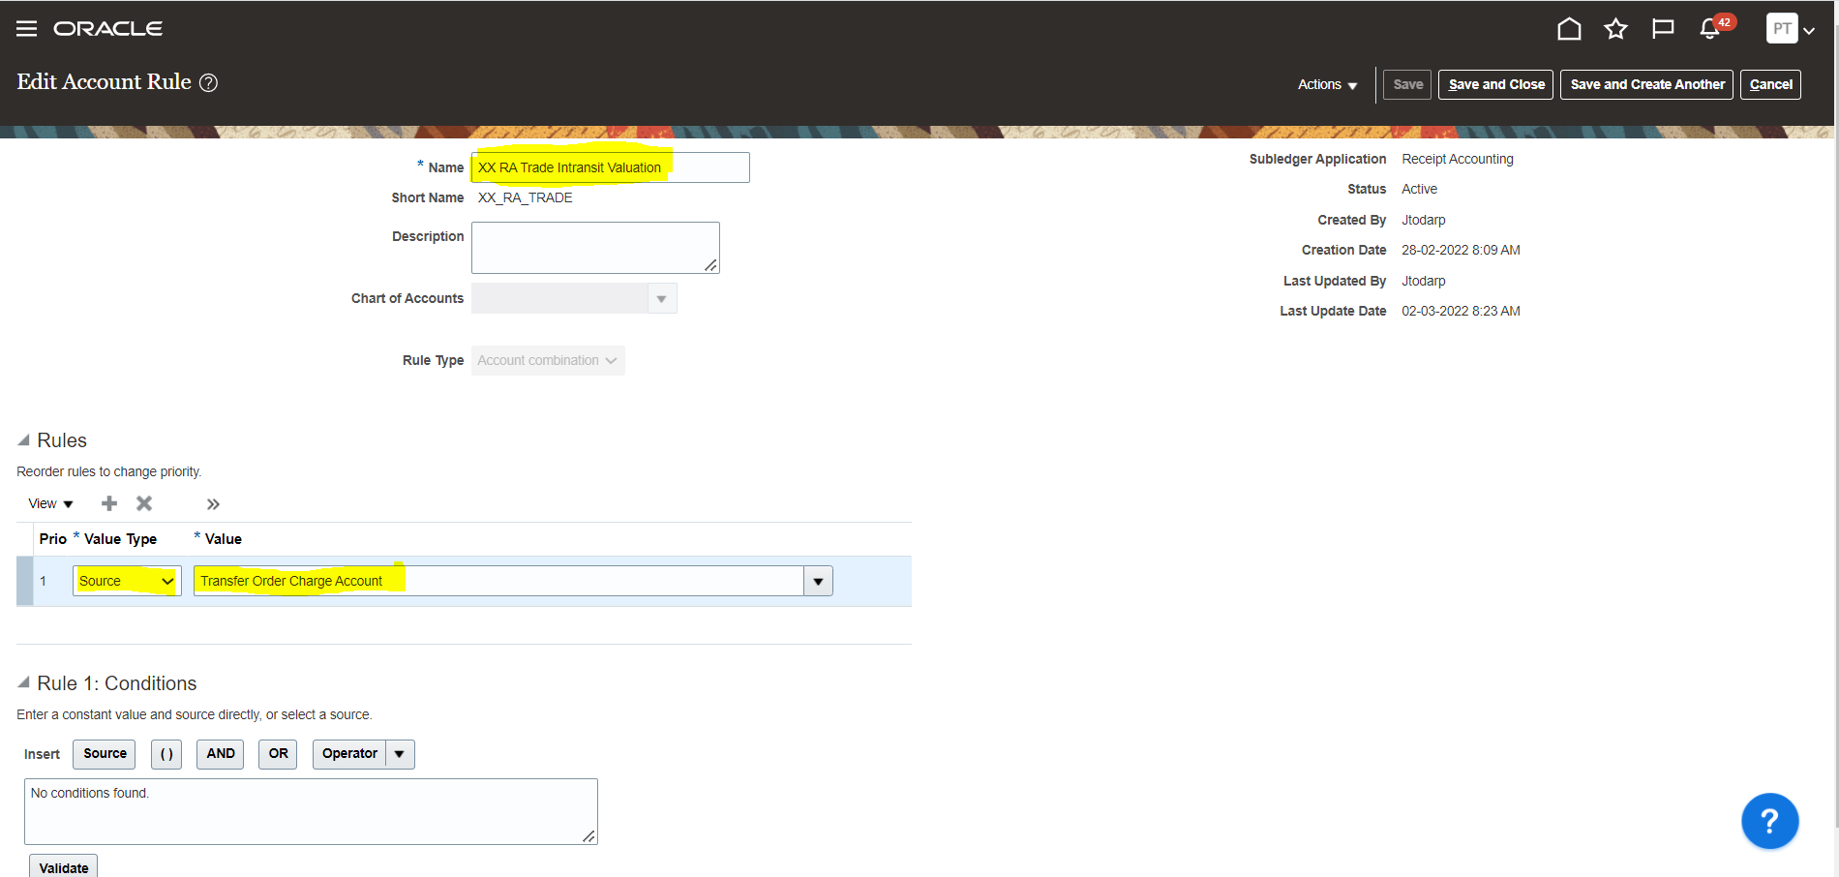

- A custom subledger journal entry rule set is created named as “XX RA Transfer Order Logical Receipt” and the custom account rule is attached for the trade intransit valuation rule
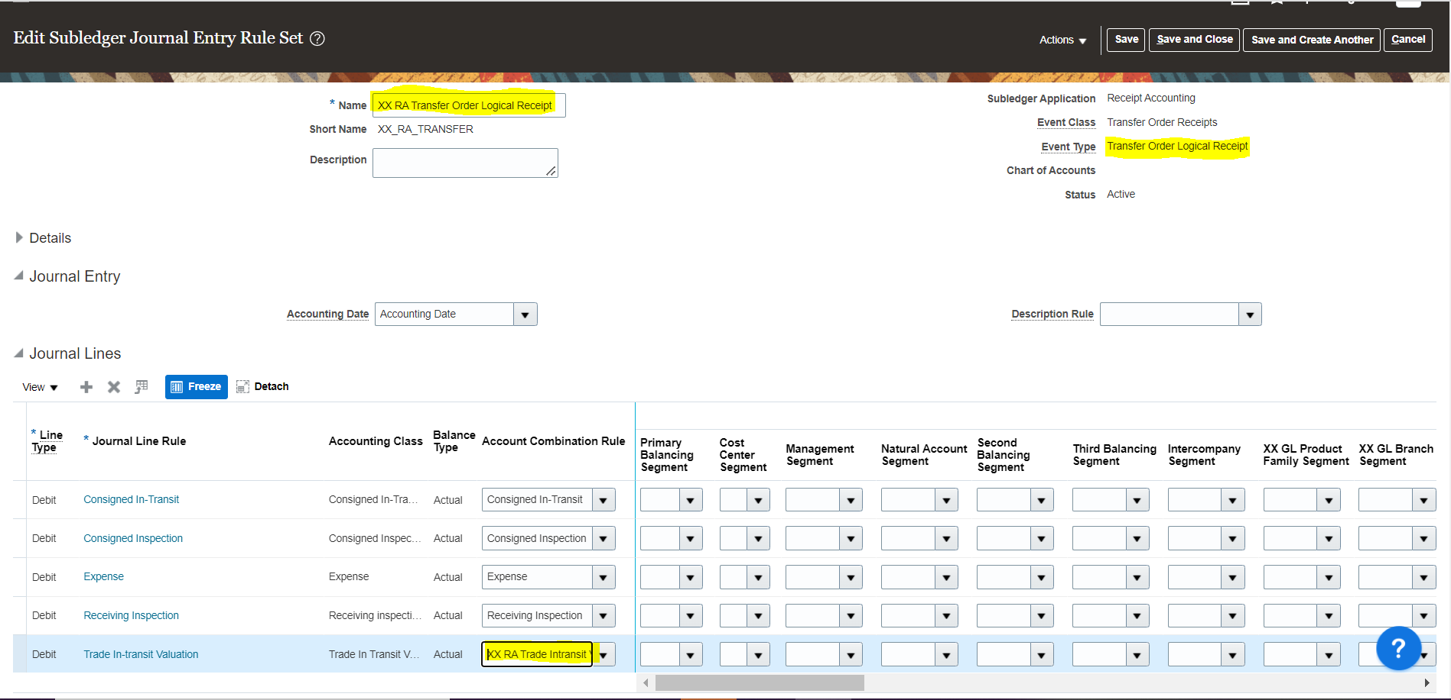

- The Custom subledger is attached in accounting method and is activated.
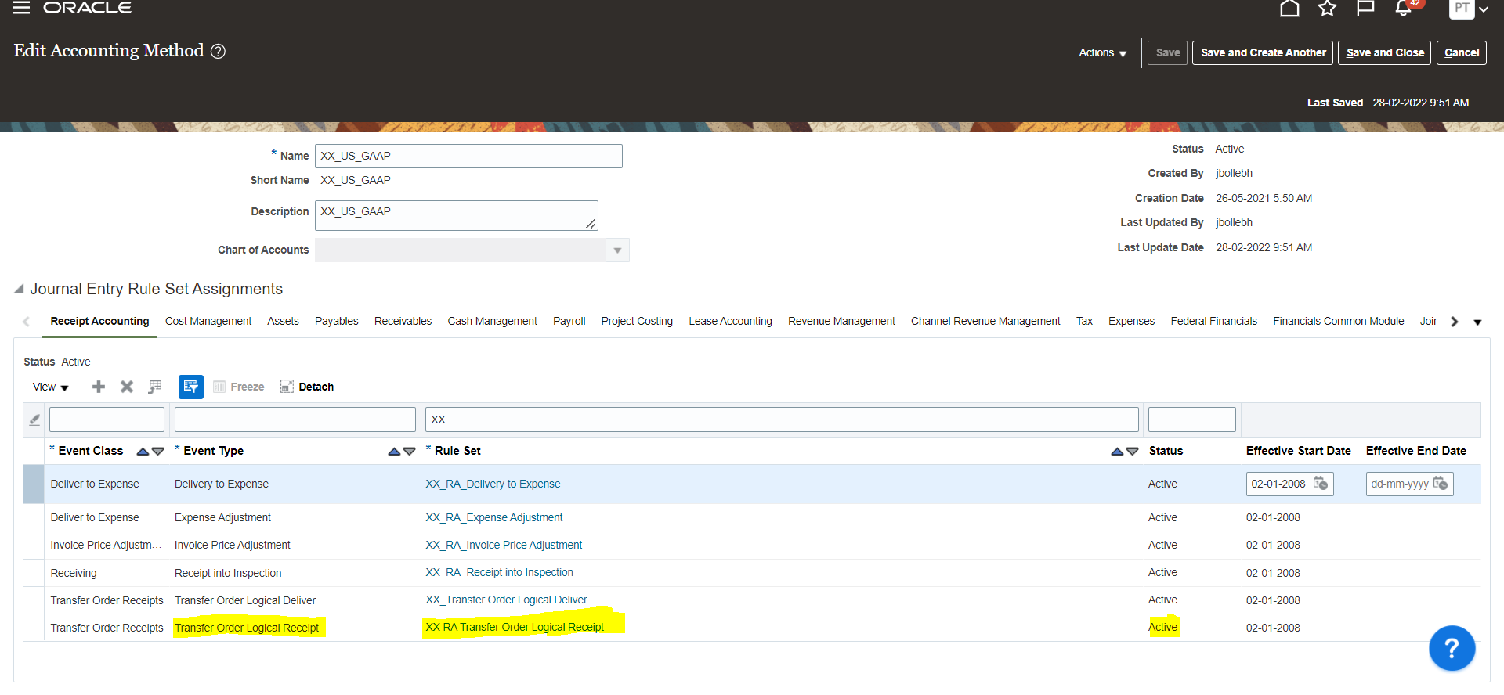
- The trade in transit valuation does not default value from source “Transfer Order Charge Account” for event “Transfer Order Logical Receipt” after the virtual receiving is done after pick pack and ship confirm.
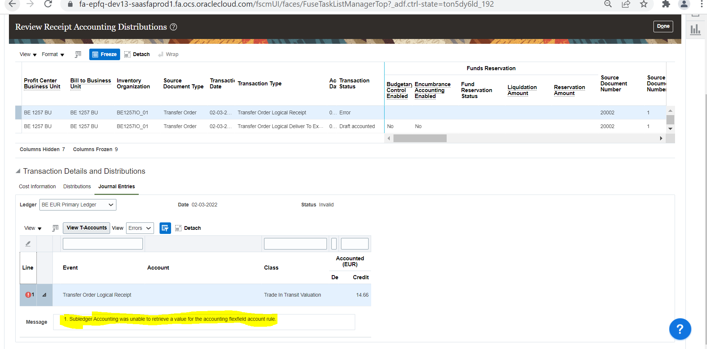

Test Case:
Requisition and Transfer Order as below

