Input file
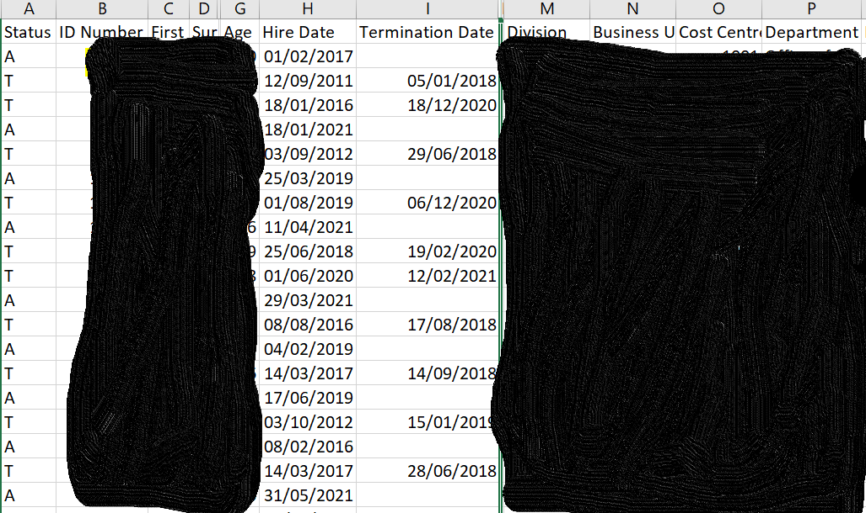

Hi,
I am new to Domo and have been asked to build a card that displays the total headcount for the year to date based on the Hire date and termination date. However, this selection should be used to check for the last two years as well.
- What is expected is to show the total active employees for that month for that period as displayed here.
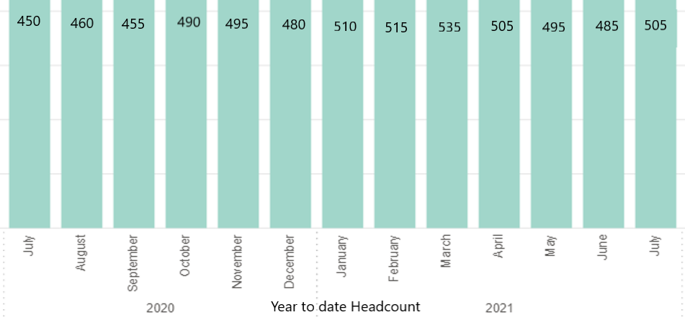

- Then based on that, the total turnover% per month for employees with < 1 year service and employees with > 1 year service to be worked out.
Guidance on whether this could be done through the ETL or beast mode and how to achieve this would be really appreciated.
Thanks

