N5LB Flex 6400
SN 1818-6579-6400-1044
HW v4.0.139161
Problem: SDR 4.0.1 basic installed on Radio using latest SDR v3. SDR 4.0.1 Basic is working as expected. Local connected to Internet.
Purchased SDR v4.0.1 + on November 30 2025 and received e-mail order “Completed” on Sunday November 30 2025 10:96AM. Order Number 46xxx.
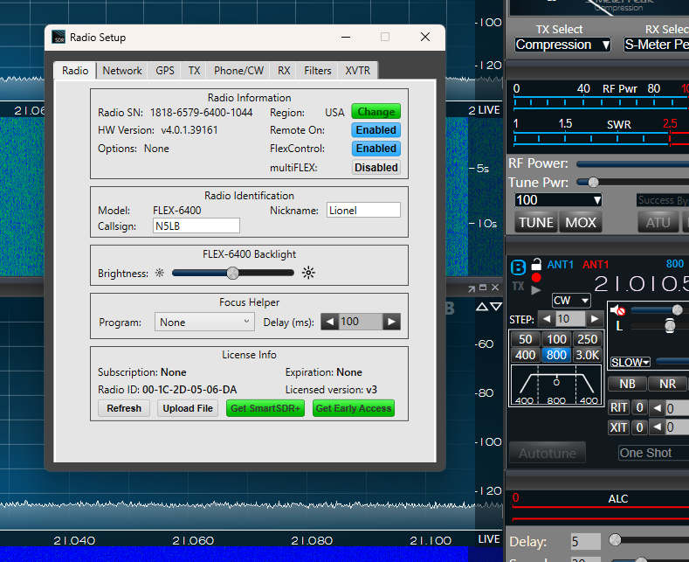
This the Radio Setup just after Completed e-mail that my v4.0.1+ license order was filled. The setup shows no subscription, a green Get SDR+ and version v3:
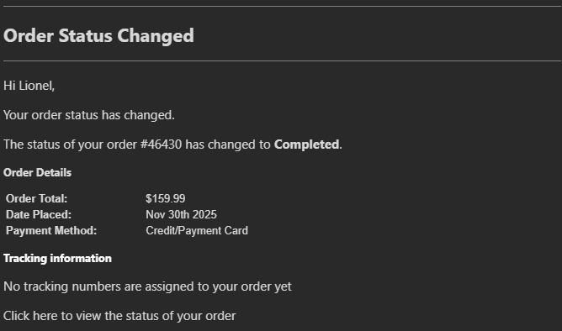

Pressing Get SmartSDR+ button goes to:
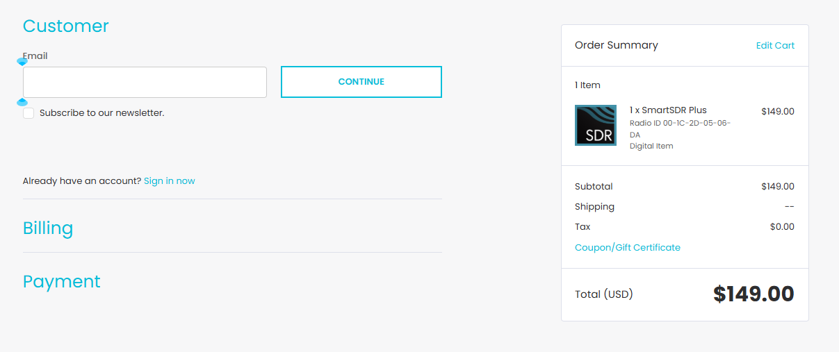
Starting over and this time pressing the Refresh button consistently results in:
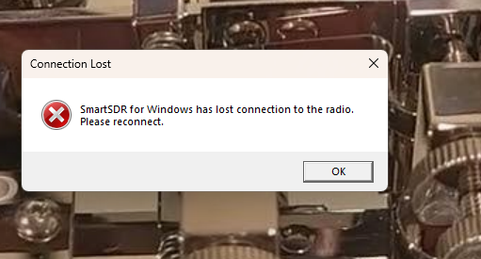
This is the result each time.
Restarting the 6400 results in:
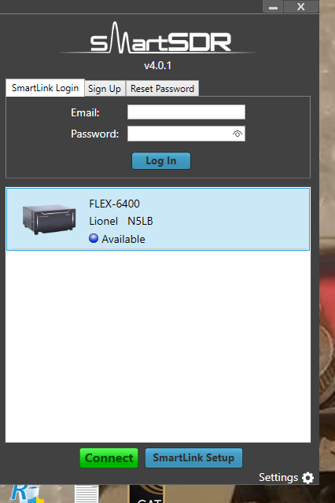
The 6400 will connect and all is fine on v4.0.1 basic.
Beginning again returns the same results.

Computer: I5-11400 48 GB RAM, W11, Core Isolation is off. Secure Boot is On, Malwarebytes Premium Latest.
Allowed Apps:
