Requirement :
- Tax to be enabled/generated @ Project Level (Segment-5) (Refer to the below Screen Shot)
- Ex: Project Segment has 3 Values
Project Segment :
GOK FUNDS
CADEP
FOREST 2020
- System should generate Tax when Invoice distributon Project Segment value is FOREST 2020 in AP Invoice Distribution
Project Segment Value Set
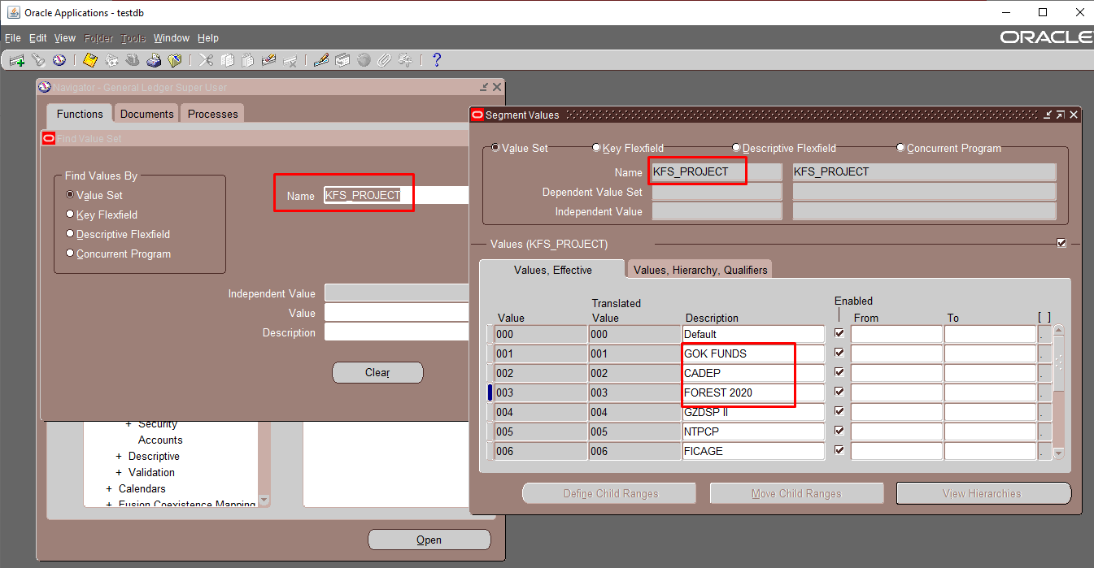

Invoice Dstributions –Segment-5 (Project)
