{{#foreach memorial}}

{{today_nice_date}}

{{addr.name}}
{{addr.address}}{{addr.address2}}
{{addr.citystatezip}}

Dear {{salutation}},

The following donations were made in memory of {{memorial_name}} to the {{funit_name}}.

Details of the donations are as follows:

{{#foreach donation}}{{donation_date}} | {{donor_name}}  {{email}}  {{address}}{{address2}}  {{citystatezip}}{{/foreach donation}}

With our best regards and gratitude for this kind and thoughtful gesture,

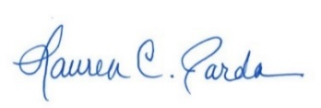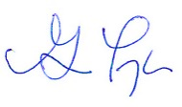
Lauren C. Parda Geoffrey Taylor
Director of Development Director of Donor Relations

{{/foreach memorial}}

