I have registered two hosts xsj-db1 and xsj-db4 to PMM
MongoDB was up on both and the agent was also alive and I was able to see all the metrics for both server and MongoDB
Now MongoDB is down on xsj-db4

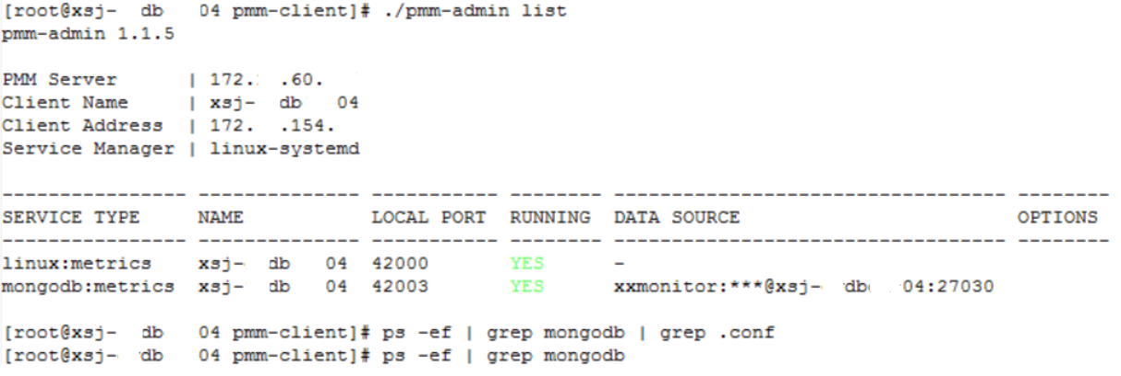

In the PMM we can see both the servers in the “Cross Server Graphs” dashboard

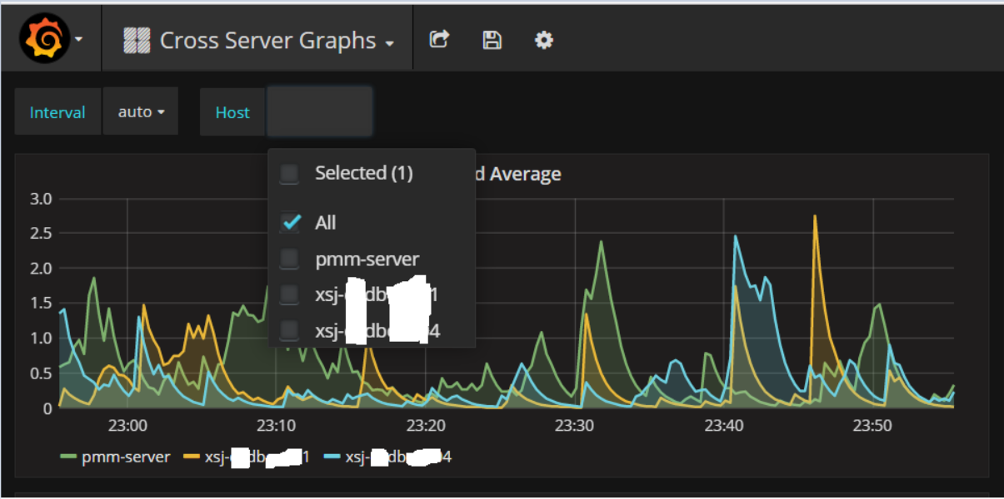

But in the MongoDB Dashboards, where we could see MongoDB metrics for xsj-db4 we cannot see it now

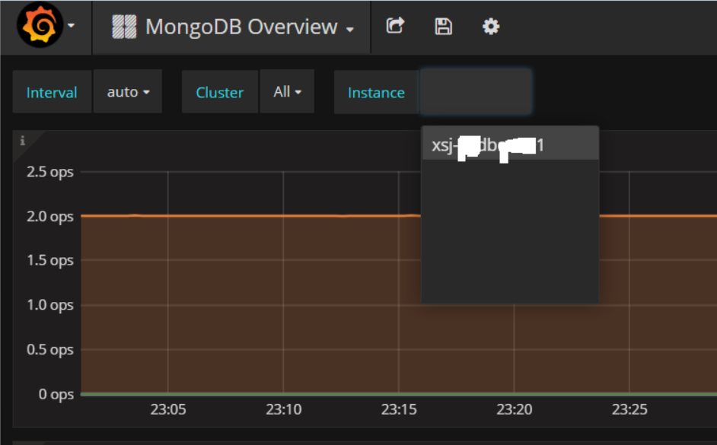

It is the same with all the rest of the MongoDB Dashboards

