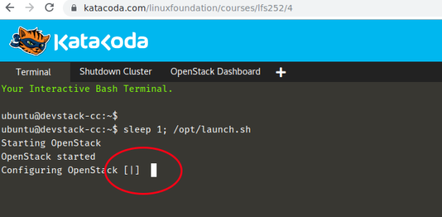
4.8. LABS
c Copyright the Linux Foundation 2018. All rights reserved.
1
Exercise 4.1: Working with Images, Snapshots and Volumes
Overview
The course material includes a URL for lab access. You will use your Linux Foundation login and password to gain access. After successfully logging in you will be presented a new page and a virtual machine instance will be created. It may take a minute or two for previous steps to be completed. You will see a line saying Configuring OpenStack and a twirling cursor while the conﬁguration takes place.
Use the OpenStack Dashboard tab via the Katacoda page to access the Horizon BUI. The Horizon URL can also be found by looking in the /opt/host ﬁle. Your URLs may be different than the example shown.
The plus sign (+) icon in the menu bar can be used to open more terminals for testing or viewing of log ﬁles in real time. Select the Shutdown cluster tab when ﬁnished with the lab.
Figure 4.6: Katacoda Horizon Login
The suggested and tested browser to use is Chrome, although others may work.
This lab uses DevStack running on Ubuntu. Later labs will use RDO running on CentOS.
Working with Volumes
In this lab we will create a snapshot from a running instance. We will create a new volume from the snapshot then use to launch a new instance and create a new image.
We will also work with encryption of volumes and volume types.
LFS252: V 2018-09-11
2
c Copyright the Linux Foundation 2018. All rights reserved.
CHAPTER 4. COMPONENTS OF AN OPENSTACK CLOUD
Create the Snapshot
In this task we will use an an existing instance to create a snapshot,then an image in a different tenant.
STEP-1: Login into a devOS1 instance using command line, using private IP and namespace ID, as explained in previous lab
sudo ip netns exec qrouter-e83cadb5-fa4c-4a44-97d4-350279124328 ssh cirros@10.0.0.12
// where qrouter-e83cadb5-fa4c-4a44-97d4-350279124328 is namespace ID obtained using sudo ip netns list command.
// where 10.0.0.12 is the private IP of the instance as can been seen from Compute > instances > devOS1 log tab.
// where cirros is the usename and cubswin:) is the password for the instance, which is also visible in the devOS1 log tab.

STEP-2: create any file, which has unique signature. Say
devOS1> touch hello_my_name_is_xyz.txt

1. Logged in as admin navigate to the Admin -> Compute -> Instances page. Select the drop-down under the Actions column of the devOS1 instance, then Create Snapshot. Give a name of dev-snap1 and then Create Snapshot into the pop-up window.
Question: Why is devOS1 instance not visible under Project > Compute > Instances ? Its only visible under Admin > Compute > Instances
Question: How do I create a snapshot from a given instance using command-line interface ? There is no option to give instance name or IP in the command “openstack volume snapshot create”
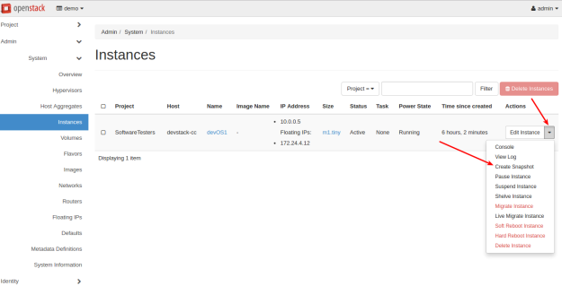
: Create Snapshot
2. Notice that upon ﬁnishing Horizon changed to the Project -> Compute -> Images page. Select the drop-down under Actions for the newly created snapshot. If the image appears queued for more than a minute refresh the page. Once it shows as active notice there are several options including launch. Select Edit Image. Note the options under Format. Then ﬁnd and change the Image Sharing Visibility to Public if not already set.
3. After noting the visibility now shows Public go to the Project -> Compute -> Images page. Use the drop down to edit dev-snap1. It should look similar to the Admin.
4. Go to the top of the BUI and change the current project to be demo instead of alt demo.
5. Select the Launch button on the dev-snap1 line.
6. Fill in the following values for the new instance. The source should already be set. Select Launch Instance when complete.

Instance Name: golden Source: Image
Under the source tab, select “Select Boot Source = Instance snapshot” to show the dev-snap1
Allocated: dev-snap1 Flavor: m1.tiny Networks: Private
7. Navigate to the Project -> Compute -> Instances page. Once the new instance becomes active and has time to boot take note of the assigned IP address and log in. The username and password remain the same as source instance. Even though a snapshot, the instance was created by a different user, in a different project, on a different network. Use the ip netns list and previous steps to ﬁnd the correct namespace to access the instance. For example to ssh, on the Private network, see the following. Your namespace will be different. Remember this is a different project, you will need to add ssh to the security group.
The historical password for Cirros images has been cubswin:). Now that the cubs have actually won, they are changing to gocubsgo. Should one password not work, try the other.

NOTE: if you get SSH error, that is probably because the RSA key mismatches. So flush out the old RSA key using ssh-keygen give below. @@@@@@@@@@@@@@@@@@@@@@@@@@@@@@@@@@@@@@@@@@@@@@@@@@@@@@@@@@@
@ WARNING: REMOTE HOST IDENTIFICATION HAS CHANGED! @
@@@@@@@@@@@@@@@@@@@@@@@@@@@@@@@@@@@@@@@@@@@@@@@@@@@@@@@@@@@
IT IS POSSIBLE THAT SOMEONE IS DOING SOMETHING NASTY!
Someone could be eavesdropping on you right now (man-in-the-middle attack)!
It is also possible that a host key has just been changed.
The fingerprint for the RSA key sent by the remote host is
SHA256:bNKBpImzaLfX+D6lXAR1v3pIS9RjVWe+CmUuDVt+lnU.
Please contact your system administrator.
Add correct host key in /root/.ssh/known_hosts to get rid of this message.
Offending RSA key in /root/.ssh/known_hosts:1
remove with:
ssh-keygen -f "/root/.ssh/known_hosts" -R 10.0.0.12
RSA host key for 10.0.0.12 has changed and you have requested strict checking.
LFS252: V 2018-09-11
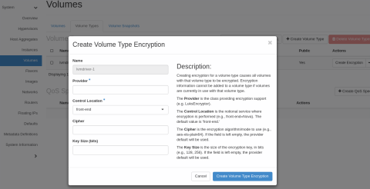
4.8. LABS
c Copyright the Linux Foundation 2018. All rights reserved.
3
ubuntu@devstack-cc:~/devstack$ sudo ip netns exec \ qrouter-0701411b-91d8-4871-8191-7c808b1c1144 \ ssh cirros@10.0.0.6
<output_omitted>
cirros@10.0.6’s password: cubswin:) $
8. Look for existing ﬁles and verify the new node name. You should see the ﬁle created in earlier steps “hello_my_name_is_xyz.txt” prior to creating the snapshot. Note the difference node name.\

$ ls uname.out
$ cat uname.out
Linux devos1 3.2.0-80-virtual #116-Ubuntu SMP Mon Mar 23 17:28:52 UTC 2015 x86_64 GNU/Linux $ uname -a
Linux golden 3.2.0-80-virtual #116-Ubuntu SMP Mon Mar 23 17:28:52 UTC 2015 x86_64 GNU/Linux $ exit
Create an Encrypted Volume
Now we enable encryption and create a new encrypted volume. Some volume drivers may not set the encrypted ﬂag. These cannot use encrypted volumes. We will review how the BUI can be used but preform the steps from the command line.
1. You can create new volume types from the BUI. Navigate to the Admin -> Volumes -> Volume Types page. In the Actions column select the Create Encryption button. Read through the Description on the right.
Figure 4.8: Create Volume Type Encryption
2. Return to the command line. Make sure you have sourced the admin ﬁle.
ubuntu@devstack-cc:~/devstack$ source openrc admin
3. Use the openstack utility to create the new volume type.
Question: Why do we need to create a Volume type first ? Can’t we just create a volume directly using a predefined default type ?
ubuntu@devstack-cc:~/devstack$ openstack volume type create LUKS <output_omitted>
4. Use the output of the cinder help command to view the syntax.
ubuntu@devstack-cc:~/devstack$ cinder help encryption-type-create <output_omitted>
c Copyright the Linux Foundation 2018. All rights reserved.
|
|
CHAPTER 4. COMPONENTS OF AN OPENSTACK CLOUD
5. Use the cinder command to create the encryption type and assign a cipher and key size.
What is encryption type ? Aren’t there predefined encryption engines and algorithms to select from ?
ubuntu@devstack-cc:~/devstack$ cinder encryption-type-create \ --cipher aes-xts-plain64 \
--key_size 256 \
--control_location front-end LUKS \ LuksEncryptor
<output_omitted>

6. Now that we have the type we can create a new encrypted volume.
ubuntu@devstack-cc:~/devstack$ openstack volume create --size 1 --type LUKS crypt-vol +---------------------+--------------------------------------+
| Field | | Value | |
+---------------------+--------------------------------------+
| attachments | availability_zone | bootable <output_omitted> | | [] | nova | false | | | |
7. View the newly created volume. Verify you can see the encrypted setting.
ubuntu@devstack-cc:~/devstack$ cinder show crypt-vol +--------------------------------+--------------------------------------+
| Property | | Value | |
+--------------------------------+--------------------------------------+
| attachments | availability_zone | bootable | consistencygroup_id | created_at | description | encrypted  | id  | metadata | migration_status | multiattach  | name  | os-vol-host-attr:host | | []  | nova  | false  | None | 2016-12-30T07:12:48.000000 | None  | True | | | | | | | |
 | | b133e0dd-177c-44f2-a8d8-418269e0211b |
 | | {}  | None | False | crypt-vol  | devstack-cc@lvmdriver-1#lvmdriver-1 | | | | | | | | | | | | | | | | |
| os-vol-mig-status-attr:migstat | None | os-vol-mig-status-attr:name_id | None
| os-vol-tenant-attr:tenant_id | replication_status  | size | snapshot_id | source_volid | status | updated_at | user_id | volume_type | | 8e806b4eeada4305a4a327341a3f44dd | disabled | 1  | None | None  | available | 2016-12-30T07:12:50.000000 | 534ab9b6f27c4be281bab1ffe94cf023 | LUKS
+--------------------------------+--------------------------------------+
8. Now we add the volume to a running instance. Begin by viewing instance information. Take note of the ID.
buntu@devstack-cc:~/devstack$ openstack server list
+--------------------------------------+----------+--------+---------------------------------------------------------+------------
| ID | | Name | | Status | Networks | | Image Name
+--------------------------------------+----------+--------+---------------------------------------------------------+------------
| e743fc56-ee0f-4858-9ce7-e0a796154319 | golden |  | | ACTIVE | private=fd12:74d3:437f:0:f816:3eff:fe35:dddf, 10.0.0.10 | dev-snap1
+--------------------------------------+----------+--------+---------------------------------------------------------+------------
Question: why “openstack server list” shows only single instance ?
I’m unable to login into CLI when I change the environment variable OS_PROJECT_NAME=SoftwareTesters and OS_TENANT_NAME=SoftwareTesters.

9. View the volume information. You can either list all or view the details of a particular. Take note of the ID for crypt-vol.
ubuntu@devstack-cc:~/devstack$ openstack volume list +--------------------------------------+--------------+-----------+------+---------------------------------+
c Copyright the Linux Foundation 2018. All rights reserved.
5
| ID | | Display Name | Status |  |  | | Size | Attached to |  | |
+--------------------------------------+--------------+-----------+------+---------------------------------+
| b133e0dd-177c-44f2-a8d8-418269e0211b | crypt-vol | 3f7d187e-0160-4a04-ba83-ceb21ca99317 | |  | | available | |  |  | 1 |  1 | Attached to golden on /dev/vda | | |
 |  | | in-use | |
+--------------------------------------+--------------+-----------+------+---------------------------------+
ubuntu@devstack-cc:~/devstack$ openstack volume show crypt-vol <output-omitted>
10. Now use the openstack utility to attach the volume to the golden instance. Pass ﬁrst the ID for the instance then the ID for the volume. The command is on multiple lines for ease of reading.
ubuntu@devstack-cc:~/devstack$ openstack server add volume \
e743fc56-ee0f-4858-9ce7-e0a796154319 \ b133e0dd-177c-44f2-a8d8-418269e0211b \ --device /dev/vdb
11. Verify the item shows a status of in-use.
ubuntu@devstack-cc:~/devstack$ openstack volume list +--------------------------------------+--------------+--------+------+---------------------------------+
| ID | | Display Name | Status | Size | Attached to |  |  | |
+--------------------------------------+--------------+--------+------+---------------------------------+
| b133e0dd-177c-44f2-a8d8-418269e0211b | crypt-vol |  | | in-use | | 1 | Attached to golden on /dev/vdb | |
NOTE: It say “attaching” but does not attach.
openstack server add volume f7be990d-66a5-4729-b737-f77dc017be76 ab4d97b4-17fe-4ddb-a7f5-8b69bf8e6996 --device /dev/vdb
ubuntu@devstack-cc:~$ openstack volume list
+--------------------------------------+-----------+-----------+------+---------------------------------+
| ID | Name | Status | Size | Attached to |
+--------------------------------------+-----------+-----------+------+---------------------------------+
| ab4d97b4-17fe-4ddb-a7f5-8b69bf8e6996 | crypt-vol | attaching | 1 | |
| 995ddacd-2ac8-452d-9198-77c33495d769 | | in-use | 1 | Attached to golden on /dev/vda |

11. debug the error in attaching the volume ?
openstack –debug server add volume f7be990d-66a5-4729-b737-f77dc017be76 ab4d97b4-17fe-4ddb-a7f5-8b69bf8e6996 --device /dev/vdb
12. Log into the instance and verify the volume can be seen.
ubuntu@devstack-cc:~/devstack$ sudo ip netns exec qrouter-0701411b-91d8-4871-8191-7c808b1c1144\ ssh cirros@10.0.0.10
cirros@10.0.0.10’s password: cubswin:) $ sudo fdisk -l | grep vdb
Disk /dev/vdb doesn’t contain a valid partition table Disk /dev/vdb: 1071 MB, 1071644672 bytes

